AC CONTROLLER - 6
Name : B.Tharun Kumar Reddy
Reg No:192565015
➔ Source Code:
#define TEMP A0 #define FAN 8 volatile byte pwm = 0; volatile byte count = 0;
// Timer1 Compare Match Interrupt
ISR(TIMER1_COMPA_vect)
{ count++; if (count >= 100)
{ count = 0;
}
digitalWrite(FAN, count < pwm);
} void setup() {
Serial.begin(9600); pinMode(FAN, OUTPUT);
// Timer1 configuration
TCCR1A = 0;
TCCR1B = (1 << WGM12) | (1 << CS11);
OCR1A = 199; TIMSK1 = (1 << OCIE1A);
sei(); }
void loop() { int adc = analogRead(TEMP);
// Convert ADC value into temperature (LM35 sensor) float temp = adc * 500.0 / 1023.0; if (temp < 25)
{
pwm = 0;
} else if (temp < 30)
{
pwm = 30;
}
else if (temp < 35)
{
pwm = 60;
} else
{
pwm = 90;
}
Serial.print("Temperature: ");
Serial.print(temp, 1);
Serial.print(" C PWM: ");
Serial.print(pwm); Serial.println("%"); delay(1000);
}

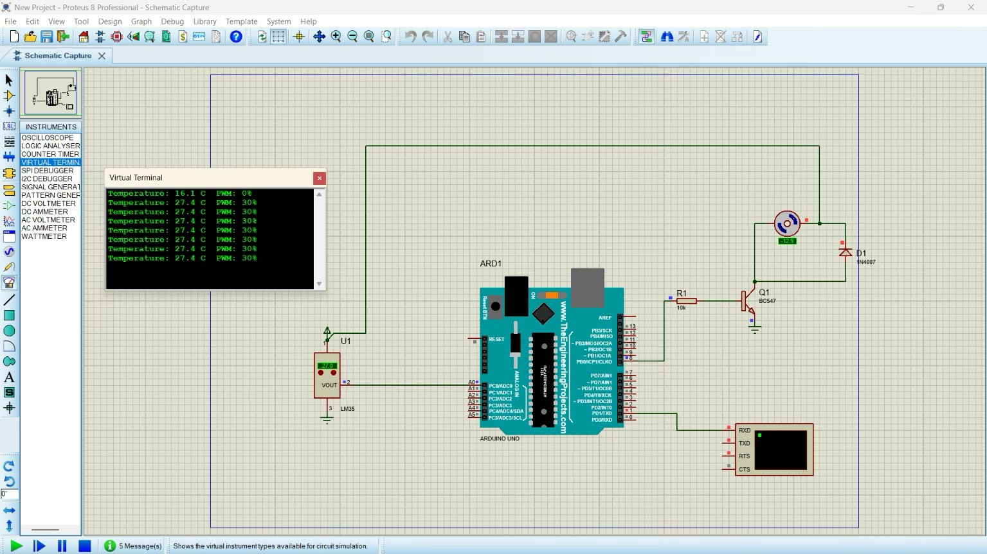
Reflections:
- Learned how to interface the LM35 temperature sensor with Arduino Uno to measure temperature.
- Understood ADC conversion and the process of converting analog sensor readings into temperature values.
- Gained practical knowledge of Timer1 configuration and Compare Match Interrupts.
- Learned to generate software-based PWM signals to control fan speed according to temperature variations.
- Understood how embedded systems use real-time sensor data for automatic temperature monitoring and fan control.

