Experiment-28
Aim:
To implement a counting semaphore and manage multiple shared resources.
Code:
//EXP:28
//roll no:192565042
//namde:SadhanaV
//class"ECA1408 Embedded system
#include <systemc.h>

SC_MODULE(counting_semaphore) {

int sem;

void task() {
while(true) {
wait(1, SC_SEC);

if(sem > 0) {
sem--;
cout << "Task Accessing Resource at "
<< sc_time_stamp()
<< " Remaining: " << sem << endl;

wait(2, SC_SEC);
sem++;
}

}
}

SC_CTOR(counting_semaphore) {
sem = 2;
SC_THREAD(task);
SC_THREAD(task);
SC_THREAD(task);
}
};

int sc_main(int argc, char* argv[]) {
counting_semaphore obj("Counting");
sc_start(10, SC_SEC);
return 0;
}
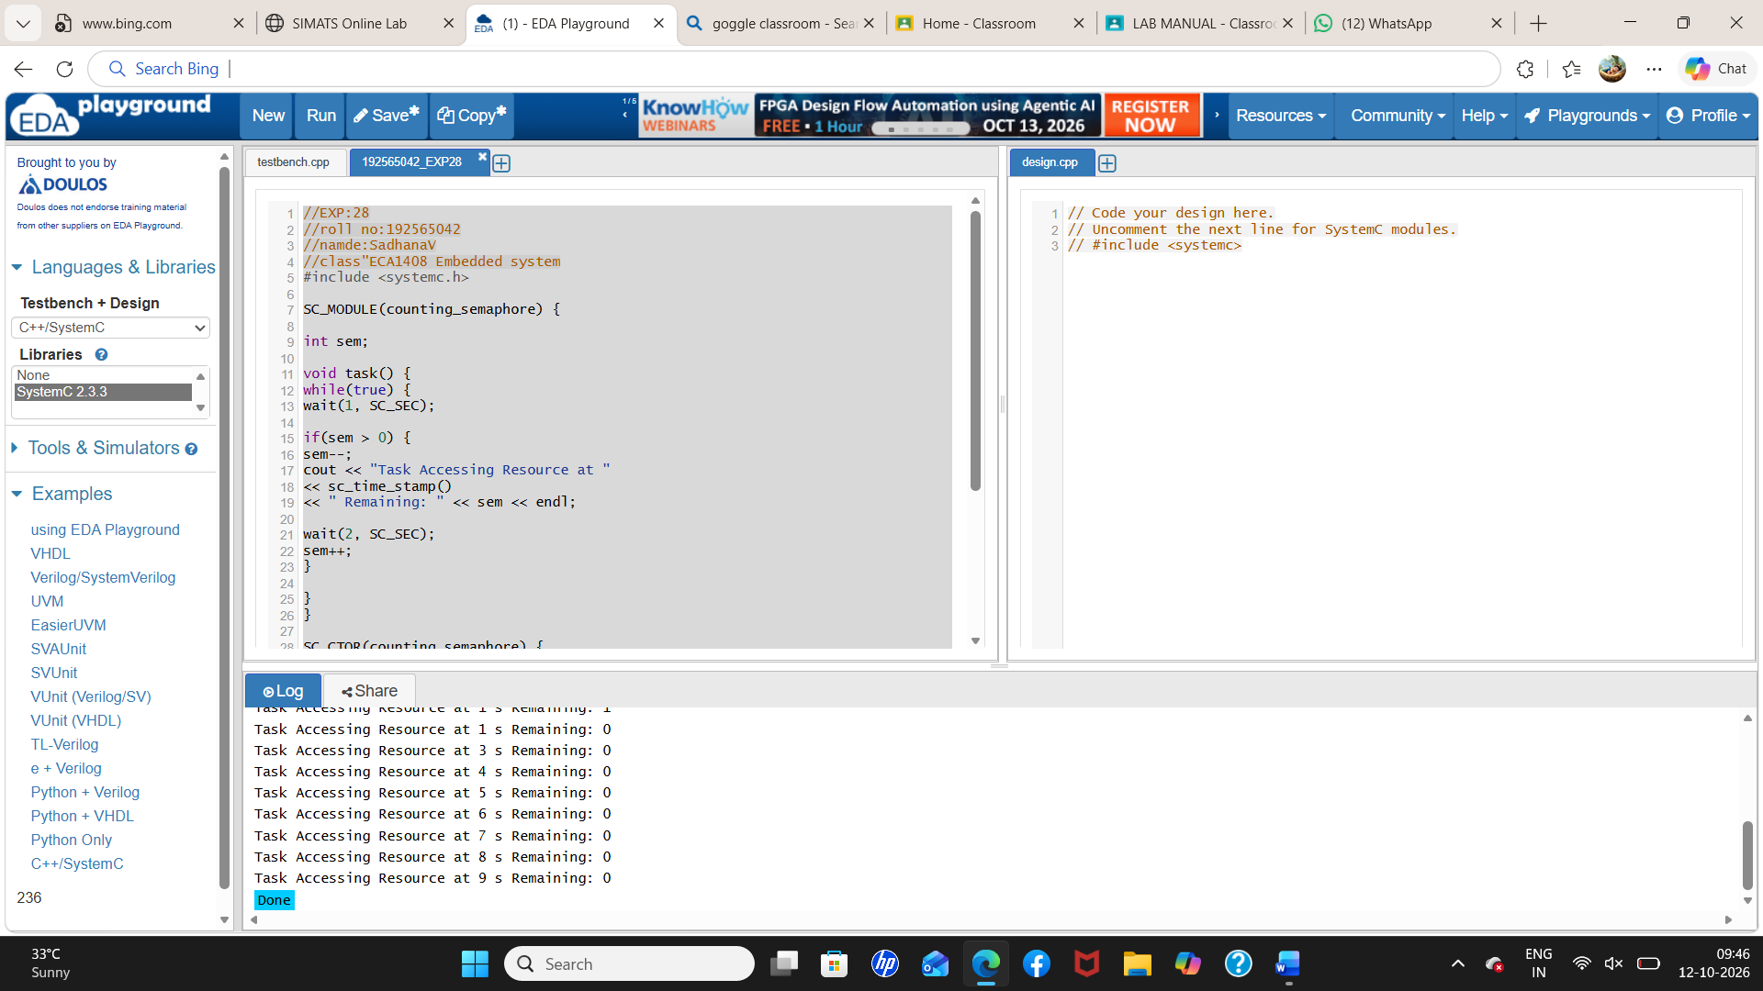
Output:
