Experiment-29
Aim:
To implement priority-based interrupt handling and study interrupt execution order.
Code:
//EXP:29
//roll no:192565042
//namde:SadhanaV
//class:ECA1408 Embedded system
#include <systemc.h>

SC_MODULE(priority_interrupt) {

sc_event low_int, high_int;

void low_ISR() {
while(true) {
wait(low_int);
cout << "Low Priority Interrupt at "
<< sc_time_stamp() << endl;
wait(3, SC_SEC);
}
}

void high_ISR() {
while(true) {
wait(high_int);
cout << "High Priority Interrupt at "

<< sc_time_stamp() << endl;
wait(1, SC_SEC);
}
}

void generator() {
wait(1, SC_SEC);
low_int.notify();

wait(1, SC_SEC);
high_int.notify();
}

SC_CTOR(priority_interrupt) {
SC_THREAD(low_ISR);
SC_THREAD(high_ISR);
SC_THREAD(generator);
}
};

int sc_main(int argc, char* argv[]) {
priority_interrupt obj("Priority_INT");
sc_start(10, SC_SEC);
return 0;
}
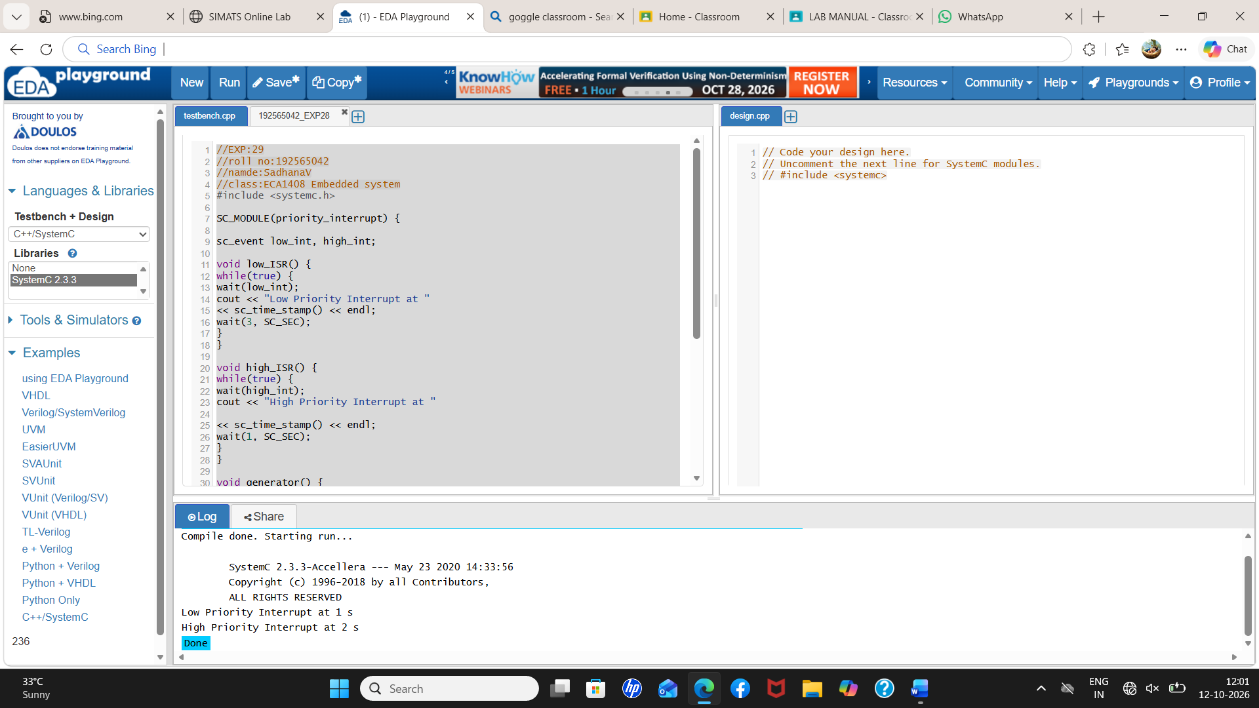
Output:
