Experiment-30
Aim:
To study RTOS task scheduling, task priorities, and context switching.
Code:
//EXP:29
//roll no:192565042
//namde:SadhanaV
//class:ECA1408 Embedded system
#include <systemc.h>
SC_MODULE(rtos_scheduler) {
void task1() {
while(true) {
cout << "Task1 Running at "
<< sc_time_stamp() << endl;
wait(1, SC_SEC);
}
}
void task2() {
while(true) {
cout << "Task2 Running at "
<< sc_time_stamp() << endl;
wait(1, SC_SEC);
}
}
SC_CTOR(rtos_scheduler) {
SC_THREAD(task1);
SC_THREAD(task2);
}
};

int sc_main(int argc, char* argv[]) {
rtos_scheduler obj("Scheduler");
sc_start(6, SC_SEC);
return 0;
}
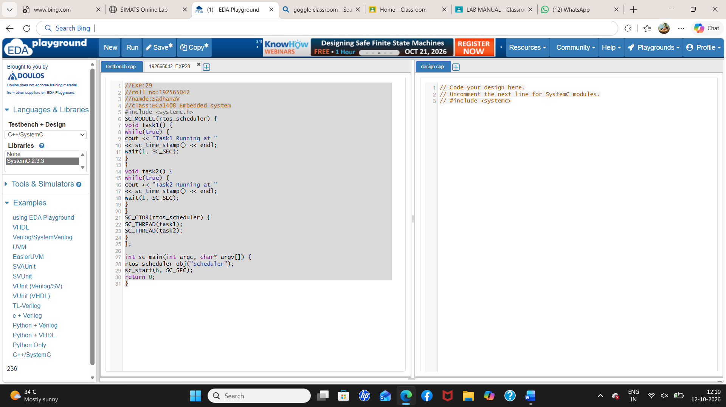
Output:
