Experiment-25

Aim:
To implement the Producer-Consumer problem and study process synchronization using SystemC.

Code:
//Exp:25
//roll no:192565042
//name:Sadhana.V
//class:ECA1408 Embedded system
#include <systemc.h>

// Producer Module
SC_MODULE(Producer) {
sc_fifo_out<int> out;

void produce() {
for (int i = 1; i <= 5; i++) {
cout << "Produced: " << i << endl;
out.write(i);
wait(1, SC_SEC);

}
}

SC_CTOR(Producer) {
SC_THREAD(produce);
}
};

// Consumer Module
SC_MODULE(Consumer) {
sc_fifo_in<int> in;

void consume() {
int value;
while (true) {
in.read(value);
cout << "Consumed: " << value << endl;
wait(1, SC_SEC);
}
}

SC_CTOR(Consumer) {
SC_THREAD(consume);
}
};

int sc_main(int argc, char* argv[]) {
sc_fifo<int> fifo(5);

Producer producer("Producer");
Consumer consumer("Consumer");

producer.out(fifo);
consumer.in(fifo);

sc_start(10, SC_SEC);

return 0;
}
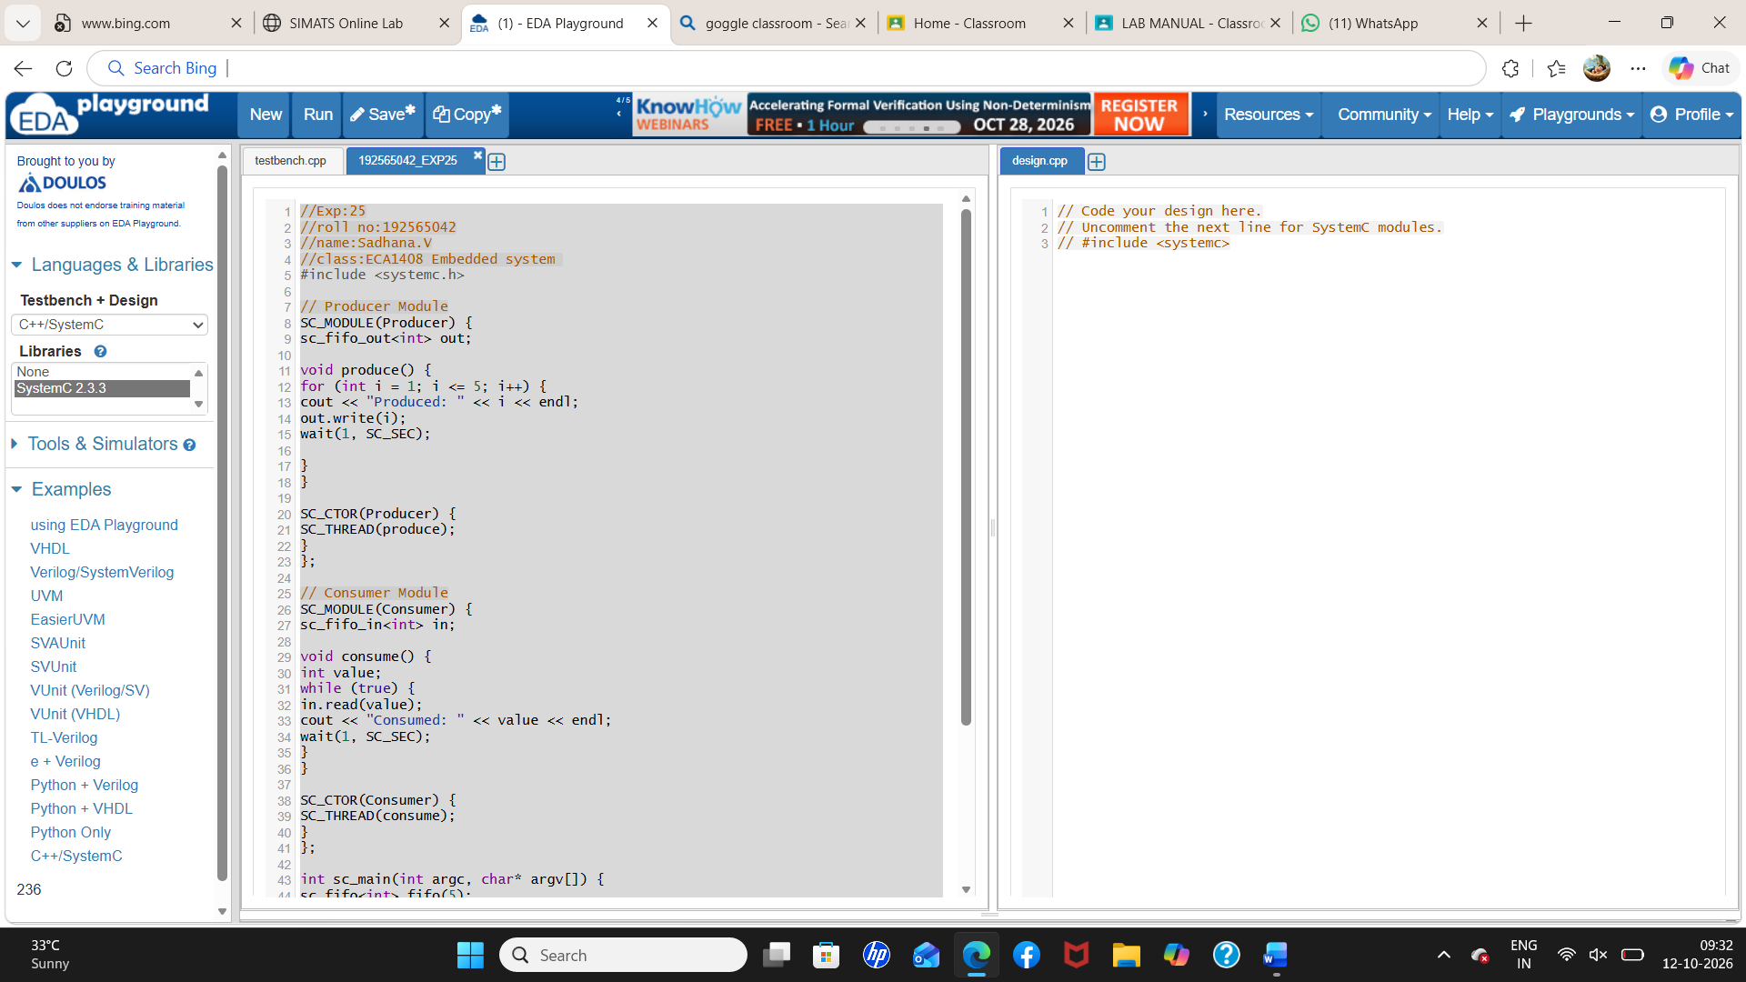

Output:
