Experiment-26
Aim:
To study Transaction Level Modeling and communication between modules using SystemC.
Code:
#include <systemc>
#include <tlm>
#include <tlm_utils/simple_initiator_socket.h>
#include <tlm_utils/simple_target_socket.h>

using namespace sc_core;
using namespace tlm;
using namespace std;

// Target
struct Target : sc_module {
tlm_utils::simple_target_socket<Target> socket;

SC_CTOR(Target) : socket("socket") {
socket.register_b_transport(this, &Target::b_transport);
}

void b_transport(tlm_generic_payload& trans, sc_time& delay) {
int* data = (int*) trans.get_data_ptr();
cout << "Target received: " << *data << endl;

delay += sc_time(10, SC_NS);
}
};

// Initiator
struct Initiator : sc_module {
tlm_utils::simple_initiator_socket<Initiator> socket;

SC_CTOR(Initiator) : socket("socket") {
SC_THREAD(thread_process);
}

void thread_process() {
tlm_generic_payload trans;
sc_time delay = SC_ZERO_TIME;

int data = 555;

trans.set_data_ptr(reinterpret_cast<unsigned char*>(&data));
trans.set_data_length(sizeof(data));

cout << "Initiator sending: " << data << endl;
socket->b_transport(trans, delay);

wait(delay);
}
};

int sc_main(int argc, char* argv[]) {

Initiator initiator("initiator");
Target target("target");

initiator.socket.bind(target.socket);

sc_start();

return 0;
}
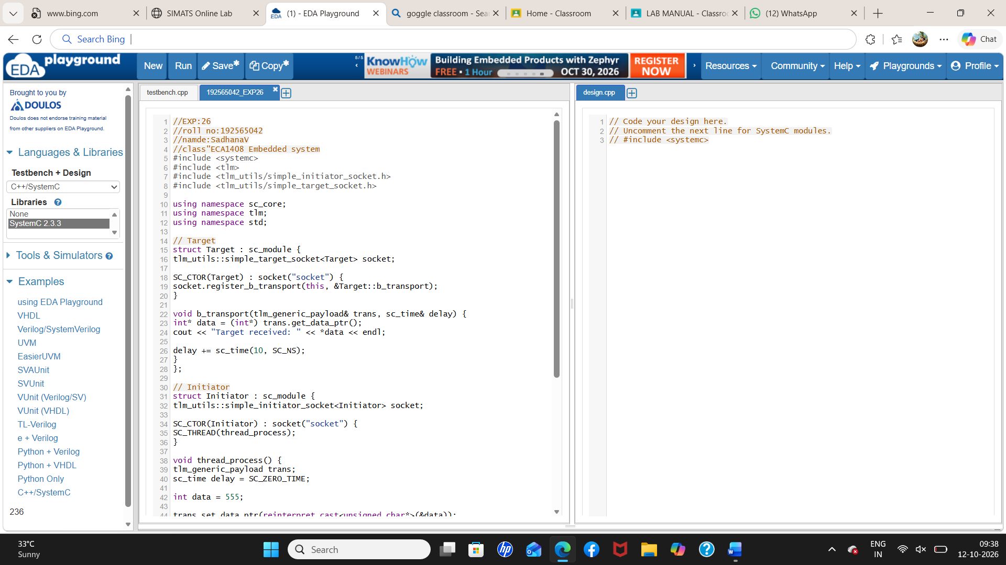
Output:
