Experiment-27
Aim:
To implement a binary semaphore and control access to a shared resource
Code:
//EXP:27
//roll no:192565042
//namde:SadhanaV
//class"ECA1408 Embedded system
#include <systemc.h>

SC_MODULE(binary_semaphore) {

int sem;
sc_event ev;

void task1() {
while(true) {
wait(1, SC_SEC);

if(sem == 1) {

sem = 0;
cout << "Task1 Entered Critical Section at " << sc_time_stamp() << endl;
wait(2, SC_SEC);
sem = 1;
ev.notify();
}
else {
wait(ev);
}
}
}

void task2() {
while(true) {
wait(2, SC_SEC);

if(sem == 1) {
sem = 0;
cout << "Task2 Entered Critical Section at " << sc_time_stamp() << endl;
wait(1, SC_SEC);
sem = 1;
ev.notify();
}
else {
wait(ev);
}
}
}

SC_CTOR(binary_semaphore) {
sem = 1;
SC_THREAD(task1);
SC_THREAD(task2);
}

};

int sc_main(int argc, char* argv[]) {
binary_semaphore obj("Binary_Semaphore");
sc_start(10, SC_SEC);
return 0;
}
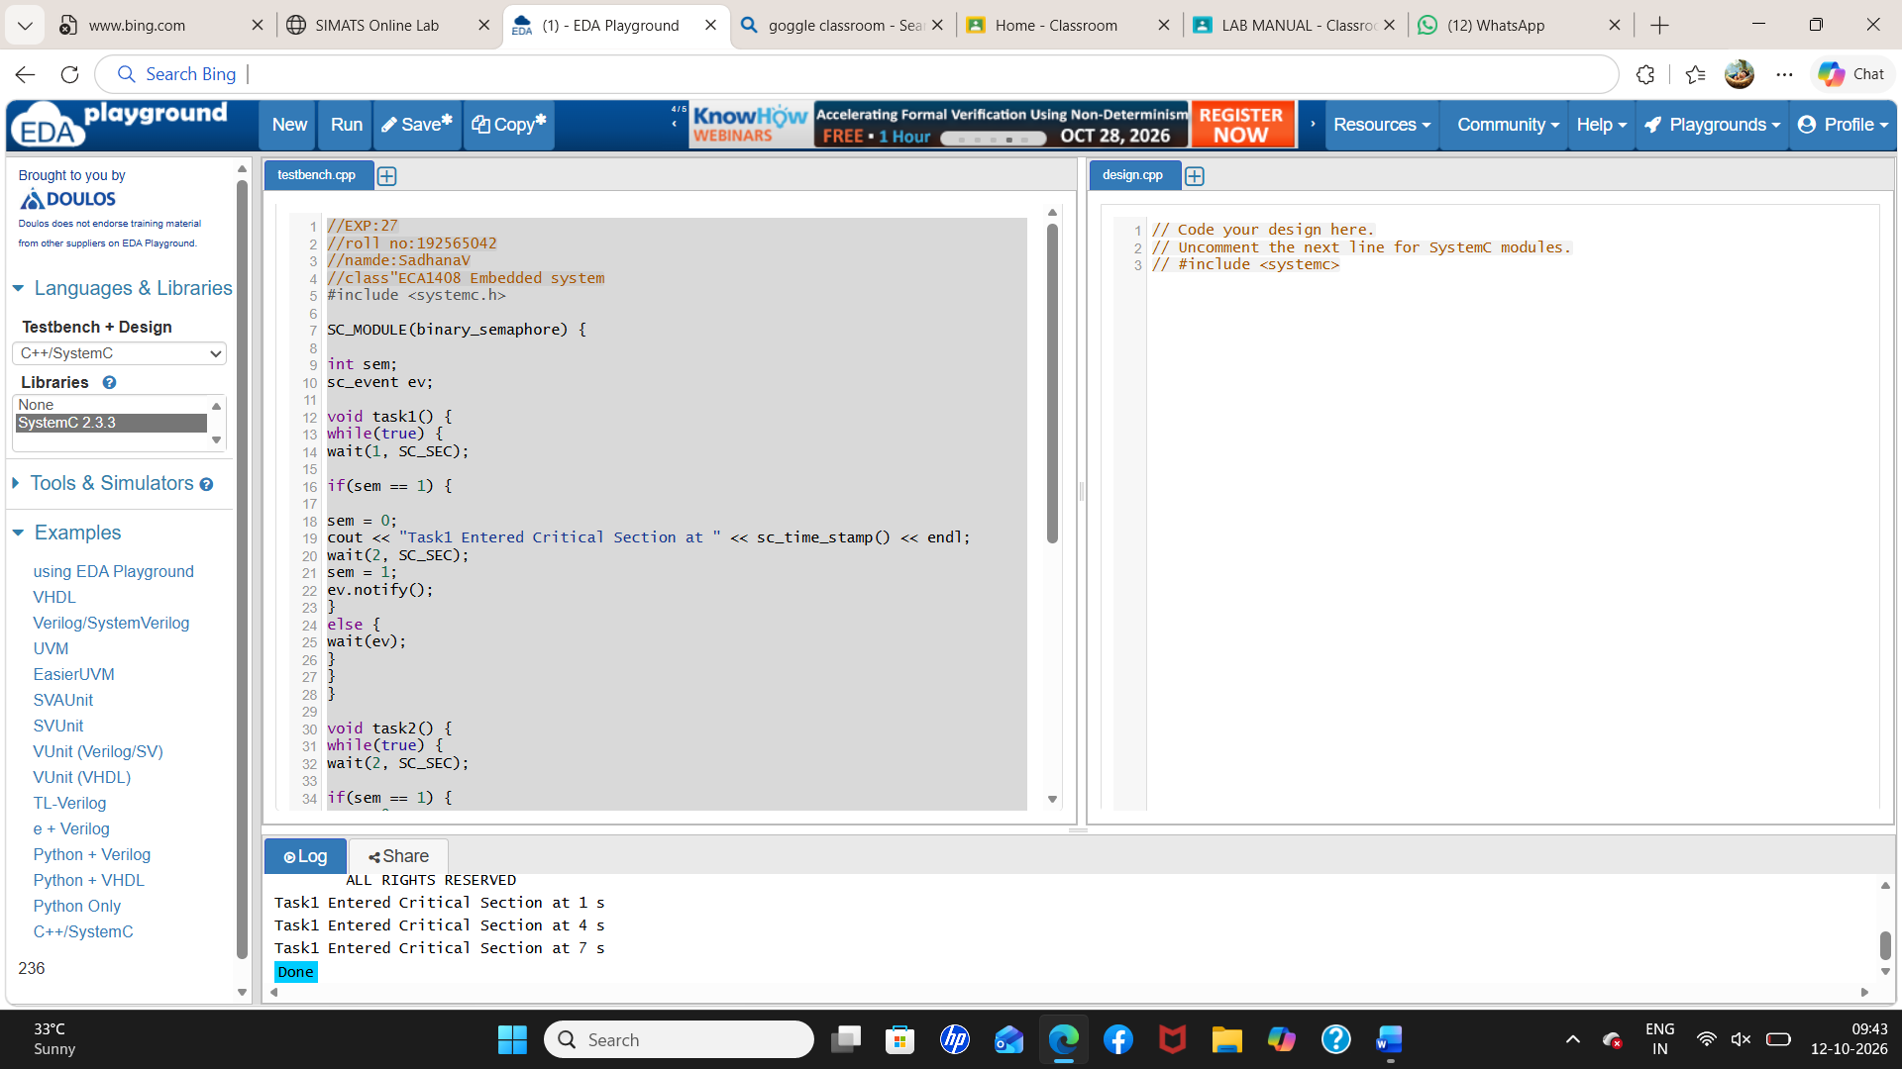
Output:
