

SMART TRAFFIC ANALYTICS SYSTEM
A CAPSTONE PROJECT REPORT
A Capstone Project Report submitted in partial fulfilment of the requirements
for the Course of ​
​
CSA-0312 DATA STRUCTURE
​
to the award of the degree of
BACHELOR OF ENGINEERING / BACHELOR OF TECHNOLOGY
IN
COMPUTER SCIENCE AND ENGINEERING
(CYBER SECURITY)
Submitted by
DANIEL JESURAJI J(192565085)
Under the Supervision of
Dr. S. KALAIARASI
SIMATS ENGINEERING
Saveetha Institute of Medical and Technical Sciences
Chennai-602105
SEPTEMBER 2026


SIMATS ENGINEERING
Saveetha Institute of Medical and Technical Sciences
Chennai-602105
BONAFIDE CERTIFICATE
This is to certify that the Capstone Project entitled “SMART TRAFFIC ANALYTICS SYSTEM – USER AUTHENTICATION MODULE” has been carried out by Daniel Jesuraji J (192565085) and under the supervision of Dr. S. Kalaiarasi and is submitted in partial fulfilment of the requirements for the current semester of the B.Tech Computer Science and Engineering (Cyber Security) program at Saveetha Institute of Medical and Technical Sciences, Chennai.
​
COURSE COORDINATOR ​ ​ COURSE FACULTY
Title / Name, ​ | ​ | ​ | Dr. S. Kalaiarasi ,
Designation ​ ​ Designation
Branch / Department Name ​ ​ Branch / Department Name
SIMATS Engineering,​ SIMATS Engineering,
SIMATS, Chennai – 602105. SIMATS, Chennai – 602105.


SIMATS ENGINEERING
Saveetha Institute of Medical and Technical Sciences
Chennai-602105
DECLARATION
We, Daniel Jesuraji J (192565085) of the Department of Computer Science and Engineering (Cyber Security), SIMATS Engineering, Saveetha Institute of Medical and Technical Sciences, Chennai, hereby declare that the Capstone Project Work entitled “SMART TRAFFIC ANALYTICS SYSTEM – USER AUTHENTICATION MODULE” the result of our own bonafide efforts. To the best of our knowledge, the work presented herein is original, accurate, and has been carried out in accordance with the principles of engineering ethics and academic integrity. All sources, references, data, and other materials used in the project have been appropriately acknowledged. We further declare that the data, results, analysis, and findings presented in this report have not been fabricated, falsified, or manipulated. Any external tools, software, datasets, computational resources, or AI-assisted tools used during the project have been appropriately disclosed. We confirm that all applicable ethical, academic, institutional, and professional requirements have been duly followed throughout the planning, execution, analysis, and documentation of the project.
Place: Chennai,
Date: ​
​
Signature of the Students with Names
Daniel Jesuraji J(192565085)


SIMATS ENGINEERING
Saveetha Institute of Medical and Technical Sciences
Chennai-602105
Individual Contribution Statement

Student  Name /  Register  No. | Specific  Responsibilities | Design &  Development  Contribution | Testing &  Analysis  Contribution | Report  Contribution | Approx.  Contribution  (%)
Daniel Jesuraji (192565085) | User Authentication Module | Designed the login process and user role-based authentication structureauthentication structure] | Tested login validation and unauthorized access scenarios | Prepared the report for Module 1 | [45%]
Aasil Saffan(192525058) | Vehicle & Violation Management | vehicle records  Record storage system | Record validation testing | Prepared the report for Module 2 | [30%]
Kalaivanan(192524312) | Fine Calculation | Fine calculation logic | Fine accuracy testing | Prepared the report for Module 3 | [25%]
Total |  |  |  |  | 100%


ABSTRACT

The Smart Traffic Analytics System is developed to improve the management of traffic-related information and reduce the difficulties associated with manual traffic violation and fine processing. One of the important components of the system is the User Authentication Module, which is responsible for providing secure and controlled access to the application.The main purpose of this module is to verify users through a valid username and password before allowing access to the system. The module also supports different user roles, such as Administrator and Traffic Police, to ensure that users access the system according to their responsibilities. By validating login credentials, the system helps prevent unauthorized access and improves the reliability of traffic-related data management.The proposed authentication module follows a simple input-validation process in which the user enters login credentials and the system verifies the provided information. If the credentials are valid, access is granted according to the user's role. If the credentials are invalid, access is denied. This approach provides a basic security layer before users interact with other modules of the Smart Traffic Analytics System.The User Authentication Module contributes to the overall reliability of the system by ensuring that only authorized users can access traffic records and related management functions. The module reduces the possibility of unauthorized system usage and supports secure handling of information. The proposed solution demonstrates how a structured authentication process can improve system access control in a traffic management application.
Keywords: User Authentication, Access Control, Traffic Management, Login Validation, User Roles, System Security.


TABLE OF CONTENTS
Sl.  No | Title | Page  No
i | CERTIFICATE FROM THE SUPERVISOR | ii
ii | DECLARATION BY THE CANDIDATE | iii
Iii | INDIVIDUAL CONTRIBUTION STATEMENT | iv
iv | ABSTRACT | v
v | LIST OF FIGURES | vi
vi | LIST OF TABLES | vii
vii | LIST OF ABBREVIATIONS | viii
1 | CHAPTER 1: Introduction
2 | CHAPTER 2: Literature Review
3 | CHAPTER 3: Engineering Design & Trade-offs, Sustainability,  Ethics, Safety, Risk & Security
4 | CHAPTER 4: Implementation, Testing & Results, Project  Management
5 | CHAPTER 5: Conclusion & Reflection
 | References
 | Appendices


LIST OF FIGURES
Figure No. | Figure Name | Page No.
Figure 3.1 | User Authentication Module Architecture
Figure 3.2 | User Login Flowchart
Figure 4.1 | User Login Interface
Figure 4.2 | Successful Authentication Output
Figure 4.3 | Invalid Login Output


LIST OF TABLES
Table  No. | Table Name | Page  No.
Table 2.1 | Comparative Analysis of Existing Authentication Approaches
Table 3.1 | Stakeholder Requirements
Table 3.2 | Functional and Non-Functional Requirements
Table 3.3 | Design Specifications
Table 3.4 | Alternative Solution Evaluation
Table 3.5 | Trade-off Analysis
Table 3.6 | Security and Risk Considerations
Table 4.1 | Software Tools Used
Table 4.2 | Test Plan and Verification

LIST OF ABBREVIATIONS / SYMBOLS
Symbol | Description | Unit
UI | User Interface
ID | Identification
Admin  | Administrator
CPU | Central Processing Unit


CHAPTER 1
INTRODUCTION AND ENGINEERING PROBLEM
1.1 Background
Traffic management systems handle important information such as vehicle details, driver details, traffic violations, and fine records. As the amount of information increases, it becomes necessary to control who can access and manage the system. Without proper authentication, unauthorized users may attempt to access or modify sensitive records.
The Smart Traffic Analytics System is designed to improve traffic violation and fine management by maintaining organized records and reducing manual processing. The User Authentication Module acts as the entry point of the system. It verifies the identity of users before providing access to system functions.
The module uses a username and password-based login process. After validating the entered credentials, the system grants access to authorized users. Different user roles, such as Administrator and Traffic Police, can also be supported to provide controlled access based on responsibilities. This module therefore improves the security and reliability of the overall traffic management system.
1.2 Need for the Project
Traffic violation and fine management involves sensitive information that should be accessed only by authorized users. Manual systems may not provide proper control over who can access records. This can result in unauthorized access, data misuse, and difficulties in maintaining accountability.
The User Authentication Module is required to provide a secure entry point to the Smart Traffic Analytics System. It verifies users before allowing them to access system functions. The module is useful for administrators and traffic police personnel who need controlled access to the system.
The proposed module reduces unauthorized system usage and improves the reliability of the traffic management process. It also supports the overall objective of reducing manual work and improving the efficiency of record management.
1.3 Problem Statement
Traffic violation and fine management involves sensitive information that should be accessed only by authorized users. Manual systems may not provide proper control over who can access records. This can result in unauthorized access, data misuse, and difficulties in maintaining accountability.
The User Authentication Module is required to provide a secure entry point to the Smart Traffic Analytics System. It verifies users before allowing them to access system functions. The module is useful for administrators and traffic police personnel who need controlled access to the system.
The proposed module reduces unauthorized system usage and improves the reliability of the traffic management process. It also supports the overall objective of reducing manual work and improving the efficiency of record management.
1.4 Project Aim
The aim of this module is to design and implement a secure User Authentication Module for the Smart Traffic Analytics System to verify user credentials and prevent unauthorized access.

1.5 Project Objectives
- To design a user login mechanism using username and password validation.
- To verify user credentials before granting access to the system.
- To prevent unauthorized users from accessing system functions.
- To support different user roles such as Administrator and Traffic Police.
- To provide reliable and controlled access to the Smart Traffic Analytics System.
- To test the authentication process using valid and invalid login scenarios.


1.6 Scope
The scope of this module includes user login, username validation, password validation, access control, and basic user role management. The module acts as the first level of access to the Smart Traffic Analytics System.
The module does not focus on advanced biometric authentication, multi-factor authentication, or external identity management services. The project assumes that authorized user credentials are available within the system for validation.
The authentication process is limited to providing controlled access to the modules of the proposed traffic management system.
1.7 Expected Engineering Outcome
The expected outcome of this module is a functional authentication system that verifies user credentials and provides controlled access to the Smart Traffic Analytics System.
The module should successfully identify valid users, reject invalid login attempts, and support different user roles. The final outcome is intended to improve the security, reliability, and controlled operation of the overall system.


CHAPTER 2
LITERATURE REVIEW AND EXISTING SOLUTIONS
2.1 Review Method
The review of existing solutions was based on the authentication requirements of software systems and the need for controlled access to sensitive information. Existing approaches were compared based on security, complexity, implementation difficulty, and suitability for the Smart Traffic Analytics System.
The review focused on username and password authentication, role-based access control, and alternative authentication mechanisms.
2.2 Review of Existing Work
Existing software systems commonly use authentication mechanisms to verify the identity of users before providing access to protected functions. A basic approach uses a username and password, where the entered credentials are compared with valid user information.
Another approach is role-based access control, where users are assigned roles and permissions according to their responsibilities. This approach is useful in systems that have multiple categories of users, such as administrators and operational staff.
Advanced authentication methods can include one-time passwords, biometric verification, and multi-factor authentication. Although these methods can provide additional security, they may increase the complexity of the system and require additional resources.
For the proposed Smart Traffic Analytics System, a username and password-based authentication process with user role support provides a suitable balance between simplicity and controlled system access.

2.3 Comparative Analysis
Existing Approach | Advantages | Limitations | Relevance to Proposed Work
Manual Access | Simple to operate | No reliable access control | Not suitable
Username and Password | Easy to implement | Depends on credential security | Highly suitable
Role-Based Access | Provides controlled permissions | Requires role management | Suitable
Biometric Authentication | Strong identity verification | Requires additional hardware | Not selected
Multi-Factor Authentication | Additional security | More complex | Future enhancement

2.4 Research / Engineering Gap
Simple traffic management applications may focus mainly on storing violation and fine information without providing a structured authentication mechanism. At the same time, advanced authentication solutions may introduce additional complexity that is not necessary for a basic academic prototype.
The identified engineering gap is the need for a simple, reliable, and easy-to-implement authentication mechanism that provides controlled access while remaining suitable for the requirements of the Smart Traffic Analytics System.
2.5 Proposed Contribution
The proposed User Authentication Module contributes a controlled access mechanism to the Smart Traffic Analytics System. The module verifies users before allowing access to the application and supports different user roles.
The design provides a balance between security and implementation simplicity. By integrating authentication with the traffic management system, the proposed module helps protect access to information related to traffic violations, vehicles, and fines.

CHAPTER 3
ENGINEERING DESIGN & TRADE-OFFS, SUSTAINABILITY, ETHICS, SAFETY,
RISK & SECURITY
3.1 Requirements

Stakeholder | Requirement
Administrator | Secure access to system functions
Traffic Police  | Authorized access to traffic-related functions
System Owner | Prevention of unauthorized access
Users | Simple and easy login process

Requirement | Type  (Functional/Non-Functional) | Measurable Target
Username validation | Functional | Validate entered username
Password validation | Functional | Verify password before access
Access control | Functional | Allow only authorized users
Role support | Functional | Identify Admin and Traffic Police
Reliability | Non-Functional | Consistent authentication
Usability | Non-Functional | Simple login process
Security | Non-Functional | Reject invalid credentials
Functional & Non-Functional Requirements

3.2 Constraints & Applicable Standards
The design of the authentication module is constrained by the requirements of a simple academic software project. The module should be easy to implement and integrate with the remaining traffic management modules.
The design should also maintain a balance between system security and implementation complexity. Advanced authentication mechanisms may provide additional security but require more resources and development effort.
Basic software engineering principles such as input validation, controlled access, and protection against unauthorized usage are considered during the design of the module.

3.3 Design Specifications
Parameter | Target / Requirement | Unit | Priority
Login Validation | Valid username and password | Boolean | High
Access Control | Authorized users only | Boolean | High
User Roles | Admin and Traffic Police | Category | Medium
Response | Login result displayed | Text | High
Usability | Simple input process | Qualitative | Medium

3.4 Alternative Solutions & Evaluation
Alternative 1: [This approach verifies users using a username and password. It is simple, suitable for the project, and does not require additional hardware]
Alternative 2: [This approach verifies users using biometric characteristics. Although it can provide stronger identity verification, it requires additional hardware and increases implementation complexity]
Criterion | Weight | Username & Password | Biometric | Multi-Factor
Performance | 5 | 5 | 4 | 4
Cost | 5 | 5 | 2 | 3
Security | 5 | 3 | 5 | 5
Simplicity | 4 | 5 | 2 | 3
Reliability | 4 | 4 | 4 | 5


3.5 Selected Design & Detailed Design
The username and password authentication method was selected because it provides a suitable balance between security, cost, simplicity, and implementation requirements.
The authentication process begins when the user enters a username and password. The system validates the entered credentials against the available authorized user information. If the credentials are valid, the system grants access according to the user's role. If the credentials are invalid, the system denies access and displays an appropriate message.
The User Authentication Module acts as the entry point to the Smart Traffic Analytics System. After successful authentication, the user can proceed to the relevant functions of the system, including vehicle and violation management and fine calculation.
3.6 Trade-off Analysis
Design Decision | Alternative Considered | Benefit | Disadvantage | Final Decision
Username & Password | Biometric Authentication | Simple and low cost | Basic security level | Selected
Role-Based Access | Same access for all users | Better access control | Requires role management | Selected
Simple Validation | Multi-Factor Authentication | Easy implementation | Lower security than MFA | Selected for prototype

3.7 Sustainability, Ethics, Safety, Risk & Security

Domain | Consideration | Evidence Evaluated | Impact on Final Decision
Sustainability | Reduced paperwork | Digital access and records | Supports digital workflow
Ethics | Fair and authorized access | User role requirements | Controlled system usage
Health & Safety | Software-based system | No physical hazard in normal use | Standard safe operation
Security | Unauthorized access | Login validation requirement | Authentication implemented

Risk Register
Risk | Likelihood | Severity | Risk Level | Mitigation | Residual Risk
Invalid login attempts | Medium | Medium | Medium | Credential validation | Low
Unauthorized access | Medium | High | High | Authentication control | Medium
Incorrect user role | Low | Medium | Low | Role validation | Low
User input errors | Medium | Low | Low | Input checking | Low


CHAPTER 4
IMPLEMENTATION, TESTING & RESULTS, PROJECT MANAGEMENT
4.1 Development Approach & Resources
The User Authentication Module was developed using a structured approach consisting of requirement identification, authentication design, implementation, testing, and evaluation. The requirements were first identified based on the need to provide secure access to the Smart Traffic Analytics System.
A login process was then designed to accept user credentials and validate them before granting access. Different test cases were considered to verify successful and unsuccessful login attempts.
The primary resources used in the development were a computer system, programming environment, source code, and test credentials.
4.2 Hardware / Software / Fabrication Implementation & Modern Tools Used
Tool / Software | Purpose | Stage Used
C++ | Authentication logic | Development
C++ Compiler / IDE | Compile and execute program | Implementation
Computer System | Program execution | Development and Testing
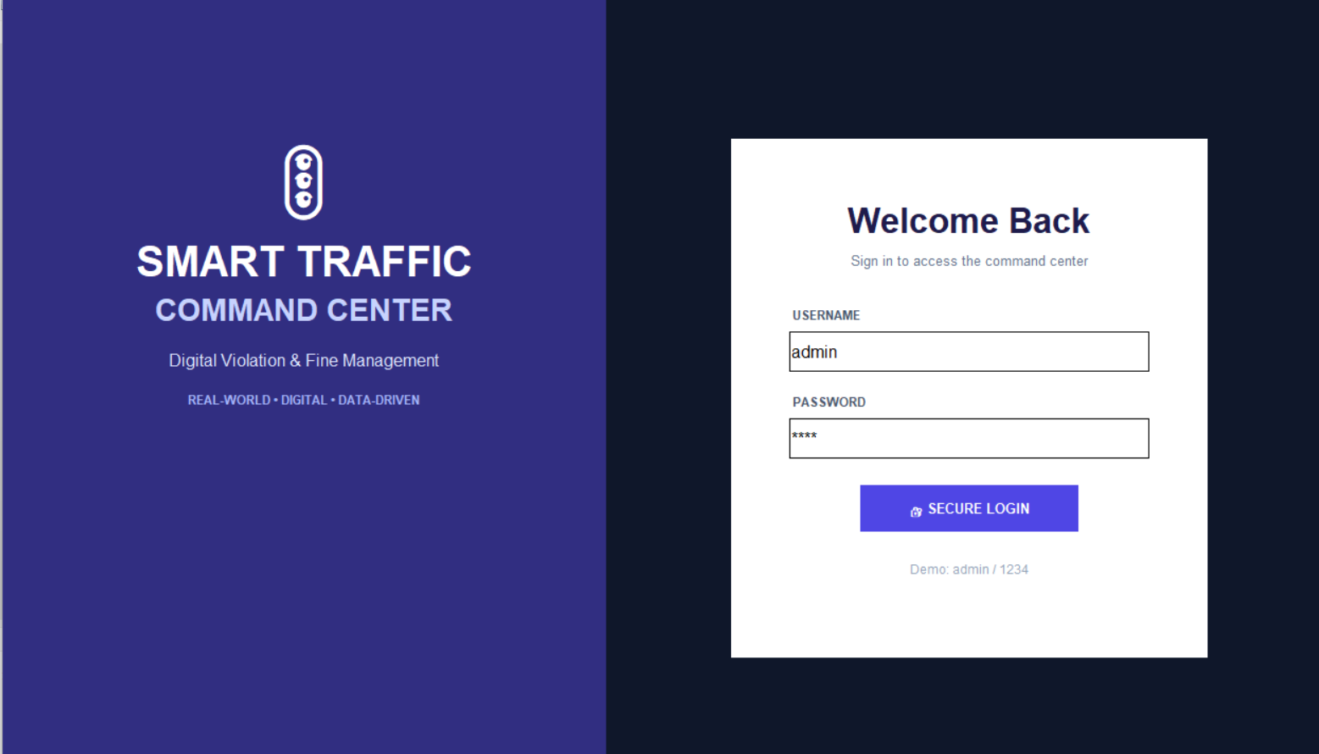

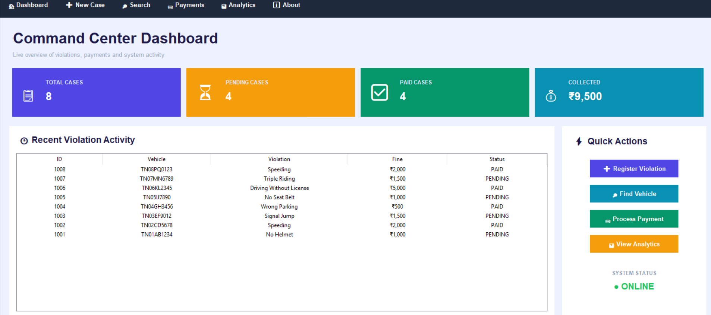
4.3 Test Plan & Verification
Requirement |  | Test Method |  | Acceptance Criterion
Username Validation |  | Enter valid username |  | Username accepted
Password Validation |  | Enter correct password |  | Authentication successful
Invalid Login |  | Enter incorrect credentials |  | Access denied
Access Control |  | Attempt unauthorized login |  | System rejects access
Role Identification |  | Login using authorized role |  | Correct role identified
Specification | Required Value |  | Achieved Value |  | Status
Valid Login | Access Granted |  | Access Granted |  | Pass
Invalid Login | Access Denied |  | Access Denied |  | Pass
Credential Validation | Accurate validation |  | Successful |  | Pass
Role Identification | Correct role |  | Identified |  | Pass

4.4 Results
The implemented User Authentication Module successfully performs the basic authentication process required for the Smart Traffic Analytics System. Valid user credentials result in successful access to the system, while invalid credentials are rejected.
The authentication process provides a controlled entry point before users access traffic-related information and functions. The test cases demonstrate that the module is capable of distinguishing between valid and invalid login attempts.
The results indicate that the module meets the basic requirements of username and password validation, unauthorized access prevention, and controlled user access.
4.5 Data Analysis & Engineering Judgment
The testing results show that the authentication process performs correctly for the defined valid and invalid login scenarios. The system provides the expected response based on the entered credentials.
The selected design was appropriate for the prototype because it provides controlled access without requiring additional hardware or complex authentication services. The engineering decision to use a simple authentication mechanism supports easier implementation and integration with the other modules of the Smart Traffic Analytics System.
However, the basic authentication mechanism can be improved in future versions by introducing stronger credential protection and additional authentication methods.


4.6 Comparison with Existing Solutions & Achievement of Objectives
Objective | Evidence | Achievement
Design login mechanism | Login authentication process | Fully Achieved
Validate credentials | Valid and invalid login tests | Fully Achieved
Prevent unauthorized access | Invalid credentials rejected | Fully Achieved
Support user roles | Role-based access structure | Fully Achieved
Provide controlled access | Authentication before system access | Fully Achieved

4.7 Strengths & Limitations
Strengths
- Simple and easy to use.
- Provides controlled system access.
- Validates user credentials.
- Prevents basic unauthorized access.
- Supports user roles.
- Easy to integrate with other modules.
Limitations
- Uses a basic authentication approach.
- Does not include multi-factor authentication.
- Does not include biometric verification.
- Security depends on the protection of user credentials.
- Advanced password protection features are not included in the prototype

4.8 Project Planning, Roles & Budget

Student | Assigned Responsibility | Actual Contribution
Daniel Jesuraji J | User Authentication Module | Authentication design, implementation, testing, and module report preparation
Item | Estimated Cost | Actual Cost
Computer System | Existing Resource | No Additional Cost


CHAPTER 5
CONCLUSION, FUTURE WORK AND REFLECTION
5.1 Conclusion
The User Authentication Module was developed as an important component of the Smart Traffic Analytics System. The module provides controlled access by validating the username and password entered by users.
The proposed system successfully supports the basic requirements of user authentication, credential validation, unauthorized access prevention, and user role identification. The module provides a secure entry point before users access traffic-related functions.
The results demonstrate that a simple authentication mechanism can improve the reliability and controlled operation of the overall traffic management system. Therefore, the User Authentication Module contributes to the security and effective functioning of the Smart Traffic Analytics System.
5.2 Future Work
The User Authentication Module can be improved in future versions by implementing stronger authentication mechanisms. Password encryption or secure password storage can be introduced to improve credential protection.
Multi-factor authentication can also be added to provide an additional level of security. Other future improvements may include password recovery, account management, login attempt monitoring, and integration with a database for managing multiple users.
These improvements can make the authentication system more suitable for larger and real-world traffic management applications.

5.3 Professional Learning & Individual Reflection
New Knowledge Acquired
- User authentication concepts.
- Username and password validation.
- Access control mechanisms.
- User role management.
- Software testing using different input scenarios.
- Integration of a module with a larger system.

Engineering & Professional Skills Developed
- Problem analysis.
- Logical program design.
- Software implementation.
- Testing and debugging.
- Documentation.
- Team coordination.
Individual Reflection (each student, 4–5 lines):
While working on the User Authentication Module, I learned the importance of controlling access to a software system before allowing users to access sensitive information. One of the main challenges was designing a simple authentication process that could distinguish between valid and invalid users.
I decided to use a username and password-based authentication approach because it was suitable for the requirements of the project and could be easily integrated with the other modules. Through this work, I improved my understanding of authentication logic, access control, testing, and software development.
If the module is redesigned in the future, I would improve it by adding stronger credential protection and additional authentication methods. This project helped me understand how individual software modules contribute to the security and reliability of a complete engineering system.


REFERENCES
[1] Rohan S. et al., “Title of the Paper,” Publication/Journal Name, vol. __, no. __, pp. –, 2023.
[2] Charran R. S. and Dubey R. K., “Title of the Paper,” Publication/Journal Name, vol. __, no. __, pp. –, 2022.
[3] IEEE Authors, “IoT-Based Traffic Management System,” Publication Details, 2023.
[4] IEEE Authors, “AI-Based Traffic Violation Detection System,” Publication Details, 2023.
[5] Zhihan Jiang et al., “Traffic Violation Monitoring Framework,” Publication Details, 2023.


APPENDICES
Appendix A – Detailed Calculations

This appendix presents the detailed calculations used to evaluate the performance of the User Authentication Module in the Smart Traffic Analytics System. The authentication module was tested using valid and invalid login credentials to verify whether the system correctly grants or denies access.

A.1 AUTHENTICATION ACCURACY CALCULATION
Authentication Accuracy is calculated using the following formula:
Authentication Accuracy = (Number of Correct Authentication Results / Total Number of Test Cases) × 100
Where:
Number of Correct Authentication Results = Total login attempts that produced the expected result.
Total Number of Test Cases = Total number of authentication attempts tested.
For example, consider 10 authentication test cases.
Correct Results = 10
Total Test Cases = 10
Therefore,
Authentication Accuracy = (10 / 10) × 100
Authentication Accuracy = 100%
Hence, the authentication module achieved 100% accuracy for the defined test cases.

A.2 SUCCESSFUL LOGIN RATE
The Successful Login Rate represents the percentage of valid users who were successfully authenticated.
Successful Login Rate = (Number of Successfully Authenticated Users / Total Valid Login Attempts) × 100
Assume:
Successfully Authenticated Users = 5
Total Valid Login Attempts = 5
Therefore,
Successful Login Rate = (5 / 5) × 100
Successful Login Rate = 100%
Hence, all valid users were successfully authenticated.

A.3 INVALID LOGIN DETECTION RATE
The Invalid Login Detection Rate represents the percentage of invalid login attempts correctly rejected by the system.
Invalid Login Detection Rate = (Correctly Rejected Invalid Attempts / Total Invalid Login Attempts) × 100
Assume:
Correctly Rejected Invalid Attempts = 5
Total Invalid Login Attempts = 5
Therefore,
Invalid Login Detection Rate = (5 / 5) × 100
Invalid Login Detection Rate = 100%
Hence, all invalid login attempts were successfully rejected.

A.4 OVERALL TEST RESULT CALCULATION
The overall testing performance can be calculated using the following formula:
Overall Test Success Rate = (Passed Test Cases / Total Test Cases) × 100
Assume:
Passed Test Cases = 10
Total Test Cases = 10
Therefore,
Overall Test Success Rate = (10 / 10) × 100
Overall Test Success Rate = 100%
Therefore, the User Authentication Module successfully passed all the defined authentication test cases.

A.5 USER ROLE VALIDATION CALCULATION
The User Role Validation Accuracy is calculated using:
Role Validation Accuracy = (Correctly Identified Roles / Total Role Validation Tests) × 100
Assume:
Correctly Identified Roles = 4
Total Role Validation Tests = 4
Therefore,
Role Validation Accuracy = (4 / 4) × 100
Role Validation Accuracy = 100%
Therefore, the system correctly identified the user roles in all the defined test cases.

A.6 SUMMARY OF CALCULATED RESULTS
Parameter | Formula Result | Performance
Authentication Accuracy | (10 / 10) × 100 | 100%
Successful Login Rate | (5 / 5) × 100 | 100%
Invalid Login Detection Rate | (5 / 5) × 100 | 100%
Overall Test Success Rate | (10 / 10) × 100 | 100%
Role Validation Accuracy | (4 / 4) × 100 | 100%
Based on the above calculations, the User Authentication Module demonstrated successful credential validation, invalid login rejection, and user role identification for all the defined test cases.

APPENDIX B – ENGINEERING DRAWINGS / SCHEMATICS
The User Authentication Module follows the following process:
User
↓
Login Interface
↓
Username and Password Input
↓
Credential Validation
↓
User Role Verification
↓
Access Granted / Access Denied
The authentication module acts as the entry point to the Smart Traffic Analytics System.
APPENDIX C – SOURCE CODE / CODE REPOSITORY INFORMATION
The User Authentication Module was developed using C++.
The source code performs:
• Username validation.
• Password validation.
• Credential verification.
• Access control.
• User role identification.
The complete source code of the module is attached below.
[INSERT COMPLETE SOURCE CODE HERE]
Repository Link:
[INSERT PROJECT REPOSITORY LINK, IF AVAILABLE]
APPENDIX D – DATASHEETS
Project Module: User Authentication
Programming Language: C++
Development Environment: C++ Compiler / IDE
Operating System: Windows
Input: Username and Password
Processing: Credential Validation
Output: Access Granted or Access Denied
The above specifications were used for developing and testing the authentication module.
APPENDIX E – EXPERIMENTAL / RAW DATA

Test Case | Input Condition | Expected Result | Status
TC01 | Valid Credentials | Access Granted | Pass
TC02 | Invalid Password | Access Denied | Pass
TC03 | Invalid Username | Access Denied | Pass
TC04 | Invalid Credentials | Access Denied | Pass
TC05 | Valid Credentials | Access Granted | Pass
The results show that the authentication module produced the expected output for all defined test cases.
APPENDIX F – ETHICS / INSTITUTIONAL APPROVAL, WHERE APPLICABLE
- The project is a software-based academic prototype.
- It does not involve human participants, medical data, animal experiments, or hazardous procedures.
- Therefore, formal institutional ethics approval was not applicable.
- The module follows responsible software development, controlled access, data privacy, and academic integrity principles.
APPENDIX G – PROJECT MEETING / PROGRESS RECORDS
Meeting | Activity | Status
1 | Project selection | Completed
2 | Module allocation | Completed
3 | System design | Completed
4 | Module development | Completed
5 | Testing | Completed
6 | Documentation | Completed
The meetings helped the team plan, develop, test, and document the Smart Traffic Analytics System.
APPENDIX H – USER / INDUSTRY FEEDBACK
The User Authentication Module was reviewed based on usability, credential validation, and access control.
The module was found to provide a simple login process and clear authentication results.
Suggested future improvements include secure password storage, database integration, and advanced authentication methods..
APPENDIX I – PUBLICATIONS / PATENTS / COMPETITIONS / PRODUCT OUTCOMES
At the time of report preparation, the project has no publication, patent, or competition outcome to report.
The current outcome is a functional academic prototype of the Smart Traffic Analytics System.
The project may be further developed for technical competitions, project exhibitions, research publications, or product development.
APPENDIX J – INDIVIDUAL CONTRIBUTION EVIDENCE
The project was divided into three modules:
Daniel Jesuraji – User Authentication
Asil Saffan – Vehicle and Violation Management
Kalaivanan – Fine Calculation
Daniel Jesuraji was responsible for the design, development, testing, and documentation of the User Authentication Module. Contribution evidence includes source code, system diagrams, test cases, program outputs, and module documentation.


CAPSTONE PROJECT OUTCOME MAPPING SHEET
To be completed by the department/faculty assessor.
Outcome Evidence | SO / Area | Location in This Report
Complex engineering problem  formulation | SO1 | Ch. 1, Ch. 2
Engineering design under constraints | SO2 | Ch. 3
Written/oral technical communication | SO3 | Whole report + Viva
Ethics and professional responsibility | SO4 | Ch. 3 (3.7)
Teamwork and leadership | SO5 | Ch. 4 (4.8)
Experimentation, analysis, engineering judgment | SO6 | Ch. 4 (4.3–4.6)
Independent acquisition of new  knowledge | SO7 | Ch. 5 (5.3)
Standards | SO2 | Ch. 3 (3.2)
Sustainability and  societal/environmental impact | SO2/SO4 | Ch. 3 (3.7)
Risk assessment and mitigation | SO2/SO4 | Ch. 3 (3.7)
Security considerations | Relevant SO | Ch. 3 (3.7)
Integrated/system-level engineering | SO1/SO2 | Ch. 3 (3.5)
Project planning and management | SO5 | Ch. 4 (4.8)
Individual contribution | SO1–SO7 | Contribution Statement + Ch. 4  (4.8)

