Name: RITHISH KUMAR D Reg. No: 192565089
Course: Design and Analysis of Algorithms (DAA)
DAA
Assignment 1
Design and Analysis of Algorithms
ASSIGNMENT 1
CO1: Algorithm fundamentals, efficiency analysis, asymptotic analysis, mathematical analysis, recurrence analysis, Master Theorem, substitution, etc.
Assignment Title: Design, Analyse and Validate an Efficient Search Strategy for a Large-Scale Student Record System (Total Marks - 50)
Duration: 1 week
Scenario — University Student Record Retrieval
A university maintains a large academic database containing student records, each identified by a unique Registration Number. Faculty and administrative staff frequently need to determine whether a particular student record exists and retrieve the corresponding information.
The database may contain:
1,000 → 10,000 → 100,000 → 1,000,000+ records
You are required to investigate, design and compare efficient algorithmic approaches for locating a given registration number as the database grows.
Your solution must remain practical for both small and very large datasets. Any preprocessing performed on the records must be included in your efficiency analysis.
Design Challenge:
The university now needs to process 50,000 search requests per hour on a database containing 1,000,000 student records. New student records are added only once per day. Re-evaluate your original design and determine whether it should be retained, modified or redesigned.
ANSWER – Understanding of the problem and my working assumptions
Before starting the tasks I fixed a few assumptions so that the analysis and the experiments talk about exactly the same problem.
- The input size n is the number of student records. Each record is identified by a unique 9-digit registration number (for example 192565089), so there are no duplicate keys.
- The whole database is held in main memory as an array of registration numbers, and "searching" means finding the position of the key (or deciding that it does not exist). Retrieving the rest of the record is then a single access by that position, so it does not change the comparison between algorithms.
- The cost of an algorithm is counted in key comparisons (the basic operation, explained in Task 2) and also measured as real running time. Preprocessing (sorting or building a table) is always counted, as the question demands.
- Every experiment uses the same random seed (192565089), so all the numbers in this report can be reproduced by running the attached script.
I picked three strategies that behave very differently as n grows: a brute-force sequential scan, a decrease-and-conquer recursive binary search on sorted data, and a hash table that trades extra memory for speed. Tasks 1 to 11 compare them for the general problem and Task 12 re-examines the choice for the 50,000 searches per hour situation.

TASK 1 – Design the Algorithm 5 Marks
Design and propose at least three meaningfully different algorithmic strategies for locating a given registration number. The three approaches must represent distinct algorithmic strategies. Iterative and recursive implementations of the same underlying algorithm will not be considered as two different approaches. Your proposed approaches must include:
- At least one iterative approach
- At least one recursive approach
- A clear explanation of the basic idea behind each approach
- Pseudocode or an appropriate flowchart for each approach
- A brief justification for selecting each approach for investigation
- Any preprocessing required by the approach, such as sorting or restructuring the data
You are expected to design and select the approaches independently. The appropriateness and diversity of the selected algorithmic strategies form part of the assessment.
Evidence Expected
Three meaningfully different algorithmic strategies, supported by pseudocode/flowcharts, identification of the design strategy, preprocessing requirements, and justification for selecting each approach.
ANSWER – Task 1
 | A1: Linear search | A2: Binary search | A3: Hash table
Design strategy | Brute force | Decrease-and-conquer (decrease by half) | Space-time trade-off (hashing)
Style | Iterative | Recursive | Iterative (chain walk)
Preprocessing | None | Sort the array (merge sort) | Build a hash table of m buckets
Extra memory | O(1) | O(1) search, O(n) for merge sort buffer | O(n) for the table

Approach A1 – Linear (sequential) search – iterative, brute force
Basic idea. Start at the first record and compare its registration number with the key. If they match, stop and report the position. Otherwise move on to the next record. If the end of the array is reached without a match, the student does not exist. It makes no assumption at all about the order of the data.
ALGORITHM LinearSearch(A[0..n-1], key)
// A is the unsorted array of registration numbers
for i <- 0 to n-1 do
if A[i] = key then // basic operation
return i
return -1 // key not present

Why I selected it. It is the natural first idea and it works directly on the data as it is stored, so it needs no preprocessing. It also acts as the baseline: without it I cannot show how much the other two approaches actually improve things. For a very small table, or for a single one-off query, it may well be the cheapest option, which is worth testing rather than assuming.
Approach A2 – Binary search – recursive, decrease-and-conquer
Basic idea. If the array is sorted by registration number, then comparing the key with the middle element tells us which half the key must lie in, so the other half can be thrown away. Repeating this on the remaining half shrinks the problem by a factor of two each time until either the key is found or the range becomes empty. Preprocessing is compulsory: the records have to be sorted first (I use merge sort so that the preprocessing cost is clearly Θ(n log n) in the worst case).
ALGORITHM MergeSort(A[0..n-1]) // preprocessing
if n > 1 then
copy A[0..floor(n/2)-1] to B ; copy A[floor(n/2)..n-1] to C
MergeSort(B) ; MergeSort(C)
Merge(B, C, A) // key comparison here

ALGORITHM BinarySearchRec(A[lo..hi], key)
if lo > hi then return -1 // empty range: not found
mid <- floor((lo + hi) / 2)
if A[mid] = key then return mid // basic operation
else if key < A[mid] then
return BinarySearchRec(A, key, lo, mid-1) // left half
else
return BinarySearchRec(A, key, mid+1, hi) // right half
// first call: BinarySearchRec(A, key, 0, n-1)

Why I selected it. It is the standard answer when a lot of searching is to be done on one fixed set of keys. It is also the approach that clearly needs preprocessing, so it lets me study the trade-off the question talks about (pay once to sort, then every search is cheap). Its recursive form gives a proper recurrence relation to formulate and solve in Tasks 6 and 7.
Approach A3 – Hash table with separate chaining – space-time trade-off
Basic idea. Instead of searching through the records, compute where the key must be. A hash function h(k) = k mod m turns the registration number into a bucket index, and each bucket keeps a small list (chain) of the keys that landed there. To search, I compute h(key) and look only inside that one chain. The table is built once (preprocessing) with m chosen as a prime a little larger than n / 0.75, so the load factor α = n/m stays at about 0.75.
ALGORITHM BuildTable(A[0..n-1]) // preprocessing
m <- smallest prime >= n / 0.75
create T[0..m-1], every bucket empty
for i <- 0 to n-1 do
append A[i] to the chain T[ A[i] mod m ]
return T, m

ALGORITHM HashSearch(T, m, key)
chain <- T[ key mod m ]
for each k in chain do
if k = key then return found // basic operation
return not found

Why I selected it. It uses a completely different idea from the other two (no ordering, no halving), and in theory it gives constant expected search time. It costs extra memory and a heavier build step, so it is a good candidate to test the idea that "the best Big-O is not automatically the best design". It also becomes very relevant for the changed requirement in Task 12, where searches are frequent and updates are rare.
Others I thought about. Interpolation search, jump search and a binary search tree are also possible. I left them out because interpolation and jump search are just other ways of searching a sorted array (not really different from A2 in the strategy), and a binary search tree gives the same O(log n) behaviour as A2 with more pointer overhead.

TASK 2 – Identify the Basic Operation 2 Marks
For each of the proposed algorithms, identify the basic operation that predominantly determines its execution time.
Discuss:
- What the basic operation is
- Where it occurs in the algorithm
- Why it is appropriate to use this operation for efficiency analysis
- How the number of times it executes may change as the input size (n) increases
Do not simply name an operation. You are expected to relate the selected operation to the behaviour of the algorithm.
Evidence Expected
Correct identification and justification of the dominant/basic operation for each proposed algorithm.
ANSWER – Task 2
A1 – Linear search
The basic operation is the comparison A[i] = key inside the for loop. The loop body does nothing else apart from incrementing i, so the running time is simply (number of iterations) × (a constant). Every iteration performs exactly one such comparison, which makes it the operation executed the most. How many times it runs depends on where the key sits: 1 time if the key is the first record, and n times if the key is the last record or is missing. So the count grows in direct proportion to n; ten times more students means about ten times more comparisons.
A2 – Binary search (and its merge-sort preprocessing)
In the search, the basic operation is the comparison of the key with A[mid] that happens once in every recursive call (I count the equality test and the less-than test together as one three-way comparison, the usual textbook convention). Everything else in a call (computing mid, making the call) is constant work that is carried out once per call too, so the number of comparisons is proportional to the number of calls, which equals the number of times the range can be halved. When n doubles, the range needs only one extra halving, so the count grows by one. In the preprocessing step, the basic operation is the key comparison inside the merge step of merge sort, which runs about n log₂ n times.
A3 – Hash table
The dominant operation is the comparison k = key while walking down the chain of the bucket. Computing h(key) = key mod m costs the same single step for every search, whatever n is, so it is a constant added to every search, while the number of chain comparisons is what actually varies between searches. The chain length depends on the load factor α = n/m and not directly on n. Because I grow the table with n (m ≈ n/0.75), α stays about 0.75 and the number of comparisons stays almost the same when n increases. For the build, the basic operation is the insertion of a key into its bucket, executed once for each of the n records.
Why comparisons are a good choice for all three. Key comparisons do not depend on the machine, the programming language or the compiler, and they let us put the three algorithms on one scale. They are also what the loops are actually doing: in each algorithm all the other statements run at most as often as the comparison does. That is why I use comparisons for the mathematical analysis and also record them in the experiments, next to the measured time.

TASK 3 – Derive the Time-Complexity Function Mathematically 6 Marks
Derive the time-complexity function for each proposed approach using mathematical analysis.
Discuss:
- The input size (n)
- The number of times the basic operation executes
- How the operation count changes with (n)
- The mathematical expression representing the running time
- Any preprocessing cost involved
- The overall cost when preprocessing and searching are considered together
You must show the mathematical reasoning leading to the complexity result. Merely stating that an algorithm is O(n), O(log n), etc., will not receive full credit.
Evidence Expected
A clear mathematical derivation of the time-complexity function for each approach, including relevant operation counts and preprocessing costs.
ANSWER – Task 3
For all three algorithms the input size n is the number of records in the database. I write C(n) for the number of basic operations in one search and k for the number of searches that will be done on the same data.
A1 – Linear search
The loop runs for i = 0, 1, …, n−1 and does one comparison each time. If the key is absent (or is the last record), the loop runs to the end:
C_worst(n) = Σ (i = 0 to n−1) 1 = n
If the key is present and is equally likely to be at any of the n positions (probability 1/n each), a key at position i needs i comparisons (counting from 1):
C_succ(n) = Σ (i = 1 to n) i · (1/n) = (1/n) · n(n+1)/2 = (n + 1) / 2
If p is the probability that the key is in the database, then C_avg(n) = p(n+1)/2 + (1−p)·n. For example with p = ½ this is (n+1)/4 + n/2 ≈ 3n/4. The running time is T(n) = c₁·C(n) + c₂, where c₁ is the cost of one iteration and c₂ the fixed set-up, and since C(n) is a linear function of n, T(n) = Θ(n). There is no preprocessing, so the total for k searches is k · Θ(n) = Θ(kn).
A2 – Binary search with merge-sort preprocessing
Each call makes one comparison and then continues with at most ⌊n/2⌋ records (derived in Task 6), so the worst-case number of comparisons satisfies C(n) = C(⌊n/2⌋) + 1 with C(1) = 1. For n = 2ᵏ, unrolling this gives C(2ᵏ) = k + 1, and in general (proved by induction in Task 7):
C_worst(n) = ⌊log₂ n⌋ + 1
Putting numbers in: n = 1,000 gives 10, n = 10,000 gives 14, n = 100,000 gives 17 and n = 1,000,000 gives 20 comparisons. These are exactly the worst-case values I observed in the experiments (Table 4). Hence T_search(n) = Θ(log n).
Preprocessing. Merge sort splits the array in two halves, sorts each and merges them. Merging two lists with total size n takes at most n − 1 comparisons, so M(n) = 2M(n/2) + (n − 1), M(1) = 0. For n = 2ᵏ, expanding gives M(n) = n log₂ n − n + 1 (check: M(4) = 2·1 + 3 = 5 and 4·2 − 4 + 1 = 5). For n = 1,000,000 that is about 19.93 million − 1 million ≈ 18.9 million comparisons, i.e. Θ(n log n).
Overall cost with k searches:
T_total(n, k) = (n log₂ n − n + 1) + k · (⌊log₂ n⌋ + 1) = Θ((n + k) log n)
A3 – Hash table with chaining
Let m be the number of buckets and α = n/m the load factor. Assuming that the hash function spreads keys uniformly (simple uniform hashing), the chain in a given bucket has n/m = α keys on average.
- Unsuccessful search: the whole chain has to be scanned, so the expected number of comparisons is α.
- Successful search: suppose the key sought is the i-th key inserted. Keys are appended at the end of a chain and we scan from the front, so the comparisons made are 1 (for the key itself) plus one for each key inserted *before* it into the same chain. On average that is (i − 1)/m keys. Averaging over i = 1…n gives 1 + (1/n) Σ (i − 1)/m = 1 + (n − 1)/(2m) = 1 + α/2 − α/(2n) ≈ 1 + α/2.
With α = 0.75, a successful search takes about 1.375 comparisons and an unsuccessful one about 0.75, whatever the value of n, so C_avg(n) = Θ(1) and T_search(n) = Θ(1) + the one constant-time hash computation. If every key falls into the same bucket, the single chain has length n and a search costs n comparisons, so the worst case is Θ(n).
Preprocessing. The table has m = Θ(n) buckets to initialise and the n keys are inserted at O(1) each, so B(n) = c·m + c′·n = Θ(n). Overall cost with k searches:
T_total(n, k) = Θ(n) + k · Θ(1) = Θ(n + k) (expected)
Summary of derived costs
Algorithm | Preprocessing | One search (worst) | One search (average) | Total for k searches
A1 Linear | 0 | n | ≈ (n+1)/2 (hit), n (miss) | Θ(k·n)
A2 Binary | n log₂ n − n + 1 | ⌊log₂ n⌋ + 1 | ≈ log₂ n − 1 (hit) | Θ((n+k) log n)
A3 Hash | Θ(n) | n (all collide) | 1 + α/2 (hit), α (miss) | Θ(n + k) expected

Note on break-even. Sorting is worth doing once the saving on the searches pays for it: n log n ≤ k(n/2 − log n) gives k ≳ 2 log₂ n, which is about 40 searches for n = 1,000,000. This calculation is compared with the measured break-even in Task 10.

TASK 4 – Analyse Best, Average and Worst-Case Behaviour 4 Marks
Analyse the performance of each algorithm under different input conditions.
Discuss, wherever applicable:
- What input condition produces the best case
- What input condition produces the average case
- What input condition produces the worst case
- How the number of operations changes in each case
- Why these differences occur
Do not simply provide a table containing complexity values. You are expected to explain the conditions that lead to each case.
Evidence Expected
A justified best-, average- and worst-case analysis for the proposed approaches, supported by appropriate mathematical reasoning.
ANSWER – Task 4
A1 – Linear search
- Best case: the registration number we want happens to be the very first record. The loop stops after one comparison, C_best = 1 = Θ(1), no matter how large the database is. In my test at n = 1,000,000 I measured exactly 1 comparison for this case.
- Worst case: the key is the last record or is not in the database at all. Since the records are in no particular order, the only way to be sure that a key is absent is to look at all of them, so C_worst = n (measured: 1,000,000 at n = 1,000,000).
- Average case: this depends on how often students are searched for who really exist. For a successful search at a random position the expected number is (n+1)/2, because each of the positions 1…n is equally likely, so on average half of the file is read. For an unsuccessful search it is n. In my experiment (100 hits + 100 misses at n = 1,000,000) the hits cost 443,024 comparisons on average (theory 500,000) and the misses cost exactly 1,000,000.
The difference between the cases occurs only because the loop can stop early: it stops as soon as there is a match, and there is no structure in the data that would let it stop sooner for a missing key.
A2 – Binary search
- Best case: the key is exactly the middle element of the sorted array. The first call finds it, so C_best = 1 = Θ(1).
- Worst case: the key is absent, or is found only at the deepest level of the comparison tree. Every call halves the range, so after ⌊log₂ n⌋ + 1 calls the range is empty or has the one remaining element: C_worst = ⌊log₂ n⌋ + 1 (20 at n = 1,000,000, as measured).
- Average case: The comparison tree has 1 element at depth 1, 2 at depth 2, 4 at depth 3 and so on, i.e. 2^(j−1) records are found with exactly j comparisons. That means about half of all the records are at the last level, a quarter at the one before it, and so the average for a successful search is very close to the worst case, about log₂ n − 1. For an unsuccessful search the average is about log₂ n. Measured at n = 1,000,000: 18.76 for hits (theory ≈ 18.9) and 19.93 for misses (theory ≈ 19.9).
The reason the best and the average cases are so far apart in A1 but so close in A2 is that halving makes the tree shape almost perfectly balanced: nearly all keys sit at the bottom, so there is not much to gain from luck.
A3 – Hash table
- Best case: the key is the first element of its bucket (one comparison), and for an absent key whose bucket is empty no comparison is needed at all after the hash calculation. This is why my average for misses at n = 1,000,000 is below 1: 40% of the buckets are non-empty so many misses end immediately.
- Average case: with load factor α = 0.75, the expected cost is 1 + α/2 ≈ 1.375 comparisons for a hit and α = 0.75 for a miss. Measured at n = 1,000,000: 1.29 and 0.59 respectively (the miss figure is a little low because only 100 queries were used, the sampling error at that size is of the order 0.09).
- Worst case: all keys land in one bucket. This can happen with a poor choice of m or hash function, for example m = 1000 if many registration numbers end in the same three digits. The chain then has n elements and the search degenerates to linear search. To show this, I generated 10,000 keys that are all multiples of m (so that k mod m = 0 for all of them). Searching for the last one needed 10,000 comparisons, exactly n. With a prime m and real registration numbers, the longest chain I saw was only 6 (at n = 1,000,000).
In short, A1 and A2 have fixed worst cases created by the data layout, but in A3 the worst case is created by a *bad hash function*, so it is something the designer can avoid.

TASK 5 – Perform Asymptotic Analysis 3 Marks
Express and compare the growth behaviour of your proposed algorithms using appropriate asymptotic notation.
Discuss:
- Appropriate use of O, Ω and/or Θ, wherever relevant
- How each algorithm behaves as n becomes very large
- How the growth rates of the proposed approaches differ
- What the growth behaviour means when the dataset increases from 1,000 to 1,000,000+ records
You are expected to interpret the asymptotic behaviour in the context of the given application, rather than merely state the notation.
Evidence Expected
Correct asymptotic representation and a meaningful comparison of the growth behaviour of the proposed approaches.
ANSWER – Task 5
Algorithm | Search – best | Search – average | Search – worst | Preprocessing
A1 Linear | Ω(1) (Θ(1)) | Θ(n) | Θ(n) | none
A2 Binary | Ω(1) (Θ(1)) | Θ(log n) | Θ(log n) | Θ(n log n)
A3 Hash | Ω(1) (Θ(1)) | Θ(1) expected | Θ(n) | Θ(n)

Why these notations. A tight bound Θ is used wherever the best and worst bounds meet. For linear search the overall running time cannot be given one Θ because the best case is constant and the worst case is linear, so I say it is O(n) and Ω(1) over all inputs, and Θ(n) for the average and worst cases. The same reasoning applies to A2 (O(log n), Ω(1)) and A3 (O(n), Ω(1)). Formally, for A2, ⌊log₂ n⌋ + 1 ≤ 2 log₂ n for all n ≥ 2, so the worst case is O(log n), and log₂ n ≤ ⌊log₂ n⌋ + 1 shows it is also Ω(log n). For A1, n ≤ 1·n for all n ≥ 1, so the worst case is O(n), and since it is at least n it is Θ(n).
Order of growth. log n ≺ n ≺ n log n, with constants in between. As n becomes very large the linear function eventually exceeds any constant multiple of the logarithm, so for large enough n A2 always beats A1, regardless of constants (lim n / log n = ∞). Likewise A3's constant expected cost is below any logarithm.
What this means from 1,000 to 1,000,000 records
Records (n) | A1 average (≈ n/2 for hits) | A2 worst (⌊log₂ n⌋+1) | A3 expected (hit)
1,000 | 500 | 10 | ≈ 1.4
10,000 | 5,000 | 14 | ≈ 1.4
100,000 | 50,000 | 17 | ≈ 1.4
1,000,000 | 500,000 | 20 | ≈ 1.4

When the database grows by a factor of 1,000, linear search has to do 1,000 times more work. Binary search does only 10 more comparisons (10 → 20), i.e. only twice the work for a thousand times more students. Hash search does the same amount of work. In the real application this decides whether the system is usable: reading half a million records for each request is slow and will get slower every year as admissions add students, while the other two algorithms would barely notice the growth. However, asymptotic notation hides the preprocessing: A2 pays Θ(n log n) and A3 pays Θ(n) once, which means the asymptotic advantage only shows up when enough searches are made. Task 10 and Task 12 look at when this happens.

TASK 6 – Formulate the Recurrence Relation 3 Marks
For the recursive approach, formulate a recurrence relation directly from the behaviour of the algorithm.
Clearly identify:
- The input size of the original problem
- The size of the recursive subproblem
- The number of recursive calls
- The work performed outside the recursive call
- The base case
- How these components lead to the recurrence relation
The recurrence must be derived from your algorithm, rather than simply writing a known recurrence formula.
Evidence Expected
A correctly formulated recurrence relation with clear identification of its components and base case.
ANSWER – Task 6 (recurrence for recursive binary search, A2)
- Input size of the original problem: n = hi − lo + 1, the number of records still in the range being searched. The first call has n equal to the total number of records.
- Size of the subproblem: after comparing with A[mid], the search continues either on A[lo..mid−1] (which has mid − lo = ⌊(n−1)/2⌋ records) or on A[mid+1..hi] (which has hi − mid = ⌊n/2⌋ records). In the worst case the larger part, ⌊n/2⌋ records, is the one searched.
- Number of recursive calls: the code contains two recursive call statements, but only one of them is executed in any call, because of the if / else-if. So a = 1 call on a subproblem of size about n/2 (b = 2).
- Work outside the recursive call: compute mid (one addition and one division), do the comparison with A[mid] and, if needed, the test key < A[mid]. That is a constant amount of work, f(n) = c; in terms of the basic operation it is exactly 1 comparison.
- Base case: when the range is empty (lo > hi, so n = 0) the function returns −1 at once, with no comparison. When n = 1 there is a single comparison and the next call has an empty range, so C(1) = 1.
To check this against the algorithm, I traced a search in an array of n = 16 records that ends in a miss: the ranges have sizes 16 → 8 → 4 → 2 → 1 → 0, and each of the first five calls does one comparison, which matches C(n) = C(⌊n/2⌋) + 1 (five comparisons = log₂ 16 + 1).
Combining the components (one call on half the size + constant work), the recurrence for the number of comparisons is:
C(n) = C(⌊n/2⌋) + 1 for n > 1, C(1) = 1
and for the running time, writing the constant work as c and the base case as d:
T(n) = T(⌊n/2⌋) + c for n > 1, T(1) = d
Recurrence for the preprocessing (merge sort). Merge sort makes two recursive calls on halves (a = 2, b = 2) and merges them with at most n − 1 comparisons outside the recursive calls: M(n) = 2M(⌊n/2⌋) + (n − 1) for n > 1, M(1) = 0. I include this because the sort is part of the cost of A2 and is solved at the end of Task 7.

TASK 7 – Solve the Recurrence Relation 4 Marks
Solve the recurrence relation obtained in Task 6 using an appropriate analytical method.
You may use:
- Substitution method
- Iteration method
- Master Theorem
- Another appropriate analytical technique
Discuss:
- Why the selected method is applicable
- The steps involved in solving the recurrence
- The resulting complexity
- What the result indicates about the behaviour of the recursive algorithm as (n) increases
You are expected to show the analytical process, rather than provide only the final complexity.
Evidence Expected
A complete recurrence solution using an appropriate method, together with justification of the method and interpretation of the result.
ANSWER – Task 7
Method chosen. I use the iteration (backward substitution) method first, because the recurrence has a single term and a constant added each time, so unrolling it shows the pattern straight away. It is exact for n = 2ᵏ, and then I prove the general formula by induction and cross-check using the Master Theorem.
Step 1 – Backward substitution for n = 2ᵏ
C(n) = C(n/2) + 1
= [C(n/4) + 1] + 1 = C(n/4) + 2
= [C(n/8) + 1] + 2 = C(n/8) + 3
… = C(n/2^i) + i
The pattern after i substitutions is C(n) = C(n/2^i) + i. The recursion stops at the base case n/2^i = 1, i.e. i = log₂ n. Substituting:
C(n) = C(1) + log₂ n = 1 + log₂ n
Step 2 – General n (proof by induction)
Claim: C(n) = ⌊log₂ n⌋ + 1 for all n ≥ 1. Base: n = 1 gives ⌊0⌋ + 1 = 1 = C(1). ✓. Inductive step: assume the claim holds for every value smaller than n (n ≥ 2). Then C(n) = C(⌊n/2⌋) + 1 = ⌊log₂ ⌊n/2⌋⌋ + 1 + 1. For n ≥ 2 we have ⌊log₂ ⌊n/2⌋⌋ = ⌊log₂ n⌋ − 1, therefore C(n) = ⌊log₂ n⌋ − 1 + 2 = ⌊log₂ n⌋ + 1. ✓
Step 3 – Cross-check with the Master Theorem
The Master Theorem applies to T(n) = aT(n/b) + f(n) with a ≥ 1, b > 1 and f(n) asymptotically positive, i.e. recurrences that divide the problem into equal-size parts, which is the case here (the floor does not change the result). Here a = 1, b = 2 and f(n) = c = Θ(1). Compute n^(log_b a) = n^(log₂ 1) = n⁰ = 1. Since f(n) = Θ(n^(log_b a)) = Θ(1), this is Case 2, and T(n) = Θ(n^(log_b a) · log n) = Θ(log n). Both methods agree.
Step 4 – Preprocessing recurrence (merge sort)
M(n) = 2M(n/2) + (n − 1): a = 2, b = 2, f(n) = Θ(n), n^(log₂ 2) = n, so again Case 2 and M(n) = Θ(n log n). The exact solution by backward substitution is n log₂ n − n + 1, as used in Task 3.
Interpretation
The recursive binary search runs in Θ(log n) time: each doubling of the database adds just one more comparison (one more recursive call). A database of 1,000,000 records needs at most 20 calls, one with 1,000,000,000 would need at most 30. The recursion depth is also at most ⌊log₂ n⌋ + 1, so the call stack is small (20 frames for a million records) and recursion creates no memory problem, even though A2 is written recursively. Overall, the cost of A2 is dominated by the one-time sort Θ(n log n) and not by the searches themselves.

TASK 8 – Implement and Test the Algorithms 4 Marks
Implement all the proposed algorithmic approaches and experimentally test their behaviour. Use datasets of approximately:
1,000 → 10,000 → 100,000 → 1,000,000 records
Ensure that:
- All algorithms produce the correct result
- The same or equivalent datasets are used for comparison
- Testing conditions are kept reasonably consistent
- Appropriate test cases are included
- The implementation corresponds to the algorithms analysed in the previous tasks
The purpose of implementation is not merely to demonstrate working code, but to generate evidence for validating your theoretical analysis.
Evidence Expected
Working implementations of the proposed algorithms together with a clearly described and reproducible testing procedure.
ANSWER – Task 8
Implementation (Python 3.12)
The three algorithms were coded exactly as in the pseudocode of Task 1. Each algorithm also has a second copy that counts comparisons (identical logic with a counter added) so that the timing runs are not slowed down by the counting.
def linear_search(arr, key): # A1 - iterative
for i in range(len(arr)):
if arr[i] == key:
return i
return -1

def binary_search(arr, key, lo, hi): # A2 - recursive (arr sorted)
if lo > hi:
return -1
mid = (lo + hi) // 2
if arr[mid] == key:
return mid
if key < arr[mid]:
return binary_search(arr, key, lo, mid - 1)
return binary_search(arr, key, mid + 1, hi)

def build_hash(arr, load=0.75): # A3 - preprocessing
m = next_prime(int(len(arr) / load))
table = [None] * m
for k in arr:
h = k % m
if table[h] is None: table[h] = [k]
else: table[h].append(k)
return table, m

def hash_search(table, m, key): # A3 - search
bucket = table[key % m]
if bucket is None: return -1
for k in bucket:
if k == key: return key
return -1

For A2 the preprocessing is Python's built-in sorted() (a highly optimised Timsort written in C) and not my own merge sort. Its asymptotic cost is the same Θ(n log n), but its constant factor is much smaller than a hand-written Python merge sort would have, and I take this into account in Task 10. The complete script (experiment.py) and the edge-case tests (test_edge.py) are supplied with this report.
Testing procedure (reproducible)
- Datasets: for n = 1,000, 10,000, 100,000 and 1,000,000, n unique 9-digit registration numbers (190,000,000 to 199,999,999) were drawn at random with the seed 192565089 and stored in random order. A2 uses a sorted copy of the same list and A3 a table built from the same list, so all algorithms see the same data.
- Queries: at every n, one fixed set of 200 queries is used by all three algorithms: 100 registration numbers randomly chosen from the database (successful searches) and 100 numbers known not to be in it (unsuccessful searches).
- Correctness: for every query, the result of each algorithm was compared with Python's own set membership test. All three agreed with it for all 200 queries at all four sizes.
- Timing: time.perf_counter() around the loop of queries, divided by the number of queries (A1: 1 pass of 200 queries, A2: 5 passes, A3: 20 passes, because the faster algorithms would otherwise be too short to measure). Preprocessing (sorting, table building) was timed separately. The machine, interpreter and background load were the same throughout the single run.
- Operation counts: the counting versions return the number of key comparisons, which are averaged separately for hits and misses.
Test cases
Apart from the random queries, the following special cases were run with all three algorithms on a small five-record database and checked for the right answer (all 11 passed):
Test case | Expected | Result
Empty database | not found | PASS (all 3)
Single record – key present / key absent | found / not found | PASS (all 3)
First record of the unsorted array / last record | found | PASS (all 3)
Smallest key / largest key / median key | found | PASS (all 3)
Absent key below the minimum / above the maximum | not found | PASS (all 3)
Absent key between two existing keys | not found | PASS (all 3)
Random 100 hits + 100 misses at n = 1,000 … 1,000,000 | matches set lookup | PASS (all 3, 4 sizes)

TASK 9 – Record Experimental Performance 3 Marks
Collect and present experimental performance data for each algorithm across the different input sizes.
Record appropriate measures such as:
- Execution time
- Number of comparisons
- Number of key operations
- Input size
- Other relevant performance measures, where justified
Present the results using appropriate:
- Tables
- Graphs
- Performance plots
Ensure that the presentation allows the different approaches to be easily compared.
Evidence Expected
Systematically collected experimental data presented clearly using appropriate tables and/or graphs.
ANSWER – Task 9
All figures below were produced by the same run of experiment.py described in Task 8.
Table 1 – Preprocessing cost (one-time, milliseconds)
Records (n) | Hash buckets (m) | Sort for A2 (ms) | Build table for A3 (ms)
1,000 | 1,361 | 0.14 | 0.37
10,000 | 13,337 | 1.40 | 3.96
100,000 | 133,337 | 20.49 | 32.02
1,000,000 | 1,333,357 | 287.82 | 1,843.04

Table 2 – Average time per search (microseconds, 100 hits + 100 misses)
Records (n) | A1 Linear (µs) | A2 Binary (µs) | A3 Hash (µs)
1,000 | 30.720 | 2.110 | 0.186
10,000 | 159.188 | 1.521 | 0.103
100,000 | 2,153.997 | 2.251 | 0.136
1,000,000 | 18,771.481 | 3.261 | 0.132

Table 3 – Average key comparisons per search (successful / unsuccessful)
Records (n) | A1 Linear | A2 Binary | A3 Hash
1,000 | 521.2 / 1,000.0 | 9.18 / 9.99 | 1.37 / 0.69
10,000 | 4,659.3 / 10,000.0 | 12.64 / 13.36 | 1.35 / 0.71
100,000 | 52,459.9 / 100,000.0 | 15.58 / 16.77 | 1.38 / 0.75
1,000,000 | 443,024.3 / 1,000,000.0 | 18.76 / 19.93 | 1.29 / 0.59

Table 4 – Best / worst-case comparisons observed, and longest hash chain
Records (n) | A1 best / worst | A2 best / worst | A3 longest chain
1,000 | 1 / 1,000 | 1 / 10 | 5
10,000 | 1 / 10,000 | 1 / 14 | 6
100,000 | 1 / 100,000 | 1 / 17 | 7
1,000,000 | 1 / 1,000,000 | 1 / 20 | 6

The overall average over the mixed query set (50% hits, 50% misses) was, for A1, 760.6, 7,329.6, 76,229.9 and 721,512.2 comparisons for the four sizes. For A2 it was 9.59, 13.00, 16.18 and 19.35, and for A3 it was 1.03, 1.03, 1.07 and 0.94.
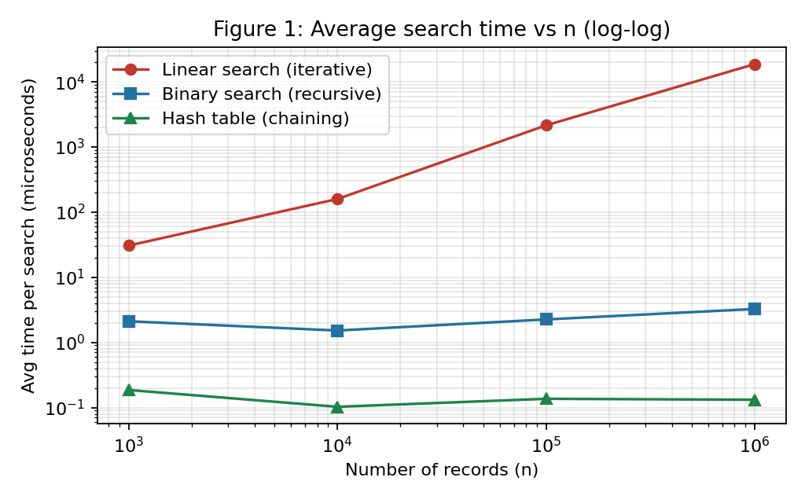
Figure 1 – Average search time versus n
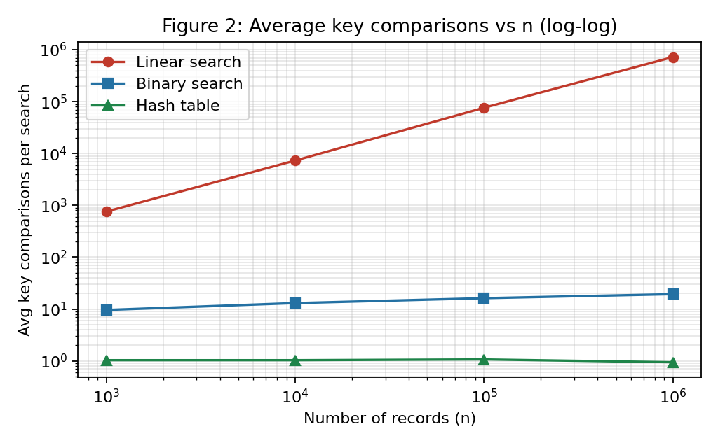
Figure 2 – Average comparisons versus n
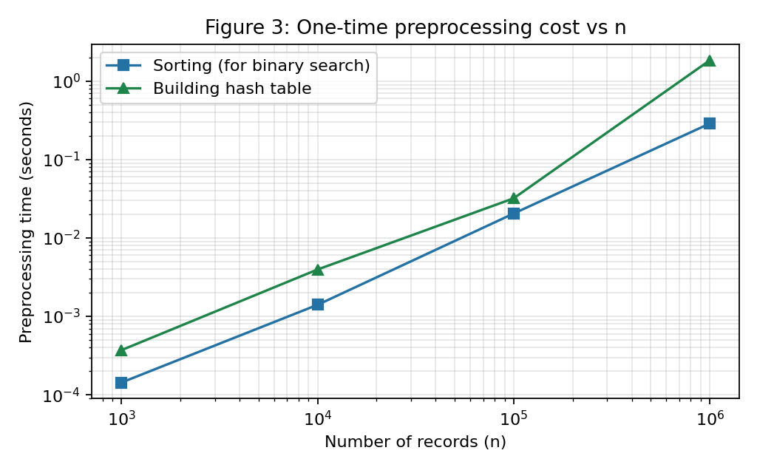
Figure 3 – Preprocessing cost versus n
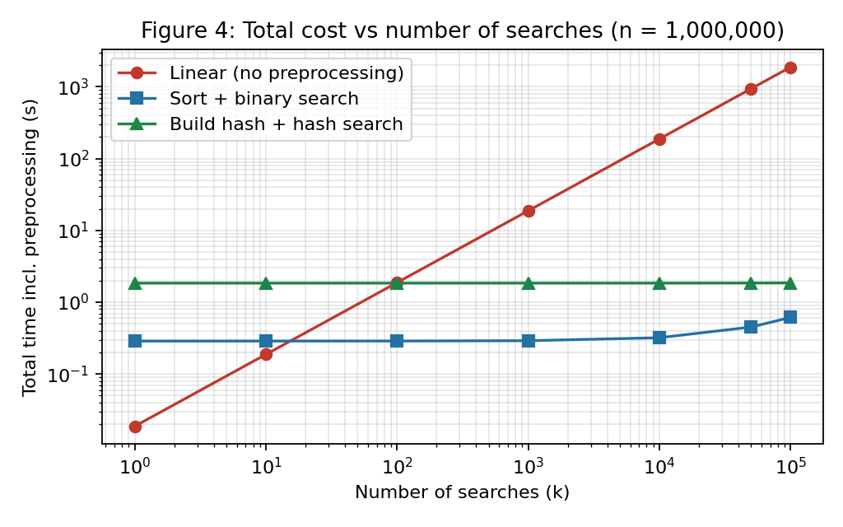
Figure 4 – Total cost (preprocessing + k searches) for n = 1,000,000

TASK 10 – Compare Theory with Experimental Behaviour 4 Marks
Compare your theoretical analysis with your experimental results.
Discuss:
- Whether the observed growth agrees with the theoretical complexity
- Which algorithm scales better as (n) increases
- Any differences between theoretical prediction and actual execution
- Possible reasons for the differences
You are expected to interpret the results, rather than simply reproduce tables or graphs.
Evidence Expected
A reasoned comparison between theoretical and experimentally observed performance.
ANSWER – Task 10
Does the observed growth agree with the theory?
Operation counts agree very closely. For A1, the theory for the mixed query set predicts 0.75n comparisons (hits (n+1)/2 and misses n); the measurements were 761, 7,330, 76,230 and 721,512 against the predicted 750, 7,500, 75,000 and 750,000, so every time n is multiplied by 10 the count is multiplied by almost exactly 10 (9.6×, 10.4×, 9.5×). The small shortfall comes from the random sample of only 100 hits (the standard error of their mean position is about 29,000 at n = 1,000,000). For A2, the number of comparisons rose by 3.4, 3.2 and 3.2 for each tenfold increase in n, and log₂10 = 3.32, and the worst cases of 10, 14, 17 and 20 equal ⌊log₂ n⌋ + 1 exactly. For A3, the hit cost 1.29 to 1.38 comparisons and the miss cost 0.59 to 0.75, compared to the predicted 1 + α/2 = 1.375 and α = 0.75, and they do not grow with n.
Running times agree in trend but are noisier. Average time per search of A1 went from 30.720 µs to 159.188 µs (5.2×), then 2,153.997 µs (13.5×) and 18,771.481 µs (8.7×), so over the 1000-fold range the time grew about 611× where the theory says 1000×. In A2 the time per search stayed in the range of 1.521 to 3.261 µs, which is consistent with a logarithm, but it is not a perfectly smooth curve. A3's search time stayed close to 0.1–0.19 µs for all sizes, which supports Θ(1).
Which algorithm scales better?
A3 scales best and A1 worst, with A2 in between: at n = 1,000,000 A1 took 18.77 ms per search, A2 3.261 µs and A3 0.132 µs. A2 is about 5,756 times faster than A1, and A3 is about 24.8 times faster than A2. When the preprocessing is included, the picture depends on k, the number of searches (Figure 4). Sorting pays for itself after about 15 searches, and building the hash table after about 98 searches, compared with doing everything with linear search.
Differences between theory and practice, and the reasons
- Break-even point. Theory (Task 3) predicted that sorting pays off after about 2 log₂ n ≈ 40 searches, but I measured about 15. The reason is that sorted() is compiled C code, whereas my linear search is an interpreted Python loop, so one linear comparison costs far more time than one comparison inside the sort. The comparison counts are in the right ratio but the time per comparison is not equal.
- Hash table build time. Theory says Θ(n), i.e. 10× per step. The measured build times were 0.37, 3.96, 32.02 and 1,843 ms, so the last step was about 57.6×, much worse than linear. I think this is caused by memory: for 1,000,000 keys, Python creates about 727,000 separate small lists, which means a lot of memory allocation, poor cache behaviour and garbage-collector activity that the O(n) model does not include. It is still O(n) in operation count, but the cost per operation rose with size.
- Sorting time. n log n predicts a factor of about 12 from n = 100,000 to 1,000,000 (10 × 19.93/16.61), and I measured 14.0×. That is a fairly good agreement.
- Linear search time not exactly proportional to n. The 1,000 → 10,000 step shows only 5.2× instead of 10×. At small sizes the data fits in the CPU cache and fixed overheads (function call, timer resolution) are a larger part of the total. The 1,000,000-record array no longer fits in the cache, which makes the large steps more expensive per element.
- Binary search time. The comparison count rises smoothly but the time per search at n = 1,000 (2.110 µs) is larger than at n = 10,000 (1.521 µs), which cannot be a real algorithmic effect. Such measurements at the microsecond level are affected by the timer, warm-up and the CPU's changing clock speed. The increase at 1,000,000 records is explained by cache misses: each of the 20 probes goes to a different memory location far from the last one.
- Sampling. The experiments used 200 queries per size and one run per size, so small differences (for example the 0.59 against 0.75 for hash misses) are statistical noise rather than evidence against the theory. A more careful study would repeat each run several times and report the median.
Overall, the theoretical growth rates Θ(n), Θ(log n) and Θ(1) are confirmed by the counts, and the timings follow the same ordering, but constants, memory behaviour and measurement noise make the real numbers deviate from the idealised model.

TASK 11 – Recommend and Defend the Final Design 4 Marks
Based on your mathematical analysis and experimental findings, recommend the most appropriate algorithmic solution for the university student-record system.
Discuss:
- Which approach you recommend
- Why it is more appropriate than the alternatives
- Its theoretical efficiency
- Its experimentally observed performance
- Any preprocessing cost involved
- Relevant trade-offs or limitations
- Whether the solution remains practical as the database grows
Your recommendation must be based on evidence obtained from your own analysis and experimentation. Simply identifying the algorithm with the lowest Big-O complexity is not sufficient.
Evidence Expected
A technically justified final design recommendation supported by both mathematical analysis and experimental evidence.
ANSWER – Task 11
Recommendation: A2, binary search on a sorted array of registration numbers, for the general problem as originally described (the number of searches is not stated, the data may change, and the database grows from thousands to millions of records). I chose this over the hash table, even though the hash table has the lowest Big-O, for the following reasons.
- Why it beats linear search. At n = 1,000,000 a linear search took 18.77 ms against 3.261 µs for binary search (about 5,756 times faster), 721,512 comparisons on average against 19. The one-time sort of 288 ms is recovered after only about 15 searches, which any real university system will do within minutes.
- Why I preferred it to the hash table for the general case. The hash table is faster per search (0.132 µs against 3.261 µs), but its preprocessing was about 6.4 times more expensive (1.84 s against 0.29 s), it needs a table of 1,333,357 buckets plus roughly 727,000 chain lists, and its good behaviour depends on a good hash function (the worst case is Θ(n), demonstrated in Task 4). Binary search gives a guaranteed worst case of 20 comparisons, needs no additional memory, and since the keys remain in order it also supports range queries such as "all registration numbers between X and Y" and ordered reports, which a hash table cannot do.
- Theoretical efficiency. Search Θ(log n), preprocessing Θ(n log n), total Θ((n + k) log n) (Task 3).
- Observed performance. 3.26 µs per search and 19.3 comparisons at n = 1,000,000 (worst case 20), from the experiments in Tasks 9 and 10.
- Trade-offs and limitations. The data must be sorted, and keeping it sorted when new students are added costs O(n) per insertion (shifting) or a repeated re-sort. So A2 is not the right choice if records are inserted continuously and searches are few. For one single search, plain linear search is still the cheapest because it has no preprocessing. And binary search needs random access (an array); it is no good on a linked list.
- Does it stay practical as the database grows? Yes. Every tenfold growth adds about 3.3 comparisons: 10 million records need at most 24 comparisons and a billion would need 30. The sorting cost does grow as n log n, but it is paid once, not per search.
So the final recommendation is evidence-based: it is binary search because it keeps the preprocessing modest, the worst case guaranteed and the structure flexible, while giving a speed-up of thousands of times over the baseline. The hash table is the main competitor, and Task 12 shows that its advantage matters once the number of searches becomes very large compared with the number of updates.

DAY-4 DESIGN CHALLENGE

TASK 12 – Re-evaluate and Adapt the Design 8 Marks
Changed Requirement
The university now needs to process 50,000 search requests per hour on a database containing 1,000,000 student records. However, new student records are added only once per day. Re-evaluate your original design in response to these changed operating conditions.
You may:
RETAIN → MODIFY → or REDESIGN
your original solution.
A. Impact Analysis – 2 Marks
Discuss:
- What has changed from the original problem
- Which original assumptions are affected
- Why the frequency of searches is now important
- Why the relatively low frequency of record updates may influence the design
Evidence Expected
A clear analysis of how the changed requirements affect the original algorithmic design.
ANSWER – Task 12 A
What changed. The original problem asked for a search method that works as the database grows, without saying how many searches there would be. Now the workload is concrete: n is fixed at 1,000,000, and the system must do 50,000 searches per hour (about 13.9 per second, or 1.2 million per day) while the data change only once per day.
Assumptions affected. (1) In Task 11 I treated the number of searches k as unknown, so the one-time preprocessing mattered a lot in the total cost T = P(n) + k·S(n). With k = 1.2 million searches per day, the term k·S(n) dominates and P(n) is shared by 1.2 million searches (the sort adds only about 0.24 µs per search, the hash build about 1.5 µs). (2) I assumed that new records might arrive at any time and so the ability to insert should be cheap. This is no longer needed. (3) I judged the algorithms on the basis of a single run of searches, whereas now the cost of a single search is multiplied more than a million times a day, so even small per-search differences add up.
Why search frequency matters now. The total daily work is k × (cost per search). With linear search that is 1.2 million × 18.8 ms ≈ 6.3 hours of processing per day, which would eat up a large part of a server. Reducing the cost of each search is therefore the only way to reduce the total.
Why rare updates matter. Since the data are updated once a day, the structure can be rebuilt completely in a batch, for example overnight, and then used read-only for the next 24 hours. That means (a) the expensive preprocessing is acceptable because it is paid once for over a million searches, (b) there is no need for a dynamic structure that handles insertions efficiently (balanced trees, hash resizing), and (c) a read-only structure can be shared by many request-handling threads without locking.
B. Evaluation of the Original Design – 2 Marks
Evaluate whether your original recommended solution remains appropriate.
Discuss:
- Its expected behaviour under 50,000 searches per hour
- Whether its preprocessing cost is acceptable under the new conditions
- Whether another approach could provide better overall performance
Evidence Expected
A technically supported evaluation of the suitability of the original design under the new operating conditions.
ANSWER – Task 12 B
Behaviour of the original design (binary search) under the load. Using my measured 3.26 µs per search at n = 1,000,000, 50,000 searches need about 0.163 seconds of processing per hour, and about 50,000 × 19.3 ≈ 0.97 million comparisons. That is a tiny fraction of the hour, so binary search handles the new workload with ease. Linear search, for comparison, would need about 939 s (about 15.6 minutes) of each hour and about 3.6 × 10¹⁰ comparisons, which is why it is ruled out.
Is its preprocessing acceptable? Yes. Sorting takes 0.29 s once a day (Θ(n log n)), compared with the 3.9 s that the day's searches need.
Could another approach do better overall? Yes, the hash table. Per search it is about 25 times faster (0.132 µs against 3.261 µs) and its work does not depend on n. Its build costs more (1.84 s against 0.29 s), but when I total the whole day (Table 5) the hash table wins: 2.00 s against 4.20 s.
C. Adaptation or Redesign – 2 Marks
Decide whether to:
Retain, modify or redesign the original solution.
If you modify or redesign it:
- Describe the revised algorithmic strategy
- Explain what has changed
- Determine the effect on computational complexity
If you retain the original solution, provide sufficient technical justification for why no redesign is necessary.
Evidence Expected
An appropriate design response to the changed requirement, with clear algorithmic reasoning.
ANSWER – Task 12 C
Decision: REDESIGN – replace the sorted array + binary search by a hash table (A3) that is rebuilt once a day.
- Revised strategy. Every night, after the day's new records have been added to the main store, build the hash table from scratch (m = smallest prime ≥ n/0.75, h(k) = k mod m, separate chaining). During the day all 50,000 requests per hour are answered from this read-only table by computing h(key) and scanning one short chain.
- What has changed. Searching no longer relies on the order of the data, so the sort and the halving are gone, and the daily preprocessing is a hash build instead of a sort. The load factor is kept at 0.75 so chains stay short, and a prime table size is used so that registration numbers with patterns (e.g. consecutive numbers in the same batch) are spread evenly.
- Effect on complexity. Search goes from Θ(log n) to Θ(1) expected (about 1 comparison instead of 19 for n = 1,000,000). The preprocessing goes from Θ(n log n) to Θ(n). The daily cost for k searches changes from Θ(n log n + k log n) to Θ(n + k). In numbers for n = 10⁶ and k = 1.2 × 10⁶: about 1.9 × 10⁷ (sort) + 2.3 × 10⁷ (search) = 4.2 × 10⁷ comparisons with binary search, against roughly 10⁶ (inserts) + 1.1 × 10⁶ (search) ≈ 2 × 10⁶ operations with the hash table.
- Safety measures against the worst case. The Θ(n) worst case happens only with a bad hash function. With a prime modulus, the longest chain in my 1,000,000-record test was 6. If registration numbers had a hidden structure that causes collisions, a universal hash function could be used instead, and the daily rebuild lets the system check the longest chain every night.
D. Evidence-Based Defence – 2 Marks
Defend your final design decision using evidence.
Use:
- Mathematical complexity analysis
- Experimental results, where appropriate
- Search frequency
- Preprocessing cost
- Dataset size
- Relevant computational trade-offs
Your final decision must follow logically from your analysis.
Evidence Expected
A well-supported final design decision integrating theoretical analysis, experimental evidence and the changed system constraints.
ANSWER – Task 12 D
Table 5 – Cost of the three designs for n = 1,000,000 (measured times)
Design | Daily build | Time per search | 50,000 searches / hour | Whole day (build + 1.2 million searches)
A1 Linear | 0 | 18.77 ms | 938.6 s | 22,526 s (≈ 6.3 h)
A2 Binary | 0.288 s | 3.261 µs | 0.163 s | 4.20 s
A3 Hash | 1.843 s | 0.132 µs | 0.0066 s | 2.00 s

- Mathematical analysis. With one rebuild per day, the cost is P(n) + k·S(n). For k = 1.2 × 10⁶ and n = 10⁶: binary search Θ((n + k) log n), hash Θ(n + k). Since n and k are of the same order, the log n factor (about 20) is the whole difference between the two, and the hash table removes it.
- Experimental evidence. At n = 1,000,000 the hash search was 24.8 times faster than binary search per query. The hash table costs 1.56 s more to build, which it recovers after about 496,925 searches, i.e. after roughly 9.9 hours of the 24-hour cycle, so over a full day it wins (2.00 s against 4.20 s). Linear search needs over 6 hours of processing per day and is not acceptable.
- Search frequency and dataset size. At 13.9 requests per second, a request needs only a small fraction of a second of work, and any of A2 or A3 can serve it. The hash design also leaves the most headroom: its search cost does not rise even if the university grows to several million students or the number of requests rises many times.
- Trade-offs, stated honestly. In absolute terms, both A2 and A3 are far below the capacity needed (0.16 s and 0.007 s of processing in an hour), so the real gain is modest and my numbers come from Python, where timings differ from a production database. The hash table uses more memory (about 1,333,357 buckets plus the chains), loses the ordering of the keys (no range queries), and depends on a good hash function. If the university also needs range or sorted queries on registration numbers, I would keep the sorted array and binary search for those, and use the hash table only for exact look-ups.
Conclusion. Because searches are very frequent, updates are rare and the structure can be rebuilt in a nightly batch, the heavier preprocessing of the hash table is paid back many times over by its constant-time searches. Hence the final design is to redesign the system around a hash table rebuilt daily, with binary search kept as a fallback for ordered queries. This follows from the numbers: Θ(n + k) against Θ((n + k) log n), 0.13 µs against 3.26 µs per search, and about 2.0 s against 4.2 s of total daily cost.
MARK DISTRIBUTION
Task | Marks
Task 1 – Algorithm Design | 5
Task 2 – Basic Operation | 2
Task 3 – Mathematical Complexity Analysis | 6
Task 4 – Best/Average/Worst-Case Analysis | 4
Task 5 – Asymptotic Analysis | 3
Task 6 – Recurrence Formulation | 3
Task 7 – Recurrence Solution | 4
Task 8 – Implementation & Testing | 4
Task 9 – Experimental Performance | 3
Task 10 – Theory vs Experiment | 4
Task 11 – Final Design Recommendation | 4
Subtotal | 42
Task 12 – Day-4 Design Challenge | 8
TOTAL | 50

Submitted by: RITHISH KUMAR D (Reg. No: 192565089)

