EXP:31
#include <stdio.h>
#include <stdint.h>

uint64_t leftShift64(uint64_t x) {
return x << 1;
}

int main() {
uint64_t L, K1, K2;

printf("Enter L (64-bit hex): ");
scanf("%llx", &L);

K1 = leftShift64(L);
if (L & 0x8000000000000000ULL)
K1 ^= 0x1B;

K2 = leftShift64(K1);
if (K1 & 0x8000000000000000ULL)
K2 ^= 0x1B;

printf("K1 = %llX\n", K1);
printf("K2 = %llX\n", K2);

return 0;
}
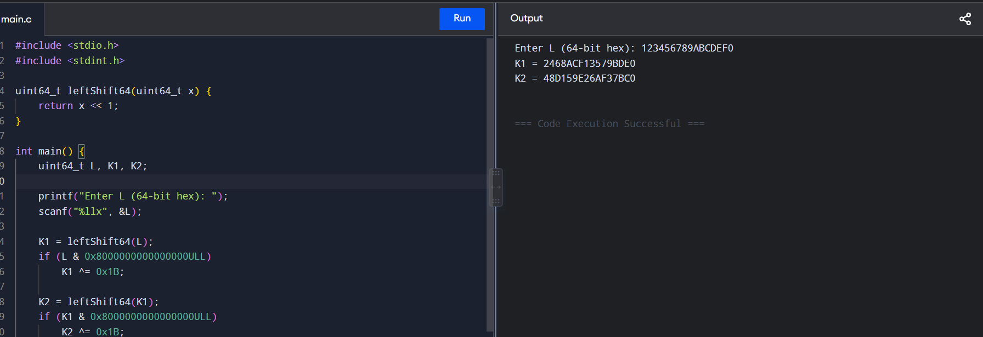

EXP:32
#include <stdio.h>
#include <stdlib.h>

int main() {
int message, x, k, r, s;

printf("Enter message value: ");
scanf("%d", &message);

printf("Enter private key x: ");
scanf("%d", &x);

printf("Enter random k for signature 1: ");
scanf("%d", &k);
r = (message + k) % 100;
s = (x + k) % 100;

printf("Signature 1 = (%d, %d)\n", r, s);

printf("Enter random k for signature 2: ");
scanf("%d", &k);
r = (message + k) % 100;
s = (x + k) % 100;

printf("Signature 2 = (%d, %d)\n", r, s);

return 0;
}
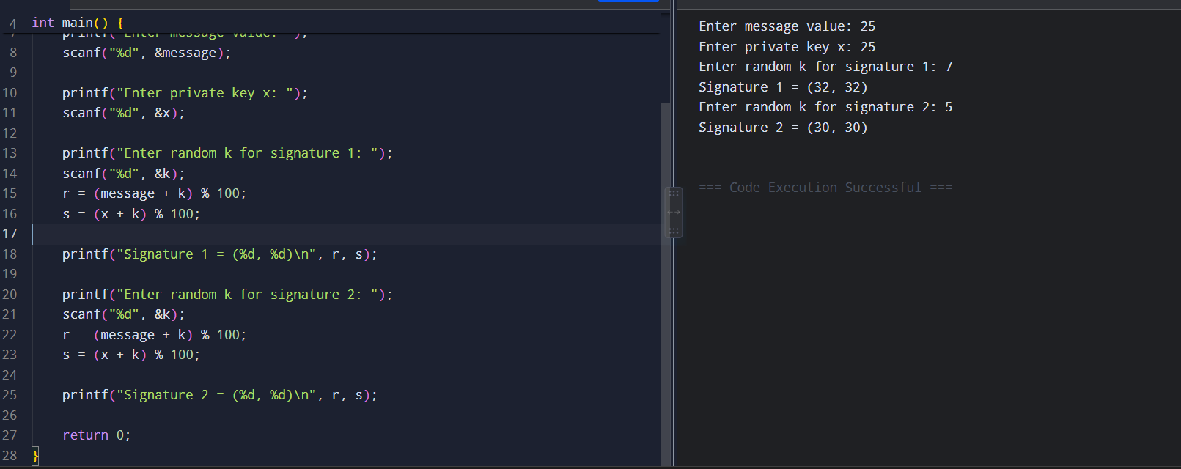

EXP:34
#include <stdio.h>

int main() {
int p[4], key, iv;
int ecb[4], cbc[4], cfb[4];

printf("Enter 4 plaintext blocks: ");
for (int i = 0; i < 4; i++)
scanf("%d", &p[i]);

printf("Enter key: ");
scanf("%d", &key);

printf("Enter IV: ");
scanf("%d", &iv);

/* ECB */
for (int i = 0; i < 4; i++)
ecb[i] = p[i] ^ key;

/* CBC */
cbc[0] = (p[0] ^ iv) ^ key;
for (int i = 1; i < 4; i++)
cbc[i] = (p[i] ^ cbc[i - 1]) ^ key;

/* CFB */
cfb[0] = p[0] ^ (iv ^ key);
for (int i = 1; i < 4; i++)
cfb[i] = p[i] ^ (cfb[i - 1] ^ key);

printf("\nECB: ");
for (int i = 0; i < 4; i++)
printf("%d ", ecb[i]);

printf("\nCBC: ");
for (int i = 0; i < 4; i++)
printf("%d ", cbc[i]);

printf("\nCFB: ");
for (int i = 0; i < 4; i++)
printf("%d ", cfb[i]);

return 0;
}
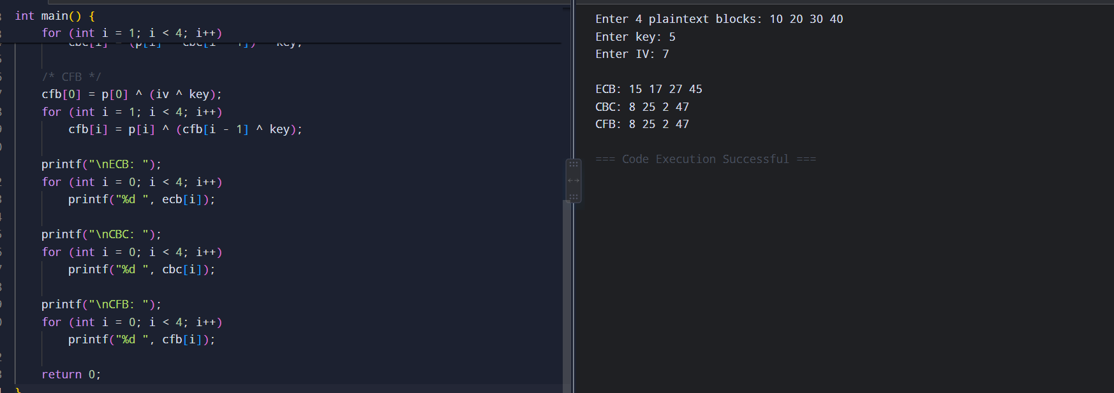
EXP:35
#include <stdio.h>
#include <string.h>

int main() {
char plaintext[100];
int key[100], n;

printf("Enter plaintext: ");
scanf("%s", plaintext);

n = strlen(plaintext);

printf("Enter %d key values (0-25): ", n);
for (int i = 0; i < n; i++)
scanf("%d", &key[i]);

printf("Ciphertext: ");

for (int i = 0; i < n; i++) {
char c = (plaintext[i] - 'A' + key[i]) % 26 + 'A';
printf("%c", c);
}

return 0;
}
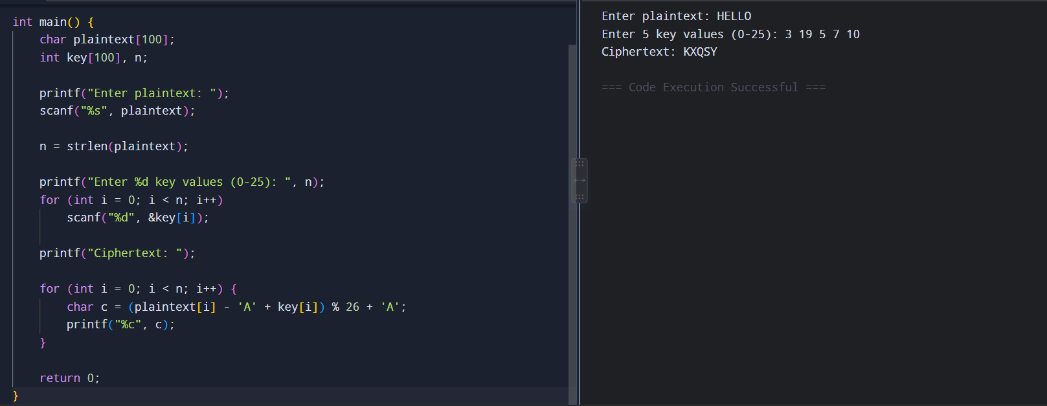

EXP:36
#include <stdio.h>
#include <string.h>

int gcd(int a, int b) {
while (b != 0) {
int t = a % b;
a = b;
b = t;
}
return a;
}

int main() {
char text[100];
int a, b;

printf("Enter plaintext: ");
scanf("%s", text);

printf("Enter a and b: ");
scanf("%d %d", &a, &b);

if (gcd(a, 26) != 1) {
printf("Invalid value of a. Encryption is not one-to-one.\n");
return 0;
}

printf("Ciphertext: ");

for (int i = 0; text[i] != '\0'; i++) {
int p = text[i] - 'A';
int c = (a * p + b) % 26;
printf("%c", c + 'A');
}

return 0;
}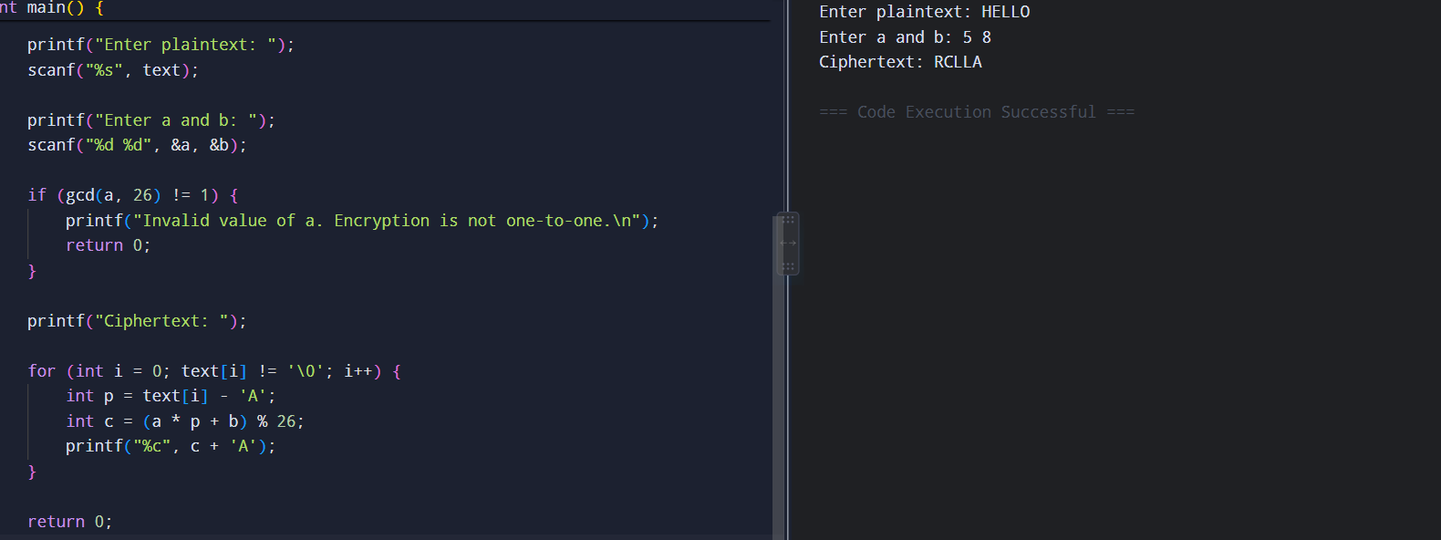

EXP:38
#include <stdio.h>

int mod26(int x) {
x %= 26;
if (x < 0) x += 26;
return x;
}

int main() {
int p[2][2], c[2][2];
int det, inv, k[2][2];

printf("Enter plaintext matrix P (2x2):\n");
for (int i = 0; i < 2; i++)
for (int j = 0; j < 2; j++)
scanf("%d", &p[i][j]);

printf("Enter ciphertext matrix C (2x2):\n");
for (int i = 0; i < 2; i++)
for (int j = 0; j < 2; j++)
scanf("%d", &c[i][j]);

det = mod26(p[0][0] * p[1][1] -
p[0][1] * p[1][0]);

for (int i = 1; i < 26; i++) {
if (mod26(det * i) == 1) {
inv = i;
break;
}
}

k[0][0] = mod26(c[0][0] * p[1][1]
- c[0][1] * p[1][0]);

k[0][1] = mod26(-c[0][0] * p[0][1]
+ c[0][1] * p[0][0]);

k[1][0] = mod26(c[1][0] * p[1][1]
- c[1][1] * p[1][0]);

k[1][1] = mod26(-c[1][0] * p[0][1]
+ c[1][1] * p[0][0]);

for (int i = 0; i < 2; i++)
for (int j = 0; j < 2; j++)
k[i][j] = mod26(k[i][j] * inv);

printf("Recovered Key Matrix:\n");

for (int i = 0; i < 2; i++) {
for (int j = 0; j < 2; j++)
printf("%d ", k[i][j]);
printf("\n");
}

return 0;
}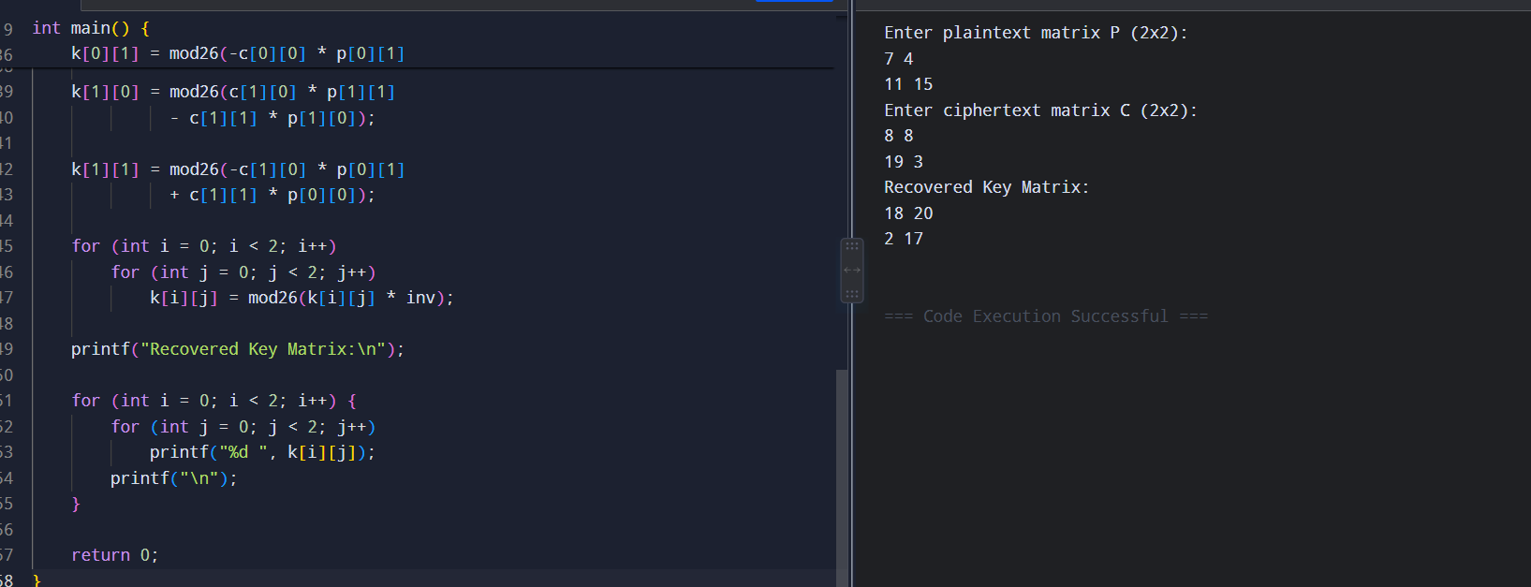

EXP:39
#include <stdio.h>
#include <string.h>

int main() {
char cipher[500];

printf("Enter ciphertext: ");
fgets(cipher, sizeof(cipher), stdin);

printf("\nPossible plaintexts:\n");

for (int k = 0; k < 26; k++) {
printf("Key %2d: ", k);

for (int i = 0; cipher[i] != '\0'; i++) {
if (cipher[i] >= 'A' && cipher[i] <= 'Z')
printf("%c",
(cipher[i] - 'A' - k + 26) % 26 + 'A');
else
printf("%c", cipher[i]);
}
}

return 0;
}
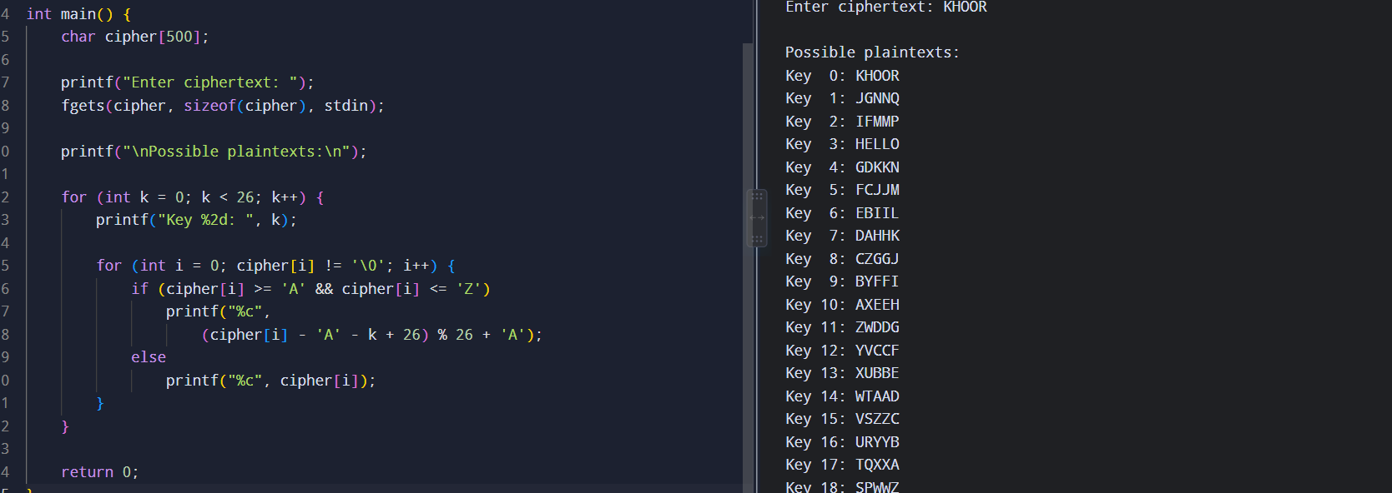

EXP:40
#include <stdio.h>

int main() {
char cipher[500];
int freq[26] = {0};

printf("Enter ciphertext: ");
fgets(cipher, sizeof(cipher), stdin);

for (int i = 0; cipher[i] != '\0'; i++) {
if (cipher[i] >= 'A' && cipher[i] <= 'Z')
freq[cipher[i] - 'A']++;
}

printf("\nFrequency Table:\n");

for (int i = 0; i < 26; i++)
printf("%c = %d\n", 'A' + i, freq[i]);

printf("\nMost frequent letters can be mapped to:\n");
printf("E T A O I N S H R D L U ...\n");

return 0;
}