SIMATS ENGINEERING
ASSESSMENT TOOL 3

COURSE NAME: Artificial Intelligence COURSE CODE: CSA17

COURSE OUTCOME COVERED

CO2: Experiment search and game-solving techniques such as Greedy Search, A*, CSP, Minimax, and Alpha-Beta pruning with heuristic functions for solving complex AI problems efficiently. (BL3)

Assessment Tool Weightage: 40%

Duration: 1 Hour QUESTIONS: 3 Total Marks:30

Annexure A

sDry Run Evaluation

Code of Conduct:

I Thejas.b/192565092(Name / Reg No) certify that this submission is my original work and that I have adhered to the guidelines specified for this assessment.
I understand that any violation of academic integrity rules will result in disciplinary action.

Signature of the student:
Thejas.b/192565092

Annexure A

Dry Run Evaluation
1. Question 1 – Breadth-First Search (BFS)
Consider the following graph: A
/ \
B C
/ \ / \
D E F G
Task: Starting from node A, perform a Breadth-First Search (BFS). Complete the following table.
Iteration Queue Visited Node
1
2
3
4
5
6
7
Questions:
- Write the BFS traversal order.
- Show the queue contents after each iteration.
Answer:
1).A → B → C → D → E → F → G
2).
Iteration | Queue
1 | B, C
2 | C, D, E
3 | D, E, F, G
4 | E, F, G
5 | F, G
6 | G
7 | Empty

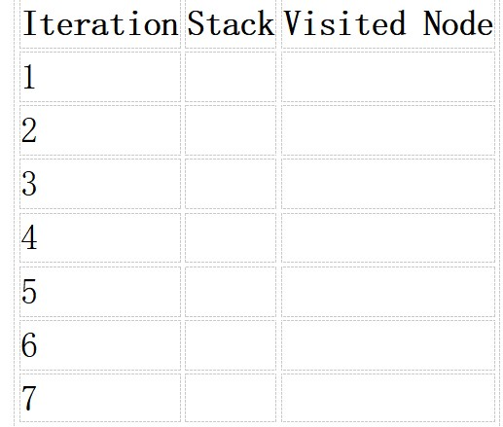
2. Depth-First Search (DFS) Using the same graph,
A
/ \
B C
/ \ / \
D E F G
Perform Depth-First Search (DFS) starting from A.
Complete the table.
3. Initial State :
1 3 6
5 0 2
4 7 8

Goal State :
1 2 3
4 5 6
7 8 0

Task
Trace Breadth-First Search (BFS) until the goal state is reached.
Fill in the table.
Iteration Current State Queue Before Expansion Queue After Expansion
1
2
3
4
5

Questions
- Which node is expanded in each iteration?
Ans:
Initial state
1 0 6 / 5 3 2 / 4 7 8
1 3 6 / 5 7 2 / 4 0 8
1 3 6 / 0 5 2 / 4 7 8
13 6 / 5 2 0 / 4 7 8

- How many states are generated in total?
Ans:
For the first 5 expansions, 12 new states are generated (excluding the initial state and avoiding repeated states).

- Write the complete solution path from the initial state to the goal state.
Ans:
1 3 6
5 0 2
4 7 8
↓
1 3 6
5 2 0
4 7 8
↓
1 3 0
5 2 6
4 7 8
↓
1 0 3
5 2 6
4 7 8
↓
1 2 3
5 0 6
4 7 8
↓
1 2 3
0 5 6
4 7 8
↓
1 2 3
4 5 6
0 7 8
↓
1 2 3
4 5 6
7 0 8
↓
1 2 3
4 5 6
4 8 0
Solution requires 8 moves.

- Why does BFS always find the shortest solution in an unweighted 8-puzzle problem?
Ans:
BFS explores the states level by level. Each move has the same cost (1), so BFS reaches all states requiring 1 move, then 2 moves, then 3 moves, and so on. Therefore, the first time BFS reaches the goal, it is guaranteed to be the shortest solution.

RUBRICS FOR CALCULATION

Criteria | Weightage (%) | Level 4 –  Exemplary (4) | Level 3 –  Proficient (3) | Level 2 –  Developing (2) | Level 1 –  Beginning (1)
Understandi ng of Search Problem | 20 | Clearly understands the search problem, initial state, goal state, and search strategy. | Understands the problem with minor misunderstandin gs. | Demonstrates partial understanding of the search problem. | Shows little or no understanding of the search problem.
Criteria | Weightage (%) | Level 4 –  Exemplary (4) | Level 3 –  Proficient (3) | Level 2 –  Developing (2) | Level 1 –  Beginning (1)
State  Expansion and Dry Run Execution | 30 | Correctly traces every iteration, expands nodes accurately, and maintains the  Queue/Stack/Priority  Queue without errors. | Performs most iterations correctly with  minor mistakes in state expansion or data structure  updates. | Performs only some iterations correctly; several errors in tracing or node expansion. | Unable to correctly perform the dry run or expand states.
Application of Search Algorithm | 20 | Applies the selected algorithm  (BFS/DFS/UCS)  correctly, following all algorithmic rules. | Applies the algorithm correctly with a few procedural errors. | Applies only basic algorithm steps with noticeable mistakes. | Fails to apply the correct search algorithm.
Accuracy of  Solution Path | 20 | Identifies the correct traversal order/solution path and goal state with proper justification. | Solution path is mostly correct with minor errors. | Partially correct solution path; goal may not be reached correctly. | Incorrect or incomplete solution path.
Presentation and Logical Reasoning | 10 | Queue/Stack/Priority Queue updates, state diagrams, and explanations are neat, organized, and logically presented. | Presentation is clear with minor organizational issues. | Limited explanation and organization; reasoning is partially clear. | Poor presentation with unclear or missing reasoning.

