WEB TECHNOLOGY EXPERIMENT
LIBRARY MANAGEMENT SYSTEM

Name: Murshidha M
Register Number: 192571007
Course Code: CSA4302

1. AIM
To design and develop a simple Library Management System webpage using HTML, CSS, and JavaScript. The webpage provides options for login, student registration, searching books, displaying available books, adding books, issuing and returning books, calculating fines, and accessing study materials.

2. ALGORITHM
- Start.
- Create the webpage structure using HTML.
- Use CSS to style the page, sections, input fields, buttons, and tables.
- Create the login and student registration sections.
- Create the book search field and the table to display book details.
- Store sample book details in a JavaScript array and display them in the table.
- Use JavaScript functions to add books and search for a book by name.
- Add buttons for issuing and returning books, calculating fines, and downloading study material.
- Display suitable messages when the user clicks the action buttons.
- Run the HTML file in a web browser and verify the webpage output.
- Stop.

3. HTML, CSS AND JAVASCRIPT CODE
The following is the code from the supplied experiment file (exp1.html). It is included as text so that it can be read and copied from this report.
<!DOCTYPE html>
<html>
<head>
<meta charset="UTF-8">
<title>Library Management System</title>

<style>
body{
font-family:Arial;
margin:20px;
background:#f4f4f4;
}

h1{
text-align:center;
}

section{
background:white;
padding:15px;
margin:20px auto;
width:80%;
border-radius:10px;
box-shadow:0 0 5px gray;
}

input,select,button{
padding:8px;
margin:5px;
}

table{
width:100%;
border-collapse:collapse;
margin-top:10px;
}

table,th,td{
border:1px solid black;
}

th,td{
padding:8px;
text-align:center;
}

button{
cursor:pointer;
}
</style>

</head>

<body>

<h1>Library Management System</h1>

<!-- LOGIN -->

<section>

<h2>Login</h2>

<select>
<option>Student</option>
<option>Admin</option>
</select>

<input type="text" placeholder="Username">

<input type="password" placeholder="Password">

<button onclick="alert('Login Successful')">Login</button>

</section>

<!-- REGISTER -->

<section>

<h2>Student Registration</h2>

<input id="name" placeholder="Name">

<input placeholder="Email">

<input placeholder="Password">

<button onclick="register()">Register</button>

</section>

<!-- SEARCH BOOK -->

<section>

<h2>Search Book</h2>

<input id="search" placeholder="Enter Book Name">

<button onclick="searchBook()">Search</button>

<p id="result"></p>

</section>

<!-- BOOK LIST -->

<section>

<h2>Books Available</h2>

<table id="bookTable">

<tr>

<th>ID</th>
<th>Book</th>
<th>Author</th>
<th>Status</th>

</tr>

</table>

</section>

<!-- ADMIN -->

<section>

<h2>Admin Panel</h2>

<input id="bookName" placeholder="Book Name">

<input id="author" placeholder="Author">

<button onclick="addBook()">Add Book</button>

</section>

<!-- ISSUE BOOK -->

<section>

<h2>Issue Book</h2>

<input placeholder="Student Name">

<input placeholder="Book Name">

<button onclick="alert('Book Issued')">Issue</button>

</section>

<!-- RETURN BOOK -->

<section>

<h2>Return Book</h2>

<input placeholder="Book Name">

<button onclick="alert('Book Returned')">Return</button>

</section>

<!-- FINE -->

<section>

<h2>Fine</h2>

<input placeholder="Days Late">

<button onclick="fine()">Calculate Fine</button>

<p id="fine"></p>

</section>

<!-- MATERIAL -->

<section>

<h2>Study Material</h2>

<select>

<option>Year 1</option>
<option>Year 2</option>
<option>Year 3</option>
<option>Year 4</option>

</select>

<select>

<option>Semester 1</option>
<option>Semester 2</option>
<option>Semester 3</option>
<option>Semester 4</option>
<option>Semester 5</option>
<option>Semester 6</option>
<option>Semester 7</option>
<option>Semester 8</option>

</select>

<button onclick="alert('Material Downloaded')">Download</button>

</section>

<!-- BORROW HISTORY -->

<section>

<h2>My Borrow History</h2>

<table>

<tr>

<th>Book</th>
<th>Issue Date</th>
<th>Expiry Date</th>

</tr>

<tr>

<td>Java</td>
<td>10/07/2026</td>
<td>20/07/2026</td>

</tr>

</table>

</section>

<!-- PROFILE -->

<section>

<h2>My Profile</h2>

<p>Name : Student</p>

<p>Department : CSE</p>

<p>Fine : ₹0</p>

</section>

<!-- CONTACT -->

<section>

<h2>Contact Library</h2>

<input placeholder="Your Name">

<input placeholder="Email">

<br>

<textarea rows="5" cols="40"></textarea>

<br>

<button onclick="alert('Message Sent')">Send</button>

</section>

<script>

let books=[
{id:1,name:"Java",author:"James Gosling",status:"Available"},
{id:2,name:"Python",author:"Guido",status:"Available"},
{id:3,name:"C Programming",author:"Dennis",status:"Issued"}
];

function displayBooks(){

let table=document.getElementById("bookTable");

table.innerHTML="<tr><th>ID</th><th>Book</th><th>Author</th><th>Status</th></tr>";

books.forEach(function(book){

table.innerHTML+=`
<tr>
<td>${book.id}</td>
<td>${book.name}</td>
<td>${book.author}</td>
<td>${book.status}</td>
</tr>
`;

});

}

displayBooks();

function addBook(){

let name=document.getElementById("bookName").value;

let author=document.getElementById("author").value;

books.push({

id:books.length+1,
name:name,
author:author,
status:"Available"

});

displayBooks();

alert("Book Added");

}

function searchBook(){

let text=document.getElementById("search").value.toLowerCase();

let found=books.find(b=>b.name.toLowerCase().includes(text));

if(found)

document.getElementById("result").innerHTML=
found.name+" by "+found.author+" ("+found.status+")";

else

document.getElementById("result").innerHTML="Book Not Found";

}

function fine(){

let days=document.querySelectorAll("input")[10].value;

let amount=days*5;

document.getElementById("fine").innerHTML="Fine : ₹"+amount;

}

function register(){

alert("Registration Successful");

}

</script>

</body>
</html>

4. OUTPUT SCREENSHOT
The screenshot below shows the Library Management System webpage layout and the sample books listed in the Books Available table.
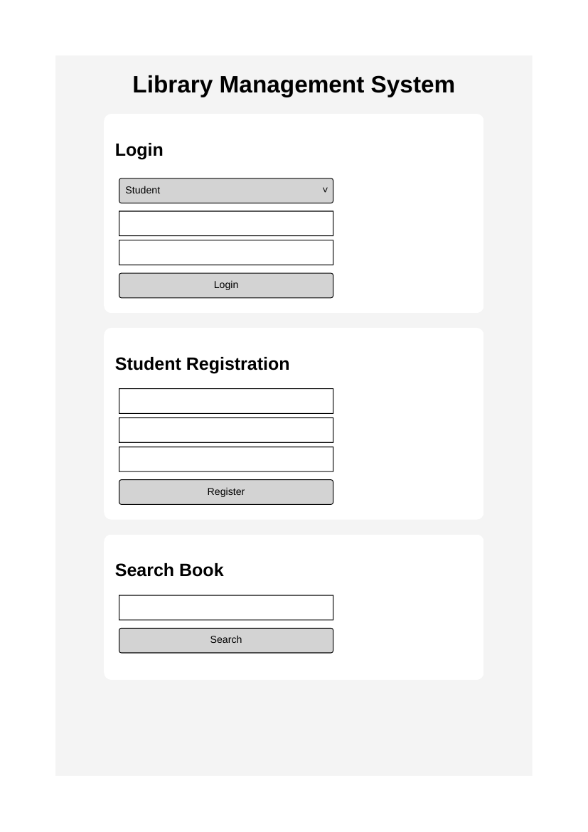

5. RESULT
Thus, the Library Management System webpage was designed using HTML, CSS, and JavaScript. The interface displays library-related sections and supports basic actions such as book searching, adding books, registration alerts, issue/return alerts, and fine calculation.

