WEB TECHNOLOGY EXPERIMENT
HOTEL ROOM BOOKING SYSTEM

Name: Murshidha M
Register Number: 192571007
Course Code: CSA4302

1. AIM
To create a Hotel Room Booking System webpage using HTML, CSS, and JavaScript. The webpage allows users to register and log in, check room availability, book rooms, view booking history, modify or cancel bookings, submit reviews, and contact the hotel. It also provides an admin panel to update room details.

2. ALGORITHM
- Start.
- Create the webpage structure using HTML.
- Apply CSS to style the header, sections, input fields, buttons, and tables.
- Create login, registration, and profile sections.
- Add room availability and room booking options.
- Create a booking history table and options to modify or cancel bookings.
- Add review, contact, about, and customer service sections.
- Create JavaScript arrays to store users, rooms, bookings, and reviews.
- Write JavaScript functions for login, registration, room checking, booking, payment, reviews, and admin updates.
- Open the HTML file in a browser and test the webpage controls.
- Stop.

3. HTML, CSS AND JAVASCRIPT CODE
The code below is taken from the supplied exp2.html file and included in the report.
<!DOCTYPE html>
<html lang="en">
<head>
<meta charset="UTF-8">
<meta name="viewport" content="width=device-width, initial-scale=1.0">
<title>Simple Hotel Booking System</title>
<style>
body{font-family:Arial;background:#f2f2f2;margin:0}
header{background:#2c3e50;color:#fff;padding:15px;text-align:center}
section{background:#fff;margin:15px;padding:15px;border-radius:8px}
input,select,textarea,button{padding:8px;margin:5px}
table{width:100%;border-collapse:collapse}
th,td{border:1px solid #999;padding:8px;text-align:center}
h2{color:#2c3e50}
</style>
</head>
<body>

<header><h1>Hotel Room Booking System</h1></header>

<section>
<h2>Login</h2>
<input id="loginUser" placeholder="Username">
<input id="loginPass" type="password" placeholder="Password">
<button onclick="login()">Login</button>
<p><b>Admin:</b> admin / admin123</p>
</section>

<section>
<h2>Register</h2>
<input id="name" placeholder="Name">
<input id="user" placeholder="Username">
<input id="pass" type="password" placeholder="Password">
<button onclick="register()">Register</button>
</section>

<section>
<h2>My Profile</h2>
<p id="profile">Login to view profile.</p>
</section>

<section>
<h2>Check Room Availability</h2>
<select id="roomType">
<option>Single</option>
<option>Double</option>
<option>Deluxe</option>
<option>Suite</option>
</select>
<button onclick="checkRoom()">Check</button>
<p id="availability"></p>
</section>

<section>
<h2>Book Room</h2>
<input type="date" id="date">
<button onclick="bookRoom()">Book</button>
<button onclick="payment()">Pay</button>
</section>

<section>
<h2>Booking History</h2>
<button onclick="showHistory()">Refresh</button>
<table id="history">
<tr><th>ID</th><th>Room</th><th>Date</th><th>Status</th></tr>
</table>
</section>

<section>
<h2>Modify Booking</h2>
<input id="bid" placeholder="Booking ID">
<input type="date" id="newDate">
<button onclick="modifyBooking()">Modify</button>
</section>

<section>
<h2>Cancel Booking</h2>
<input id="cid" placeholder="Booking ID">
<button onclick="cancelBooking()">Cancel</button>
</section>

<section>
<h2>Reviews</h2>
<textarea id="review"></textarea><br>
<button onclick="addReview()">Submit Review</button>
<div id="reviews"></div>
</section>

<section>
<h2>Contact Us</h2>
<input placeholder="Your Name">
<input placeholder="Email"><br>
<textarea placeholder="Message"></textarea><br>
<button onclick="alert('Message Sent')">Send</button>
</section>

<section>
<h2>About Us</h2>
<p>We provide affordable and comfortable hotel rooms with 24/7 customer support.</p>
<h2>Customer Service Q&A</h2>
<p><b>Q:</b> Check-in time?<br><b>A:</b> 12 PM</p>
<p><b>Q:</b> Check-out time?<br><b>A:</b> 11 AM</p>
<h2>Travel Guide</h2>
<p>Taxi, bus and railway station are available nearby.</p>
<h2>Privacy Policy</h2>
<p>Your information is used only for demo purposes.</p>
</section>

<section>
<h2>Admin Panel</h2>
<select id="adminRoom">
<option>Single</option>
<option>Double</option>
<option>Deluxe</option>
<option>Suite</option>
</select>
<input id="price" placeholder="New Price">
<input id="qty" placeholder="Quantity">
<button onclick="updateRoom()">Update Room</button>
<br><br>
<input id="adminCancelId" placeholder="Booking ID">
<button onclick="adminCancel()">Cancel Booking</button>
</section>

<script>
let currentUser=null;
let users=[];
let rooms=[
{type:"Single",price:1000,quantity:5},
{type:"Double",price:1800,quantity:4},
{type:"Deluxe",price:3000,quantity:3},
{type:"Suite",price:5000,quantity:2}
];
let bookings=[];
let reviewList=[];

function register(){
users.push({
name:name.value,
username:user.value,
password:pass.value
});
alert("Registration Successful");
}

function login(){
let u=loginUser.value,p=loginPass.value;
if(u==="admin"&&p==="admin123"){
currentUser="Admin";
profile.innerHTML="<b>Logged in as Admin</b>";
alert("Admin Login");
return;
}
let found=users.find(x=>x.username===u&&x.password===p);
if(found){
currentUser=found.username;
profile.innerHTML="<b>Name:</b> "+found.name+"<br><b>Username:</b> "+found.username;
alert("Welcome "+found.name);
}else alert("Invalid Login");
}

function checkRoom(){
let r=rooms.find(x=>x.type===roomType.value);
availability.innerHTML=r.quantity+" room(s) available. Price ₹"+r.price;
}

function bookRoom(){
if(!currentUser||currentUser==="Admin"){alert("Login as User");return;}
let r=rooms.find(x=>x.type===roomType.value);
if(r.quantity<=0){alert("No rooms available");return;}
r.quantity--;
bookings.push({id:bookings.length+1,user:currentUser,room:r.type,date:date.value,status:"Booked"});
alert("Booking Successful");
}

function showHistory(){
history.innerHTML="<tr><th>ID</th><th>Room</th><th>Date</th><th>Status</th></tr>";
bookings.forEach(b=>{
if(currentUser==="Admin"||b.user===currentUser){
history.innerHTML+=`<tr><td>${b.id}</td><td>${b.room}</td><td>${b.date}</td><td>${b.status}</td></tr>`;
}
});
}

function modifyBooking(){
let b=bookings.find(x=>x.id==bid.value);
if(b){b.date=newDate.value;alert("Booking Updated");showHistory();}
else alert("Booking Not Found");
}

function cancelBooking(){
let i=bookings.findIndex(x=>x.id==cid.value);
if(i!=-1){bookings.splice(i,1);alert("Cancelled");showHistory();}
else alert("Booking Not Found");
}

function adminCancel(){
let i=bookings.findIndex(x=>x.id==adminCancelId.value);
if(i!=-1){bookings.splice(i,1);alert("Booking Cancelled");showHistory();}
}

function updateRoom(){
let r=rooms.find(x=>x.type===adminRoom.value);
r.price=price.value;
r.quantity=parseInt(qty.value);
alert("Room Updated");
}

function payment(){alert("Payment Successful (Demo)");}

function addReview(){
reviewList.push(review.value);
reviews.innerHTML="";
reviewList.forEach(x=>reviews.innerHTML+="<p>⭐ "+x+"</p>");
review.value="";
}
</script>
</body>
</html>

4. OUTPUT SCREENSHOT
Output preview of the Hotel Room Booking System webpage based on the supplied HTML file:
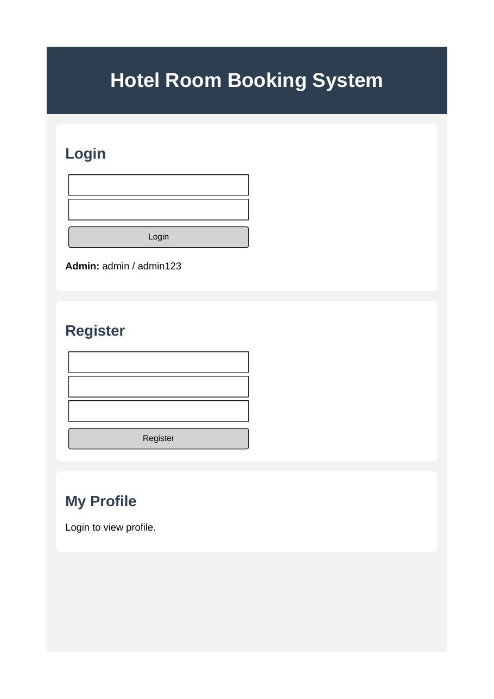

5. RESULT
Thus, the Hotel Room Booking System webpage was created using HTML, CSS, and JavaScript. It provides a basic interface for user registration and login, room availability checking, booking management, reviews, contact information, and administrator room updates.

