WEB TECHNOLOGY EXPERIMENT 3
ONLINE BUS TICKET BOOKING SYSTEM
Name: Murshidha M
Register Number: 192571007
Course Code: CSA4302

1. AIM
To develop an Online Bus Ticket Booking System using HTML, CSS, and JavaScript. It supports login, registration, bus searching, ticket booking, booking history, cancellation, comments, and administration.

2. ALGORITHM
- Start.
- Create the page structure with HTML and style it using CSS.
- Add login and registration forms.
- Create bus search and ticket booking sections.
- Add booking history, cancellation, and comments sections.
- Use JavaScript arrays to store users, buses, bookings, and comments.
- Write functions for login, registration, searching, booking, cancellation, and payment.
- Add admin features to update bus details, publish news, and generate reports.
- Open the HTML file in a browser and test the features.
- Stop.

3. HTML, CSS AND JAVASCRIPT CODE
Complete code from the supplied exp3(1).html file:

<!DOCTYPE html>
<html>
<head>
<meta charset="UTF-8">
<meta name="viewport" content="width=device-width,initial-scale=1">
<title>Simple Bus Ticket Booking System</title>
<style>
body{font-family:Arial;background:#eef2f5;margin:0}
header{background:#1565c0;color:#fff;padding:15px;text-align:center}
section{background:#fff;margin:15px;padding:15px;border-radius:8px}
input,select,textarea,button{padding:8px;margin:5px}
table{width:100%;border-collapse:collapse}
th,td{border:1px solid #999;padding:8px;text-align:center}
</style>
</head>
<body>
<header><h1>Online Bus Ticket Booking System</h1></header>

<section>
<h2>Login</h2>
<input id="loginUser" placeholder="Username">
<input id="loginPass" type="password" placeholder="Password">
<button onclick="login()">Login</button>
<p><b>Admin:</b> admin / admin123</p>
</section>

<section>
<h2>Register</h2>
<input id="name" placeholder="Full Name">
<input id="user" placeholder="Username">
<input id="pass" type="password" placeholder="Password">
<button onclick="register()">Register</button>
</section>

<section>
<h2>Search Bus</h2>
<input id="route" placeholder="Route">
<input id="travelDate" type="date">
<button onclick="searchBus()">Search</button>
<p id="searchResult"></p>
</section>

<section>
<h2>Book Ticket</h2>
<select id="busSelect">
<option>Volvo</option>
<option>Sleeper Coach</option>
<option>AC Coach</option>
<option>Non AC Coach</option>
</select>
<input id="seat" type="number" min="1" placeholder="Seats">
<button onclick="bookTicket()">Book Ticket</button>
<button onclick="payment()">Pay</button>
</section>

<section>
<h2>Booking History</h2>
<button onclick="showBookings()">Refresh</button>
<table id="bookingTable">
<tr><th>ID</th><th>Bus</th><th>Route</th><th>Date</th><th>Seats</th><th>Status</th></tr>
</table>
</section>

<section>
<h2>Cancel Ticket</h2>
<input id="cancelId" placeholder="Booking ID">
<button onclick="cancelBooking()">Cancel</button>
</section>

<section>
<h2>Comments</h2>
<textarea id="comment"></textarea><br>
<button onclick="postComment()">Post</button>
<div id="commentList"></div>
</section>

<section>
<h2>Admin Panel</h2>
<h3>Update Bus Information</h3>
<select id="adminBus">
<option>Volvo</option>
<option>Sleeper Coach</option>
<option>AC Coach</option>
<option>Non AC Coach</option>
</select>
<input id="price" placeholder="Price">
<input id="available" placeholder="Available Seats">
<button onclick="updateBus()">Update</button>

<h3>News</h3>
<textarea id="news"></textarea><br>
<button onclick="updateNews()">Publish</button>
<p id="newsDisplay"></p>

<h3>Reports</h3>
<button onclick="generateReport()">Generate Report</button>
<p id="report"></p>
</section>

<script>
let currentUser=null;
let users=[];
let comments=[];
let bookings=[];
let buses=[
{type:"Volvo",price:1200,seats:40},
{type:"Sleeper Coach",price:1500,seats:30},
{type:"AC Coach",price:1000,seats:35},
{type:"Non AC Coach",price:700,seats:45}
];

function register(){
users.push({name:name.value,username:user.value,password:pass.value});
alert("Registration Successful");
}

function login(){
if(loginUser.value==="admin"&&loginPass.value==="admin123"){
currentUser="Admin";
alert("Welcome Admin");
return;
}
let u=users.find(x=>x.username===loginUser.value&&x.password===loginPass.value);
if(u){currentUser=u.username;alert("Welcome "+u.name);}
else alert("Invalid Login");
}

function searchBus(){
let bus=buses.find(x=>x.type===busSelect.value);
searchResult.innerHTML="Bus: "+bus.type+
"<br>Price: ₹"+bus.price+
"<br>Available Seats: "+bus.seats;
}

function bookTicket(){
if(!currentUser||currentUser==="Admin"){alert("Login as User");return;}
let bus=buses.find(x=>x.type===busSelect.value);
let s=parseInt(seat.value)||1;
if(bus.seats<s){alert("Not enough seats");return;}
bus.seats-=s;
bookings.push({
id:bookings.length+1,
user:currentUser,
bus:bus.type,
route:route.value,
date:travelDate.value,
seats:s,
status:"Booked"
});
alert("Ticket Booked");
}

function showBookings(){
bookingTable.innerHTML="<tr><th>ID</th><th>Bus</th><th>Route</th><th>Date</th><th>Seats</th><th>Status</th></tr>";
bookings.forEach(b=>{
if(currentUser==="Admin"||b.user===currentUser){
bookingTable.innerHTML+=`<tr><td>${b.id}</td><td>${b.bus}</td><td>${b.route}</td><td>${b.date}</td><td>${b.seats}</td><td>${b.status}</td></tr>`;
}
});
}

function cancelBooking(){
let i=bookings.findIndex(x=>x.id==cancelId.value);
if(i!=-1){
let bus=buses.find(x=>x.type===bookings[i].bus);
bus.seats+=bookings[i].seats;
bookings.splice(i,1);
alert("Booking Cancelled");
showBookings();
}else alert("Booking Not Found");
}

function postComment(){
comments.push(comment.value);
commentList.innerHTML="";
comments.forEach(c=>commentList.innerHTML+="<p>🚌 "+c+"</p>");
comment.value="";
}

function updateBus(){
let b=buses.find(x=>x.type===adminBus.value);
b.price=parseInt(price.value)||b.price;
b.seats=parseInt(available.value)||b.seats;
alert("Bus Information Updated");
}

function updateNews(){
newsDisplay.innerHTML="<b>Latest News:</b><br>"+news.value;
}

function generateReport(){
report.innerHTML="Registered Users: "+users.length+
"<br>Total Bookings: "+bookings.length+
"<br>Total Comments: "+comments.length;
}

function payment(){
alert("Payment Successful (Demo)");
}
</script>
</body>
</html>

4. OUTPUT SCREENSHOT
Rendered preview based on the supplied HTML file. This is a recreated preview, not a direct screenshot captured from a browser.
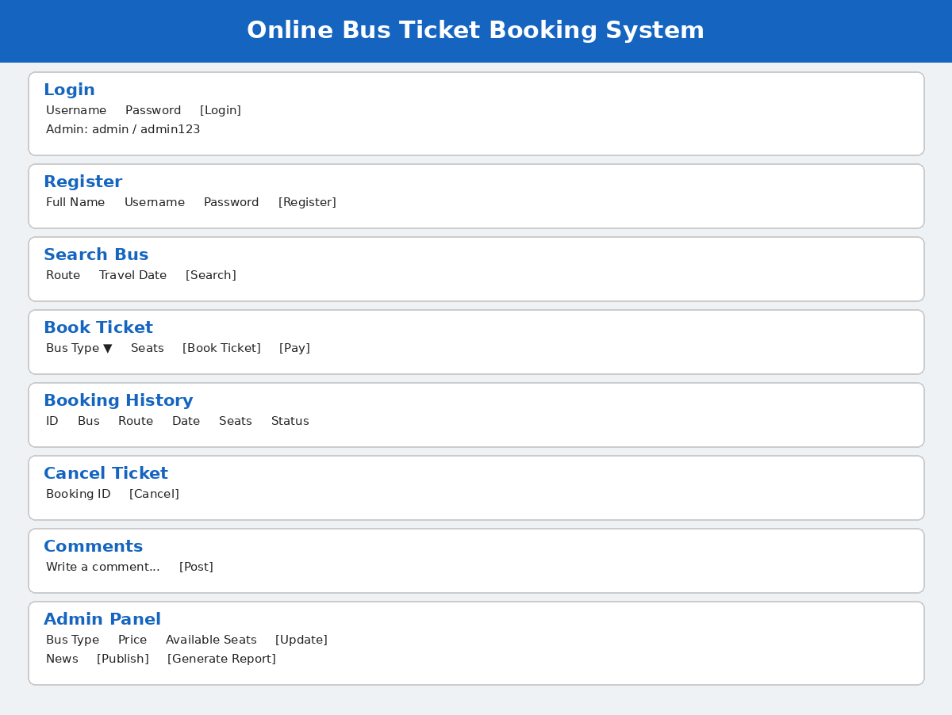

5. RESULT
Thus, the Online Bus Ticket Booking System webpage was created using HTML, CSS, and JavaScript, with the main interface sections and basic interactive features included in the experiment.

