WEB TECHNOLOGY EXPERIMENT 4
RAILWAY RESERVATION SYSTEM
Name: Murshidha M
Register Number: 192571007
Course Code: CSA4302

1. AIM
To create a Railway Reservation System using HTML, CSS, and JavaScript. It includes registration, login, train searching, ticket booking, PNR status checking, cancellation, and admin train updates.

2. ALGORITHM
- Start.
- Create the HTML structure and style it using CSS.
- Add login and registration forms.
- Create train search fields for origin, destination, journey date, and class.
- Add ticket booking, booking history, PNR status, and cancellation sections.
- Store train, user, and booking details in JavaScript arrays.
- Write functions for login, registration, train searching, booking, and PNR checking.
- Add cancellation with refund calculation and admin train updates.
- Open the file in a browser and test the interface.
- Stop.

3. HTML, CSS AND JAVASCRIPT CODE
Complete code from the supplied exp4.html file:

<!DOCTYPE html>
<html lang="en">
<head>
<meta charset="UTF-8">
<meta name="viewport" content="width=device-width,initial-scale=1">
<title>Simple Railway Reservation System</title>
<style>
body{font-family:Arial;margin:0;background:#eef3f8}
header{background:#0b5ed7;color:#fff;padding:15px;text-align:center}
section{background:#fff;margin:15px;padding:15px;border-radius:8px}
input,select,button,textarea{padding:8px;margin:5px}
table{width:100%;border-collapse:collapse}
th,td{border:1px solid #999;padding:8px;text-align:center}
</style>
</head>
<body>
<header><h1>Railway Reservation System</h1></header>

<section>
<h2>Login</h2>
<input id="loginUser" placeholder="Username">
<input id="loginPass" type="password" placeholder="Password">
<button onclick="login()">Login</button>
<p><b>Admin:</b> admin / admin123</p>
</section>

<section>
<h2>Register</h2>
<input id="name" placeholder="Name">
<input id="user" placeholder="Username">
<input id="pass" type="password" placeholder="Password">
<button onclick="register()">Register</button>
</section>

<section>
<h2>Search Train</h2>
<input id="origin" placeholder="Origin">
<input id="destination" placeholder="Destination">
<input id="journeyDate" type="date">
<select id="trainClass">
<option>Sleeper</option>
<option>3A</option>
<option>2A</option>
<option>1A</option>
</select>
<button onclick="searchTrain()">Search</button>
<p id="searchResult"></p>
</section>

<section>
<h2>Book Ticket</h2>
<select id="trainSelect">
<option>Express 101</option>
<option>Superfast 202</option>
<option>Intercity 303</option>
</select>
<input id="passenger" placeholder="Passenger Name">
<button onclick="bookTicket()">Book Ticket</button>
<button onclick="payment()">Pay</button>
</section>

<section>
<h2>Booking History</h2>
<button onclick="showBookings()">Refresh</button>
<table id="bookingTable">
<tr><th>PNR</th><th>Train</th><th>Passenger</th><th>Date</th><th>Status</th></tr>
</table>
</section>

<section>
<h2>PNR Status</h2>
<input id="pnrInput" placeholder="Enter PNR">
<button onclick="checkPNR()">Check</button>
<p id="pnrStatus"></p>
</section>

<section>
<h2>Cancel Ticket</h2>
<input id="cancelPNR" placeholder="PNR">
<button onclick="cancelTicket()">Cancel Ticket</button>
<p id="refund"></p>
</section>

<section>
<h2>Admin Panel</h2>
<h3>Update Train</h3>
<select id="adminTrain">
<option>Express 101</option>
<option>Superfast 202</option>
<option>Intercity 303</option>
</select>
<input id="fare" placeholder="Fare">
<input id="seats" placeholder="Available Seats">
<button onclick="updateTrain()">Update</button>

<h3>Reports</h3>
<button onclick="report()">Generate Report</button>
<p id="reportData"></p>
</section>

<script>
let currentUser=null;
let users=[];
let trains=[
{name:"Express 101",fare:450,seats:50},
{name:"Superfast 202",fare:700,seats:40},
{name:"Intercity 303",fare:350,seats:60}
];
let bookings=[];

function register(){
users.push({name:name.value,username:user.value,password:pass.value});
alert("Registered Successfully");
}

function login(){
if(loginUser.value==="admin"&&loginPass.value==="admin123"){
currentUser="Admin";
alert("Admin Login Successful");
return;
}
let u=users.find(x=>x.username===loginUser.value&&x.password===loginPass.value);
if(u){currentUser=u.username;alert("Welcome "+u.name);}
else alert("Invalid Login");
}

function searchTrain(){
let t=trains.find(x=>x.name===trainSelect.value);
searchResult.innerHTML=
"Train: "+t.name+
"<br>Fare: ₹"+t.fare+
"<br>Available Seats: "+t.seats+
"<br>Class: "+trainClass.value;
}

function payment(){
alert("Payment Successful (Demo)");
}

function bookTicket(){
if(!currentUser||currentUser==="Admin"){alert("Login as User");return;}
let t=trains.find(x=>x.name===trainSelect.value);
if(t.seats<=0){alert("No Seats Available");return;}
t.seats--;
let pnr="PNR"+Math.floor(Math.random()*900000+100000);
bookings.push({
pnr:pnr,
user:currentUser,
train:t.name,
passenger:passenger.value,
date:journeyDate.value,
status:"Confirmed"
});
alert("Ticket Booked\nPNR: "+pnr);
}

function showBookings(){
bookingTable.innerHTML="<tr><th>PNR</th><th>Train</th><th>Passenger</th><th>Date</th><th>Status</th></tr>";
bookings.forEach(b=>{
if(currentUser==="Admin"||b.user===currentUser){
bookingTable.innerHTML+=`<tr><td>${b.pnr}</td><td>${b.train}</td><td>${b.passenger}</td><td>${b.date}</td><td>${b.status}</td></tr>`;
}
});
}

function checkPNR(){
let b=bookings.find(x=>x.pnr===pnrInput.value);
pnrStatus.innerHTML=b?"Status: "+b.status:"PNR Not Found";
}

function cancelTicket(){
let i=bookings.findIndex(x=>x.pnr===cancelPNR.value);
if(i!=-1){
let fare=trains.find(x=>x.name===bookings[i].train).fare;
let refundAmt=fare*0.8;
refund.innerHTML="Refund Amount: ₹"+refundAmt;
bookings.splice(i,1);
alert("Ticket Cancelled");
showBookings();
}else alert("PNR Not Found");
}

function updateTrain(){
let t=trains.find(x=>x.name===adminTrain.value);
t.fare=parseInt(fare.value)||t.fare;
t.seats=parseInt(seats.value)||t.seats;
alert("Train Updated");
}

function report(){
reportData.innerHTML=
"Registered Users: "+users.length+
"<br>Total Bookings: "+bookings.length+
"<br>Total Trains: "+trains.length;
}
</script>
</body>
</html>

4. OUTPUT SCREENSHOT
Rendered preview based on the supplied HTML file. This is a recreated preview, not a direct screenshot captured from a browser.
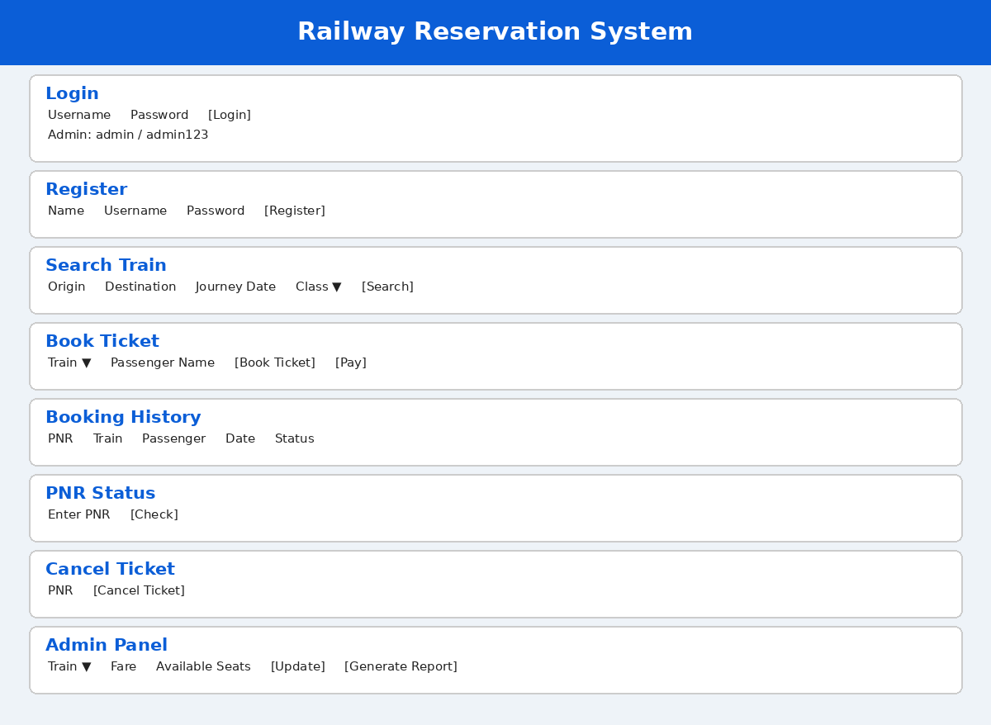

5. RESULT
Thus, the Railway Reservation System webpage was created using HTML, CSS, and JavaScript, with the main interface sections and basic interactive features included in the experiment.

