WEB TECHNOLOGY EXPERIMENT 5
FLIGHT RESERVATION SYSTEM
Name: Murshidha M
Register Number: 192571007
Course Code: CSA4302

1. AIM
To design a Flight Reservation System using HTML, CSS, and JavaScript. It includes login, registration, flight search, ticket booking, status checking, printing and cancellation, feedback, and an admin panel.

2. ALGORITHM
- Start.
- Create the webpage structure with HTML and apply CSS styling.
- Add login, registration, and forgot-password options.
- Create flight search fields for source, destination, date, and class.
- Add booking, ticket list, status, print, and cancellation sections.
- Store flight, user, feedback, and ticket details in JavaScript arrays.
- Write functions for login, registration, searching, booking, payment, and status checking.
- Add cancellation, refund calculation, feedback, and admin flight updates.
- Open the HTML file in a browser and test the interface.
- Stop.

3. HTML, CSS AND JAVASCRIPT CODE
Complete code from the supplied exp5.html file:

<!DOCTYPE html>
<html lang="en">
<head>
<meta charset="UTF-8">
<meta name="viewport" content="width=device-width,initial-scale=1">
<title>Flight Reservation System</title>
<style>
body{font-family:Arial;margin:0;background:#eef4fb}
header{background:#003366;color:#fff;padding:15px;text-align:center}
section{background:#fff;margin:15px;padding:15px;border-radius:8px}
input,select,button,textarea{padding:8px;margin:5px}
table{width:100%;border-collapse:collapse}
th,td{border:1px solid #999;padding:8px;text-align:center}
</style>
</head>
<body>
<header><h1>Online Flight Reservation System</h1></header>

<section>
<h2>Login</h2>
<input id="loginUser" placeholder="Username">
<input id="loginPass" type="password" placeholder="Password">
<button onclick="login()">Login</button>
<p><b>Admin:</b> admin / admin123</p>
<p><a href="#" onclick="alert('Demo: Password reset link sent.')">Forgot Password?</a></p>
</section>

<section>
<h2>Register</h2>
<input id="name" placeholder="Name">
<input id="user" placeholder="Username">
<input id="pass" type="password" placeholder="Password">
<button onclick="register()">Register</button>
</section>

<section>
<h2>Search Flight</h2>
<input id="from" placeholder="From">
<input id="to" placeholder="Destination">
<input id="travelDate" type="date">
<select id="flightClass">
<option>Economy</option>
<option>Premium Economy</option>
<option>Business</option>
<option>First Class</option>
</select>
<button onclick="searchFlight()">Search</button>
<p id="searchResult"></p>
</section>

<section>
<h2>Book Ticket</h2>
<select id="flightSelect">
<option>AI101</option>
<option>6E202</option>
<option>UK303</option>
</select>
<input id="passenger" placeholder="Passenger Name">
<input id="seat" placeholder="Seat (e.g. 12A)">
<button onclick="bookTicket()">Book Ticket</button>
<button onclick="payment()">Pay</button>
</section>

<section>
<h2>My Tickets</h2>
<button onclick="showTickets()">Refresh</button>
<table id="ticketTable">
<tr><th>Ticket</th><th>Flight</th><th>Passenger</th><th>Date</th><th>Status</th></tr>
</table>
</section>

<section>
<h2>View Booking Status</h2>
<input id="ticketNo" placeholder="Ticket Number">
<button onclick="status()">Check</button>
<p id="statusText"></p>
</section>

<section>
<h2>Print Ticket</h2>
<input id="printNo" placeholder="Ticket Number">
<button onclick="printTicket()">Print Ticket</button>
</section>

<section>
<h2>Cancel Ticket</h2>
<input id="cancelNo" placeholder="Ticket Number">
<button onclick="cancelTicket()">Cancel</button>
<p id="refund"></p>
</section>

<section>
<h2>Customer Feedback</h2>
<textarea id="feedback"></textarea><br>
<button onclick="addFeedback()">Submit</button>
<div id="feedbackList"></div>
</section>

<section>
<h2>Admin Panel</h2>
<select id="adminFlight">
<option>AI101</option>
<option>6E202</option>
<option>UK303</option>
</select>
<input id="fare" placeholder="Fare">
<input id="seats" placeholder="Seats">
<button onclick="updateFlight()">Update Flight</button>
<br><br>
<button onclick="report()">Admin Report</button>
<p id="reportText"></p>
</section>

<script>
let currentUser=null;
let users=[];
let feedbacks=[];
let flights=[
{name:"AI101",fare:5000,seats:80},
{name:"6E202",fare:4200,seats:70},
{name:"UK303",fare:6200,seats:50}
];
let tickets=[];

function register(){
users.push({name:name.value,username:user.value,password:pass.value});
alert("Registration Successful");
}
function login(){
if(loginUser.value==="admin"&&loginPass.value==="admin123"){currentUser="Admin";alert("Admin Login");return;}
let u=users.find(x=>x.username===loginUser.value&&x.password===loginPass.value);
if(u){currentUser=u.username;alert("Welcome "+u.name);}
else alert("Invalid Login");
}
function searchFlight(){
let f=flights.find(x=>x.name===flightSelect.value);
searchResult.innerHTML="Flight: "+f.name+"<br>Fare: ₹"+f.fare+"<br>Seats: "+f.seats+"<br>Class: "+flightClass.value;
}
function payment(){alert("Payment Successful (Demo)");}
function bookTicket(){
if(!currentUser||currentUser==="Admin"){alert("Login as User");return;}
let f=flights.find(x=>x.name===flightSelect.value);
if(f.seats<=0){alert("No seats available");return;}
f.seats--;
let id="FLT"+Math.floor(Math.random()*900000+100000);
tickets.push({id:id,user:currentUser,flight:f.name,passenger:passenger.value,date:travelDate.value,status:"Confirmed"});
alert("Booked! Ticket No: "+id);
}
function showTickets(){
ticketTable.innerHTML="<tr><th>Ticket</th><th>Flight</th><th>Passenger</th><th>Date</th><th>Status</th></tr>";
tickets.forEach(t=>{
if(currentUser==="Admin"||t.user===currentUser){
ticketTable.innerHTML+=`<tr><td>${t.id}</td><td>${t.flight}</td><td>${t.passenger}</td><td>${t.date}</td><td>${t.status}</td></tr>`;
}
});
}
function status(){
let t=tickets.find(x=>x.id===ticketNo.value);
statusText.innerHTML=t?"Status: "+t.status:"Ticket Not Found";
}
function printTicket(){
let t=tickets.find(x=>x.id===printNo.value);
if(t) window.print(); else alert("Ticket Not Found");
}
function cancelTicket(){
let i=tickets.findIndex(x=>x.id===cancelNo.value);
if(i!=-1){
let fare=flights.find(x=>x.name===tickets[i].flight).fare;
refund.innerHTML="Refund Amount: ₹"+(fare*0.75);
tickets.splice(i,1);
alert("Ticket Cancelled");
showTickets();
}else alert("Ticket Not Found");
}
function addFeedback(){
feedbacks.push(feedback.value);
feedbackList.innerHTML="";
feedbacks.forEach(f=>feedbackList.innerHTML+="<p>✈️ "+f+"</p>");
feedback.value="";
}
function updateFlight(){
let f=flights.find(x=>x.name===adminFlight.value);
f.fare=parseInt(fare.value)||f.fare;
f.seats=parseInt(seats.value)||f.seats;
alert("Flight Updated");
}
function report(){
reportText.innerHTML="Users: "+users.length+"<br>Bookings: "+tickets.length+"<br>Flights: "+flights.length+"<br>Feedback: "+feedbacks.length;
}
</script>
</body>
</html>

4. OUTPUT SCREENSHOT
Rendered preview based on the supplied HTML file. This is a recreated preview, not a direct screenshot captured from a browser.
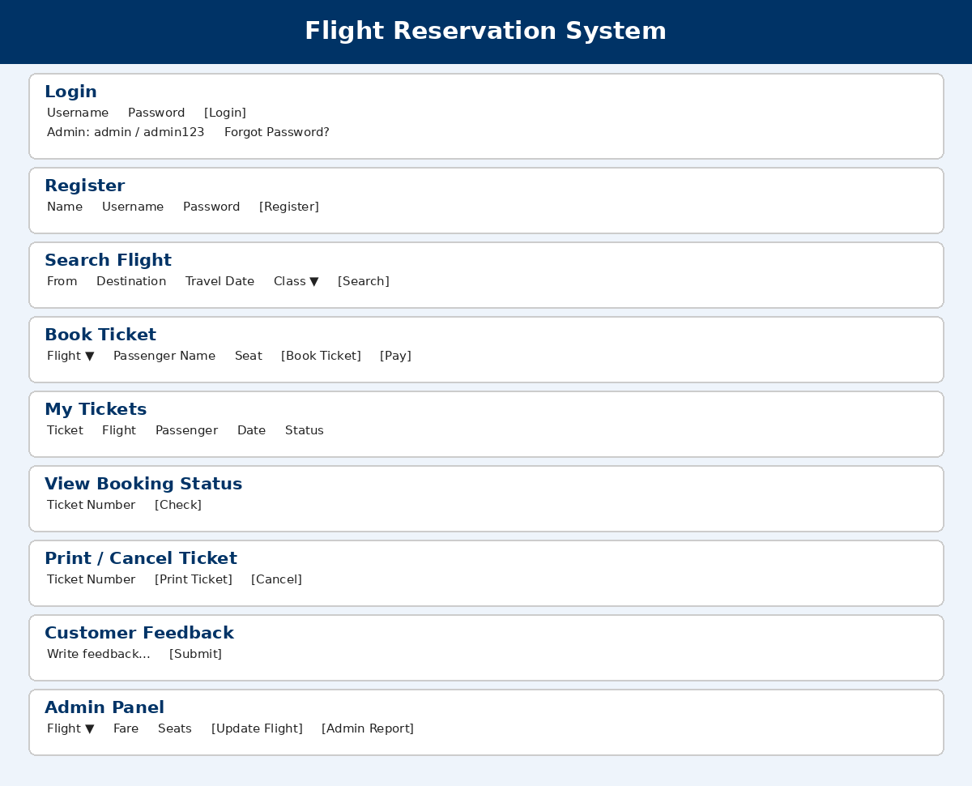

5. RESULT
Thus, the Flight Reservation System webpage was created using HTML, CSS, and JavaScript, with the main interface sections and basic interactive features included in the experiment.

