WEB TECHNOLOGY EXPERIMENT 6
CAKE ORDERING SYSTEM
Name: Murshidha M
Register Number: 192571007
Course Code: CSA4302

1. AIM
To create an Online Cake Ordering System using HTML, CSS, and JavaScript. It allows users to register, search and filter cakes, view descriptions, add cakes to a cart, save an address, place orders, track delivery, and manage products.

2. ALGORITHM
- Start.
- Create the webpage structure with HTML and CSS.
- Add login and registration forms.
- Create cake search and filter options by name, category, and price.
- Add cake description, size selection, message, and cart options.
- Create address, payment, order, order history, and tracking sections.
- Store cake, user, cart, and order details in JavaScript variables and arrays.
- Write functions for login, searching, viewing cake details, cart management, and order placement.
- Add order tracking and admin product/status updates.
- Open the HTML file in a browser and test the page.
- Stop.

3. HTML, CSS AND JAVASCRIPT CODE
Complete code from the supplied exp6.html file:

<!DOCTYPE html>
<html lang="en">
<head>
<meta charset="UTF-8">
<meta name="viewport" content="width=device-width,initial-scale=1">
<title>Cake Ordering System</title>
<style>
body{font-family:Arial;margin:0;background:#f8f3f6}
header{background:#c2185b;color:#fff;padding:15px;text-align:center}
section{background:#fff;margin:15px;padding:15px;border-radius:8px}
input,select,button,textarea{padding:8px;margin:5px}
table{width:100%;border-collapse:collapse}
th,td{border:1px solid #999;padding:8px;text-align:center}
</style>
</head>
<body>
<header><h1>Online Cake Ordering System</h1></header>

<section>
<h2>Login</h2>
<input id="loginUser" placeholder="Username">
<input id="loginPass" type="password" placeholder="Password">
<button onclick="login()">Login</button>
<p><b>Admin:</b> admin / admin123</p>
</section>

<section>
<h2>Register</h2>
<input id="name" placeholder="Name">
<input id="user" placeholder="Username">
<input id="pass" type="password" placeholder="Password">
<button onclick="register()">Register</button>
</section>

<section>
<h2>Search & Filter Cakes</h2>
<input id="search" placeholder="Search Cake">
<select id="category">
<option>Birthday</option><option>Wedding</option><option>Anniversary</option><option>Custom</option>
</select>
<select id="priceFilter">
<option>All</option><option>0-500</option><option>500-1000</option><option>1000+</option>
</select>
<button onclick="searchCake()">Search</button>
<p id="result"></p>
</section>

<section>
<h2>Cake Description</h2>
<select id="cakeSelect">
<option>Chocolate Cake</option>
<option>Vanilla Cake</option>
<option>Red Velvet</option>
<option>Black Forest</option>
</select>
<select id="size">
<option>0.5 Kg</option><option>1 Kg</option><option>2 Kg</option>
</select>
<input id="message" placeholder="Cake Message">
<button onclick="viewCake()">View Description</button>
<p id="description"></p>
<button onclick="addCart()">Add to Cart</button>
</section>

<section>
<h2>Shipping Address</h2>
<textarea id="address" placeholder="Enter Shipping Address"></textarea><br>
<button onclick="saveAddress()">Save / Update Address</button>
</section>

<section>
<h2>Place Order</h2>
<button onclick="payment()">Pay</button>
<button onclick="placeOrder()">Place Order</button>
</section>

<section>
<h2>My Orders</h2>
<button onclick="showOrders()">Refresh</button>
<table id="orders">
<tr><th>ID</th><th>Cake</th><th>Size</th><th>Status</th></tr>
</table>
</section>

<section>
<h2>Shipping Status</h2>
<input id="track" placeholder="Order ID">
<button onclick="trackOrder()">Track</button>
<p id="trackResult"></p>
</section>

<section>
<h2>Admin Panel</h2>
<input id="newCake" placeholder="Cake Name">
<input id="newPrice" placeholder="Price">
<input id="image" placeholder="Image File Name">
<textarea id="desc" placeholder="Description"></textarea><br>
<button onclick="addProduct()">Post Cake</button>
<br><br>
<input id="orderId" placeholder="Order ID">
<select id="status">
<option>Preparing</option>
<option>Shipped</option>
<option>Delivered</option>
</select>
<button onclick="updateStatus()">Update Order Status</button>
</section>

<script>
let currentUser=null;
let users=[];
let cart=[];
let cakes=[
{name:"Chocolate Cake",price:600,desc:"Rich chocolate cake."},
{name:"Vanilla Cake",price:500,desc:"Classic vanilla cake."},
{name:"Red Velvet",price:900,desc:"Cream cheese frosting."},
{name:"Black Forest",price:800,desc:"Chocolate & cherries."}
];
let orders=[];
let shippingAddress="";

function register(){users.push({name:name.value,username:user.value,password:pass.value});alert("Registered");}
function login(){
if(loginUser.value==="admin"&&loginPass.value==="admin123"){currentUser="Admin";alert("Admin Login");return;}
let u=users.find(x=>x.username===loginUser.value&&x.password===loginPass.value);
if(u){currentUser=u.username;alert("Welcome "+u.name);} else alert("Invalid Login");
}
function searchCake(){
let c=cakes.find(x=>x.name.toLowerCase().includes(search.value.toLowerCase()))||cakes[0];
result.innerHTML="Found: "+c.name+" | ₹"+c.price+" | Category: "+category.value;
}
function viewCake(){
let c=cakes.find(x=>x.name===cakeSelect.value);
description.innerHTML="<b>"+c.name+"</b><br>"+c.desc+"<br>₹"+c.price;
}
function addCart(){cart.push({cake:cakeSelect.value,size:size.value});alert("Added to Cart");}
function saveAddress(){shippingAddress=address.value;alert("Address Saved");}
function payment(){alert("Payment Successful (Demo)");}
function placeOrder(){
if(!currentUser||currentUser==="Admin"){alert("Login as User");return;}
if(cart.length==0){alert("Cart Empty");return;}
let item=cart.pop();
let id="ORD"+(orders.length+1);
orders.push({id:id,user:currentUser,cake:item.cake,size:item.size,status:"Preparing"});
alert("Order Placed. ID: "+id);
}
function showOrders(){
orders.innerHTML="<tr><th>ID</th><th>Cake</th><th>Size</th><th>Status</th></tr>";
let tbl=document.getElementById("orders");
tbl.innerHTML="<tr><th>ID</th><th>Cake</th><th>Size</th><th>Status</th></tr>";
ordersData=orders;
ordersData.forEach(o=>{
if(currentUser==="Admin"||o.user===currentUser){
tbl.innerHTML+=`<tr><td>${o.id}</td><td>${o.cake}</td><td>${o.size}</td><td>${o.status}</td></tr>`;
}
});
}
function trackOrder(){
let o=orders.find(x=>x.id===track.value);
trackResult.innerHTML=o?"Status: "+o.status:"Order Not Found";
}
function addProduct(){
cakes.push({name:newCake.value,price:newPrice.value,desc:desc.value,image:image.value});
alert("Cake Added");
}
function updateStatus(){
let o=orders.find(x=>x.id===orderId.value);
if(o){o.status=status.value;alert("Status Updated");showOrders();} else alert("Order Not Found");
}
</script>
</body>
</html>

4. OUTPUT SCREENSHOT
Rendered preview based on the supplied HTML file. This is a recreated preview, not a direct screenshot captured from a browser.
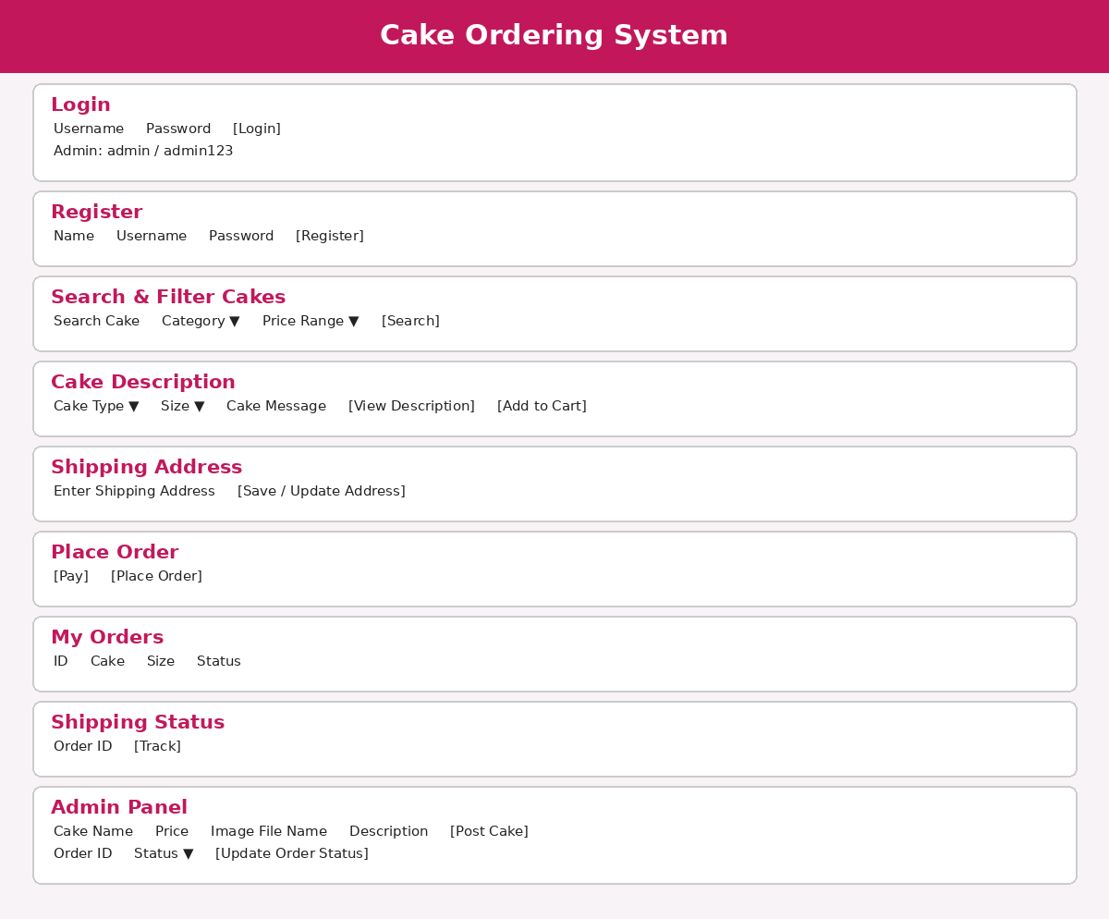

5. RESULT
Thus, the Cake Ordering System webpage was created using HTML, CSS, and JavaScript, with the main interface sections and basic interactive features included in the experiment.

