
Department of Computer Science and Engineering
Course Code & Name | CSA06 – Design and Analysis of Algorithms
Assessment | CO1 – Assessment Tool 1: IT Application-Based Problem Solving – Scalability Audit of an E-Commerce Platform
Course Outcome Assessed | Determine algorithm efficiency using asymptotic notations and mathematical techniques including Master Theorem and substitution method.
Duration | 3 Days
Mode | Individual  (githublink: https://github.com/192571027/CSA0607-)
Student Reg. No. | 192571027
Student Name | RITHIKA.G

Instructions: Answer all parts. Show the basic operation, every step of each derivation and the final asymptotic result, and interpret what each result means for the platform. Assume the platform’s servers execute 10⁸ basic operations per second.
IT APPLICATION-BASED PROBLEM
Scenario – Scalability Audit of “ShopSphere”, an Online Shopping Platform: ShopSphere is a growing e-commerce platform whose product catalogue currently holds n = 100,000 products and is expected to reach n = 1,000,000 within a year. Before the expansion, the CTO has asked you, as the platform’s algorithm engineer, to audit five back-end modules, predict how each will behave as n grows, and recommend which modules must be redesigned. The modules are described below.
Module M1 – Duplicate-Listing Detector: Sellers sometimes upload the same product twice. Every night, the following routine compares every product with every later product.
FOR i ← 0 TO n − 2 DO
FOR j ← i + 1 TO n − 1 DO
IF Product[i].title = Product[j].title AND Product[i].seller = Product[j].seller THEN
MarkDuplicate(j)
END IF
END FOR
END FOR

Module M2 – API Rate Limiter: The public API audits request windows of doubling size using the routine below. A team member claims that it is Θ(n log n) because the outer loop runs about log n times and the inner loop runs up to n times.
i ← 1
WHILE i < n DO
FOR j ← 0 TO i − 1 DO
Audit(Request[j]) // basic operation
END FOR
i ← i × 2
END WHILE

Module M3 – Product Search: Two versions exist. Version S1 scans the unsorted catalogue sequentially until the product is found. Version S2 searches a sorted product index by comparing the key with the middle entry and discarding half the index after each comparison; its comparison count satisfies T(n) = T(n/2) + 1, T(1) = 1.
Module M4 – Recommendation Engine: The engine splits the customer–product data into four parts of size n/2 (because of replicated partitions) and merges the partial results in linear time: T(n) = 4T(n/2) + n. A proposed redesign removes the replication, giving T(n) = 2T(n/2) + n.
Module M5 – Sales Analytics Engine: The analytics engine splits the sales data into halves recursively and sorts the records by revenue at every level, giving T(n) = 2T(n/2) + n log n. Separately, profiling shows that the nightly report generator performs f(n) = 3n² + 10n log₂ n + 50 operations.
(a) Understand the Problem: For each of the five modules, identify the input size and the basic operation that dominates the running time, explain where it occurs, and state how you expect its execution count to grow as n increases. Justify each choice briefly.
(b) Analyse the Iterative Modules: For M1, derive the exact number of comparisons as a function of n and state the time and space complexity. For M2, derive the exact number of Audit operations, decide whether the team member’s Θ(n log n) claim is correct and give the tight bound. Verify your M2 result for n = 1,024.
(c) Solve a Recurrence by Substitution: Solve the recurrence for search version S2 using backward substitution, showing every intermediate step, and derive the exact closed form. State the time complexity and the space complexity of both an iterative and a recursive implementation.
(d) Apply the Master Theorem: For M4, apply the Master Theorem to both the current design and the proposed redesign, clearly identifying a, b, f(n), n^(log_b a) and the case used, and explain what happens to the running time when the data doubles. For M5, determine whether any of the three standard cases applies to T(n) = 2T(n/2) + n log n; if not, derive the complexity using the extended Master Theorem or a recursion tree.
(e) Analyse Best, Average and Worst Cases: For search versions S1 and S2, identify the input condition that produces the best, average and worst case and give the number of comparisons in each. For S1, derive the average number of comparisons when the probability that the searched product exists is p, and evaluate it for n = 1,000,000 and p = 0.5.
(f) Prove an Asymptotic Bound: Using the formal definitions, prove that the report generator’s cost f(n) = 3n² + 10n log₂ n + 50 is Θ(n²) by finding constants c₁, c₂ and n₀, and show that f(n) is not O(n).
(g) Scalability Decision: Estimate the number of basic operations and the running time of M1, M2, S2, M4 (both designs) and M5 for n = 1,000,000. Identify the modules that will fail to meet a nightly processing window of 10 minutes, and recommend, with justification, which modules must be redesigned and how.
Rubrics – Application-Based Question
Criteria | Weightage (%) | Level 4 – Exemplary | Level 3 – Proficient | Level 2 – Developing | Level 1 – Beginning
Understanding of Problem Context | 20 | Clearly understands the problem and accurately identifies all requirements | Good understanding with minor gaps | Basic understanding; some requirements unclear | Poor understanding or misinterpretation of the problem
Application of Concepts | 30 | Accurately applies appropriate concepts to solve complex problems | Applies relevant concepts correctly with minor errors | Applies basic concepts with limited accuracy | Fails to apply appropriate concepts
Problem-Solving Approach | 20 | Logical, well-structured, and efficient approach | Mostly logical approach with minor gaps | Basic approach with some inconsistencies | Illogical or unclear approach
Accuracy of Solution | 20 | Completely correct solution with proper justification | Mostly correct with minor errors | Partially correct solution | Incorrect or incomplete solution
Clarity | 10 | Clear, well-organized, and properly explained solution | Understandable with minor clarity issues | Limited clarity and explanation | Poorly presented and difficult to understand

Mark Evaluation:
Criteria | Weightage (%) | Level 4 – Exemplary | Level 3 – Proficient | Level 2 – Developing | Level 1 – Beginning
Understanding of Problem Context | 20
Application of Concepts | 30
Problem-Solving Approach | 20
Accuracy of Solution | 20
Clarity | 10
Total Marks

Code of Conduct
I RITHIKA.G(192571027)_______ (Name / Reg. No.) certify that this submission is my original work and that I have adhered to the guidelines specified for this assessment. I understand that any violation of academic integrity rules will result in disciplinary action.
Signature of the Student: ____ Date: _11/09/2026_____________

Problem Statement and Scope
ShopSphere is a growing e-commerce platform whose product catalogue holds n = 100,000 products today and is expected to reach n = 1,000,000 within a year. As the platform's algorithm engineer, I audit five back-end modules (M1–M5, with M3 having two versions S1 and S2), predict how each behaves as n grows, and recommend which must be redesigned. The servers execute 10⁸ basic operations per second, and the nightly processing window is 10 minutes (6 × 10¹⁰ operations).
Every result below is derived by hand (basic operation → exact count → asymptotic bound → interpretation) and then verified by an instrumented Python program that executes the algorithms and counts the basic operations. Screenshots of the source code and the program output are included in the ‘Screenshots’ sections of this report.

Summary of results
Module | Exact count / recurrence solution | Time | Space
M1 Duplicate detector | n(n − 1)/2 comparisons | Θ(n²) | Θ(1)
M2 Rate limiter | 2^ceil(log₂ n) − 1 audits (n = 1024 → 1023) | Θ(n) (claim of Θ(n log n) is wrong) | Θ(1)
M3-S1 Sequential search | best 1, worst n, avg p(n+1)/2 + (1−p)n | Θ(n) | Θ(1)
M3-S2 Binary search | T(n) = 1 + log₂ n (floor(log₂ n) + 1 in general) | Θ(log n) | Iterative Θ(1); recursive Θ(log n)
M4 current | T(n) = 4T(n/2) + n → 2n² − n | Θ(n²) | —
M4 redesign | T(n) = 2T(n/2) + n → n(log₂ n + 1) | Θ(n log n) | —
M5 Sales analytics | T(n) = 2T(n/2) + n log n → n + n·L(L+1)/2 | Θ(n log² n) | —
Report generator | f(n) = 3n² + 10n log₂ n + 50 | Θ(n²), not O(n) | —

(a) Understanding the Problem – Input Size and Basic Operation
The input size is the quantity whose growth drives the running time; the basic operation is the statement executed most often, whose count determines the order of growth.
Module | Input size | Basic operation and where it occurs | Expected growth of its count
M1 Duplicate-Listing Detector | n = number of products | Comparison of Product[i] with Product[j] (title test, then seller test) in the IF statement of the inner loop. Executed once per pair (i, j) with i < j. The loop bodies contain nothing heavier; MarkDuplicate runs only on a match. | Quadratic – every product meets every later one, so doubling n quadruples the work.
M2 API Rate Limiter | n = upper limit on the request window (number of requests) | Audit(Request[j]) inside the inner FOR loop. The inner loop runs i times, and i doubles each outer iteration (1, 2, 4, …). | Linear – a geometric series dominated by its last term; not n log n, because the inner loop does not run n times in every outer iteration.
M3-S1 Sequential Search | n = number of products in the unsorted catalogue | Comparison of the search key with the current product while scanning. | Linear – up to n comparisons, about n/2 on average for a successful search.
M3-S2 Binary (index) Search | n = number of entries in the sorted index | Comparison of the key with the middle entry; each comparison discards half of the remaining index (T(n) = T(n/2) + 1). | Logarithmic – doubling n adds only one comparison.
M4 Recommendation Engine | n = size of the customer–product data | The linear-time merge of partial results at every node of the recursion (f(n) = n unit steps), plus the recursive calls (4 or 2 sub-problems of size n/2). | Current: quadratic (four half-size subproblems). Redesign: n log n (two half-size subproblems).
M5 Sales Analytics Engine | n = number of sales records | Record comparison made while sorting by revenue at each recursion level (f(n) = n log n at the top level). | Between n log n and n²; solved below as n log² n.
Nightly report generator | n = number of records processed | The dominant term of f(n) = 3n² + 10n log₂ n + 50 is the 3n² pairwise-style step; the n log n and constant terms are lower-order. | Quadratic.

(b) Analysis of the Iterative Modules

M1 – Duplicate-Listing Detector
Basic operation: one comparison of Product[i] with Product[j] (the IF test). For a fixed i the inner loop j = i+1 … n−1 runs n − 1 − i times, and i runs from 0 to n − 2.
C(n) = Σ (i = 0 to n−2) Σ (j = i+1 to n−1) 1
= Σ (i = 0 to n−2) (n − 1 − i)
= (n−1) + (n−2) + … + 2 + 1 (k = n − 1 − i)
= Σ (k = 1 to n−1) k
= (n − 1)·n / 2
= (n² − n) / 2

C(n) = n(n − 1)/2 comparisons; Time complexity Θ(n²); Space complexity Θ(1) auxiliary.
• Asymptotic form: n²/2 − n/2 ≤ n² for n ≥ 1 and ≥ n²/4 for n ≥ 2, so C(n) = Θ(n²). The count depends only on n (no early exit), hence best = average = worst case. (If both the title and seller fields are tested, at most 2 field comparisons occur per pair, which only changes the constant.)
• Space: only the loop counters i, j are needed – Θ(1) extra space (the catalogue itself, Θ(n), is the input and is not counted).
• Values: n = 100,000 → 4,999,950,000 comparisons (50.0 s); n = 1,000,000 → 499,999,500,000 comparisons (83.3 min). A 10× larger catalogue costs 100× more.

M2 – API Rate Limiter
Basic operation: Audit(Request[j]). The outer loop uses i = 1, 2, 4, …, 2ᵗ, … and continues while i < n. Let the loop run k times, i.e. i takes the values 2⁰, 2¹, …, 2^(k−1). The loop stops at the first power of two that is ≥ n, so k = ceil(log₂ n). In the iteration where i = 2ᵗ the inner loop runs i = 2ᵗ times.
A(n) = Σ (t = 0 to k−1) 2ᵗ
= 2⁰ + 2¹ + … + 2^(k−1)
= (2ᵏ − 1) / (2 − 1) (geometric series)
= 2^ceil(log₂ n) − 1

Bounding the closed form: since k = ceil(log₂ n), we have 2^(k−1) < n ≤ 2ᵏ. The right inequality gives A(n) = 2ᵏ − 1 ≥ n − 1. The left inequality (2^(k−1) ≤ n − 1 for integers) gives 2ᵏ ≤ 2n − 2, so A(n) ≤ 2n − 3.
n − 1 ≤ A(n) ≤ 2n − 3 for all n ≥ 2 ⇒ A(n) = Θ(n)

A(n) = 2^ceil(log₂ n) − 1 = Θ(n). Space complexity Θ(1).

Is the team member's Θ(n log n) claim correct?
No. The reasoning ‘the outer loop runs about log n times and the inner loop runs up to n times’ multiplies the worst case of each loop, but the inner loop only reaches n in the last iteration; in iteration t it runs 2ᵗ times. The total is a geometric series dominated by its largest term, giving about n to 2n operations, not n log n. The claim n log n is only a loose upper bound (A(n) = O(n log n) is true but not tight); the statement Θ(n log n) is false because A(n) ≤ 2n is far below c·n log n for large n. The tight bound is Θ(n).

Verification for n = 1,024
Outer iterations: i = 1, 2, 4, 8, 16, 32, 64, 128, 256, 512 → k = 10
(i = 1024 is not < 1024, so the loop stops)
Audits = 1 + 2 + 4 + 8 + 16 + 32 + 64 + 128 + 256 + 512 = 1,023 = 2¹⁰ − 1 OK
Claim n log₂ n = 1024 × 10 = 10,240 → about 10× too large

Verified by execution: the program counts exactly 1,023 Audit operations for n = 1024. For n = 1,000,000 it counts 1,048,575 (≈ 1.05 n).

(c) Solving a Recurrence by Substitution – Search Version S2
Recurrence: T(n) = T(n/2) + 1, T(1) = 1 (one comparison, then half of the index remains). Assume n = 2ᵏ.
T(n) = T(n/2) + 1
= [T(n/4) + 1] + 1 = T(n/4) + 2
= [T(n/8) + 1] + 2 = T(n/8) + 3
= [T(n/16) + 1] + 3 = T(n/16) + 4
⋮
= T(n/2ⁱ) + i (general pattern after i substitutions)

The recursion bottoms out when n/2ⁱ = 1, i.e. i = log₂ n. Substituting:
T(n) = T(1) + log₂ n = 1 + log₂ n

Proof by induction: T(1) = 1 + log₂ 1 = 1 OK. If T(n/2) = 1 + log₂(n/2) = log₂ n, then T(n) = T(n/2) + 1 = log₂ n + 1 OK. For arbitrary n the exact worst case is floor(log₂ n) + 1 (for n = 1,000,000 this is 20 comparisons).
Exact closed form: T(n) = 1 + log₂ n (floor(log₂ n) + 1 for general n) ⇒ Θ(log n).
Implementation | Time complexity | Space complexity | Reason
Iterative binary search | Θ(log n) (best Θ(1)) | Θ(1) | Only lo, hi and mid are stored; the index is searched in place.
Recursive binary search | Θ(log n) (best Θ(1)) | Θ(log n) | Each call adds a stack frame; the recursion depth is floor(log₂ n) + 1 (11 frames for n = 1024, 20 for n = 10⁶).
Interpretation: the product index can grow ten-fold (10⁵ → 10⁶) at a cost of only about 3.3 extra comparisons per search (17 → 20), which is why S2 is the right design for the live search path. The program confirms T(n) = 1 + log₂ n for n = 2⁰ … 2²⁰ and the recursion depth/worst case of 10 for n = 1,023.

(d) Applying the Master Theorem
Master Theorem for T(n) = a·T(n/b) + f(n), a ≥ 1, b > 1, with critical exponent n^(log_b a):
• Case 1: f(n) = O(n^(log_b a − ε)) for some ε > 0 ⇒ T(n) = Θ(n^(log_b a)).
• Case 2: f(n) = Θ(n^(log_b a)) ⇒ T(n) = Θ(n^(log_b a) · log n).
• Case 3: f(n) = Ω(n^(log_b a + ε)) and a·f(n/b) ≤ c·f(n) for some c < 1 ⇒ T(n) = Θ(f(n)).

M4 – Recommendation Engine
 | a | b | f(n) | n^(log_b a) | Comparison | Case | Result
Current: 4T(n/2) + n | 4 | 2 | n | n^(log₂ 4) = n² | f = n = O(n^(2−ε)), ε = 1 | 1 | Θ(n²)
Redesign: 2T(n/2) + n | 2 | 2 | n | n^(log₂ 2) = n | f = n = Θ(n) | 2 | Θ(n log n)

Both designs have been solved exactly as well (T(1) = 1, n = 2ᵏ):
Current : T(n) = 4T(n/2) + n = 2n² − n (check: T(2) = 4 + 2 = 6 = 2·4 − 2 OK)
Redesign: T(n) = 2T(n/2) + n = n(log₂ n + 1) (check: T(2) = 2 + 2 = 4 = 2·(1+1) OK)

What happens when the data doubles?
Current : T(2n)/T(n) = (8n² − 2n)/(2n² − n) = 4 + 2/(2n − 1) → 4
Redesign: T(2n)/T(n) = 2n(log₂ n + 2) / n(log₂ n + 1) = 2(L + 2)/(L + 1) → 2 (≈ 2.095 at n = 2²⁰)

Current design: doubling the data multiplies the running time by 4 (Θ(n²)). Redesign: doubling multiplies it by only slightly more than 2 (Θ(n log n)). At n = 10⁶ the redesign needs about 2.1 × 10⁷ operations versus 2 × 10¹² for the current design – roughly 95,000 times fewer.

M5 – Sales Analytics Engine: T(n) = 2T(n/2) + n log n
a = 2, b = 2, f(n) = n log n, n^(log_b a) = n^(log₂ 2) = n

Do the three standard cases apply?
• Case 1: needs f(n) = O(n^(1−ε)). But f(n) = n log n grows faster than n, so it fails.
• Case 2: needs f(n) = Θ(n). But n log n / n = log n → ∞, so f is not Θ(n); it fails.
• Case 3: needs f(n) = Ω(n^(1+ε)) for a fixed ε > 0. But f(n)/n^(1+ε) = log n / n^ε → 0 for every ε > 0, so f is larger than n only by a log factor, not polynomially; it fails (the regularity condition is not even reached).
Conclusion: none of the three standard cases applies – f(n) lies in the gap between Case 2 and Case 3. The extended Master Theorem (or a recursion tree) is needed.

Extended Master Theorem
If f(n) = Θ(n^(log_b a) · logᵏ n) with k ≥ 0, then T(n) = Θ(n^(log_b a) · log^(k+1) n). Here f(n) = n log n = Θ(n · log¹ n), so k = 1:
T(n) = Θ(n · log^(1+1) n) = Θ(n log² n)

Verification by recursion tree
Let L = log₂ n. Level i (i = 0 … L−1): 2ⁱ sub-problems of size n/2ⁱ
cost per sub-problem = (n/2ⁱ)·log₂(n/2ⁱ) = (n/2ⁱ)(L − i)
cost of level i = 2ⁱ · (n/2ⁱ)(L − i) = n(L − i)
Internal levels: n · Σ (L − i) = n · (L + (L−1) + … + 1) = n·L(L+1)/2
Leaves: n sub-problems of size 1, each T(1) = 1 → n
T(n) = n + n·L(L+1)/2 = n + n·log₂ n·(log₂ n + 1)/2

T(n) = Θ(n log² n); the program's direct evaluation of the recurrence equals n + nL(L+1)/2 exactly (e.g. n = 16 → 176) and T(n)/(n log² n) settles near 0.5.

(e) Best, Average and Worst Case Analysis – S1 and S2

S1 – Sequential search (unsorted catalogue)
Case | Input condition | Comparisons
Best | Searched product is the first item scanned | 1 → Θ(1)
Worst | Searched product is the last item, or is absent | n → Θ(n)
Average (successful) | Product present, equally likely at each of n positions | (n + 1)/2 → Θ(n)
Average (unsuccessful) | Product absent | n

Average with probability p that the product exists. If it exists, position i (1 … n) is equally likely, costing i comparisons; if absent, all n items are compared.
A(n, p) = p · [ (1/n) Σ (i=1..n) i ] + (1 − p) · n
= p · (n + 1)/2 + (1 − p) · n
= n − p·n/2 + p/2 = n(1 − p/2) + p/2

Evaluation for n = 1,000,000 and p = 0.5:
A = 0.5 × (1,000,001 / 2) + 0.5 × 1,000,000
= 0.5 × 500,000.5 + 500,000
= 250,000.25 + 500,000 = 750,000.25 comparisons

A(1,000,000, 0.5) = 750,000.25 comparisons (≈ 7.5 ms at 10⁸ comparisons/s). Boundary checks: p = 1 → (n+1)/2; p = 0 → n.

S2 – Binary search (sorted index)
Case | Input condition | Comparisons
Best | Key equals the middle entry of the whole index | 1 → Θ(1)
Average | Key present, all positions equally likely (most keys sit in the lowest tree levels) | ≈ log₂ n − 1 → Θ(log n) (18.95 measured for n = 10⁶)
Worst | Key found only at the last level, or absent | floor(log₂ n) + 1 → Θ(log n) (20 for n = 10⁶)
Average reasoning: the comparison tree has 2^(j−1) keys at level j, so for n = 2ᵏ − 1 the average successful search costs Σ j·2^(j−1) / n = ((k − 1)2ᵏ + 1)/n ≈ log₂ n − 1. The program measured 18.951 comparisons averaged over all 10⁶ keys.
Interpretation: S1 needs about 750,000 comparisons per lookup at p = 0.5, S2 needs at most 20 – around 37,500 times fewer on average – at the price of keeping the index sorted.

(f) Proof of an Asymptotic Bound – Report Generator
Claim: f(n) = 3n² + 10n log₂ n + 50 = Θ(n²). By definition we must find constants c₁, c₂ > 0 and n₀ such that c₁n² ≤ f(n) ≤ c₂n² for all n ≥ n₀.

Lower bound (f(n) = Ω(n²))
For n ≥ 1, log₂ n ≥ 0, so 10n log₂ n ≥ 0 and 50 > 0. Therefore f(n) ≥ 3n². Take c₁ = 3.

Upper bound (f(n) = O(n²))
For n ≥ 1: log₂ n ≤ n, hence 10n log₂ n ≤ 10n²; and 50 ≤ 50n². Therefore
f(n) = 3n² + 10n log₂ n + 50 ≤ 3n² + 10n² + 50n² = 63n²

Constants: c₁ = 3, c₂ = 63, n₀ = 1 ⇒ 3n² ≤ f(n) ≤ 63n² for all n ≥ 1, hence f(n) = Θ(n²).
A tighter pair also works: c₁ = 3, c₂ = 4, n₀ = 60, because 10n log₂ n + 50 ≤ n² once n ≥ 60 (at n = 60: 3,594 ≤ 3,600; at n = 59 it fails: 3,521 > 3,481, so n₀ = 60 is the smallest). The program checks both pairs numerically up to n = 20,000.

f(n) is not O(n)
Suppose f(n) = O(n). Then there exist c > 0 and n₁ such that f(n) ≤ c·n for all n ≥ n₁. But f(n) ≥ 3n², so 3n² ≤ c·n, i.e. n ≤ c/3 for every n ≥ n₁. This is false for any n > max(n₁, c/3) – a contradiction. Equivalently, f(n)/n ≥ 3n → ∞. Hence f(n) ∉ O(n).
Numerical check (program): f(n)/n² → 3.0002 at n = 10⁶ (bounded), while f(n)/n = 3,000,199 grows without bound. For c = 10⁶ the first violation is n = 333,334, where f(n) = 333,395,822,203 > c·n = 333,334,000,000.

(g) Scalability Decision for n = 1,000,000
Assumptions: 10⁸ basic operations per second; nightly window 10 min = 600 s = 6 × 10¹⁰ operations. Operation counts use the exact closed forms from parts (b)–(f); the logarithm is base 2 (log₂ 10⁶ ≈ 19.93).
Module | Complexity | Operations | Time | 10-min window
M1 Duplicate detector | Θ(n²) | 4.99999 × 10¹¹ | 83.3 min | FAIL
M2 Rate limiter | Θ(n) | 1,048,575 | 10.5 ms | PASS
S2 Binary search (per query) | Θ(log n) | 20 | 0.2 µs | PASS
M4 current (2n² − n) | Θ(n²) | 2.0 × 10¹² | 5.56 h | FAIL
M4 redesign (n(log n + 1)) | Θ(n log n) | 2.09 × 10⁷ | 209 ms | PASS
M5 Sales analytics | Θ(n log² n) | 2.10 × 10⁸ | 2.10 s | PASS
Report generator f(n) | Θ(n²) | 3.0 × 10¹² | 8.33 h | FAIL

Growth from n = 100,000 to n = 1,000,000 (10× catalogue)
Module | Operations at 10⁵ | Operations at 10⁶ | Growth factor
M1 | 4,999,950,000 | 499,999,500,000 | 100×
M2 | 131,071 | 1,048,575 | 8×
M4 current | 19,999,900,000 | 1,999,999,000,000 | 100×
M4 redesign | 1,760,964 | 20,931,569 | 11.9×
M5 | 14,724,490 | 209,599,497 | 14.2×
Report generator | 30,016,609,690 | 3,000,199,315,736 | 100×

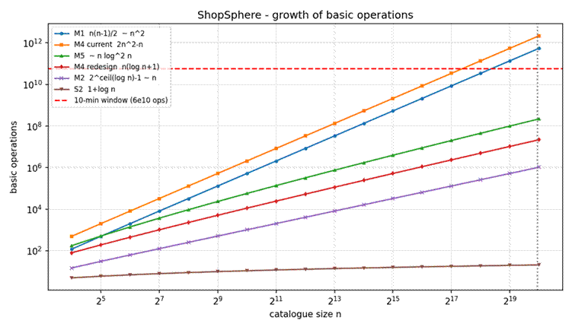
Figure 1 – Growth of basic operations against catalogue size (log–log axes); the red line is the 10-minute window.

Modules that fail the 10-minute window
• M1 Duplicate-Listing Detector – ≈ 5 × 10¹¹ operations, 83 min: 8.3× over the 10-minute budget.
• M4 Recommendation Engine (current design) – ≈ 2 × 10¹² operations, 5.6 h: 33× over the budget.
• Nightly report generator – ≈ 3 × 10¹² operations, 8.3 h: also quadratic and also fails, so it should be redesigned alongside M1 and M4.
M2 (10 ms), S2 (0.2 µs per query), the M4 redesign (0.21 s) and M5 (2.1 s) all finish far inside the window; at n = 10⁶ M5's Θ(n log² n) is acceptable.

Recommendations
• Redesign M1 (Θ(n²) → Θ(n) expected or Θ(n log n)). Build a hash set keyed on (normalised title, seller) and flag a product as a duplicate when its key is already present: one pass, about n operations (≈ 10 ms), at the cost of Θ(n) extra memory. If memory is tight, sort by the (title, seller) key (Θ(n log n) ≈ 2.1 × 10⁷ operations ≈ 0.21 s) and compare only neighbours. Either option also makes the nightly job incremental (check only newly uploaded listings).
• Redesign M4: remove the replication-driven fourth sub-problem. The proposed T(n) = 2T(n/2) + n design is Θ(n log n) and cuts the cost from 2 × 10¹² to 2.1 × 10⁷ operations (5.56 h → 0.21 s). Fault-tolerance can be kept at the storage layer (replicated copies of the data) instead of replicating the computation.
• Redesign the report generator (Θ(n²)). Identify the quadratic step and replace it with sorting/hash-based aggregation (Θ(n log n) or Θ(n)); at 8.3 h it cannot fit any nightly window.
• Keep S2 and retire S1 for live search. S1 averages 750,000 comparisons per lookup (p = 0.5) versus at most 20 for S2; maintain the sorted (or hash) index incrementally.
• Keep M2; optionally optimise M5. M5 is fine at 2.1 s; sorting once with a Θ(n log n) merge sort instead of re-sorting at every level would bring it to Θ(n log n) if the catalogue grows well beyond 10⁶.

Implementation and Execution
Language: Python 3 (standard library only; matplotlib is optional and used only for Figure 1). File: Source_Code/shopsphere_audit.py.
• Each module is implemented as in the question and instrumented to return its basic-operation count: m1_duplicate_detector, m2_rate_limiter, s1_sequential_search, s2_binary_search_iter and s2_binary_search_rec.
• The recurrences T_s2, T_m4_cur, T_m4_new and T_m5 are evaluated directly for n = 2ᵏ and compared with the closed forms derived above.
• Parts (b)–(g) each have a function (part_b … part_g) that prints measured-versus-derived values; part_g prints the scalability table with PASS/FAIL against the 6 × 10¹⁰ operation window.
How to run:
cd CO1_AT1/Question_1/Source_Code
python shopsphere_audit.py # prints all results, saves ../Supporting_Files/growth_chart.png

Verification summary
• M1: measured n(n−1)/2 exactly for n = 5, 10, 100, 500, 1000; duplicate demo flags the repeated listing.
• M2: measured 2^ceil(log₂ n) − 1 for every tested n, including 1,023 audits at n = 1,024 and 1,048,575 at n = 10⁶.
• S2: recurrence equals 1 + log₂ n for n = 2⁰ … 2²⁰; the worst case and recursion depth at n = 1,023 are both 10.
• M4/M5: recurrences equal 2n² − n, n(log₂ n + 1) and n + nL(L+1)/2 exactly; doubling ratios are 4.00 and ≈ 2.1.
• S1: Monte-Carlo estimate (n = 2000, p = 0.5, 60,000 trials) 1,501.6 against formula 1,500.2.

Screenshots of the Source Code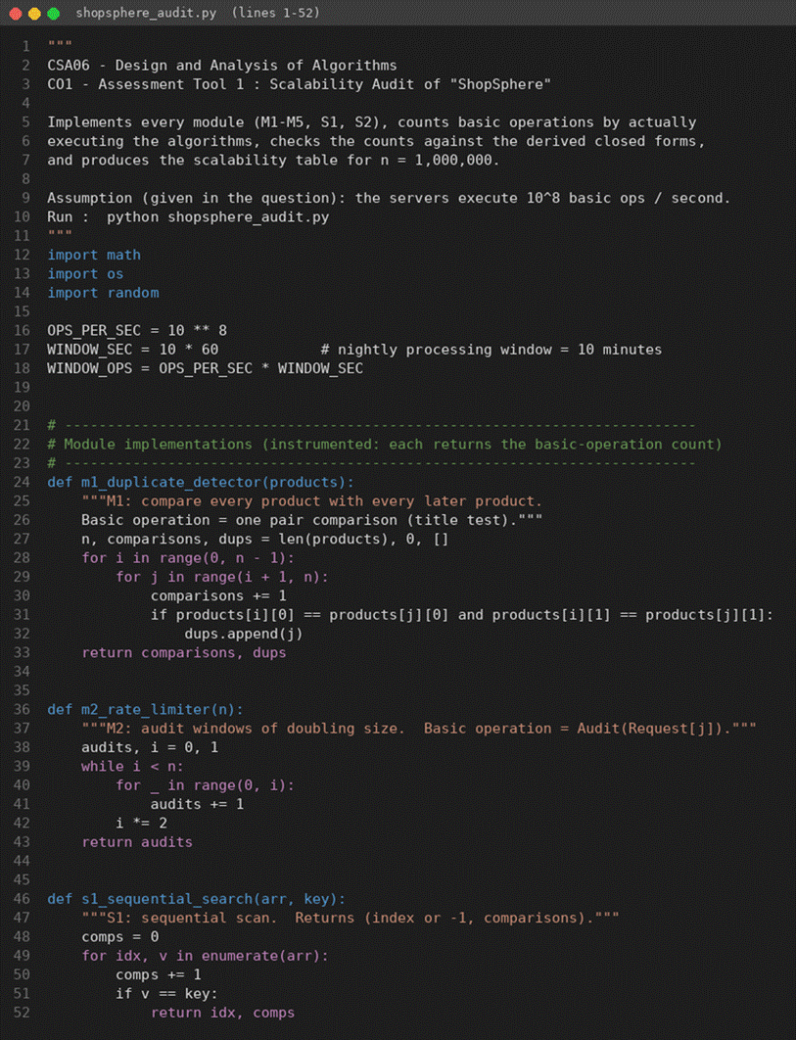
Screenshot 1 – Source code (shopsphere_audit.py), part 1 of 7
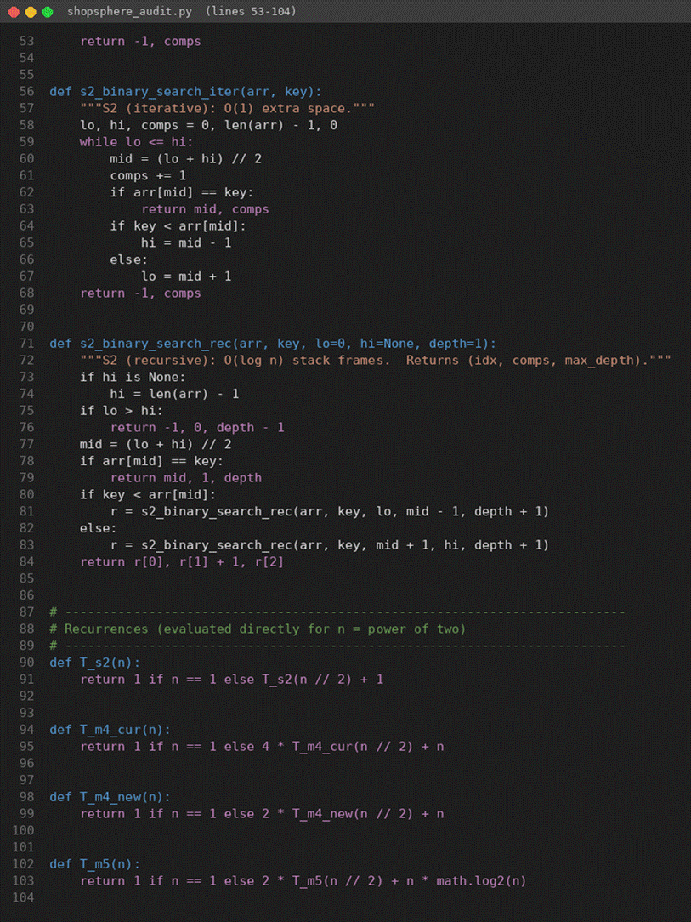
Screenshot 2 – Source code (shopsphere_audit.py), part 2 of 7
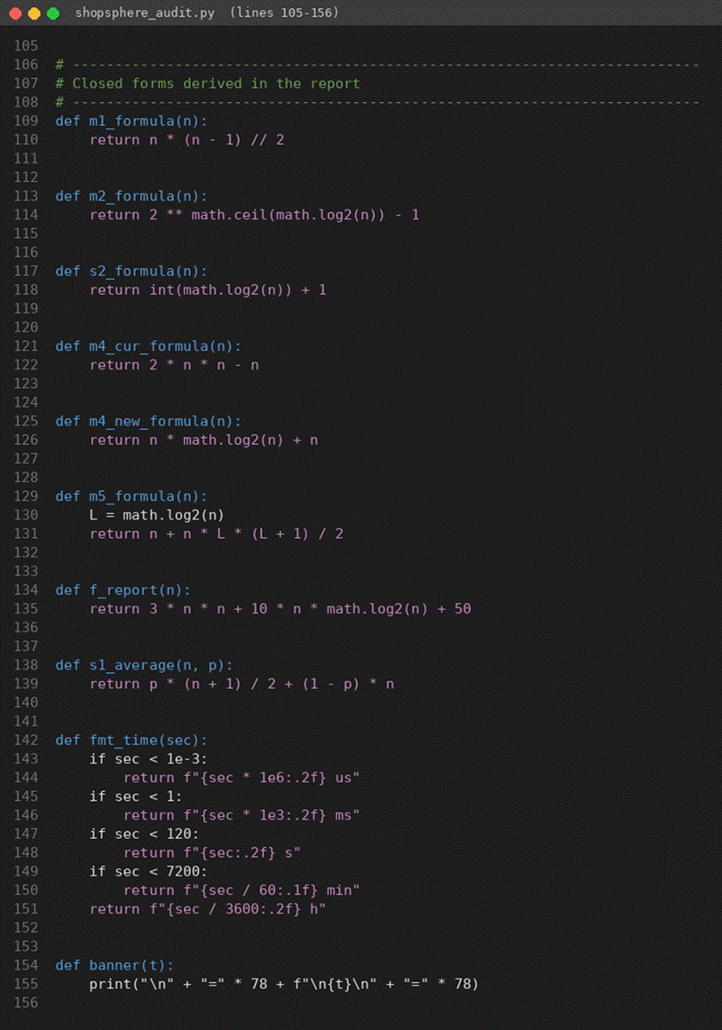
Screenshot 3 – Source code (shopsphere_audit.py), part 3 of 7
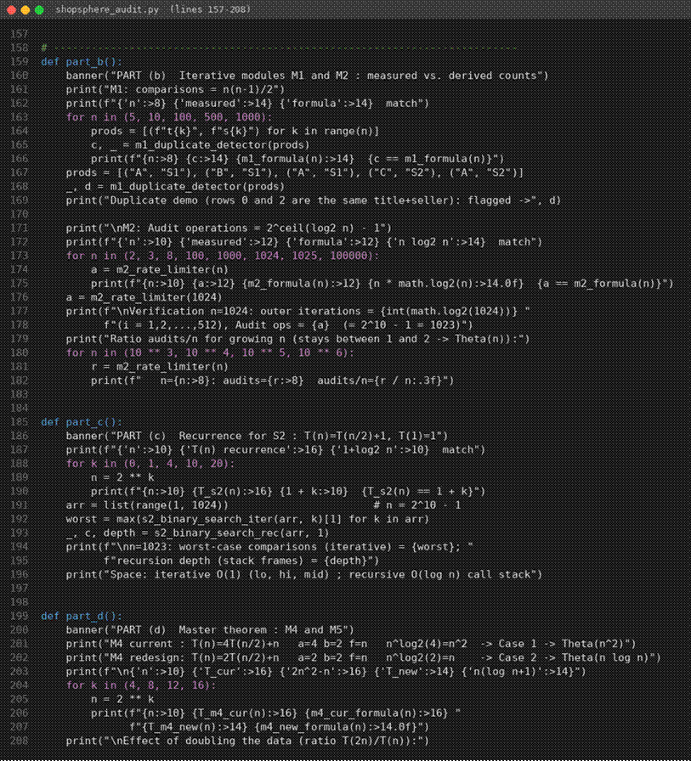
Screenshot 4 – Source code (shopsphere_audit.py), part 4 of 7
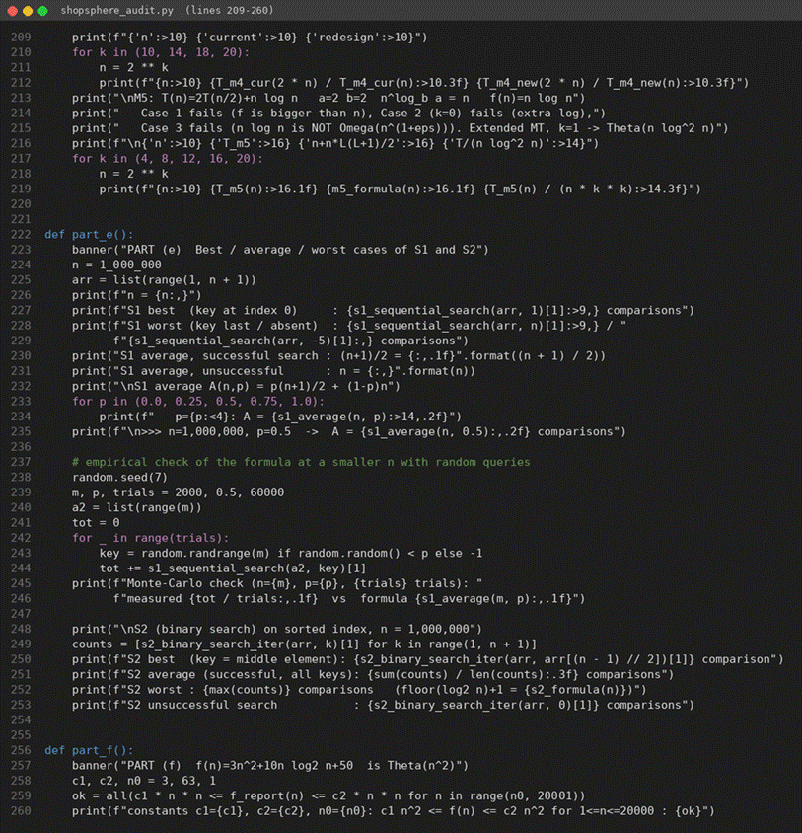
Screenshot 5 – Source code (shopsphere_audit.py), part 5 of 7
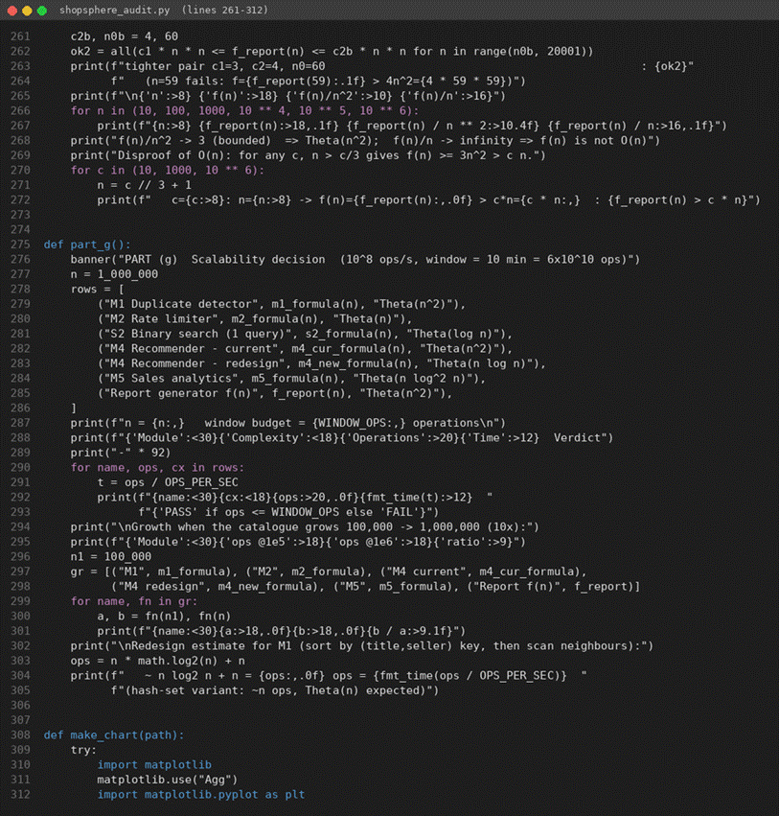
Screenshot 6 – Source code (shopsphere_audit.py), part 6 of 7
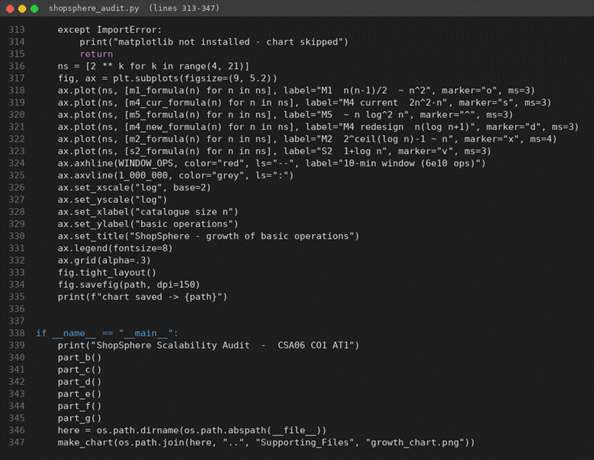
Screenshot 7 – Source code (shopsphere_audit.py), part 7 of 7

Screenshots of the Program Output
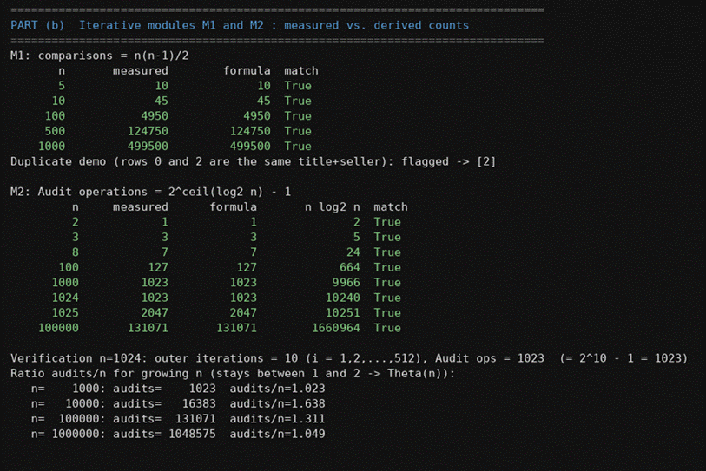
Output – part (b): M1 and M2 measured vs. derived counts, n = 1,024 verification
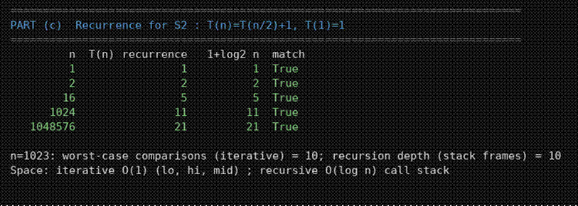
Output – part (c): S2 recurrence verification and space usage
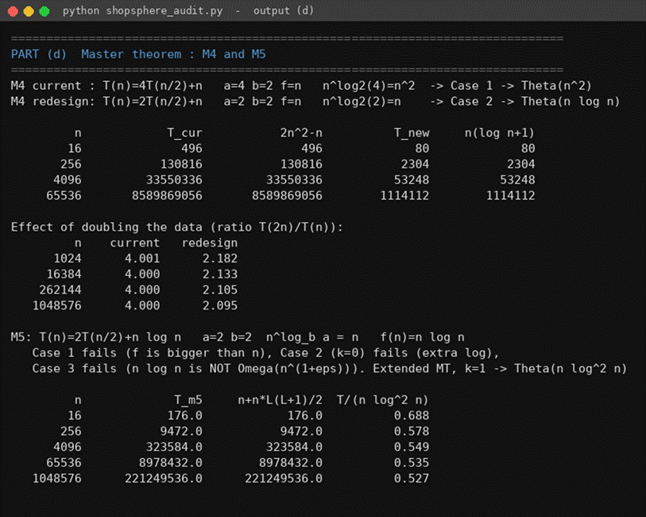
Output – part (d): Master Theorem cases, exact solutions, doubling ratios
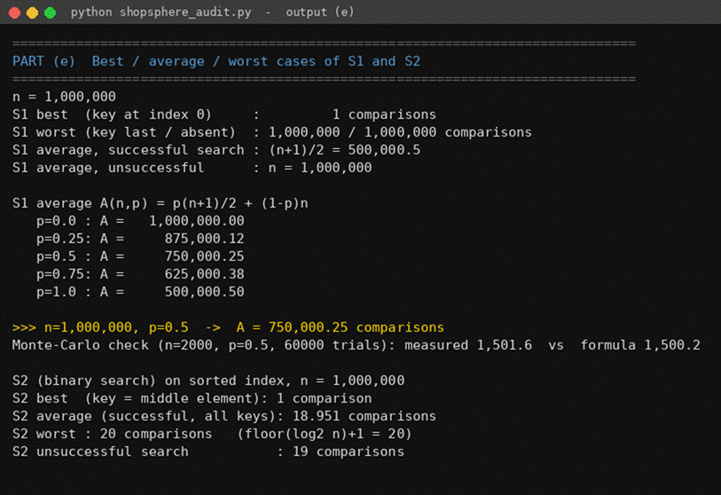
Output – part (e): best/average/worst cases, S1 average for n = 10⁶, p = 0.5
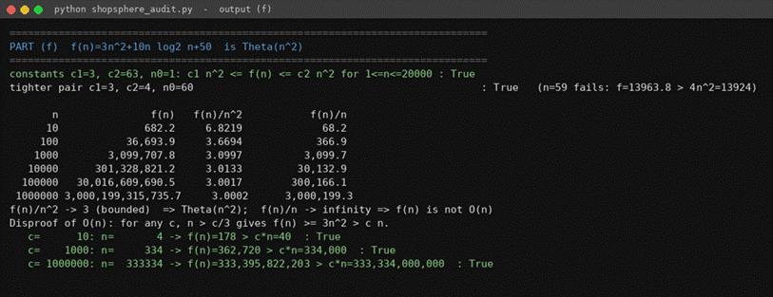
Output – part (f): Θ(n²) constants and non-O(n) check
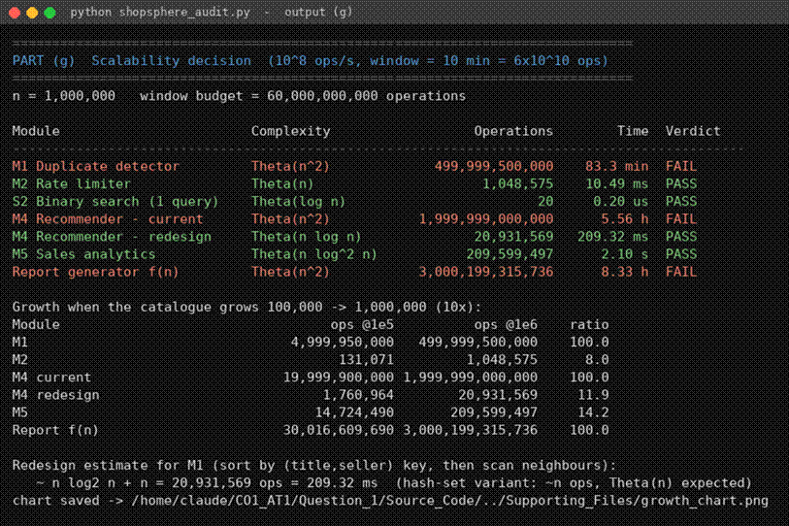
Output – part (g): scalability table and growth factors

Conclusion
At the projected catalogue size of one million products, three components do not fit the 10-minute nightly window: the duplicate detector M1 (Θ(n²), 83 min), the current recommendation engine M4 (Θ(n²), 5.6 h) and the report generator (Θ(n²), 8.3 h). The rate limiter M2 is linear – not n log n as claimed – and, together with binary search S2, the redesigned M4 and the analytics engine M5 (Θ(n log² n)), it scales comfortably. The three quadratic modules should be redesigned to Θ(n) or Θ(n log n) before the expansion; the single most effective changes are hashing the (title, seller) key in M1 and adopting the non-replicated divide-and-conquer design in M4.

