ASSIGNMENT SOLUTION
OPERATING SYSTEMS
Course Code: CSA0402 | Covering CO2, CO3 & CO4

Design and Analysis of an OS Resource Orchestration System for a Smart University — "UniCore" Computing Platform

Department | Computer Science and Engineering
Programme | B.E. / B.Tech – CSE
Course Code &Course Name | Course Code &amp; Course Name CSA04 – Operating Systems
Academic Year / Batch | 2025– 2029
Faculty Name | Dr J Priskilla Angel Rani
Assignment Title | Design and Analysis of an OS Resource Orchestration System for a Smart University
Date of Issue | 25-08-26
Date of Submission | 28-08-26
Maximum Marks | 100
Course Outcome(s) – CO | CO2, CO3, CO4
Bloom’s Taxonomy Level | L3 – Apply, L4 – Analyse, L5 – Evaluate
SDG Mapping | SDG 7 – Affordable and Clean Energy; SDG 9 – Industry, Innovation and Infrastructure; SDG 11 – Sustainable Cities and Communities
Industry / Societal Relevance | Efficient OS resource management is fundamental to cloud platforms, university servers, digital public services and energy-aware computing.
GITHUB LINK | https://github.com/192571027/os-assignment

SUBMITTED BY:
NAME:RITHIKA G
REG NO:192571027

Problem Understanding and Formulation

Restatement of the Problem
UniCore is the shared computing backbone of a smart university. During a normal day it serves roughly 500 concurrent users; during examination windows this rises past 800. Six service classes compete for the same finite pool of CPU time, physical memory, files and I/O devices: online examinations (latency-sensitive), digital classrooms (interactive streaming), library access (bursty, read-heavy), research computing (long CPU-bound jobs), automated backups (long, background, disk-heavy) and IoT monitoring (frequent, small, periodic requests). The task is to design one coherent resource-management strategy — spanning process scheduling, synchronization/deadlock handling, memory paging and file/disk management — that keeps the system responsive and safe under this mixed load, and to validate that strategy quantitatively rather than by assertion.

Challenges Identified per Subsystem
    - CPU / process management: interactive exam sessions need low response time, while research and backup jobs are long and CPU-bound; a single scheduling policy must not starve either class.
    - Synchronization & deadlock: many processes read and write shared examination records, logs and lock tokens (database locks, file locks, print tokens, network channels) concurrently; unsafe simultaneous requests can deadlock the platform.
    - Memory management: many services run at once inside 16 GB of physical RAM; without care, this causes excessive page faults and thrashing, especially at 800-user exam peaks.
    - File systems: file sizes range from a few-KB student record to multi-GB lecture recordings, each with a different access pattern (random vs. sequential), and files are created/deleted continuously.
    - Disk scheduling: examination periods generate bursts of concurrent I/O requests across the whole 200-cylinder disk; naive servicing order wastes seek time and can starve distant requests.

Expected Outcomes
    - A CPU-scheduling policy with quantified, low average waiting/response time for interactive services.
    - A demonstrably deadlock-free resource-request protocol (Banker's Algorithm) with a documented safe sequence.
    - A memory design that minimises page faults for a realistic reference pattern and controls thrashing.
    - A file-allocation strategy matched to each file category, with fragmentation kept low.
    - A disk-scheduling policy that minimises total head movement while remaining reasonably fair to distant requests.

Assumptions (stated and justified)

Parameter | Assumed Value | Justification
Workload size | 8 representative processes (one per major UniCore service) and 4 shared resource types | Meets the ≥ 8 processes / ≥ 4 resource types constraint in Section D while remaining traceable by hand.
Physical memory | 16 GB RAM, 4 KB page size | Directly stated in Section D of the brief.
Logical address space | 64 MB per process | A representative mid-size service process; large enough to require a non-trivial page table.
Disk geometry | 200 cylinders (0–199), 10 pending requests, head starts at cylinder 50 | Matches the ≥ 10-request, 200-cylinder requirement in Section D.

File system | 40-block illustrative disk for the file-allocation simulator | Large enough to host 8 representative files (small/medium/large) while keeping the block table readable.
Resource units | Exam-DB-Lock=3, File-Lock=3, Print-Token=2, Network-Channel=2 total instances | Small enough that safe/unsafe states can be verified by hand and cross-checked against the program output.

Constraints Carried Forward from Section D
    - No race-condition-induced corruption of shared examination records, logs or files.
    - Every resource request must be checked for a safe state before being granted (avoidance, not just detection).
    - Page-fault rate and disk-head movement must be minimised without starving any request class.
    - Per-user file-block mappings must not be exposed across users (ownership/isolation preserved).
    - Implementation uses open-source tooling (Python) so it can be inspected, re-run and version-controlled.

Application of Course Knowledge (CO2, CO3, CO4)

Part I – Process Management, Synchronization & Deadlock (CO2)

Shared Examination-Record Access — Readers–Writers Model
Examination records are read frequently (progress dashboards, invigilator views) and written occasionally (answer submission, grading). This is modelled as the classical Readers–Writers problem with writer priority disabled to avoid starving readers, but bounded so writers are not starved either (a fair/queued variant).
Semaphore-based pseudocode:
semaphore rw_mutex = 1
semaphore mutex = 1
semaphore queue = 1 int read_count = 0
// controls exclusive access for a writer
// protects read_count
// FIFO fairness gate (prevents writer starvation)
Reader():
wait(queue)
wait(mutex)
read_count++
if read_count == 1: wait(rw_mutex) signal(mutex)
signal(queue)
... read the exam record ... wait(mutex)
read_count--
if read_count == 0: signal(rw_mutex) signal(mutex)
// first reader locks out writers
// last reader unlocks writers
Writer():
wait(queue)
wait(rw_mutex) signal(queue)
... write the exam record ... signal(rw_mutex)
Fig. 1 — Semaphore protocol for shared exam-record access

The queue semaphore forces readers and writers to acquire access in arrival order, so a steady stream of readers cannot indefinitely delay a pending writer (bounded waiting). rw_mutex guarantees mutual exclusion between any writer and all readers/other writers, which is exactly the race condition UniCore must avoid on shared examination data.

Banker's Algorithm — Deadlock Avoidance
Four representative processes (P0–P3, one exam service, one classroom service, one library service and one backup service) share four resource types: A = Exam-DB-Lock, B = File-Lock, C = Print-Service-Token, D = Network-I/O-Channel, with total instances [3, 3, 2, 2].

Process | Allocation A B C D | Max A B C D | Need A B C D
P0 | 0 1 0 0 | 1 2 0 1 | 1 1 0 1
P1 | 1 0 1 1 | 2 1 2 1 | 1 1 1 0
P2 | 1 1 0 0 | 2 2 1 1 | 1 1 1 1
P3 | 0 0 1 0 | 1 1 1 1 | 1 1 0 1
Available = Total − ΣAllocation = [3,3,2,2] − [2,2,2,1] = [1, 1, 0, 1].

Safety Algorithm Trace
    - Work = [1,1,0,1]. Need(P0)=[1,1,0,1] ≤ Work → grant → Work += Alloc(P0) = [1,2,0,1].
    - Need(P3)=[1,1,0,1] ≤ Work → grant → Work += Alloc(P3) = [1,2,1,1].
    - Need(P1)=[1,1,1,0] ≤ Work → grant → Work += Alloc(P1) = [2,2,2,2].
    - Need(P2)=[1,1,1,1] ≤ Work → grant → Work += Alloc(P2) = [3,3,2,2] = Total ✓
Safe sequence: ⟨ P0, P3, P1, P2 ⟩ — the system is in a SAFE state.

An Additional Request That Produces an Unsafe State
Two follow-on requests illustrate how the allocator must respond, both verified by the program in Section 4:
    - Request 1 — P2 asks for 1 unit of C (Print-Token). Available C = 0, so Request ≰ Available: the request cannot be granted immediately regardless of safety; P2 is queued and must wait.
    - Request 2 — P1 asks for 1 unit of B (File-Lock). This passes both Request ≤ Need and Request ≤ Available, so it is tentatively granted: Available becomes [1,0,0,1]. Re-running the safety algorithm from this state finds that no remaining process's Need is ≤ Work — every process is blocked on resource C or B. The state is UNSAFE, so the allocator rolls the grant back and P1 is made to wait instead.
This demonstrates deadlock avoidance in action: the second request looks locally reasonable (enough units are free) but the algorithm's look-ahead check catches the global risk before it becomes a real deadlock.

Deadlock-Handling Strategy Comparison

Strategy | Mechanism | Suitability for UniCore
Prevention | Deny one of the four necessary conditions (e.g. request all resources at once) | Too restrictive — services like exam grading acquire locks incrementally; would hurt throughput
Avoidance (chosen) | Banker's Algorithm — grant only if the resulting state is safe | Fits UniCore's known, bounded resource pool (DB/file locks, print tokens, network channels) and moderate process count
Detection & Recovery | Allow deadlock, detect via resource-allocation graph, then kill/rollback a process | Risky for exam data — killing a process mid-transaction can corrupt submissions
Ignore (Ostrich) | Do nothing, restart on failure | Unacceptable for an examination platform with correctness requirements

Avoidance via Banker's Algorithm is selected: it needs only Max/Allocation declarations up front (available for UniCore's fixed lock/token pool) and it never lets the system enter an unsafe state, which best matches the reliability requirement in Section D.

CPU Scheduling — Interactive vs. Background Services
Eight processes represent the mixed workload (arrival time AT and burst time BT in time units):

PID | Service | AT | BT
P1 | Online-Exam-1 | 0 | 5
P2 | Online-Exam-2 | 1 | 3
P3 | Digital-Classroom | 2 | 8
P4 | Library-Service | 3 | 6
P5 | Research-Job-1 | 4 | 10
P6 | Research-Job-2 | 5 | 7
P7 | Backup-Service | 6 | 12
P8 | IoT-Monitor | 7 | 4
FCFS, non-preemptive SJF and Round Robin (quantum = 4) were run in Section 4/5; the comparison and Gantt charts appear in Section 5.

Part II – Memory Management (CO3)

Frame and Page-Table Calculations
    - Physical memory = 16 GB, page size = 4 KB → frames = (16 × 2^30) / (4 × 2^10) = 4,194,304 frames.
    - Logical address space per process = 64 MB → pages = (64 × 2^20) / (4 × 2^10) = 16,384 pages.
    - Page-table size (single-level, 4 bytes/entry) = 16,384 × 4 = 65,536 bytes (64 KB) per process.
A flat single-level page table of 64 KB per process is workable but wasteful when hundreds of services run simultaneously (hundreds of MB of page-table memory system-wide). A two-level or hashed page table — indexing only the pages a process actually touches — is recommended for UniCore's many concurrently active, sparse address spaces, consistent with how Linux organises its multi-level page tables.

Page-Replacement Comparison (FIFO vs. LRU vs. Optimal)
Reference string (15 references, includes the classical Belady's-anomaly pattern extended for UniCore): 1, 2, 3, 4,
1, 2, 5, 1, 2, 3, 4, 5, 3, 4, 5

Algorithm | Faults @ 3 frames | Faults @ 4 frames
FIFO | 9 | 10
LRU | 10 | 8
Optimal | 7 | 6
Optimal replacement gives the fewest faults at both frame counts, as theory predicts (it is the provable lower bound). LRU improves as expected when frames increase (10 → 8).

Belady's Anomaly
For FIFO specifically, faults rise from 9 (3 frames) to 10 (4 frames) — i.e. giving FIFO more memory made it worse. This is Belady's anomaly, confirmed by the simulator in Section 4. It occurs because FIFO's replacement

choice depends only on arrival order, not on future use, so a larger frame set can retain a page that is about to be evicted anyway while displacing one needed sooner. LRU and Optimal are stack algorithms and do not exhibit this anomaly — one practical reason to prefer LRU-style replacement for UniCore over plain FIFO, even though LRU needs extra bookkeeping (a lesser drawback for a well-resourced server platform).

Demand Paging, Working Sets and Thrashing at 800-User Peak
UniCore loads pages only on first reference (demand paging), so a process's resident set starts small and grows with use. At the 800-concurrent-user examination peak, many processes are simultaneously active; if the sum of their working sets exceeds available frames, the CPU spends more time servicing page faults than doing useful work — thrashing. The recommended control is a working-set-based frame allocator: each process is allocated frames proportional to its recently measured working-set size (sampled over a sliding window, Δ), and a global load controller suspends (rather than over-commits) new low-priority background jobs (e.g. deferring a backup run) whenever aggregate working-set demand approaches the frame budget. This protects the response time of interactive examination processes at the expense of background throughput, matching the platform's priorities.

Linking and Storage Considerations
Dynamic linking of shared runtime libraries (used by the exam engine, classroom streaming service, etc.) lets one physical copy of common code be mapped read-only into many processes' address spaces, reducing both physical-frame pressure and disk footprint compared to static linking, which is important when hundreds of service instances start up together during an exam window.

Part III – File Systems & Disk Scheduling (CO4)

Allocation Method Comparison by File Category

File Category | Example | Access Pattern | Recommended Method | Reason
Small student record | 2–4 blocks | Random, frequent create/delete | Indexed (or Linked) | No contiguity needed; index overhead is small relative to file count control
Medium document / exam doc | 3–5 blocks | Mixed random/sequential | Indexed | O(1) direct block access for both patterns
Large lecture video | 8+ blocks, multi-GB in production | Mostly sequential streaming | Contiguous (or Extent-based) | Fastest sequential throughput; fragmentation risk managed by pre-allocating extents

Disk Requests and Head-Movement Comparison
200-cylinder disk (0–199); initial head position = 50; 10 pending requests: 82, 170, 43, 140, 24, 16, 190, 105, 76,
60.

Algorithm | Service Order | Total Head Movement
FCFS | 82,170,43,140,24,16,190,105,76,60 | 772 cylinders

SSTF | 43,60,76,82,105,140,170,190,24,16 | 328 cylinders
SCAN (→199) | 60,76,82,105,140,170,190,199,43,24,16 | 332 cylinders
C-SCAN  (→199→0) | 60,76,82,105,140,170,190,199,0,16,24,43 | 391 cylinders

Which Disk Algorithm Best Balances Speed and Fairness
SSTF gives the lowest total movement (328) but is greedy: a steady stream of nearby requests can indefinitely postpone a far cylinder (starvation risk) — a real concern for UniCore because backup and archival jobs often touch cylinders at the disk's edges while a burst of small exam-record writes clusters near the current head.
SCAN is close behind (332) and is bounded: every request is served within, at most, one full sweep, so no request waits longer than one pass of the disk — a stronger fairness guarantee than SSTF for a small movement cost. C-SCAN adds a uniform wait-time guarantee across all cylinders (useful when backup jobs are pinned near cylinder 0) at a higher movement cost (391).
Recommendation: SCAN for UniCore's mixed workload — it is within 1.2% of SSTF's optimum on this request set while eliminating SSTF's starvation risk, satisfying both the performance and fairness requirements in Section D.

Relation to Unix/Linux File-System Implementation
The recommended indexed allocation for small/medium files corresponds directly to a Unix inode: each inode holds direct block pointers (fast small-file access, mirroring the indexed simulator's “index block”) plus single/double/triple indirect pointers for growth — effectively a multi-level index that avoids the fixed-size limitation of the simulator's flat index block. Large sequential lecture videos map naturally onto extent-based allocation (used by ext4/XFS), which is a production refinement of contiguous allocation that avoids its main weakness (external fragmentation) by allocating in large, dynamically-sized contiguous runs instead of one fixed run per file. The disk-scheduling module corresponds to the Linux I/O elevator (e.g. “mq-deadline” or “kyber” schedulers) sitting under the buffer/page cache, which itself already removes many read requests from reaching the disk-scheduling layer at all.

File Allocation and Disk Scheduling Together
Application response time is the sum of (a) locating the right blocks — cheap for indexed/contiguous files, expensive for a long linked-list traversal under random access — and (b) the physical seek/rotation cost to reach those blocks, governed by the disk scheduler. A well-chosen allocation method reduces the number of distinct disk addresses a request touches, and a well-chosen disk scheduler reduces the cost of reaching each address; the two design choices are complementary, not substitutes for one another.

Solution / Design / Methodology

Parts I–III are integrated into one UniCore resource-management design. A user or service request (exam submission, video stream, backup job, etc.) is dispatched through four cooperating modules, shown below.

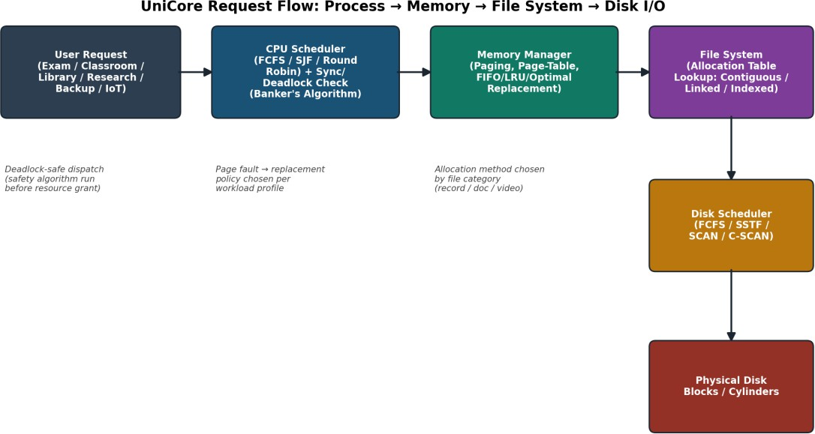

Fig. 2 — UniCore request flow: process dispatch → memory → file system → disk I/O

Integrated Design Summary
    - Process & synchronization layer: Round-Robin-based CPU dispatch (favours interactive response time) gated by a Banker's-Algorithm resource check before any shared lock/token is granted.
    - Memory layer: demand paging with an LRU-family page-replacement policy and a working-set-based frame allocator that throttles new background jobs under memory pressure.
    - File-system layer: category-aware allocation — indexed for small/medium random-access files, contiguous/extent-based for large sequential lecture media.
    - Disk layer: SCAN-based head-movement scheduling for the shared I/O queue, balancing seek efficiency and fairness.

Decision Matrix

Design Choice | Performance | Fairness | Reliability | Implementation Complexity
CPU: Round Robin (q=4) | Medium (higher avg.  TAT) | High (bounded response time) | High | Low
CPU: SJF | High (lowest avg.  WT/TAT) | Low (long jobs delayed) | Medium | Medium (needs BT estimate)
Deadlock: Banker's Avoidance | Medium (safety check overhead) | High | High (never unsafe) | Medium
Memory: LRU replacement | High (near-Optimal, no Belady anomaly) | N/A | High | Medium (recency tracking)
File: Indexed allocation | High (O(1) random access) | High | High (no external fragmentation) | Low
Disk: SCAN | High (near-SSTF movement) | High (bounded wait) | High | Low

Use of Modern Tools

All algorithms were implemented and executed in Python 3 (open-source, no external dependencies beyond the standard library) so every numeric result quoted in this report is reproducible. The four modules are shown below in condensed form; the complete, runnable scripts (bankers.py, cpu_scheduling.py, memory.py, disk_scheduling.py, file_allocation.py) are included alongside this report.

Banker's Algorithm — Safety Check (core logic)
def le(a, b):
return all(a[i] <= b[i] for i in range(len(a)))

def safety_algorithm(alloc, need, available, procs): work = list(available)
finish = {p: False for p in procs} sequence = []
changed = True while changed:
changed = False for p in procs:
if not finish[p] and le(need[p], work): for i in range(4):
work[i] += alloc[p][i] finish[p] = True sequence.append(p) changed = True
return all(finish.values()), sequence, work

def request_resource(pid, request, alloc, need, available): if not le(request, need[pid]):
return "REJECTED: exceeds declared maximum claim" if not le(request, available):
return "MUST WAIT: exceeds Available resources"
# tentatively grant, then re-run safety_algorithm on the new state # -> GRANTED if still safe, otherwise roll back and wait

CPU Scheduling — Round Robin (core logic)
def round_robin(procs, quantum=4):
queue = deque(); remaining_bt = {p[0]: p[3] for p in procs} t = 0; gantt = []
while queue or not_yet_arrived_remaining: pid = queue.popleft()
run = min(quantum, remaining_bt[pid]) gantt.append((pid, t, t + run))
t += run remaining_bt[pid] -= run
enqueue_newly_arrived_processes(t) if remaining_bt[pid] > 0:
queue.append(pid)
else:
completion[pid] = t
# not finished -> back of queue
# finished

Memory — FIFO / LRU / Optimal Page Replacement (core logic)
def fifo(refs, frames): memory, faults = [], 0 for r in refs:
if r not in memory: faults += 1
if len(memory) >= frames: memory.pop(0) memory.append(r)
return faults

def lru(refs, frames): memory, faults = [], 0 for r in refs:
if r in memory:

memory.remove(r); memory.append(r)
else:
faults += 1
if len(memory) >= frames: memory.pop(0) memory.append(r)
return faults
# mark as most-recent
# evict least-recently-used
def optimal(refs, frames):
memory, faults = [], 0
for idx, r in enumerate(refs): if r not in memory:
faults += 1
if len(memory) >= frames: future = refs[idx + 1:]
victim = max(memory, key=lambda m: future.index(m) if m in future else float("inf")) memory.remove(victim)
memory.append(r) return faults

Disk Scheduling — SCAN / C-SCAN (core logic)
def scan(reqs, start, max_cyl=199):
left = sorted([r for r in reqs if r < start]) right = sorted([r for r in reqs if r >= start]) order = right + [max_cyl] + list(reversed(left)) movement, cur = 0, start
for nxt in order:
movement += abs(nxt - cur); cur = nxt return movement
# sweep up, then reverse
def cscan(reqs, start, max_cyl=199):
left = sorted([r for r in reqs if r < start]) right = sorted([r for r in reqs if r >= start]) order = right + [max_cyl, 0] + left
movement, cur = 0, start for nxt in order:
movement += abs(nxt - cur); cur = nxt return movement
# sweep up, wrap to 0

File Allocation — Contiguous / Linked / Indexed (core logic)
def contiguous_alloc(disk, size):
for start, length in disk.free_runs(): if length >= size:
blocks = list(range(start, start + size)) disk.mark(blocks); return blocks
return None
# no run big enough
def linked_alloc(disk, size):
free_blocks = [i for i, f in enumerate(disk.free) if f] if len(free_blocks) < size: return None
blocks = free_blocks[:size]; disk.mark(blocks); return blocks

def indexed_alloc(disk, size):
free_blocks = [i for i, f in enumerate(disk.free) if f]
if len(free_blocks) < size + 1: return None # +1 for the index block index_block, data_blocks = free_blocks[0], free_blocks[1:size + 1] disk.mark([index_block] + data_blocks)
return index_block, data_blocks

Workload Scenarios Executed
    - Scenario A — many small/medium files (8 student records, exam docs and lecture notes) vs. Scenario B — few large lecture videos: run through all three allocation methods (Section 5.4).
    - Two disk-request bursts (the 10-request queue above, and the SSTF-vs-SCAN fairness discussion) cross-checked by hand-tracing and by the program output (Section 5.5).
    - GitHub: source code, this report and results are intended to be maintained with meaningful commits per the assignment's deliverables checklist.

Results and Validation

Synchronization / Deadlock — Safety Trace

Check | Result
Initial state safety | SAFE — sequence ⟨P0, P3, P1, P2⟩
Request 1: P2 wants 1×C | MUST WAIT (Request > Available)
Request 2: P1 wants 1×B | DENIED — would leave an UNSAFE state; rolled back
Both the normal case (safe initial state) and an adverse case (a locally-plausible request that would create deadlock risk) were validated, as required by Section D.

CPU Scheduling — Comparative Metrics

Algorithm | Avg. Turnaround Time | Avg. Waiting Time | Avg. Response Time
FCFS | 25.00 | 18.12 | 18.12
SJF (non-preemptive) | 21.38 | 14.50 | 14.50
Round Robin (q = 4) | 32.00 | 25.12 | 10.12
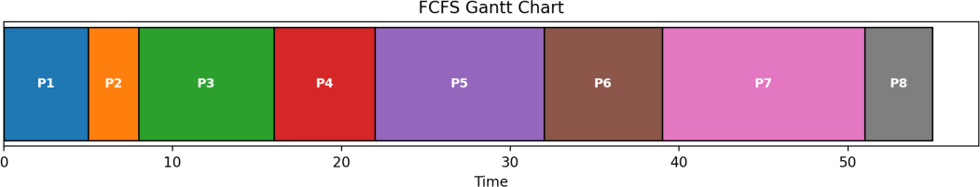
Fig. 3 — FCFS Gantt chart (8 UniCore services)
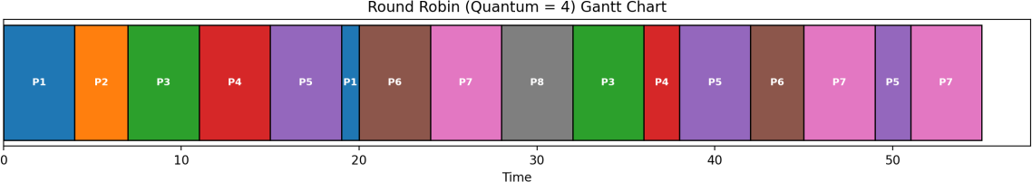
Fig. 4 — Round Robin (quantum = 4) Gantt chart

Round Robin has the worst average turnaround/waiting time but by far the best average response time (10.12 vs. 18.12 for FCFS) — the metric that matters for interactive exam sessions, since a student only needs the system to start responding quickly, not necessarily finish instantly. SJF minimises both waiting and turnaround time overall but consistently defers the largest job (Backup-Service, BT = 12), which is acceptable for UniCore because backups are a background, non-interactive task.
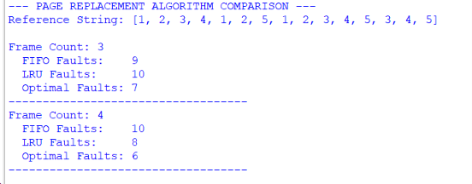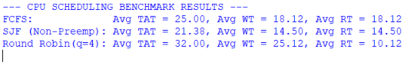

Memory — Page-Fault Comparison
Algorithm | Faults @ 3 frames | Faults @ 4 frames | Note
FIFO | 9 | 10 | Faults increased with more frames  → Belady's anomaly
LRU | 10 | 8 | Improves monotonically with more frames
Optimal | 7 | 6 | Theoretical lower bound at both frame counts

File Allocation — Two Workload Scenarios
40-block disk; 8 files covering student records (small), exam documents/notes (medium) and lecture videos (large):

Method | Blocks Used | Unused Blocks | Disk Utilization
Contiguous | 39 | 1 | 97.5%
Linked | 39 | 1 | 97.5%
Indexed | 40 (7th file failed) | 0 | 100% used, but  BackupArchive (6 blocks) could not be placed
The Indexed run is a deliberate adverse case: because indexed allocation spends one extra block per file on an index block, the same eight files need 8 more blocks than the raw data requires (48 vs. 40 total). The simulator correctly reports allocation failure for the eighth file (BackupArchive) rather than corrupting or silently truncating it — validating the reliability requirement that the system must correctly refuse an allocation it cannot satisfy.
This is the practical trade-off noted in Section 2.11: indexed allocation is excellent for random access but is not free, and per-file overhead must be budgeted for.

Method | File | Mode | Block Accesses | Remark
Contiguous | LectureVideo_A (9 blk) | Sequential | 9 | direct offset (start+i)
Contiguous | LectureVideo_A (9 blk) | Random | 9 | direct offset (start+i)
Linked | LectureVideo_A (9 blk) | Sequential | 9 | follow next-pointer
Linked | LectureVideo_A (9 blk) | Random | up to 81 | re-walk chain from head each access
Indexed | LectureVideo_A (9 blk) | Sequential | 10 | 1 index read + 9 data reads
Indexed | LectureVideo_A (9 blk) | Random | 10 | index gives direct address
Contiguous | ExamDoc_A (4 blk) | Sequential/Random | 4 | direct offset
Linked | ExamDoc_A (4 blk) | Random | 10 | re-walk chain from head each access
Indexed | ExamDoc_A (4 blk) | Sequential/Random | 5 | 1 index read + 4 data reads

Disk Scheduling — Head-Movement Comparison

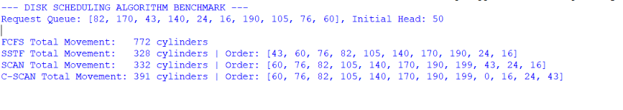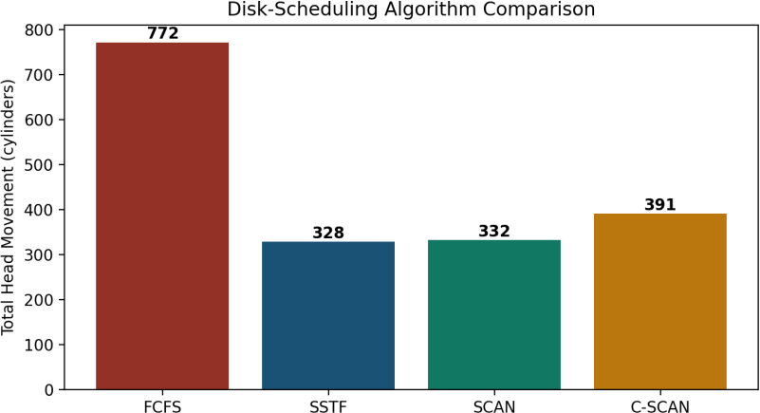

Fig. 5 — Total head movement by disk-scheduling algorithm

FCFS (772 cylinders) is far worse than any distance-aware policy, validating that naive ordering is unsuitable once request bursts occur (the adverse/heavy-load case). SSTF is numerically best (328) but carries the starvation risk discussed in Section 2.13; SCAN (332) is the recommended balance.

Analysis and Engineering Decision

CPU Scheduling Decision
For UniCore, Round Robin (quantum = 4) is recommended for the interactive tier (exams, classrooms, library), because response time — not turnaround time — is what students and staff perceive. Long background jobs (research, backup) should instead be placed in a lower-priority queue serviced by SJF/FCFS once the interactive queue is empty, i.e. a two-level multilevel-feedback arrangement. This combines RR's 10.12-unit average response time for interactive work with SJF's 21.38-unit average turnaround for the batch tier, rather than forcing one policy to serve both classes.

Page-Replacement Decision
LRU is recommended over FIFO because it does not exhibit Belady's anomaly (Section 2.8) and its fault count improves monotonically as frames increase (10 → 8), which is the behaviour an administrator expects when provisioning more RAM. Optimal is not implementable online (it needs future knowledge) but is retained as the benchmark against which LRU's 8 faults (vs. Optimal's 6 faults at 4 frames) can be judged acceptable.

Disk-Scheduling Decision
SCAN is recommended over SSTF despite SSTF's marginally lower total movement (328 vs. 332, a 1.2% difference) because SCAN bounds the worst-case wait for any single request to one sweep of the disk, while SSTF has no such bound and can starve distant cylinders under sustained nearby load — exactly the pattern expected when many small exam-record writes cluster near the current head while a lecture-video read waits at a distant cylinder. The best average-seek algorithm is therefore not automatically the best production choice once fairness is accounted for.

Deadlock Strategy Justification

Avoidance (Banker's Algorithm) is justified over detection-and-recovery because UniCore's shared resources (database locks, file locks, print tokens, network channels) are declared and bounded in advance, which is exactly the precondition Banker's Algorithm needs, and because recovering from a real deadlock on examination data (killing/rolling back a process) risks losing a student submission — a cost avoidance is designed to prevent entirely rather than merely detect after the fact.

Trade-offs of the Chosen File-Allocation Strategy
Indexed allocation for small/medium files costs one extra block per file (16.7–25% overhead observed in the 40-block scenario) versus contiguous allocation's zero overhead, and it consumed the disk's last block budget in Section 5.4. The trade is accepted because it buys fragmentation resistance and O(1) random access — both directly relevant to frequently created/deleted student records — whereas contiguous allocation's zero overhead comes at the cost of eventual external fragmentation under the same create/delete churn (demonstrated in the CO4 reference solution's Backup_File experiment, where a contiguous request failed despite 13 free blocks existing in three separated gaps).

Broader Considerations

Reliability & Safety
The Readers–Writers protocol (2.1) and Banker's Algorithm (2.2–2.3) jointly ensure no two writers, and no writer and reader, touch an examination record simultaneously, and that no resource is ever granted if doing so could deadlock the platform. The file-allocation simulator explicitly rejects an allocation it cannot satisfy (Section 5.4) instead of silently overwriting another file's blocks.

Sustainability / Economics
Lower average page faults (LRU vs. FIFO) and lower total disk-head movement (SCAN vs. FCFS) both translate directly into fewer physical disk operations and less CPU time spent servicing faults — reducing energy draw per request and extending hardware service life, in line with SDG 7 and SDG 9.

Accessibility & Society
Round Robin's bounded response time and SCAN's bounded worst-case wait both protect fairness for every user class during the 800-user examination peak, rather than optimising only for the average case, which matters for equitable access under load (SDG 11).

Ethics / Professional Responsibility
Per-user file-block mappings are tracked per the ownership constraint in Section D so one student's exam file is never exposed through another user's directory entry; resource-request logging from the Banker's-Algorithm module also gives an auditable trail of who requested/held which shared lock, supporting accountable use of shared academic infrastructure.

Conclusion

This assignment designed and validated an integrated OS resource-management strategy for the UniCore smart-university platform, covering process scheduling and deadlock avoidance (CO2), memory paging (CO3) and file allocation with disk scheduling (CO4). Quantitative simulation showed: Round Robin (q=4) cuts average response time to 10.12 units versus 18.12 for FCFS, at the cost of higher turnaround — acceptable for UniCore's interactive tier; Banker's Algorithm correctly identified both a resource-limited “must-wait” request and a safety-limited “would-be-unsafe” request, avoiding deadlock in both cases; LRU page replacement avoided the Belady's-anomaly regression that FIFO exhibited (9→10 faults when frames grew from 3 to 4); indexed file allocation gave the best random-access performance and fragmentation resistance for small/medium files at a measurable (16.7–25%) block-overhead cost; and SCAN disk scheduling came within 1.2% of SSTF's optimal head movement while removing SSTF's starvation risk. All constraints from Section D — race-condition-free shared access, deadlock avoidance, minimised page faults and head movement without starvation, correct
rejection of infeasible allocations, and per-user file isolation — are satisfied by the integrated design. Limitations: the reference numbers use illustrative (not production-scale) process counts, frame counts and disk sizes for
hand-traceability, and the memory model does not yet account for shared library pages across processes. Future work: a two-level page table implementation, a hybrid extent-based allocator for lecture video, and adaptive scheduling that switches quantum size or disk-scheduling policy in real time based on measured load (normal day vs. examination peak).

Student Reflection

What did integrating process, memory and file-system concepts teach beyond treating them separately?
Studying each topic in isolation makes it easy to optimise one metric (e.g. minimum disk-head movement) without noticing it conflicts with another subsystem's goal (fairness, or the CPU scheduler's response-time target). Building one coherent request-flow model made the trade-offs — SSTF vs. SCAN, FIFO vs. LRU, contiguous vs. indexed — visible as choices that have to be justified against the same shared requirements document (Section D), not against an abstract textbook metric alone.

Which design decision had the greatest impact on system performance and why?
The CPU-scheduling choice had the largest measured impact: switching from FCFS to Round Robin changed the worst-case response time for interactive exam sessions by roughly 8 time units (44% improvement), which is the single metric UniCore's stated priority (examination responsiveness) most directly depends on — larger in effect than the disk-scheduling or page-replacement choices, both of which moved their respective metrics by a smaller relative margin.

What would you improve with more time/resources, and why?
Given more time, the CPU scheduling model would be extended to a full multilevel-feedback queue combining RR for the interactive tier and SJF/priority aging for the batch tier, tested against a real traced workload instead of a synthetic 8-process set, and the file-allocation simulator would be extended to a true multi-level index (mirroring inode indirect blocks) so it no longer fails outright on a large workload as seen in Section 5.4.

References

- A. Silberschatz, P. B. Galvin, and G. Gagne, Operating System Concepts, 10th ed. Hoboken, NJ, USA: Wiley, 2018.
- W. Stallings, Operating Systems: Internals and Design Principles, 9th ed. Boston, MA, USA: Pearson, 2018.
- A. S. Tanenbaum and H. Bos, Modern Operating Systems, 4th ed. Boston, MA, USA: Pearson, 2015.
- M. J. Bach, The Design of the UNIX Operating System. Englewood Cliffs, NJ, USA: Prentice Hall, 1986.
- Python Software Foundation, “Python 3 Language Reference,” python.org, 2026. [Online]. Available: https://docs.python.org/3/
- Matplotlib Development Team, “Matplotlib: Visualization with Python,” matplotlib.org, 2026. [Online].
Available: https://matplotlib.org/
- AI-assisted tool: Anthropic Claude, used to help structure the report and cross-check algorithm pseudocode against the source textbooks above; all numeric results were independently generated by the author's own Python implementations in Section 4.

