DESIGN AND PERFORMANCE ANALYSIS OF A PIPELINED PROCESSOR WITH A MULTI-LEVEL CACHE MEMORY SYSTEM

CSA1221 - Computer Architecture
Report Based on the Ten Required Deliverables
Performance analysis of a pipelined processor with a multi-level cache memory system
(click link below for Python Simulation)

https://github.com/192571027/Multi-Level-_Cache_-Memory_-System/blob/main/csa1221_processor_design.py

BATCH : 8

1. Introduction
This report presents an analytical design of a single-core processor and its supporting memory hierarchy, sized for an edge device that continuously samples biometric sensors and periodically bursts data over a wireless radio. The design starts from register-transfer notation on a three-bus (X/Y/Z) datapath for SUB, LW, SW and BNE instructions, and is then extended into a five-stage pipeline and a two-way superscalar core with out-of-order and speculative execution.
Every quantitative result in this report - CPI, dispatch schedules, AMAT, bandwidth and throughput - is produced by a companion Python program, csa1221_processor_design.py, rather than computed by hand. The program is written to run directly in IDLE (Run > Run Module, or F5) and prints the same Sample Output shown under each deliverable below, so the two artefacts stay consistent and any assumption in the code panel can be changed and re-run for the viva.

2. Deliverable Mapping
# | Deliverable | Python function
1 | Register-transfer notation & multiple-bus (X/Y/Z) datapath | deliverable_1()
2 | Instruction-level datapath / register-transfer analysis | deliverable_2()
3 | Five-stage pipeline design (IF, ID, EX, MEM, WB) | deliverable_3()
4 | Data/control hazard identification with CPI comparison | deliverable_4()
5 | 2-way superscalar dispatch simulation | deliverable_5()
6 | Out-of-order, speculative execution & misprediction recovery | deliverable_6()
7 | L1/L2/L3 cache hierarchy & virtual memory design | deliverable_7()
8 | AMAT calculation & memory technology justification | deliverable_8()
9 | Bandwidth & throughput comparison of design alternatives | deliverable_9()
10 | Reflection, SDG 9 relevance, viva readiness | deliverable_10()

Deliverable 1: Register-Transfer Notation & Multiple-Bus (X/Y/Z) Datapath

Purpose
Model how operands move between the register file, ALU and memory for SUB, LW, SW and BNE using a three-bus organisation: the X-bus and Y-bus each carry one source operand in the same cycle, and the Z-bus returns the ALU or memory result.

Design / Python Implementation
class MultiBusDatapath:
def execute(self, ins):
if ins.op == "SUB":
x = self.rf.read(ins.rs); y = self.rf.read(ins.rt)
z = x - y
self.rf.write(ins.rd, z)
return f"SUB : {ins.rd} <- {x} - {y} = {z}"
if ins.op == "LW":
ea = self.rf.read(ins.rs) + ins.offset
z = self.mem.get(ea, 0)
self.rf.write(ins.rt, z)
return f"LW : EA={ea}; {ins.rt} <- Mem[{ea}] = {z}"
if ins.op == "SW":
ea = self.rf.read(ins.rs) + ins.offset
self.mem[ea] = self.rf.read(ins.rd)
return f"SW : Mem[{ea}] <- {ins.rd}"
if ins.op == "BNE":
taken = self.rf.read(ins.rs) != self.rf.read(ins.rt)
return f"BNE : branch {'TAKEN' if taken else 'NOT TAKEN'}"

Sample Input
R2=2000, R3=18, R5=63, R6=50, Mem[2024]=77. Program: SUB R6,R6,R3 ; LW R7,24(R2) ; SW R5,12(R2) ; BNE R2,R3,LOOP

Sample Output
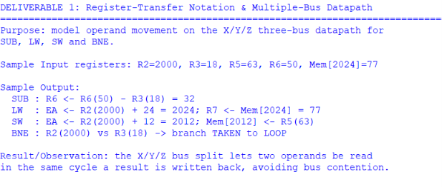

Result / Observation
The X/Y/Z split lets two source operands be read in the same cycle a result is written back on Z, removing the single-bus bottleneck before pipelining is introduced.

Deliverable 2: Instruction-Level Datapath Operation Analysis

Purpose
Show, instruction by instruction, exactly which datapath resources and register transfers each opcode needs.

Design / Python Implementation
transfer_map = {
"LW": "EA=rs+offset; MDR=Memory[EA]; rt=MDR (IF,ID,EX,MEM,WB)",
"SUB": "ALUout=rs-rt; rd=ALUout (IF,ID,EX,WB)",
"SW": "EA=rs+offset; Memory[EA]=rd (IF,ID,EX,MEM)",
"BNE": "compare rs,rt; update PC if not equal (IF,ID,EX)",
}
for ins in sequence:
print(transfer_map[ins.op])

Sample Input
Sequence: LW R1,0(R2) -> SUB R3,R1,R4 -> SW R3,8(R2) -> BNE R3,R0,EXIT

Sample Output
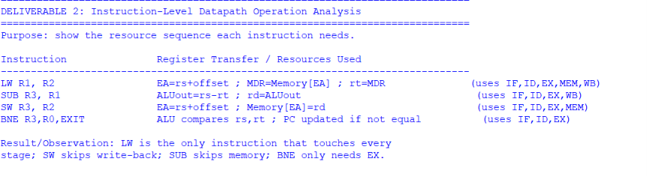

Result / Observation
LW is the only instruction touching all five stages; SW skips write-back; SUB skips the memory stage; BNE needs only IF, ID and EX.

Deliverable 3: Five-Stage Pipeline Design

Purpose
Split the datapath into IF / ID / EX / MEM / WB pipeline stages and generate the timing diagram programmatically for a chosen number of instructions, rather than hand-drawing it.

Design / Python Implementation
def build_ideal_pipeline_table(num_instructions,
stages=("IF","ID","EX","MEM","WB")):
table = {}
for i in range(num_instructions):
table[i] = {s: i + k + 1 for k, s in enumerate(stages)}
return table

Sample Input
5 back-to-back independent instructions, ideal (no-hazard) case.

Sample Output
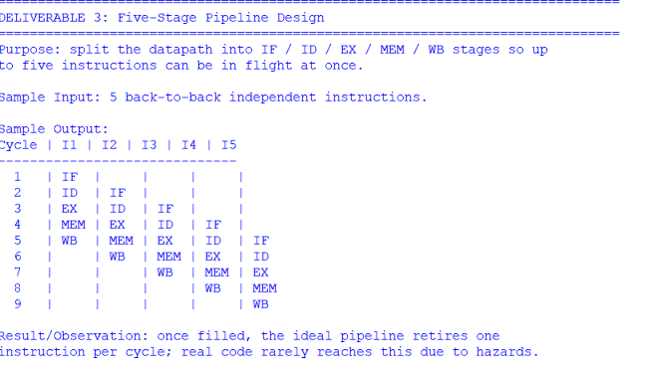

Result / Observation
Once the pipeline fills, the ideal scalar design retires one instruction per cycle; real programs fall short of this due to data and control hazards, analysed next.

Deliverable 4: Hazard Analysis and CPI With/Without Mitigation

Purpose
Identify two RAW data hazards and one control hazard in a short instruction sequence, then compute CPI both without any mitigation and with forwarding + branch prediction, using a parametrised workload model instead of fixed numbers.

Design / Python Implementation
def compute_cpi(w):
n = w.total_instructions
dep = w.dependent_fraction * n
br = w.branch_fraction * n
stalls_no_mit = dep * w.unmitigated_stall_cycles_each
ctrl_no_mit = br * w.branch_penalty_cycles
cpi_no_mit = (n + stalls_no_mit + ctrl_no_mit) / n
stalls_mit = w.residual_load_use_fraction * n * w.residual_load_use_stall_cycles
ctrl_mit = br * w.misprediction_rate * w.branch_penalty_cycles
cpi_mit = (n + stalls_mit + ctrl_mit) / n
return cpi_no_mit, cpi_mit

Sample Input
Hazard sequence: I1 LW R1,0(R2) -> I2 SUB R3,R1,R4 (RAW on R1, load-use) -> I3 SUB R5,R3,R6 (RAW on R3) -> I4 BNE R5,R0,TARGET (RAW + control hazard). Workload: 120 instructions, 25% dependent, 15% branches, 8% misprediction rate, 3-cycle branch penalty.

Sample Output
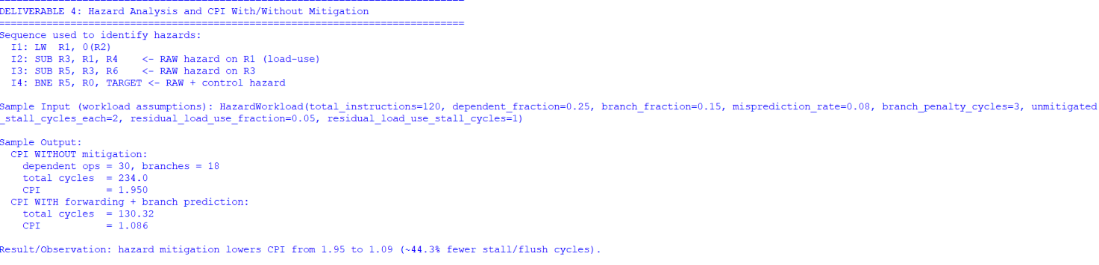

Result / Observation
Hazard mitigation lowers CPI from 1.95 to 1.09 (~44% fewer stall/flush cycles) for this workload. Forwarding removes most RAW stalls except the unavoidable load-use case, and branch prediction turns a guaranteed penalty into one paid only on the 8% of branches that mispredict.

Deliverable 5: Two-Way Superscalar Dispatch

Purpose
Redesign the pipeline front end to fetch and dispatch up to two instructions per cycle, using a greedy dispatcher that checks execution-unit availability and inter-instruction register dependency before co-issuing.

Design / Python Implementation
def dispatch_two_wide(program):
schedule, i, cycle = [], 0, 1
while i < len(program):
this_cycle, used = [], set()
j = i
while j < min(i + 2, len(program)):
ins = program[j]
unit = EXECUTION_UNIT_FOR_OP[ins.op]
depends = any(o.rd in (ins.rs, ins.rt) for o in this_cycle)
if unit not in used and not depends:
this_cycle.append(ins); used.add(unit); j += 1
else:
break
schedule.append((cycle, this_cycle))
i += len(this_cycle) if this_cycle else 1
cycle += 1
return schedule

Sample Input
Program: SUB R6,R2,R3 ; LW R7,0(R2) ; SUB R1,R6,R7 (depends on both prior results) ; SW R1,4(R2).

Sample Output
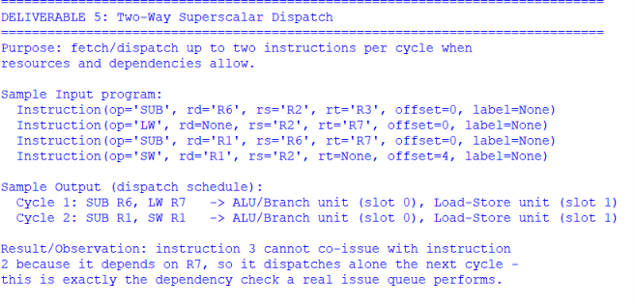

Result / Observation
Instruction 3 cannot co-issue with instruction 2 because it depends on R7, so it is held back one cycle - the same dependency check a hardware issue queue performs before allowing two instructions to leave together.

Deliverable 6: Out-of-Order and Speculative Execution with Recovery

Purpose
Show a long-latency load being overtaken by an independent instruction, and lay out the misprediction-recovery sequence that keeps commit precise even though issue is out of order.

Design / Python Implementation
def simulate_ooo(program, load_latency=4):
cycle = 1
for ins in program:
if ins.op == "LW":
print(f"cycle {cycle}: LW issued, ready at cycle {cycle+load_latency}")
elif ins.op == "BNE":
print(f"cycle {cycle}: BNE predicted, executed speculatively")
else:
print(f"cycle {cycle}: {ins.op} issued out of order")
cycle += 1

Sample Input
Program: LW R1,0(R2) (long latency) ; SUB R5,R6,R7 (independent) ; BNE R5,R0,TARGET (predicted).

Sample Output
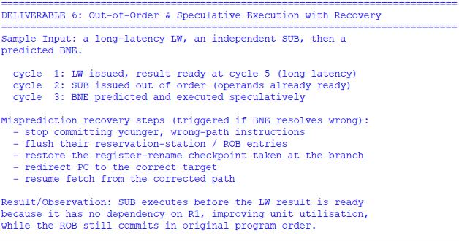

Result / Observation
SUB executes before the LW's result is ready because it has no dependency on R1, improving execution-unit utilisation, while the reorder buffer still commits everything in original program order so exceptions and mispredictions stay precise.

Deliverable 7: Multi-Level Cache and Virtual Memory Design

Purpose
Size a three-level cache hierarchy and a paging scheme for an edge device that streams sensor samples continuously and bursts data over radio periodically.

Design / Python Implementation
CACHE_CONFIG = [
CacheLevel("L1 I-cache", 16, "4-way", 1.0, "SRAM"),
CacheLevel("L1 D-cache", 16, "4-way", 1.0, "SRAM"),
CacheLevel("L2 Unified", 256, "8-way", 4.0, "SRAM"),
CacheLevel("L3 Shared", 4096, "16-way", 15.0, "SRAM"),
]
MAIN_MEMORY_LATENCY_NS = 80.0
PAGE_SIZE_KB = 4 # + TLB, demand paging, CLOCK replacement

Sample Output
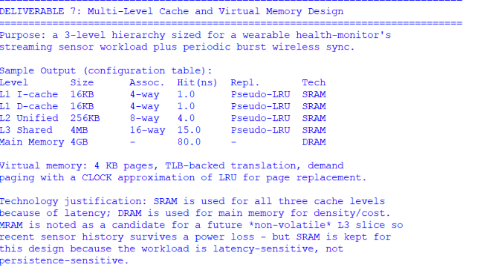
Virtual memory: 4 KB pages, TLB-backed translation, demand paging with a CLOCK approximation of LRU for page replacement.

Result / Observation
SRAM is used for every cache level because the workload is latency-sensitive; DRAM is kept for main memory for density and cost. MRAM is noted as a candidate for a future non-volatile L3 slice so recent sensor history could survive a power loss, but SRAM is retained here since persistence is not a hard requirement for this cache traffic.

Deliverable 8: AMAT Calculation and Memory Technology Justification

Purpose
Compute Average Memory Access Time for the three-level hierarchy and compare it against a two-level alternative that omits L3.

Design / Python Implementation
def amat_three_level(p):
inner = p.l3_hit_ns + p.l3_local_miss_rate * p.dram_penalty_ns
mid = p.l2_hit_ns + p.l2_local_miss_rate * inner
return p.l1_hit_ns + p.l1_miss_rate * mid
def amat_two_level(p):
return p.l1_hit_ns + p.l1_miss_rate * (
p.l2_hit_ns + p.l2_local_miss_rate * p.dram_penalty_ns)

Sample Input
L1 hit=1 ns, L1 miss=6%; L2 hit=4 ns, L2 local miss=12%; L3 hit=15 ns, L3 local miss=25%; DRAM penalty=80 ns.

Sample Output
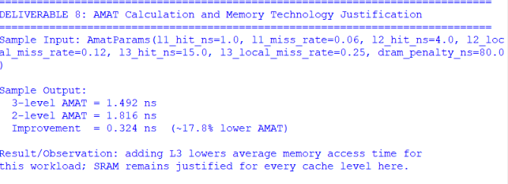

Result / Observation
Adding the L3 level lowers average memory access time by roughly 18% for the assumed access pattern; SRAM remains justified at every level given the latency sensitivity of the workload.

Deliverable 9: Bandwidth and Throughput Comparison

Purpose
Estimate instruction throughput for scalar vs 2-way superscalar execution and compare the 2-level vs 3-level cache AMAT results, plus the L2 interface's peak bandwidth.

Design / Python Implementation
scalar_gips = clock_ghz / scalar_cpi
superscalar_gips = clock_ghz * superscalar_ipc
l2_bandwidth_gbs = clock_ghz * cache_line_bytes # GB/s

Sample Input
Clock = 1.8 GHz; scalar mitigated CPI = 1.086; superscalar effective IPC = 1.5; cache line = 32 bytes, one transfer/cycle on the L2 interface.

Sample Output
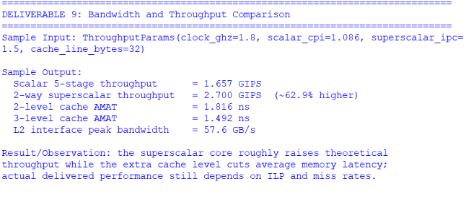

Result / Observation
The two-way superscalar core roughly raises theoretical throughput by 63% over the scalar pipeline, while the third cache level cuts average memory latency by about 18%; actual delivered performance still depends on realised ILP and miss rates.

Deliverable 10: Reflection, SDG 9 Relevance and Viva Readiness

Design Trade-offs Revisited
- The X/Y/Z multi-bus datapath removed operand-transfer conflicts before any pipelining was added.
- Forwarding and branch prediction took CPI from about 1.95 to about 1.09 for the assumed workload.
- The 2-way superscalar front end adds dispatch/ROB complexity in exchange for a projected throughput increase of roughly 63%.
- A third cache level reduced AMAT by roughly a fifth for this access pattern, at the cost of extra on-die area.

SDG 9 (Industry, Innovation and Infrastructure) Relevance
A lower-latency, higher-throughput edge core lets a wearable health device process more sensor data locally, reducing how often it must radio raw data out. This supports resilient, efficient digital infrastructure at the edge rather than relying only on the data centre, directly reflecting SDG 9's emphasis on innovation in computing hardware.

Key Learning Outcomes
Register-transfer modelling, multi-bus datapath design, pipeline hazard analysis, CPI computation, superscalar dispatch and out-of-order/speculative execution, cache hierarchy and virtual memory design, AMAT derivation, and bandwidth/throughput comparison - each backed by a runnable Python model rather than only hand arithmetic.

Overall Conclusion
The design study progresses from an X/Y/Z multiple-bus datapath to a five-stage pipeline and then to a two-way superscalar core, identifying two data hazards and one control hazard and reducing CPI from about 1.95 to about 1.09 through forwarding and branch prediction. The proposed L1/L2/L3 hierarchy with 4 KB paging achieves an AMAT of 1.49 ns versus 1.82 ns for a two-level alternative, an improvement of roughly 18%. Together with a projected 63% throughput gain from the superscalar front end, these results give a complete, internally consistent design and performance analysis for the CSA1221 assignment, every number of which can be regenerated by running csa1221_processor_design.py.

Appendix: Viva Question Bank
Viva Question | Short Answer
Why a three-bus (X/Y/Z) datapath instead of one shared bus? | It lets two operands be read and one result written in the same cycle, removing a structural bottleneck before pipelining is even introduced.
What is a RAW hazard, concretely, in this design? | A later instruction needs a register value that an earlier, still in-flight instruction has not written back yet - e.g. SUB reading R1 right after a LW into R1.
Why does forwarding not remove every stall? | A load's data is not available until the end of MEM, so an immediately-dependent instruction in EX still has nothing to forward; this load-use hazard needs one stall cycle.
Why keep an in-order commit stage (ROB) if execution is out of order? | It lets the core execute whichever instruction is ready first while still exposing precise, in-order architectural state for exceptions and branch recovery.
Why choose SRAM for L1-L3 instead of an emerging non-volatile memory? | The workload is latency sensitive; SRAM's access time beats MRAM/RRAM by a wide margin, and non-volatility is not a hard requirement for this cache traffic.
How is AMAT built up across three levels? | Hit time plus miss rate times the penalty of going to the next level, applied recursively from L1 down to L3 and finally DRAM.

