SIMATS ENGINEERING
Department of Computer Science and Engineering

COMPILER DESIGN — UNIT I
ASSIGNMENT 1 — CO1
AUG–DEC 2026

Development of a Domain-Specific Compiler Front-End using LEX for Federated Cyber Threat Detection in Security Operations Centers
Student information
Student name | __________________________________
Register number | __________________________________
Class / section | __________________________________
Submission date | __________________________________
Evaluation (faculty use)
Faculty | Dr. N. Deepa
Marks awarded | __________ / 50
Evaluation date | __________________________________
Faculty signature | __________________________________
Student signature | __________________________________

Assignment 1 Report: ThreatRule Compiler Front-End
Evidence note. The scanner outputs, test results, generated data, timings,
and graphs in this project are produced by running the supplied scripts on
this machine. Syntax trees and later compiler-phase examples explicitly marked
illustrative are not claimed as execution output: this deliverable compiles
and tests the lexical analyzer, not a complete parser or target-code compiler.

Cover and contents
See Cover_Page.md. Student and evaluation fields remain blank.
- Task 1 — Language processors
- Task 2 — Compiler phases
- Task 3 — Phase grouping
- Task 4 — Construction tools
- Task 5 — Lexical analyzer
- Task 6 — Token specification
- Task 7 — Token recognition
- Task 8 — LEX specification
- Task 9 — Implementation and tests
- Task 10 — Performance
- Task 11 — Final design
- Task 12 — Day-4 live-feed challenge
- Appendices and references

Project and implementation boundary
ThreatRule is a small, case-insensitive rule-description language for defensive
SOC detection. Its sample program is:
RULE ssh_attack IF src_ip == 10.0.0.5 AND port == 22 AND attempts > 5 THEN ALERT "SSH brute force" ;
The actual implementation is the Flex scanner
(threatrule.l); Flex generates
LEX_Scanner/lex.yy.c, which GCC compiles. The scanner emits line-numbered
tokens, validates IPv4 octets and port values, interns identifiers in a symbol
table, and reports recoverable lexical errors. A grammar parser, complete
semantic analyzer, optimizer, and target-code emitter are not implemented.
Their roles and phase examples below are theory/design examples, not executable
claims. This is a material limitation of this submission.

Task 1 — Language processors
Processor | Input → output | Typical use | Suitability to central SOC
Compiler | Whole source → translated target program | Ahead-of-time translation and diagnostics | Selected: validate rule packs before controlled deployment; reusable native engine and batch diagnostics
Interpreter | Source plus input → actions at run time | Interactive scripts | Useful for experimentation, but runtime parsing adds latency and can make deployment behavior dependent on interpreter/runtime availability
Assembler | Assembly language → machine/object code | Low-level instruction translation | Necessary only if a compiler emits assembly; does not translate ThreatRule semantics directly
Hybrid compiler | Source → intermediate/bytecode, then VM/JIT | Portable managed runtimes | Plausible for heterogeneous SOC nodes, at cost of VM and runtime management
Preprocessor | Source directives → expanded source | Includes, macros, conditional compilation | Optional configuration stage; not the core ThreatRule translator
Linker | Object files/libraries → executable | Resolve symbols and combine modules | Used when linking the generated SOC engine, not for rule syntax
Loader | Executable → process image | Load and start a program | Operating-system/runtime service, not a source translator
A compiler is chosen because rules can be checked and transformed before
deployment, errors can be reported together, and a stable target can be rolled
out to federated SOC nodes. This assumes the SOC can tolerate a compile/deploy
boundary; a live authoring console may still provide an interpreter-like preview.
Figure 1. ThreatRule language-processing system. The diagram shows source,
translator, engine, and runtime; it is an architecture, not evidence that all
boxes are implemented.
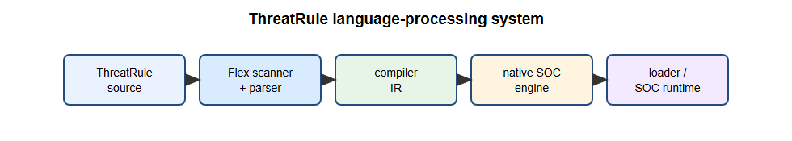

Task 2 — Compiler phases

Lexical analysis — actual generated-scanner output
The scanner run on the sample recognizes these 18 tokens:
RULE RULE
IDENTIFIER ssh_attack
IF IF
IDENTIFIER src_ip
EQ ==
IPV4 10.0.0.5
AND AND
IDENTIFIER port
EQ ==
PORT 22
AND AND
IDENTIFIER attempts
GT >
INTEGER 5
THEN THEN
ALERT ALERT
STRING "SSH brute force"
SEMICOLON ;
The line-numbered exact output is in
`Output_Files/token_output.txt`. The
identifier table from this scanner run is in
`Output_Files/symbol_table_output.txt`.

Syntax analysis — illustrative tree, not parser output
Rule(ssh_attack,
AND(
AND(Equal(src_ip, IPv4(10.0.0.5)), Equal(port, Integer(22))),
Greater(attempts, Integer(5))),
Alert("SSH brute force"))
The actual project stops before this phase; no parser output is generated.

Semantic analysis
Implemented scanner-level checks: every IPv4 octet is 0–255 and a value
immediately following the port field and relational operator is 0–65535.
Those are lexical/attribute checks, not a complete semantic pass. Field
declarations, type compatibility, duplicate rule names, and action policy are
not checked.

Intermediate code generation and optimization — illustrative
Three-address-code sketch:
t1 = src_ip == 10.0.0.5
t2 = port == 22
t3 = t1 AND t2
t4 = attempts > 5
t5 = t3 AND t4
if t5 goto alert_ssh_attack
Illustrative optimization: common-subexpression elimination would reuse a
previously computed identical predicate when one exists. No optimizer runs in
this implementation, and this one-rule input offers no demonstrated
cross-expression reuse.

Target-code generation — illustrative
LOAD_FIELD r1, src_ip
CMP_IPV4 r1, 10.0.0.5
JNE next_rule
LOAD_FIELD r2, port
CMP_U16 r2, 22
JNE next_rule
LOAD_FIELD r3, attempts
CMP_GT r3, 5
JNE next_rule
EMIT_ALERT "SSH brute force"
These are abstract SOC-engine instructions, not machine code emitted by this
project. A symbol table stores identifier attributes for later phases; this
scanner currently stores distinct identifier spellings. An error handler
attaches line numbers, records diagnostics, skips the invalid lexeme, and
continues scanning where possible. See Figure 2,
compiler phases.
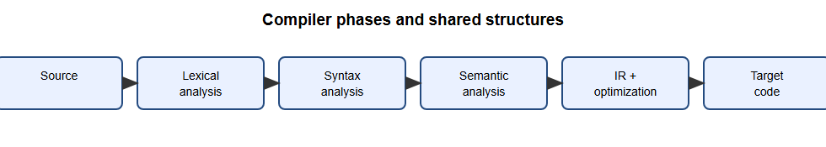

Task 3 — Grouping of phases
The front end comprises scanning, parsing, and semantic checks and is tied to
ThreatRule syntax and meaning. The back end consumes an intermediate
representation, performs target-oriented optimization, and emits instructions.
An IR boundary allows the same validated rule semantics to target different
SOC engines, while branch SOCs can share the language front end. A pass is one
complete traversal/analysis of a representation. A multi-pass design is easier
to diagnose and extend; a one-pass design may reduce work for simple rules but
couples phases and limits optimization. A staged multi-pass design is the
recommended architecture; only the scanning pass is implemented. Figure 3:
front end and back end.
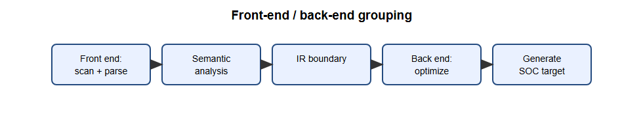
Figure 4. ThreatRule compiler architecture (implemented scanner and planned stages).
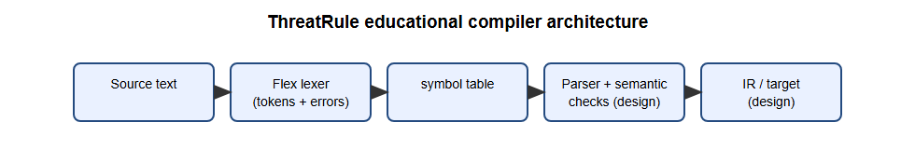

Task 4 — Compiler construction tools
Tool class | Purpose | Example | ThreatRule placement
Scanner generator | Convert regular-expression rules to a lexer | LEX/Flex | Used; produces lex.yy.c
Parser generator | Convert grammar to parser | Yacc/Bison | Not implemented
Syntax-directed translation engine | Attach actions/attributes to productions | Bison semantic actions | Design option for AST/IR construction
Code-generator generator | Map IR patterns to target instructions | BURG-style tree-pattern selector | Not implemented
Data-flow analysis engine | Compute liveness, reaching definitions, etc. | LLVM analyses | Future optimizer
Compiler construction toolkit | Reusable IR, passes, target interfaces | LLVM | Possible larger implementation platform
Flex is preferred to an all-manual scanner here because regular definitions are
visible and auditable, generated DFA-style code handles maximal munch, and
changes to token patterns are reproducible. A hand-written scanner may be
simpler for a tiny stable language, but it transfers boundary and lookahead
maintenance to every developer.

Task 5 — Lexical analyzer
A token is a category (IPV4), a pattern is its accepted character language,
and a lexeme is the concrete source spelling (10.0.0.5). Flex discards spaces,
tabs, line breaks, and supported comments while yylineno tracks source lines.
The scanner separates token boundaries from grammar structure: it recognizes
AND, while a parser would decide whether that operator is legal in a
condition.
A conventional parser consumes returned tokens and may update a shared symbol
table; this project is a standalone scanner and prints tokens. It does not use
yylval because no Bison/parser interface is linked. Flex provides buffered
input internally; Figure 6,
paired buffers and sentinels, is a
conceptual illustration of the classic two-buffer technique, not a claim about
Flex's internal buffer implementation.
Figure 5. Scanner, parser, and symbol-table interaction (conceptual).

Figure 6. Paired input buffers and sentinels (conceptual).
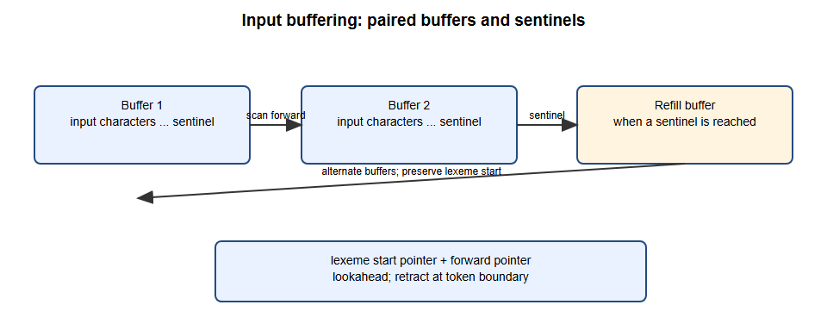
Faulty-input evidence (diagnostics continue in the same file):
Input | Error | Recovery and evidence
src_ip == 10.0.300.5 | IPv4 octet 300 is outside 0–255 | Consume/reject the full dotted lexeme; continue at the next token. See invalid_errors.txt.
ALERT "Login failed ; | Closing quote missing before newline/EOF | Consume the malformed string through the line boundary; report and continue on the next line.
port == 22 @ attempts > 5 | @ has no token rule | Report one invalid-character diagnostic and continue scanning attempts > 5.
The test inputs contain these cases; exact line-numbered diagnostics are saved
in `Output_Files`.

Task 6 — Token specification
A string is a finite sequence of alphabet symbols; a language is a set of
strings over an alphabet. Language operations include union, concatenation,
and Kleene closure. A regular expression denotes a regular language and can be
recognized by a finite automaton. A regular definition names reusable regular
expressions such as DIGIT = [0-9].
Token | Regular definition / pattern | Example | Attribute
Keyword | `RULE | IF | AND | OR | THEN | ALERT | BLOCK` (case-insensitive lookup) | ALERT | canonical keyword
Identifier | [A-Za-z_][A-Za-z0-9_]* | ssh_attack | spelling, symbol-table entry
Integer | [0-9]+ | 5 | decimal value
IPv4 | [0-9]+\.[0-9]+\.[0-9]+\.[0-9]+ plus range validation | 255.255.255.255 | four validated octets
Port | integer in port context plus 0–65535 check | 65535 | unsigned port
String | `\"([^\"\\\n] | \\.)*\"` | "SSH brute force" | quoted lexeme
Relation | == != <= >= < > = | >= | operator kind
Hash | 32, 40, or 64 hexadecimal digits | 64-char SHA-256 | algorithm by length
CVE | CVE- + >=4 year digits + - + >=1 digit | CVE-2024-3400 | identifier spelling
URL | lowercase http:// or https://, ASCII hostname with nonempty labels (1–63 chars), optional path/query/fragment with no whitespace, quote, semicolon, or comma | https://example.com/a | whole URL lexeme
Comment | //..., #..., or /*...*/ | # feed | discarded
The rule order and the keyword lookup ensure equal-length keyword/identifier
matches resolve as keywords; Flex first chooses the longest match, and breaks
equal-length ties by the first rule. The scanner uses a generic identifier
pattern and case-insensitive keyword lookup.

Task 7 — Token recognition
Figure 7, transition diagrams,
contains the relational, identifier/keyword, integer, and IPv4 recognition
paths. Relational lookahead distinguishes < from <=: after <, inspect the
next character; consume = for LE, otherwise retract the lookahead and accept
LT. Similar lookahead applies to > and =.
Hand traces:
- src_ip: start → letter s → identifier body; consume r c _ i p → delimiter
whitespace → retract delimiter → accept identifier; table lookup says not a
keyword.
- 10.0.0.5: start → digits 10 → dot → digits 0 → dot → digits 0 → dot →
digits 5 → delimiter → retract → validate 4 octets → accept IPv4.
The actual Flex engine handles these transitions; the SVG is a teaching model
rather than a generated DFA dump.
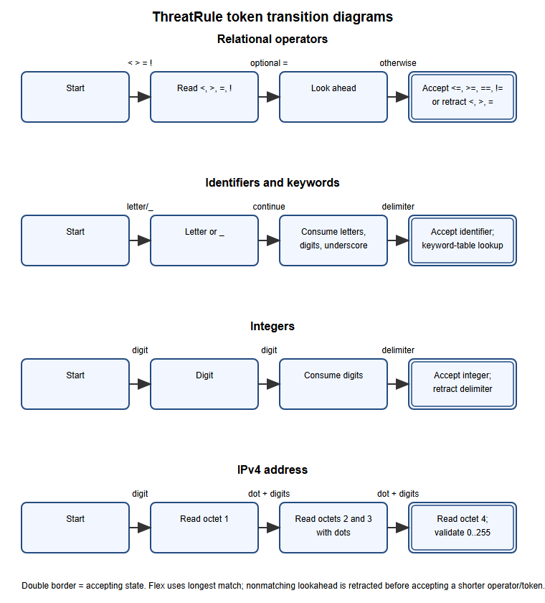

Task 8 — LEX specification
The complete, compilable and commented source is
`LEX_Scanner/threatrule.l`; the generated source
is `LEX_Scanner/lex.yy.c`. Definitions name token
patterns; the rules section resolves matches; auxiliary C functions perform
range checks, symbol insertion, printing, and diagnostics.
- yytext: current matched lexeme.
- yyleng: lexeme length, used when copying a symbol.
- yylineno: Flex line counter included in tokens and errors.
- yylval: not used because this scanner has no generated parser and returns
printed tokens instead. A parser integration should define a shared semantic
value type and assign it for token values rather than inventing a disconnected
global.
Flex's longest-match rule selects the longest candidate; rule order breaks
ties. flex threatrule.l in LEX_Scanner/ generates lex.yy.c; GCC compiles
the generated scanner. The actual generated C compiled successfully with GCC
9.2.0 and Flex 2.5.4. Compiler warnings in generated Flex support code are
tool-generated unused-label/function warnings; no handwritten-source errors
were reported.

Task 9 — Implementation and tests
The reproducible test runner invokes Flex, compiles its output, and runs the
scanner. The actual test report is
`Test_Cases/test_results.md`; token streams and
stderr logs are in Output_Files/. It tests valid and invalid rules,
empty input, IPv4/port boundaries, comments, strings, operators, bad
characters, the extended feed, and legacy-mode behavior. The four generated
rule sets (100, 1,000, 10,000, and 100,000 rules) are produced by
scripts/generate_inputs.py. Generated evidence reflects the compiled Flex
scanner, not a Python reference lexer. No execution screenshots are supplied.
Figure 8. Reproducible scanner testing workflow.
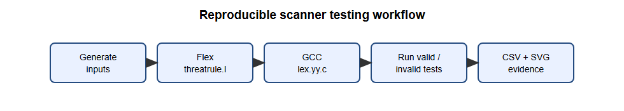

Task 10 — Performance
The benchmark runs the compiled scanner five times per input and records the
median wall-clock duration using time.perf_counter; timing includes fresh
process startup and file I/O. Counts are read from the scanner's own counters.
The machine, OS, compiler, Flex version, and measured table are recorded in
`Performance_Analysis/performance_report.md`,
with machine-readable rows in
`Performance_Analysis/performance_results.csv`.
Four actual SVG charts are in Graphs/: rules/time, rules/tokens,
rules/throughput, and rules/errors. Error counts should be zero for generated
valid files. Timings are local measurements and are not portable guarantees.
Figures 9a–9d. Actual measured scanner performance.
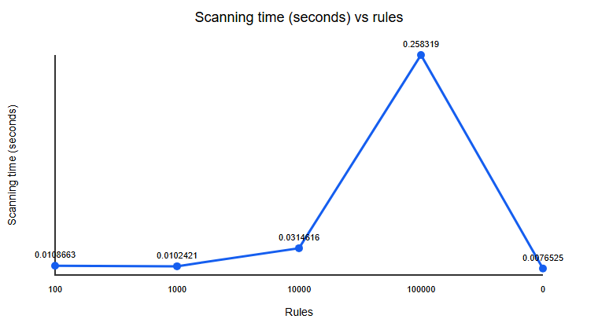
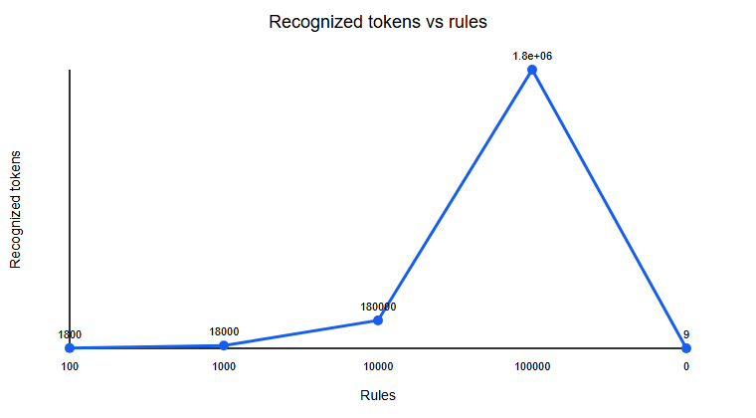
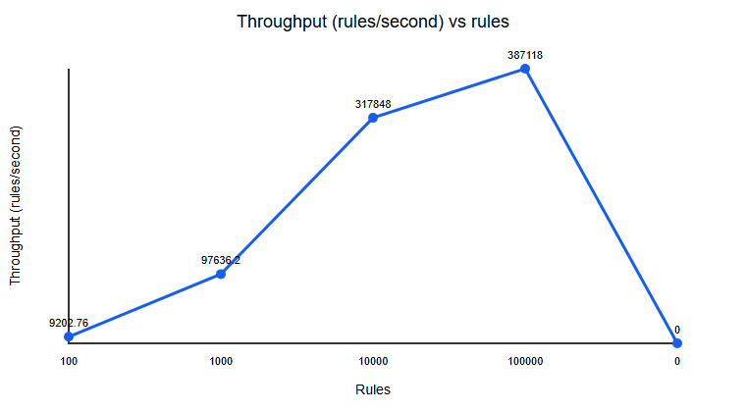
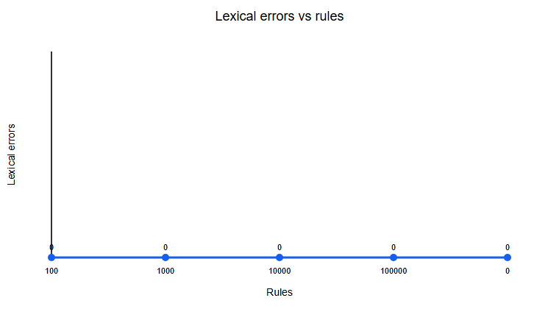

Task 11 — Final design
The generated scanner is suitable as a transparent lexical front-end prototype:
it accepts 100,000 generated valid rules, counts tokens without retaining token
streams, and reports lexical errors while continuing. Its measured throughput
is in the generated report. This demonstrates input-size handling, not
production SOC suitability: no rule parser, policy/type checker, deployment
safety review, streaming mode, or target engine is supplied. The identifier
table grows with the number of distinct identifiers; scanner input buffering
and Flex's generated automaton use additional memory. Retain the Flex-based
scanner for the course prototype, but require parser/semantic integration and
production-scale profiling before deployment.

Task 12 — Day-4 live-feed challenge

12A. Impact analysis
Hashes, CVE identifiers, and URLs introduce long tokens and lexical overlap
with identifiers, integers, punctuation, and comments. The rules must appear
before shorter component patterns where longest-match does not resolve them;
hashes require format-length and hex validation, CVEs require the CVE prefix
and numeric components, and URLs require explicit scheme/host boundaries.
Continuous diagnostics must preserve line numbers and recover after malformed
feed entries.

12B. Original-design evaluation
There was no preexisting scanner source in the repository. The --legacy mode
in the same Flex source is a controlled compatibility simulation: extended
lexemes produce unsupported diagnostics instead of HASH/CVE/URL tokens. It is
not a separately preserved pre-extension binary. The actual run reports 3
unsupported items and 6 other tokens for the sample feed; the enhanced mode
reports 9 tokens and 0 errors. See
Output_Files/design_challenge_legacy_errors.txt and
Output_Files/design_challenge_tokens.txt. Therefore the evidence demonstrates
the designed compatibility behavior, not a historical scanner's exact DFA.

12C. Adaptation / redesign
The scanner adds HASH, CVE, and URL patterns. Supported hash formats are
MD5/SHA-1/SHA-256 (32/40/64 hex chars); CVE years contain at least four digits,
with a numeric identifier of at least one digit. URLs support lowercase
http(s)://, an ASCII hostname, and optional path/query/fragment without
whitespace or the documented excluded punctuation. Invalid extended inputs
produce a line-numbered error, and scanning continues. The actual
hash_cve_url_feed.tr execution recognizes the three new token kinds;
invalid_feed.tr demonstrates rejection of a malformed host and recovery to
the following CVE and valid URL tokens.
Figure 10. Day-4 design comparison.


12D. Evidence-based defence
The six actual performance rows include four valid rule-set sizes and the
legacy/enhanced feed comparison. The table and environment are regenerated by
scripts/benchmark.py; the original mode has three errors on the feed, while
enhanced mode has none and recognizes three additional tokens. The enhanced
mode costs a small measured runtime difference on this tiny feed; that
difference is dominated by process-start timing and is not sufficient to
recommend a performance conclusion. Keep the extension for required
recognition, and profile repeated in-process scans before optimizing.

Appendices and references
- Appendix A — LEX source: `threatrule.l`.
- Appendix B — Reproduction: Windows commands are in README.md;
scripts are in scripts/.
- Appendix C — Execution outputs: Output_Files/ and Test_Cases/test_results.md.
- References: A. V. Aho, M. S. Lam, R. Sethi, J. D. Ullman,
Compilers: Principles, Techniques, and Tools, 2nd ed.; Flex manual,
https://westes.github.io/flex/manual/; GCC online documentation,
https://gcc.gnu.org/onlinedocs/.

Blank mark sheet
Task | Marks available | Marks awarded
Tasks 1–11 and 12A–12D | 50
Faculty comments
Evaluation date / signature
No marks, signature, viva completion, or evaluation date are asserted here.

