SIMATS ENGINEERING

ASSESSMENT TOOL 1

COURSE NAME: Database Management Systems COURSE CODE: CSA0504

COURSE OUTCOME COVERED

CO5: Implement database operations using query processing, optimization, and transaction management to ensure consistency and reliability. (BL3, BL4)

Activity Tool : Constraint-Based Problem Solving (High) Assessment Tool Weightage:40%

Dr

QUESTIONS
Q.N  o | Question | Bloom's Level
1 | Given a complex SQL query with nested joins and sub-queries, draw the query execution plan and apply heuristic optimization rules step-by-step. | BL4 – Analyze
2 | Apply cost-based optimization to choose between nested-loop join, sort-merge join, and hash join for the given relations with specified tuple counts and page sizes. | BL4 – Analyze
3 | Implement JDBC connectivity in Java to a MySQL database and write code to execute parameterized queries with PreparedStatement. | BL3 – Apply
4 | Given a schedule of four concurrent transactions, determine whether it is conflict-serializable using a precedence graph. | BL4 – Analyze
5 | Demonstrate the application of Basic Two-Phase Locking (2PL) on a given transaction set. Identify and resolve any deadlocks. | BL3 – Apply
6 | Apply the Wait-Die and Wound-Wait timestamp-based deadlock prevention schemes on a given set of transactions requesting locks. | BL4 – Analyze

7 | Given transaction logs with checkpoints, apply the Immediate Update recovery protocol to recover the database after a system failure. | BL3 – Apply
8 | Apply Deferred Update (NO-UNDO/REDO) recovery technique on a given log file with committed and uncommitted transactions. | BL3 – Apply
9 | Design a concurrency control mechanism using strict 2PL for a banking system where T1 transfers funds and T2 reads balance simultaneously. | BL4 – Analyze
10 | Write pseudocode for query optimization using heuristics: push down selection, project early, and order joins by smaller intermediate results. | BL4 – Analyze

Code of Conduct:

I Geferlin Boffy R 192571080 certify that this submission is my original work and that I have adhered to the guidelines specified for this assessment. I understand that any violation of academic integrity rules will result in disciplinary action.

Signature of the student:

RUBRICS FOR CALCULATION:

Criteria | Weightage | Level 4 (Exemplary) | Level 3 (Proficient) | Level 2 (Developi ng) | Level 1 (Beginning)
Problem Understanding | 25% | Clearly defines the problem and identifies all relevant constraints accurately | Identifies most constraints with minor gaps | Partial understan ding; misses key constraint s | Fails to identify constraints correctly
Constraint Analysis | 25% | Analyzes constraints effectively and prioritizes them logically | Provides reasonable analysis with some prioritization | Limited analysis; weak prioritizati on | No meaningful analysis or prioritization
Solution Development | 25% | Develops optimal and feasible solutions | Develops workable solutions with minor  limitations | Solutions partially satisfy constraint  s | Solutions do not meet constraints

satisfying all
constraints
Application of Concepts | 15% | Effectively applies appropriate concepts, methods, or tools | Applies concepts with minor errors | Limited application  ; requires guidance | Unable to apply relevant concepts
Justification | 10% | Provides strong justification for decisions with logical reasoning | Provides justification with some clarity | Weak or unclear justificatio n | No justification provided

ANSWERS:
QUESTION 1 – QUERY EXECUTION PLAN AND HEURISTIC OPTIMIZATION

Aim
To analyze a complex SQL query containing joins and a subquery, obtain its execution plan, and optimize it using heuristic optimization techniques.

1. Database and Table Setup
A separate database was created with three relations: Student, Department, and Marks. Sample records were inserted into the tables to demonstrate query execution and optimization.
Figure 1: Database and Table Setup with Sample Records
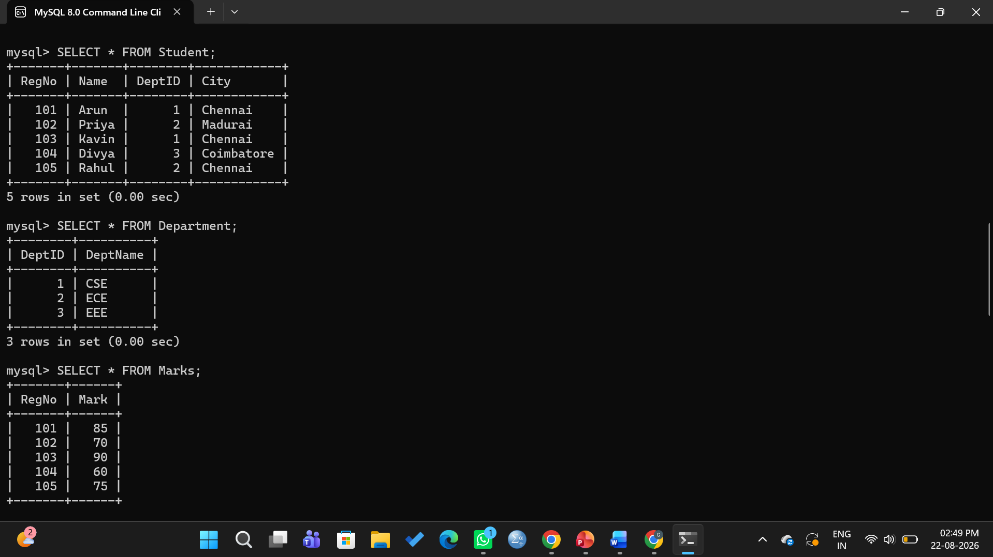
2. Complex SQL Query
The query retrieves students who satisfy the following conditions:
- The student is from Chennai.
- The student belongs to the CSE department.
- The student's mark is greater than the average of marks above 80.
The query uses two joins and a nested subquery to obtain the required result.
For the given data, the average of marks greater than 80 is:
Average = (85 + 90) / 2 = 87.5
Therefore, the student with a mark greater than 87.5 is Kavin, with a mark of 90.
Figure 2: Execution of the Complex SQL Query and Result
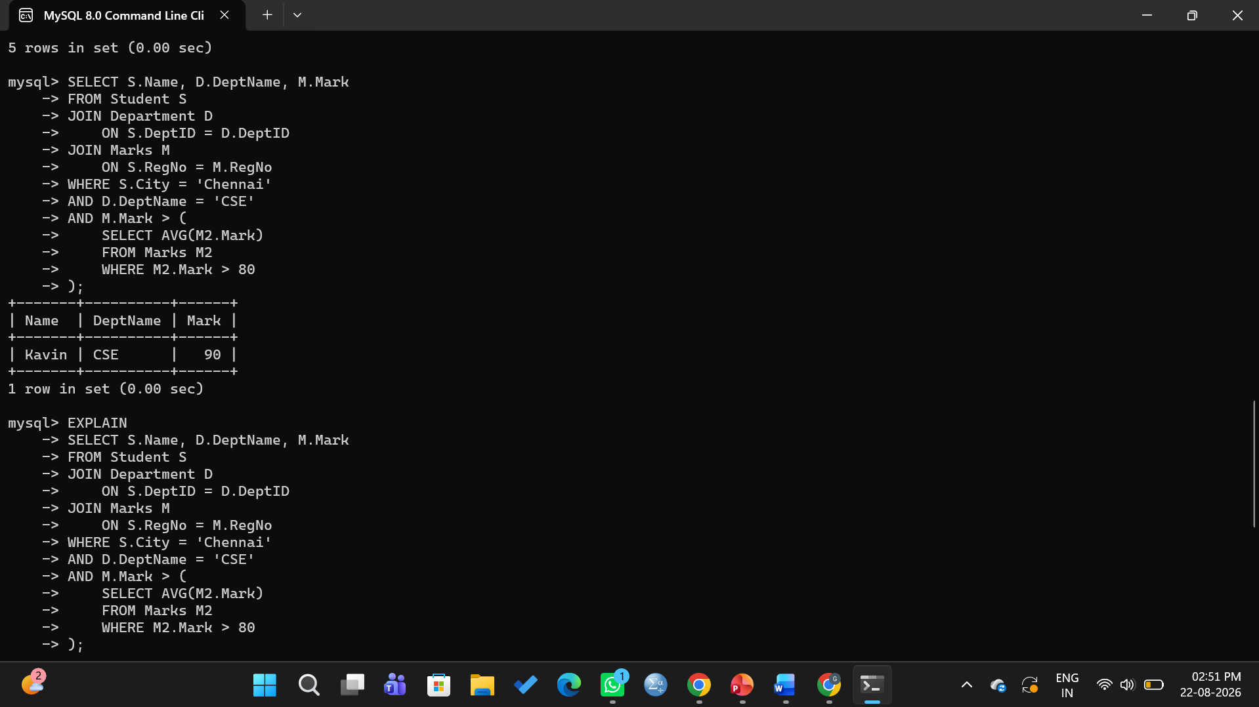

3. Query Execution Plan
A query execution plan represents the sequence of operations performed by the DBMS to execute a query. The EXPLAIN command was used to analyze how the database system processes the given query.
The execution involves:
- Reading the required relations.
- Applying selection conditions.
- Evaluating the subquery.
- Performing join operations.
- Producing the required output attributes.
Figure 3: Query Execution Plan Obtained Using EXPLAIN
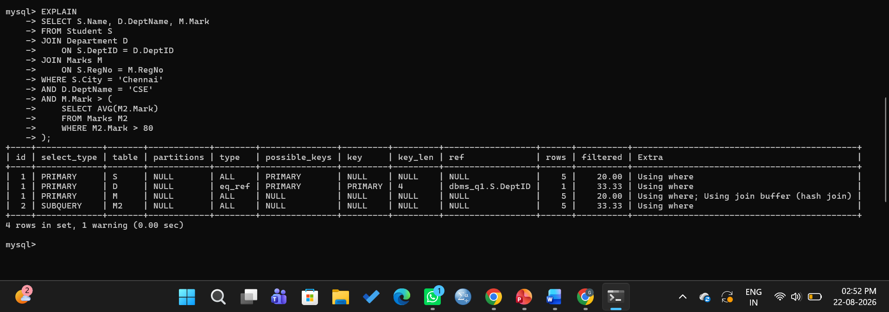

4. Initial Query Execution Plan
The initial execution plan can be represented as:
SELECT
|
Projection
Name, DeptName, Mark
|
JOIN
/ \
JOIN Marks
/ \ |
/ \ Selection
/ \ Mark > 80
Student Department
| |
Selection Selection
City='Chennai' DeptName='CSE'
The initial plan processes the relations and applies the required conditions before producing the final result.

5. Heuristic Optimization
Heuristic optimization applies predefined rules to improve query performance by reducing unnecessary processing and intermediate results.
5.1 Selection Pushdown
Selection conditions are moved closer to the base relations.
σ City='Chennai' (Student)

σ DeptName='CSE' (Department)

σ Mark > 80 (Marks)
Benefit: Unwanted tuples are eliminated early, reducing the amount of data involved in subsequent operations.

5.2 Projection Pushdown
Only the attributes required for selection, joining, and final output are retained.
Student → RegNo, Name, DeptID
Department → DeptID, DeptName
Marks → RegNo, Mark
Benefit: Unnecessary attributes are removed early, reducing memory usage and data processing.

5.3 Join Ordering
The filtered and smaller relations are joined first to reduce the size of intermediate results.
Filtered Student
+
Filtered Department
↓
First Join
↓
Filtered Marks
↓
Final Join
Benefit: Smaller intermediate relations reduce processing time, memory requirements, and disk I/O.

6. Optimized Query Execution Plan
The optimized plan is:
π Name, DeptName, Mark
|
JOIN
/ \
JOIN Marks
/ \ |
/ \ σ Mark>80
/ \
σ City='Chennai' σ DeptName='CSE'
| |
Student Department
The optimized plan performs selections and projections before the join operations, thereby reducing the size of intermediate relations.

7. Comparison

Before Optimization | After Optimization
More tuples are processed | Fewer tuples are processed
Unnecessary attributes may be carried | Only required attributes are retained
Larger intermediate results | Smaller intermediate results
Higher processing cost | Lower processing cost
More disk I/O | Reduced disk I/O

8. Result
The SQL query was successfully analyzed and its execution plan was obtained using EXPLAIN. Heuristic optimization was applied using selection pushdown, projection pushdown, and join ordering.
Conclusion
Heuristic optimization reduces the number of tuples, attributes, and intermediate results processed by the DBMS. Therefore, the optimized query requires less processing, memory, and disk I/O while producing the same required result.

QUESTION 2 – COST-BASED OPTIMIZATION OF JOIN OPERATIONS
Aim
To analyze different join algorithms and select the most efficient join technique using cost-based query optimization.
1. Given Information
Consider two relations R and S with the following properties:
Parameter | Relation R | Relation S
Number of tuples | 10,000 | 5,000
Number of pages | 100 | 50
Available memory buffers = 10 pages
The join algorithms considered are:
- Nested-Loop Join
- Sort-Merge Join
- Hash Join
Caption: Figure 1: Creation and Population of Relations R and S
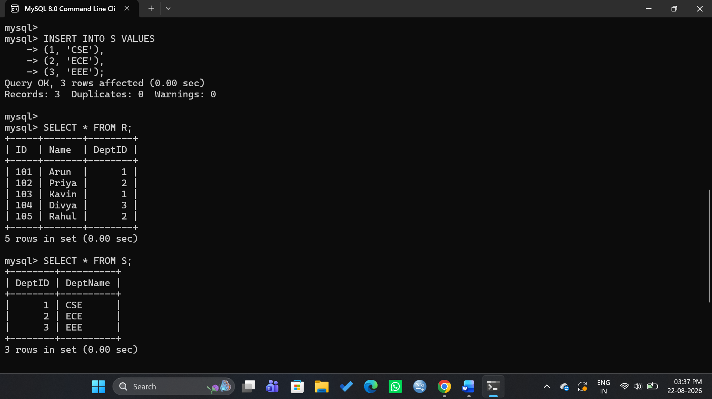

2. Nested-Loop Join
For Block Nested-Loop Join, the cost is:
Cost = B(R) + ⌈B(R)/(M − 2)⌉ × B(S)
Where:
- B(R) = 100 pages
- B(S) = 50 pages
- M = 10 buffers
Therefore,
Cost = 100 + ⌈100/8⌉ × 50
Cost = 100 + 13 × 50
Cost = 750 page I/Os
Thus, the estimated cost of Nested-Loop Join is 750 page I/Os.

3. Sort-Merge Join
Sort-Merge Join consists of two main phases:
- Sorting: Both relations are sorted based on the join attribute.
- Merging: The sorted relations are scanned and matching tuples are combined.
The total cost depends on the number of pages, available memory buffers, and the number of sorting passes.
For the given relations, Sort-Merge Join requires additional I/O for sorting and merging. Therefore, its cost is compared with the other join methods before selecting the final execution plan.

4. Hash Join
For a Grace Hash Join, the approximate cost is:
Cost = 3 × (B(R) + B(S))
Substituting the values:
Cost = 3 × (100 + 50)
Cost = 3 × 150
Cost = 450 page I/Os
Thus, the estimated cost of Hash Join is 450 page I/Os.

5. Cost Comparison
Join Algorithm | Estimated Cost
Nested-Loop Join | 750 page I/Os
Sort-Merge Join | Depends on sorting passes
Hash Join | 450 page I/Os
For the given equality join, Hash Join provides the lowest estimated cost among the calculated alternatives.

6. SQL Demonstration
The join operation was implemented using the following SQL query:
SELECT R.ID, R.Name, S.DeptName
FROM R
JOIN S
ON R.DeptID = S.DeptID;
The query joins relations R and S using the common attribute DeptID.

Caption: Figure 2: Execution of Join Query and Result
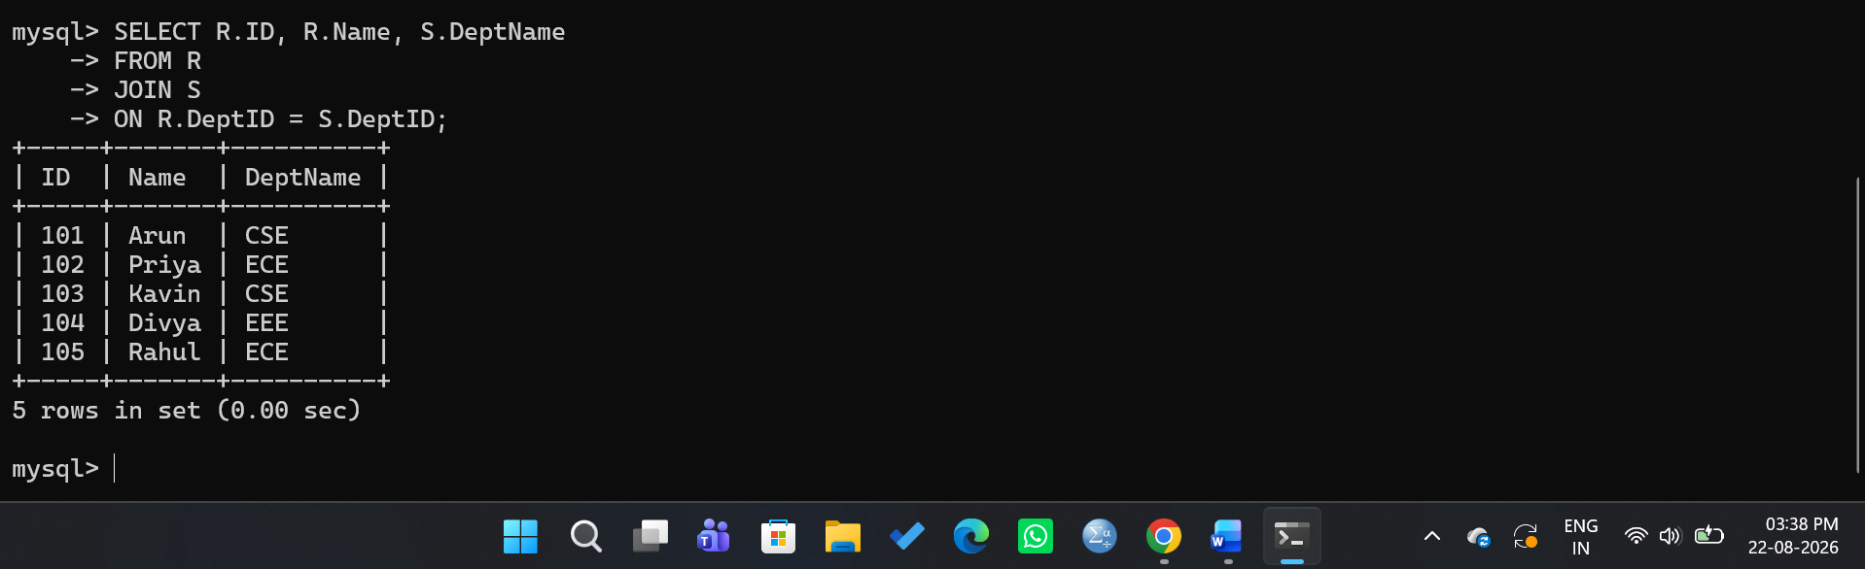

7. Cost-Based Decision
Cost-based optimization compares different execution strategies using factors such as:
- Number of tuples
- Number of pages
- Disk I/O cost
- Available memory
- Sorting cost
- Join processing cost
For the given relations:
Nested-Loop Join = 750 page I/Os
Hash Join = 450 page I/Os
Since Hash Join has the lower estimated cost, it is selected as the preferred join algorithm for this equality condition.

8. Advantages of Hash Join
- Efficient for equality-based joins.
- Requires fewer I/O operations in suitable cases.
- Avoids repeated scanning of the inner relation.
- Provides efficient processing for large relations.

9. Result
The costs of Nested-Loop Join, Sort-Merge Join, and Hash Join were analyzed. Based on the estimated I/O cost, Hash Join is selected as the most efficient option for the given equality join.

10. Conclusion
Cost-based optimization helps the DBMS choose an efficient execution plan by comparing the estimated costs of different join algorithms. For the given relations, Hash Join has a lower estimated cost than Block Nested-Loop Join and is therefore preferred.

QUESTION 3 – JDBC CONNECTIVITY WITH MYSQL

Aim
To establish JDBC connectivity between a Java application and a MySQL database and execute a parameterized SQL query using Prepared Statement.

1. Database and Table Creation
A MySQL database named DBMS_Q3 was created with a Student table containing student registration number, name, gender, and city. Sample records were inserted into the table.

Figure 1: Student Table with Sample Records in MySQL
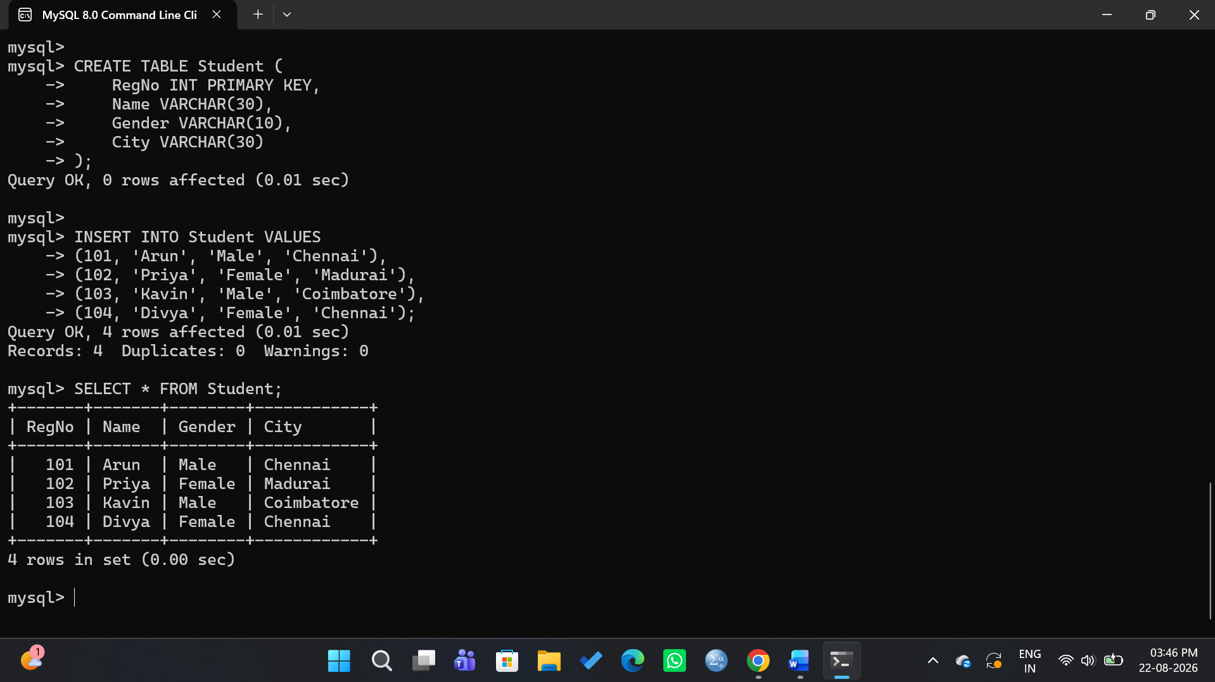

2. JDBC Connectivity
JDBC (Java Database Connectivity) is an API that allows Java applications to communicate with relational databases such as MySQL.
The JDBC program performs the following operations:
- Loads the MySQL JDBC driver.
- Establishes a connection with the MySQL database.
- Creates a PreparedStatement.
- Assigns a value to the parameter using setString().
- Executes the SQL query.
- Retrieves the result using ResultSet.
- Closes the database resources.

3. JDBC Program
import java.sql.*;

public class JDBCExample {
public static void main(String[] args) {

String url = "jdbc:mysql://localhost:3306/DBMS_Q3";
String username = "root";
String password = "YOUR_PASSWORD";

try {
Class.forName("com.mysql.cj.jdbc.Driver");

Connection con = DriverManager.getConnection(
url, username, password
);

System.out.println("Database Connected Successfully!");

String sql = "SELECT * FROM Student WHERE City = ?";
PreparedStatement ps = con.prepareStatement(sql);

ps.setString(1, "Chennai");

ResultSet rs = ps.executeQuery();

System.out.println("\nStudents from Chennai:");
while (rs.next()) {
System.out.println(
rs.getInt("RegNo") + " " +
rs.getString("Name") + " " +
rs.getString("Gender") + " " +
rs.getString("City")
);
}

rs.close();
ps.close();
con.close();

} catch (Exception e) {
e.printStackTrace();
}
}
}

Figure 2: JDBC Connectivity and Parameterized Query Execution
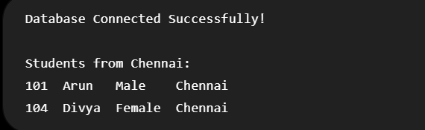

4. Role of PreparedStatement
PreparedStatement is used to execute parameterized SQL queries. In the given program, the ? symbol acts as a parameter placeholder.
SELECT * FROM Student WHERE City = ?
The value is supplied using:
ps.setString(1, "Chennai");
This approach improves security by reducing the risk of SQL injection and allows the same SQL statement to be executed with different parameter values.

5. Important JDBC Components
Component | Function
DriverManager | Establishes a connection with the database
Connection | Represents the database connection
PreparedStatement | Executes parameterized SQL queries
ResultSet | Stores the retrieved records
executeQuery() | Executes a SELECT query
setString() | Assigns a value to a parameter

6. Result
The Java application successfully established a connection with the MySQL database and retrieved the required student records using a parameterized query.

Conclusion
JDBC provides a standard mechanism for connecting Java applications with MySQL databases. Prepared Statement enables secure and efficient execution of parameterized SQL queries and helps prevent SQL injection attacks.

QUESTION 4 – CONFLICT SERIALIZABILITY USING PRECEDENCE GRAPH
Aim
To determine whether a given schedule of concurrent transactions is conflict-serializable using a precedence graph.
1. Given Schedule
The following schedule consists of four concurrent transactions T1, T2, T3, and T4 operating on data items X and Y.
Step | Transaction Operation
1 | T1: R(X)
2 | T1: W(X)
3 | T2: R(X)
4 | T2: W(X)
5 | T3: R(Y)
6 | T3: W(Y)
7 | T4: R(Y)
8 | T4: W(Y)
9 | T2: R(Y)
10 | T2: W(Y)
11 | T1: R(Y)
12 | T1: W(Y)

2. Identification of Conflicting Operations
Two operations are said to be conflicting when:
- They belong to different transactions.
- They access the same data item.
- At least one of them is a write operation.
The conflicting operations produce the following precedence relationships:
- T1 → T2 because T1 writes X before T2 accesses X.
- T3 → T4 because T3 writes Y before T4 accesses Y.
- T4 → T2 because T4 writes Y before T2 accesses Y.
- T2 → T1 because T2 writes Y before T1 accesses Y.

3. Precedence Graph
The precedence graph contains four vertices:
T1, T2, T3, T4
The directed edges are:
T1 → T2
T3 → T4
T4 → T2
T2 → T1
Precedence Graph for the Given Transaction Schedule:
┌─────────┐
│ ↓
T1 ──────→ T2
↑ ↑
│ │
└──────────┘
↑
│
T4
↑
│
T3

4. Cycle Detection
From the precedence graph, the following cycle is present:
T1 → T2 → T1
Therefore, the graph is cyclic.

5. Serializability Analysis
A schedule is conflict-serializable if and only if its precedence graph is acyclic.
In this case, the precedence graph contains a cycle:
T1 → T2 → T1
Hence, the given schedule is not conflict-serializable.

6. Result
The precedence graph for the given schedule was constructed and analyzed. Since the graph contains a cycle between T1 and T2, the given schedule is not conflict-serializable.
7. Conclusion
Conflict serializability can be determined by constructing a precedence graph and checking for cycles. An acyclic graph represents a conflict-serializable schedule, while a cyclic graph represents a non-conflict-serializable schedule. Therefore, the given schedule is not conflict-serializable.

QUESTION 5 – BASIC TWO-PHASE LOCKING (2PL)

Aim
To demonstrate the application of the Basic Two-Phase Locking (2PL) protocol on a given set of transactions and identify and resolve deadlocks.

1. Given Transactions
Consider two concurrent transactions T1 and T2 operating on data items A and B.
Transaction | Operations
T1 | Read(A), Write(A), Read(B), Write(B)
T2 | Read(B), Write(B), Read(A), Write(A)

2. Two-Phase Locking Protocol
Basic 2PL divides a transaction into two phases:
Growing Phase
- The transaction can acquire locks.
- It cannot release any lock.
Shrinking Phase
- The transaction can release locks.
- It cannot acquire any new lock.
Therefore:
Growing Phase → Shrinking Phase

3. Locking Schedule
The transactions may execute as follows:
T1: LOCK-X(A)
READ(A)
WRITE(A)
LOCK-X(B)
READ(B)
WRITE(B)
UNLOCK(B)
UNLOCK(A)
COMMIT

T2: LOCK-X(B)
READ(B)
WRITE(B)
LOCK-X(A)
READ(A)
WRITE(A)
UNLOCK(A)
UNLOCK(B)
COMMIT
Figure 1: Application of Basic Two-Phase Locking to Transactions T1 and T2
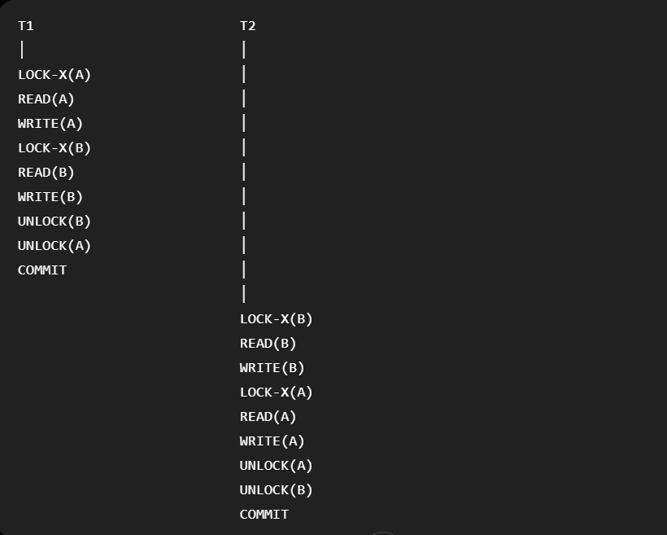

4. Deadlock Condition
A deadlock can occur when both transactions hold a lock and wait for a lock held by the other transaction.
For example:
T1 holds X(A) → requests X(B)
T2 holds X(B) → requests X(A)
This creates a circular wait:
T1 → T2 → T1
Therefore, a deadlock occurs.

5. Deadlock Detection
The deadlock can be represented using a wait-for graph:
T1 ─────→ T2
↑ │
└─────────┘
The cycle indicates the presence of a deadlock.
Figure 2: Wait-for Graph Showing Deadlock Between T1 and T2
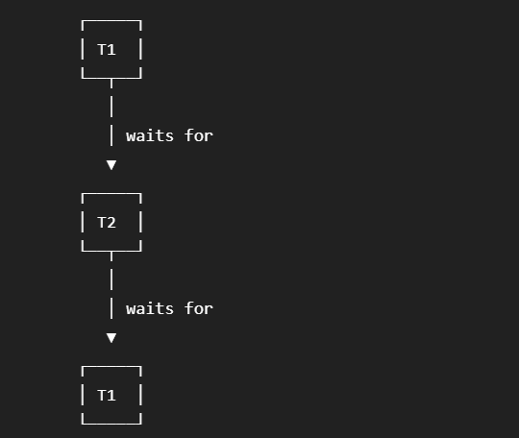

6. Deadlock Resolution
One transaction can be selected as the victim and rolled back.
For example:
- T1 holds lock on A and waits for B.
- T2 holds lock on B and waits for A.
- Deadlock is detected.
- T2 is selected as the victim.
- T2 is rolled back and its locks are released.
- T1 obtains the required lock on B.
- T1 completes and commits.
- T2 is restarted later.
T1 → continues → COMMIT

T2 → ROLLBACK → RELEASE LOCKS → RESTART

7. Important Properties of 2PL
- A transaction must acquire locks during the growing phase.
- Once a lock is released, no new lock can be acquired.
- It ensures conflict serializability.
- Basic 2PL does not completely prevent deadlocks.
- Deadlocks can be detected using a wait-for graph and resolved by rollback.

8. Result
Basic Two-Phase Locking was applied to the given transactions. A deadlock was identified when T1 and T2 waited for each other's locks. The deadlock was resolved by rolling back one transaction and releasing its locks.
Conclusion
Basic 2PL ensures conflict-serializable schedules by controlling the acquisition and release of locks. However, it can result in deadlocks when transactions wait for each other's resources. Such deadlocks can be detected using a wait-for graph and resolved through transaction rollback.

QUESTION 6 – WAIT-DIE AND WOUND-WAIT DEADLOCK PREVENTION

Aim
To apply the Wait-Die and Wound-Wait timestamp-based deadlock prevention schemes to a given set of transactions requesting locks.

1. Given Transactions
Consider three transactions with the following timestamps:
Transaction | Timestamp | Age
T1 | 10 | Older
T2 | 20 | Younger
T3 | 30 | Youngest
The lock requests are:
- T1 holds lock on A
- T2 requests lock on A
- T2 holds lock on B
- T3 requests lock on B
A smaller timestamp indicates an older transaction.

2. Wait-Die Scheme
Wait-Die is a non-preemptive deadlock prevention technique based on transaction timestamps.
Rules
- If an older transaction requests a lock held by a younger transaction, the older transaction waits.
- If a younger transaction requests a lock held by an older transaction, the younger transaction rolls back (dies).
Applying the Rule
Case 1: T2 requests A
T1 holds A and has timestamp 10.
T2 has timestamp 20.
Since T2 is younger than T1:
T2 → ROLLBACK (DIE)
Case 2: T3 requests B
T2 holds B and has timestamp 20.
T3 has timestamp 30.
Since T3 is younger than T2:
T3 → ROLLBACK (DIE)
Wait-Die Result
Request | Lock Holder | Comparison | Action
T2 requests A | T1 | T2 is younger | T2 rolls back
T3 requests B | T2 | T3 is younger | T3 rolls back

Figure 1: Wait-Die Analysis
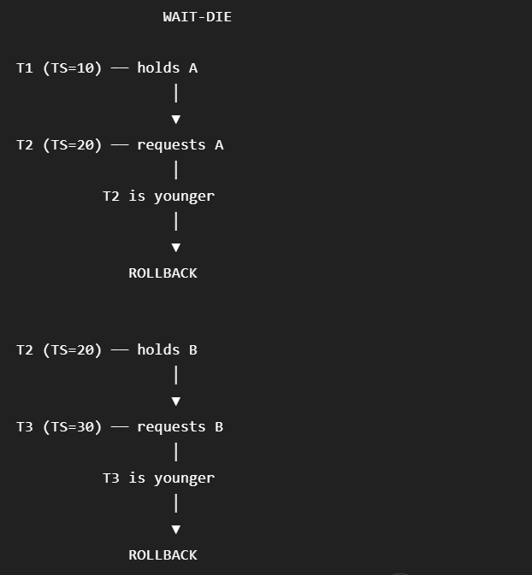

3. Wound-Wait Scheme
Wound-Wait is a preemptive deadlock prevention technique based on transaction timestamps.
Rules
- If an older transaction requests a lock held by a younger transaction, the older transaction wounds the younger transaction, causing it to roll back.
- If a younger transaction requests a lock held by an older transaction, the younger transaction waits.
Applying the Rule
Case 1: T2 requests A
T1 holds A and is older than T2.
T2 is younger than T1, so:
T2 → WAIT
Case 2: T3 requests B
T2 holds B and is older than T3.
T3 is younger than T2, so:
T3 → WAIT

Wound-Wait Result
Request | Lock Holder | Comparison | Action
T2 requests A | T1 | T2 is younger | T2 waits
T3 requests B | T2 | T3 is younger | T3 waits

Figure 2: Wound-Wait Analysis
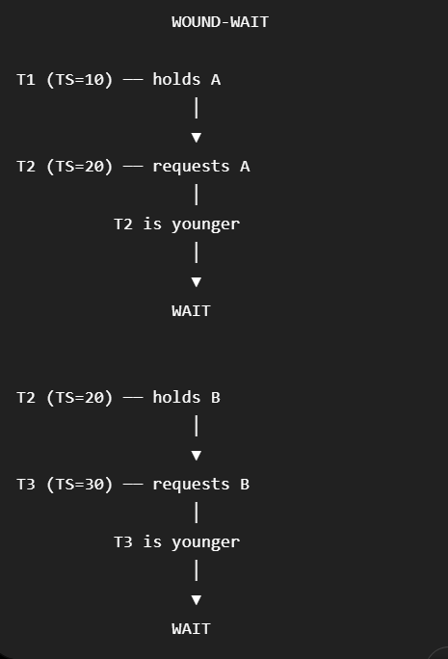

4. Comparison of Wait-Die and Wound-Wait
Feature | Wait-Die | Wound-Wait
Type | Non-preemptive | Preemptive
Older requests younger's lock | Wait | Younger rolls back
Younger requests older's lock | Rolls back | Waits
Uses timestamps | Yes | Yes
Prevents deadlock | Yes | Yes

5. Analysis
Both techniques use transaction timestamps to prevent circular waiting.
In Wait-Die, younger transactions are more likely to be rolled back when they request locks held by older transactions.
In Wound-Wait, older transactions have priority and can force younger transactions to roll back when necessary.
Thus, both techniques prevent deadlocks by maintaining an ordering based on transaction age.

6. Result
The Wait-Die and Wound-Wait schemes were successfully applied to the given transaction and lock requests. The appropriate WAIT or ROLLBACK action was determined using transaction timestamps.
Conclusion
Wait-Die and Wound-Wait are timestamp-based deadlock prevention techniques. Wait-Die is non-preemptive, whereas Wound-Wait is preemptive. Both techniques prevent deadlocks by controlling transaction waiting and rollback based on transaction age.

QUESTION 7 – IMMEDIATE UPDATE RECOVERY WITH CHECKPOINT
Aim
To apply the Immediate Update Recovery Protocol to recover the database after a system failure using transaction logs and checkpoints.

1. Given Transaction Log
Consider the following transaction log:
<START T1>
<T1, A, 100, 150>

<START T2>
<T2, B, 200, 250>

<COMMIT T1>

<START T3>
<T3, C, 300, 350>

<CHECKPOINT {T2, T3}>

<T2, B, 250, 280>

<T3, C, 350, 400>

<COMMIT T3>

--- SYSTEM FAILURE ---
Here:
- T1 committed before the checkpoint.
- T2 was active at the checkpoint and did not commit.
- T3 committed after the checkpoint.
- The system failure occurred after these operations.

2. Immediate Update Recovery
In the Immediate Update technique, database changes may be written to disk before the transaction commits.
Therefore, after a system failure:
- Committed transactions are REDONE if necessary.
- Uncommitted transactions are UNDONE to remove their effects.
The recovery process uses the transaction log to determine which transactions were committed and which were active at the time of failure.

3. Identify Transactions
From the given log:
Transaction | Status at Failure | Recovery Action
T1 | Committed | REDO
T2 | Uncommitted | UNDO
T3 | Committed | REDO

4. Recovery Analysis
Transaction T1
T1 committed before the checkpoint.
<T1, A, 100, 150>
<COMMIT T1>
Since T1 is committed, its update is retained.
Action: REDO T1
Therefore:
A = 150
Transaction T2
T2 did not commit before the system failure.
<T2, B, 200, 250>
<T2, B, 250, 280>
Since T2 is uncommitted, its changes must be undone.
Undo operations are performed in reverse order:
B: 280 → 250
B: 250 → 200
Therefore:
B = 200
Action: UNDO T2

Transaction T3
T3 committed before the system failure.
<T3, C, 300, 350>
<T3, C, 350, 400>
<COMMIT T3>
Since T3 committed, its changes must be retained.
Action: REDO T3
Therefore:
C = 400

5. Recovery Process
The recovery process can be represented as:
SYSTEM FAILURE
|
↓
Check Transaction Log
|
┌────────┴────────┐
↓ ↓
Committed Uncommitted
T1, T3 T2
| |
REDO UNDO
| |
↓ ↓
Keep Changes Remove Changes

6. Final Database State
Data Item | Before Recovery | Final Value | Action
A | 150 | 150 | REDO T1
B | 280 | 200 | UNDO T2
C | 400 | 400 | REDO T3

Figure 1: Immediate Update Recovery Process After System Failure
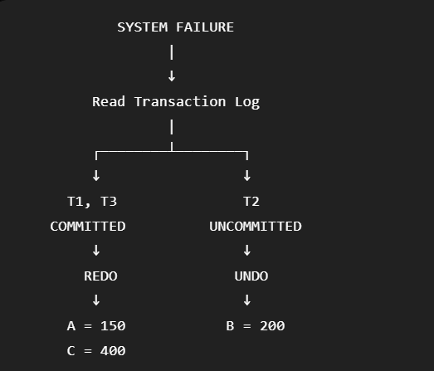

7. Role of Checkpoint
A checkpoint reduces the amount of log that needs to be examined during recovery.
The checkpoint in the given log is:
<CHECKPOINT {T2, T3}>
At the checkpoint:
- T2 was still active.
- T3 was still active.
- T1 had already committed.
Therefore, the recovery manager can use the checkpoint to identify the transactions that may require recovery.

8. Recovery Algorithm
The basic recovery steps are:
- Locate the most recent checkpoint in the log.
- Identify committed and uncommitted transactions.
- REDO the updates of committed transactions when required.
- UNDO the updates of uncommitted transactions in reverse order.
- Restore the database to a consistent state.

9. Result
After applying Immediate Update recovery:
A = 150
B = 200
C = 400
T1 and T3 are preserved because they committed, while T2 is rolled back because it was uncommitted at the time of failure.
Conclusion
Immediate Update recovery uses transaction logs and checkpoints to restore the database after a system failure. Committed transactions are redone when necessary, while uncommitted transactions are undone. In this example, T1 and T3 are retained and T2 is rolled back, resulting in a consistent database state.

QUESTION 8 – DEFERRED UPDATE (NO-UNDO/REDO) RECOVERY
Aim
To apply the Deferred Update (NO-UNDO/REDO) recovery technique to a transaction log containing committed and uncommitted transactions.

1. Given Transaction Log
Consider the following transaction log:
<START T1>
<T1, A, 100, 150>

<START T2>
<T2, B, 200, 250>

<COMMIT T1>

<START T3>
<T3, C, 300, 350>

<COMMIT T3>

<T2, B, 250, 280>

--- SYSTEM FAILURE ---

2. Deferred Update Recovery
In the Deferred Update technique, changes made by a transaction are not written to the database until the transaction commits.
Therefore:
- Committed transactions → REDO
- Uncommitted transactions → IGNORE
- UNDO is not required
This is why the technique is called NO-UNDO/REDO.

3. Identify Transaction Status
Transaction | Status at Failure | Recovery Action
T1 | Committed | REDO
T2 | Uncommitted | IGNORE
T3 | Committed | REDO

4. Recovery Analysis
Transaction T1
T1 committed successfully:
<T1, A, 100, 150>
<COMMIT T1>
Therefore, T1's update is applied during recovery.
REDO T1
Final value:
A = 150

Transaction T2
T2 did not commit before the system failure.
<T2, B, 200, 250>
<T2, B, 250, 280>
Since the updates of an uncommitted transaction are not written to the database in deferred update:
T2 is ignored.
Therefore:
B = 200
No UNDO operation is required.

Transaction T3
T3 committed successfully:
<T3, C, 300, 350>
<COMMIT T3>
Therefore:
REDO T3
Final value:
C = 350

5. Recovery Process
SYSTEM FAILURE
|
↓
Examine Transaction Log
|
┌────────────┴────────────┐
↓ ↓
Committed Uncommitted
T1, T3 T2
↓ ↓
REDO IGNORE
↓ ↓
Apply Updates No Action

Caption: Figure 1: Deferred Update Recovery Process
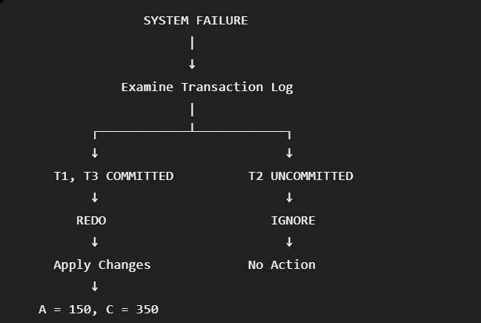

6. Final Database State
Data Item | Initial Value | Final Value | Recovery Action
A | 100 | 150 | REDO T1
B | 200 | 200 | IGNORE T2
C | 300 | 350 | REDO T3

7. Why UNDO Is Not Required
In Deferred Update recovery, database changes are postponed until the transaction commits.
Therefore, an uncommitted transaction such as T2 has not modified the database permanently.
Hence, there is no need to undo T2's changes.
Only committed transactions need to be REDONE.

8. Recovery Steps
- Scan the transaction log.
- Identify transactions that committed before the failure.
- REDO the updates of committed transactions.
- Ignore transactions that were active or uncommitted.
- Restore the database to a consistent state.

9. Result
After applying Deferred Update recovery:
A = 150
B = 200
C = 350
T1 and T3 are recovered because they committed successfully. T2 is ignored because it was uncommitted at the time of system failure.

Conclusion
Deferred Update uses the NO-UNDO/REDO recovery technique. Since uncommitted updates are not written to the database, there is no need for UNDO operations. Only committed transactions are redone during recovery, allowing the database to be restored to a consistent state.

QUESTION 9 – CONCURRENCY CONTROL USING STRICT 2PL

Aim
To design a concurrency control mechanism using Strict Two-Phase Locking (Strict 2PL) for a banking system where one transaction transfers funds and another transaction reads the balance simultaneously.

1. Banking Scenario
Consider a bank account A with an initial balance of ₹10,000.
Two transactions are executed concurrently:
- T1: Transfers ₹2,000 from Account A to Account B.
- T2: Reads the balance of Account A.
The objective is to ensure that T2 does not read an inconsistent or partially updated balance while T1 is transferring the money.

2. Transactions
Transaction T1 – Fund Transfer
T1:
LOCK-X(A)
READ(A)
A = A - 2000
WRITE(A)

LOCK-X(B)
READ(B)
B = B + 2000
WRITE(B)

COMMIT
UNLOCK(A)
UNLOCK(B)
Transaction T2 – Balance Reading
T2:
LOCK-S(A)
READ(A)
UNLOCK(A)
COMMIT

3. Strict 2PL
In Strict Two-Phase Locking:
- A transaction can acquire locks during the growing phase.
- Exclusive locks are held until the transaction commits or aborts.
- Shared locks may also be held until commit in strict implementations.
- This prevents other transactions from reading uncommitted data.

4. Execution of T1 and T2
Initial balance:
A = ₹10,000
T1 starts the transfer:
T1 → LOCK-X(A)
T1 → READ(A)
T1 → A = ₹8,000
T1 → WRITE(A)
At this point, T2 requests a shared lock on A:
T2 → LOCK-S(A)
T2 cannot obtain the lock because T1 currently holds an exclusive lock.
Therefore:
T2 → WAIT
T1 continues:
T1 → LOCK-X(B)
T1 → READ(B)
T1 → B = B + ₹2,000
T1 → WRITE(B)
T1 → COMMIT
T1 → UNLOCK(A)
T1 → UNLOCK(B)
After T1 releases the lock, T2 can continue:
T2 → LOCK-S(A)
T2 → READ(A)
T2 → UNLOCK(A)
T2 → COMMIT
Therefore, T2 reads the final committed balance of:
₹8,000

- Strict 2PL Schedule

Step | T1 – Transfer | T2 – Read Balance
1 | LOCK-X(A)
2 | READ(A)
3 | WRITE(A = ₹8,000)
4 | LOCK-X(B)
5 | WRITE(B)
6 | COMMIT
7 | UNLOCK(A), UNLOCK(B)
8 |  | LOCK-S(A)
9 |  | READ(A) = ₹8,000
10 |  | UNLOCK(A)
11 |  | COMMIT

Figure 1: Strict 2PL Schedule for Fund Transfer and Balance Reading
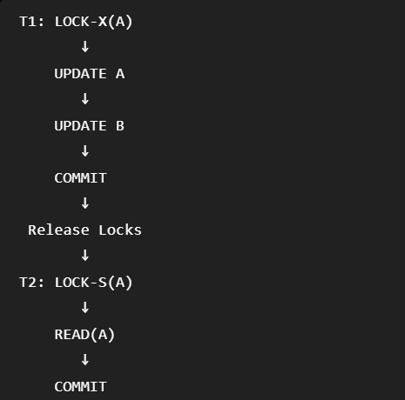

6. Locking Behavior
The locking mechanism can be represented as:
T1
|
LOCK-X(A)
|
Update A
|
LOCK-X(B)
|
Update B
|
COMMIT
|
Release Locks
|
↓
T2
|
LOCK-S(A)
|
READ(A)
|
COMMIT
T2 waits until T1 commits because T1's exclusive lock prevents T2 from reading the account while the transfer is incomplete.

7. Why Strict 2PL Is Required
Strict 2PL prevents dirty reads and ensures that transactions do not read uncommitted data.
Without strict locking, T2 might read the temporary balance of ₹8,000 before T1 finishes updating Account B. If T1 later fails, T2 would have read an incorrect value.
Strict 2PL prevents this situation by making T2 wait until T1 commits.

8. Advantages
- Prevents dirty reads.
- Maintains database consistency.
- Ensures conflict serializability.
- Prevents cascading rollback caused by reading uncommitted data.
- Suitable for financial transactions where consistency is critical.

9. Result
Strict 2PL was applied to the banking scenario. T1 obtains an exclusive lock during the fund transfer, while T2 waits before reading the balance. After T1 commits and releases its locks, T2 reads the updated balance of ₹8,000.

Conclusion
Strict Two-Phase Locking provides safe concurrency control for banking transactions. By holding exclusive locks until commit, it prevents T2 from reading intermediate or uncommitted values. Thus, the banking system maintains consistency, isolation, and reliable transaction execution.

QUESTION 10 – PSEUDOCODE FOR HEURISTIC QUERY OPTIMIZATION
Aim
To design pseudocode for query optimization using heuristic rules such as selection pushdown, early projection, and ordering joins to produce smaller intermediate results.

1. Heuristic Query Optimization
Heuristic query optimization improves query performance by applying predefined rules to the query execution plan instead of calculating the exact cost of every possible plan.
The main rules used are:
- Push selections down as close as possible to the base relations.
- Perform projections early to remove unnecessary attributes.
- Order joins so that smaller intermediate relations are produced first.

- Heuristic Optimization Pseudocode

ALGORITHM Heuristic_Query_Optimization

INPUT:
Query Q containing selections, projections and joins

OUTPUT:
Optimized query execution plan

BEGIN

Step 1: Convert Q into a relational algebra expression
and construct the initial query tree.

Step 2: Push selection operations downward.
Move each selection as close as possible
to the corresponding base relation.

Step 3: Push projection operations downward.
Keep only attributes required for:
- selection conditions
- join conditions
- final output

Step 4: Identify all join operations.

Step 5: Estimate the size of intermediate relations.

Step 6: Order the joins.
Perform joins involving smaller relations first.

Step 7: Reconstruct the optimized query tree.

Step 8: Return the optimized execution plan.

END

3. Selection Pushdown
Selection operations are performed as early as possible.
Example
Before:

JOIN
/ \
Student Department
|
Selection
City='Chennai'

After:

JOIN
/ \
Selection Department
|
Student

Benefit: Unwanted tuples are removed before the join, reducing intermediate results.

4. Projection Pushdown
Projection is moved closer to the base tables.
Only attributes required for joins, selections, and final output are retained.
Student → RegNo, Name, DeptID
Department → DeptID, DeptName
Benefit: It reduces the number of attributes and the amount of data processed.

5. Join Ordering
Joins should be performed in an order that produces smaller intermediate relations.
Relation A
+
Small Relation B
↓
Small Intermediate Result
+
Relation C
↓
Final Result
Benefit: Smaller intermediate results reduce memory usage and disk I/O.

6. Optimized Query Tree
The general optimized structure is:
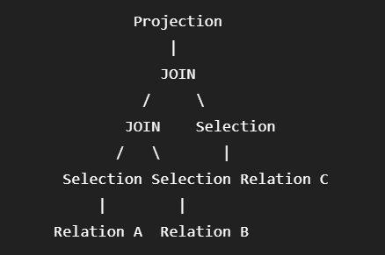
This structure ensures that selections and projections are applied before expensive join operations.

7. Advantages of Heuristic Optimization
- Reduces the number of tuples processed.
- Reduces the size of intermediate relations.
- Reduces memory requirements.
- Reduces disk I/O.
- Improves query execution performance.
- Produces a simpler and more efficient execution plan.

8. Result
A pseudocode algorithm for heuristic query optimization was designed using selection pushdown, projection pushdown, and join ordering. These techniques reduce unnecessary processing and intermediate results.

Conclusion
Heuristic query optimization improves query performance by applying simple but effective transformation rules. Selection is pushed down, required attributes are projected early, and joins are ordered to produce smaller intermediate results. These techniques help the DBMS execute queries more efficiently.

