SIMATS ENGINEERING (SAVEETHA SCHOOL OF ENGINEERING)
Department of Computer Science and Engineering

ASSESSMENT TOOL 1 – Coding Challenge Task

Course Code: | CSA06 | Course Title: | Design and Analysis of Algorithms
CO Assessed: | CO4: Articulation (BL4, BL5) | Assessment: | Assessment Tool 1 – Coding Challenge Task
Weightage: | 40% of CIA | Total Marks: | 100
CO4 Statement: | Solve optimization problems using dynamic programming and greedy strategies.
Student Name: | Geferlin Boffy R | Reg. No.: | 192571080
Section / Batch: | B Tech CSE Bioscience | Date: | 11/08/2026
Instructions to Students
- Answer the following question. Total Marks: 100.
- Carefully analyze the given questions.
- Write clear code for the given problem.
- Analyze the Time complexity and Space complexity of your code using dynamic programming and greedy strategies

Question Type | Focus Area | Questions
Coding Challenge Task | Focus on Code and analyze optimization problems using dynamic programming and greedy strategies | Q1

SECTION A – Coding Challenge Task

Code of Conduct
I (Name / Reg No) certify that this submission is my original work and that I have adhered to the guidelines specified for this assessment. I understand that any violation of academic integrity rules will result in disciplinary action.
Signature of the Student:

RUBRICS FOR CALCULATION

Coding Challenge Task

Criteria | Weightage | Level 4 (Exemplary) | Level 3 (Proficient) | Level 2 (Developing) | Level 1 (Beginning)
Problem Understanding | 20% | Clearly understands problem constraints, edge cases, and  competitive requirements | Understands problem with minor gaps in constraints | Partial understanding; misses key constraints | Misinterprets problem or constraints
Algorithm | 25% | Selects optimal algorithm with best time and space complexity for competitive constraints | Uses efficient algorithm with minor scope for improvement | Uses basic/inefficient approach | No clear algorithmic approach
Code Implementation | 20% | Writes correct, efficient, and clean code that passes all  constraints | Code works with minor errors or inefficiencies | Partially correct code; fails for some cases | Code does not execute or gives incorrect results
Competitive Performance | 20% | Solves problem within time limits and  handles large inputs effectively | Solves within acceptable time with minor delays | Struggles with time limits or larger inputs | Unable to solve within time constraints
Test Case Handling | 15% | Handles all test cases including edge and hidden cases | Handles most test cases | Misses important edge cases | Fails on multiple test cases

Marks Evaluation:
Criteria | Wt. | Level 4 – Exemplary | Level 3 – Proficient | Level 2 – Developing | Level 1 – Beginning
Problem Understanding | 20%
Algorithm | 25%
Code Implementation | 20%
Competitive Performance | 20%
Test Case Handling | 15%
Total Marks (100):

Faculty In-charge | Course Coordinator | Head of Department
Name: | Name: | Name:
Signature: | Signature: | Signature:
Date: | Date: | Date:

Q39.Decode Ways Problem
A string of digits represents encoded letters where &#39;1&#39; to &#39;26&#39; map to &#39;A&#39; to &#39;Z&#39;. The task is to count how
many ways the string can be decoded. The goal is to determine all valid decoding combinations. Use
Dynamic Programming to compute efficiently.
Input Format:
s = digit string
Sample Input:
s = 226
Expected Output:
Ways = 3
Answer:
Problem Statement:
A string of digits represents encoded letters where '1' to '26' map to 'A' to 'Z'. The task is to count how many ways the string can be decoded. The goal is to determine all valid decoding combinations using Dynamic Programming.
Input Format:
A string of digits s.
Sample Input:
226

Python Program:
def num_decodings(s):
n = len(s)

if n == 0 or s[0] == '0':
return 0

dp = [0] * (n + 1)

dp[0] = 1
dp[1] = 1

for i in range(2, n + 1):
if s[i - 1] != '0':
dp[i] += dp[i - 1]

two_digit = int(s[i - 2:i])

if 10 <= two_digit <= 26:
dp[i] += dp[i - 2]

return dp[n]

s = input("Enter digit string: ")
print("Ways =", num_decodings(s))

Output:
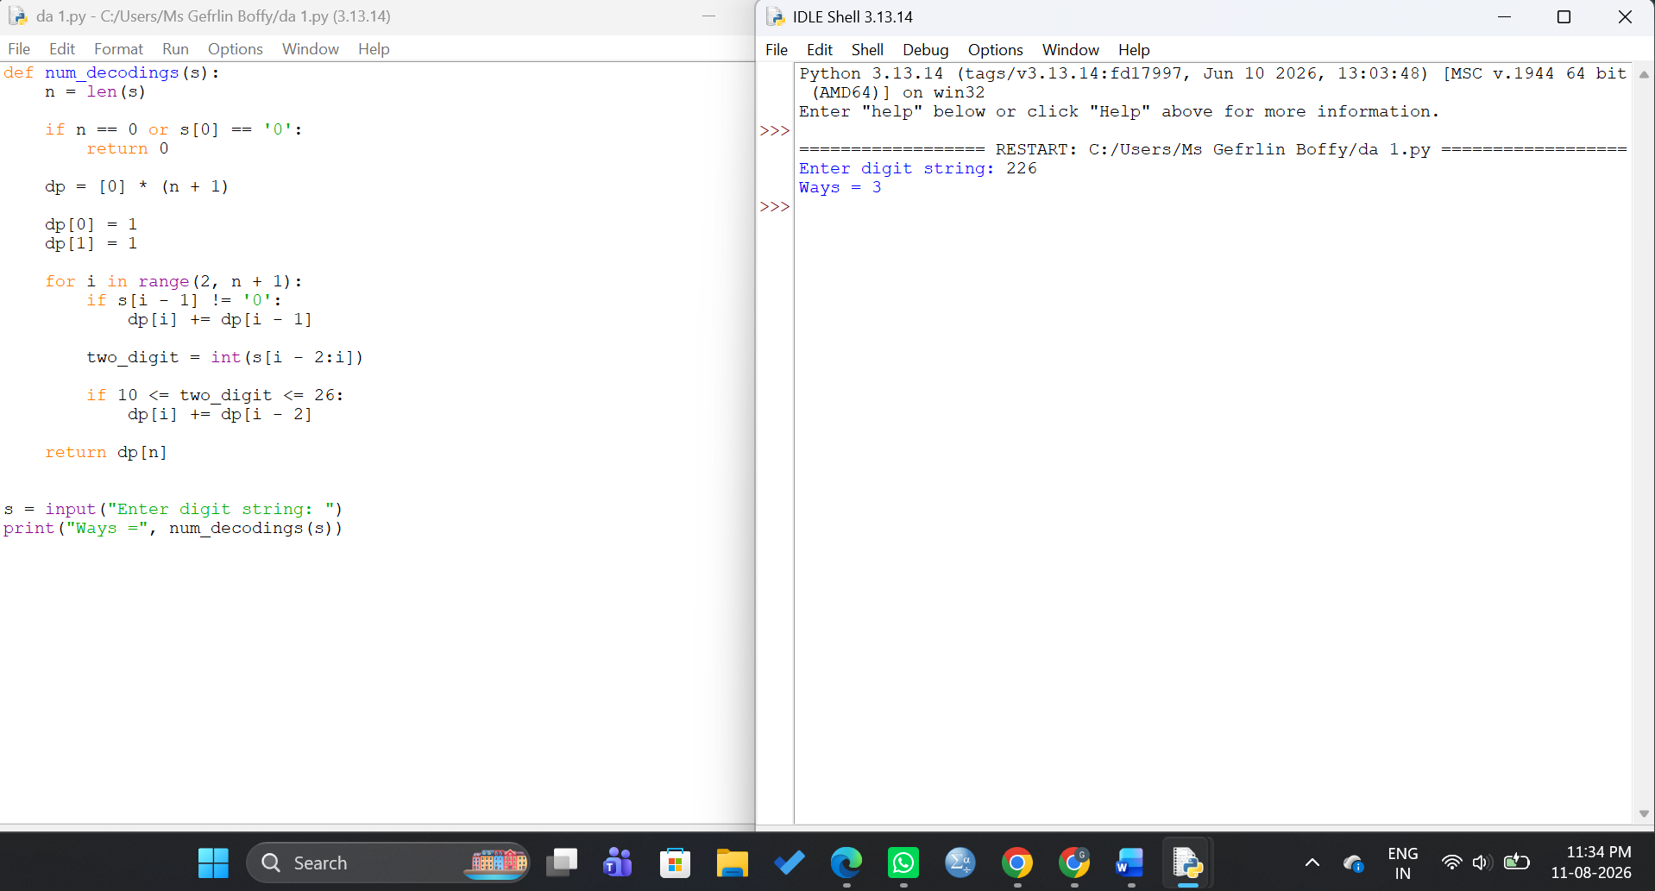
Explanation:
The string 226 can be decoded in three different ways:
- 2 2 6 → B B F
- 22 6 → V F
- 2 26 → B Z
Therefore, the total number of valid decoding ways is 3.
Dynamic Programming Approach:
The array dp[i] stores the number of ways to decode the first i characters of the string.
- A single non-zero digit can be decoded as one letter.
- A two-digit number between 10 and 26 can be decoded as one letter.
- The previous computed values are reused to avoid repeated calculations.
Complexity Analysis:
Time Complexity: O(n)
Space Complexity: O(n)
Result:
For the input 226, the number of valid decoding ways is 3.

