DSA0118
ASSIGNMENT 1 – CO3
C++ PROGRAMMING LAB
Question statements and submitted code/output screenshots

Q1 – Check Whether a Number Is a Münchhausen Number
Question
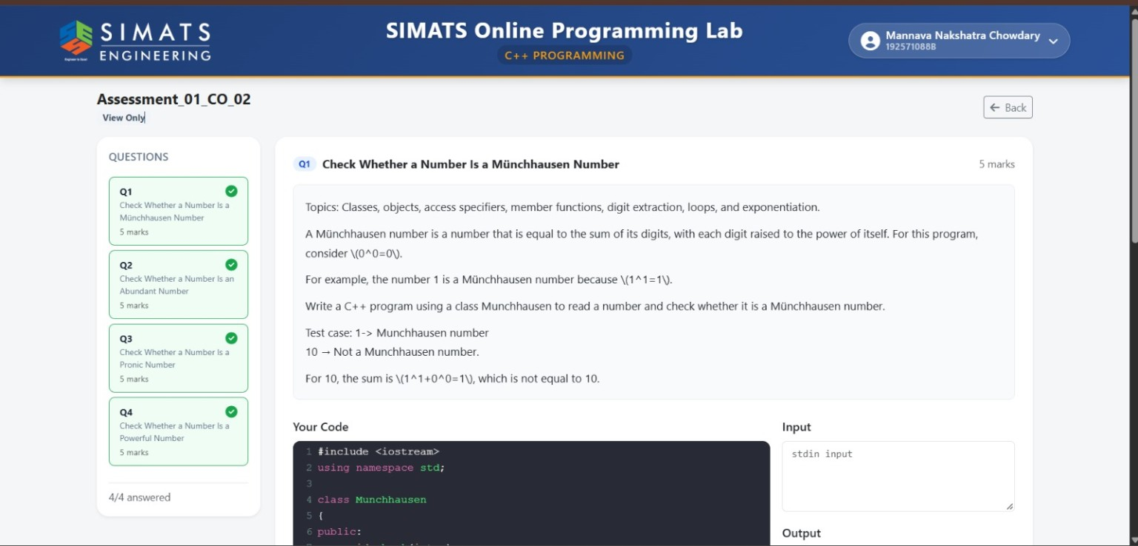
Code and Output
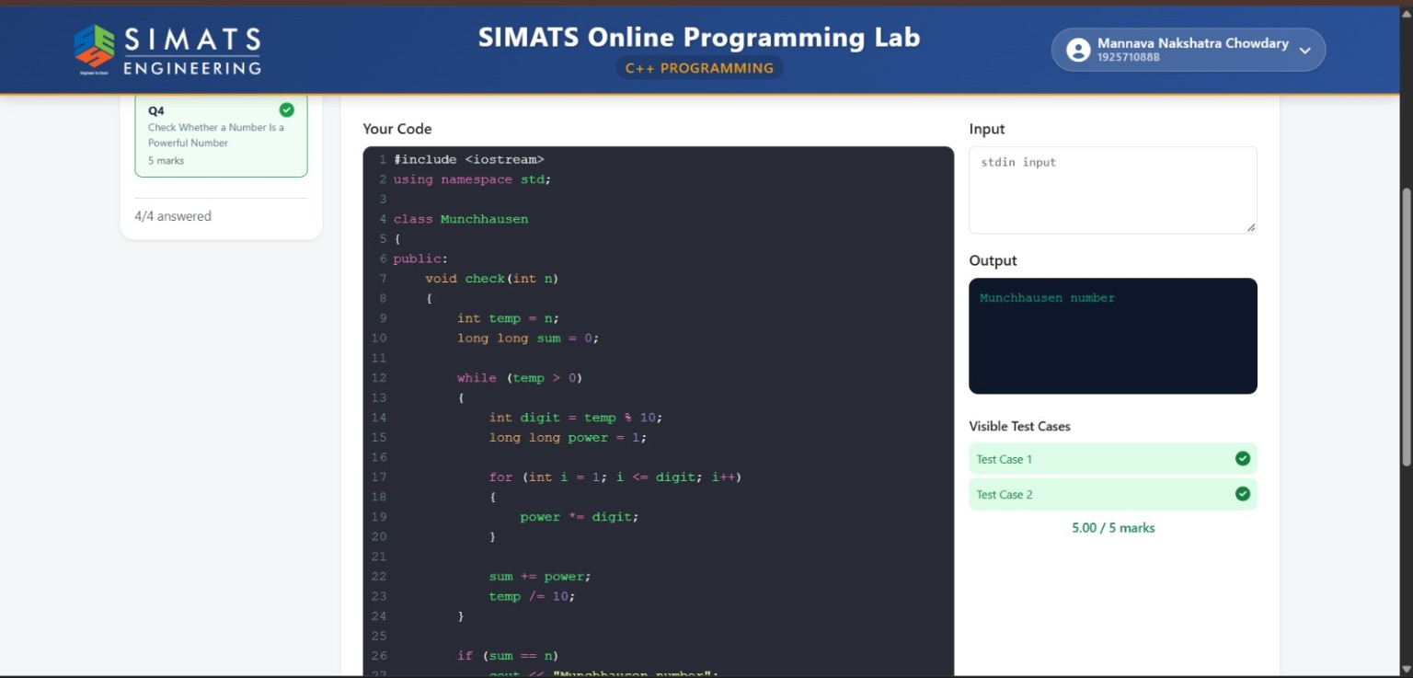

Q2 – Check Whether a Number Is an Abundant Number
Question
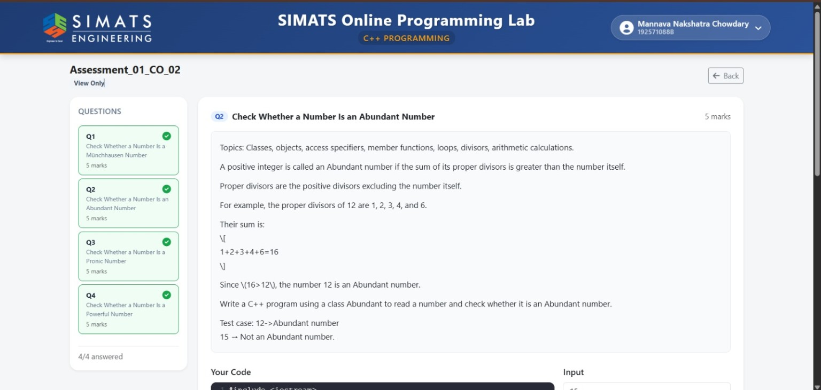
Code and Output
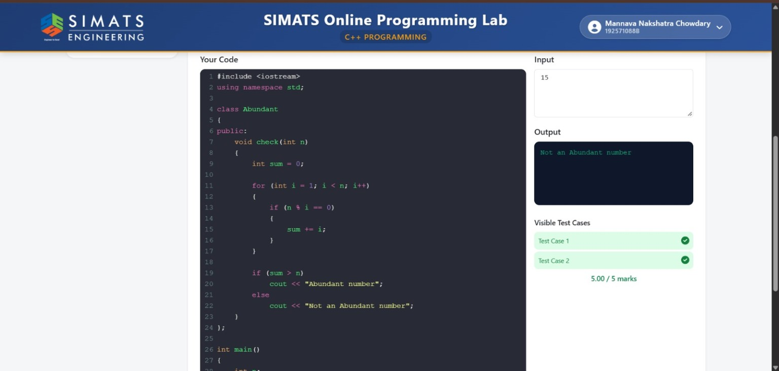

Q3 – Check Whether a Number Is a Pronic Number
Question
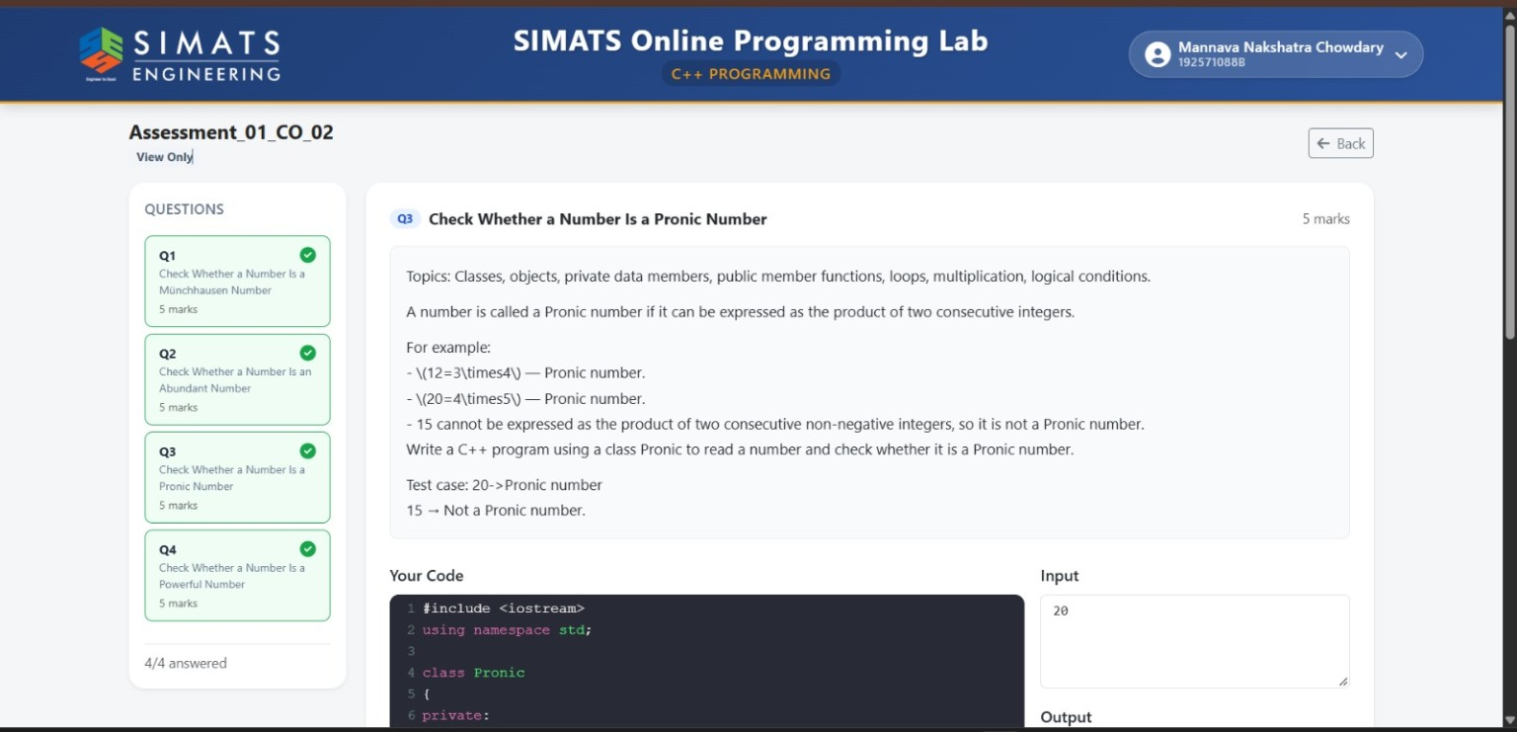
Code and Output
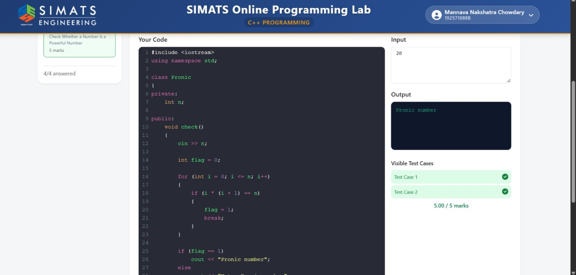

Q4 – Check Whether a Number Is a Powerful Number
Question
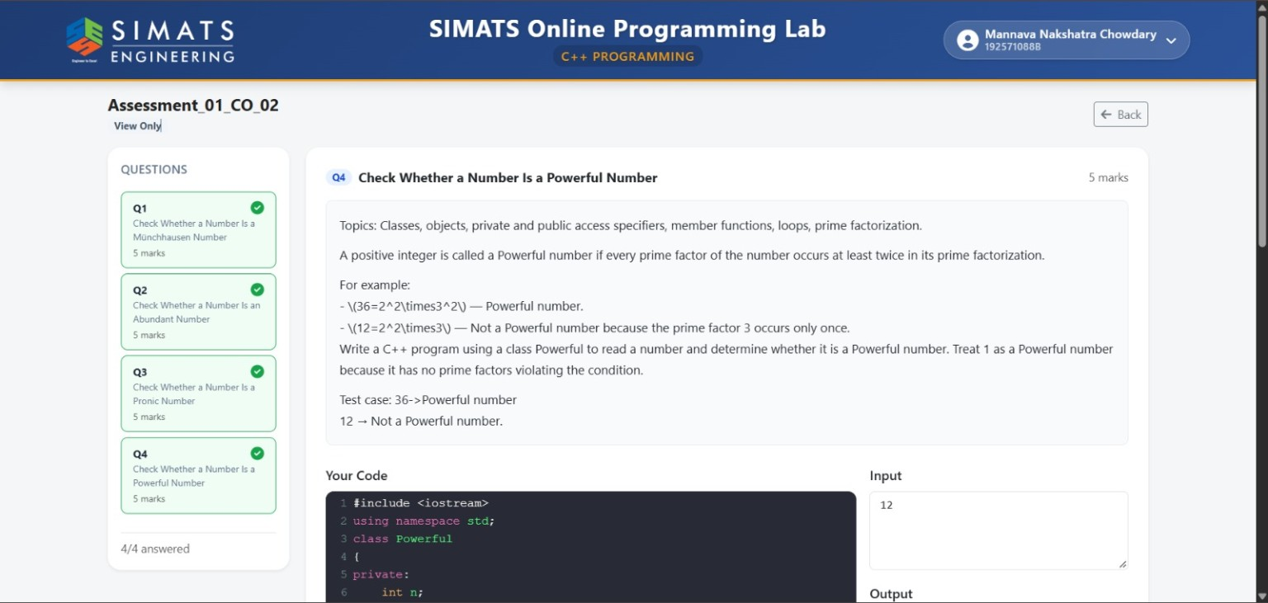
Code and Output


