DATA WAREHOUSING – CLASSROOM ACTIVITY
Name: Siva Balan K | Reg. No.: 192572037
Course: CSA1613- Data Warehousing and Data mining
Marks: 50 Duration: 1 hour
Activity 1: Design a Star Schema (15 Marks)
Grain: One fact row represents one student’s result in one course in one semester. Each dimension has a surrogate primary key (PK); the fact table stores foreign keys (FKs).
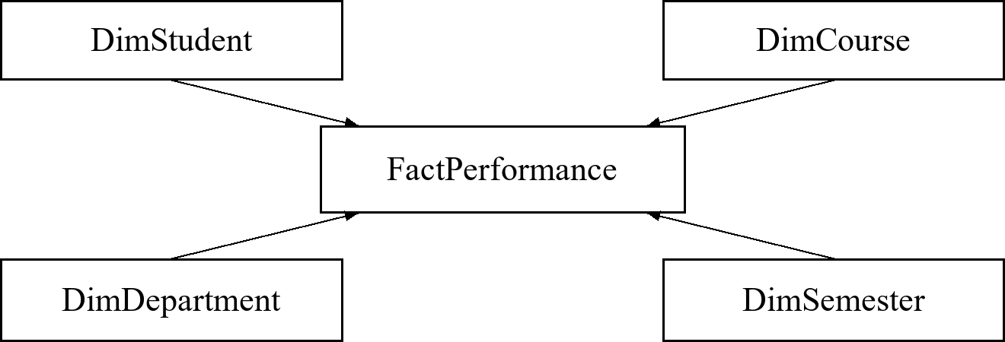
Arrows show dimension-to-fact, one-to-many relationships.
Tables, attributes, and keys
FactPerformance: Performance_Key (PK); Student_Key, Course_Key, Department_Key, Semester_Key (FKs); Internal_Mark, Assignment_Mark, Model_Mark, Final_Mark, Total_Mark, Average_Mark, Attendance_Percent, Result_Status.
DimStudent: Student_Key (PK), Student_ID, Student_Name, Gender, Admission_Year.
DimCourse: Course_Key (PK), Course_Code, Course_Name, Credits, Course_Type.
DimDepartment: Department_Key (PK), Department_Code, Department_Name, Faculty_Name.
DimSemester: Semester_Key (PK), Semester_Number, Academic_Year, Start_Date, End_Date.
Each FK references the matching dimension PK. Enforce uniqueness on (Student_Key, Course_Key, Semester_Key). Department_Key represents the student’s department for that result. Total_Mark is the sum of four marks; Average_Mark is that sum divided by four. Use marks on comparable scales and calculate averages at the required reporting level.

Activity 2: Perform ETL Operations (10 Marks)
Extract admission, examination, and attendance records into a staging area. Retain source identifiers and original values for audit. The sample below uses one course and semester for each student.
Sample source records
Source | Student | Raw values
Admission | S01 | Anu; CSE; 15/07/2025
Admission | S01 | Anu; CSE; 15/07/2025 (duplicate)
Admission | S02 | Bala; Computer Science; 2025-07-16
Exam | S01 | CSA1613; Sem 1; mark 78
Exam | S02 | CSA1613; Sem 1; mark missing
Attendance | S01 | CSA1613; Sem 1; 90%
Attendance | S02 | CSA1613; Sem 1; 80%

Transformations performed
1. Trim spaces and standardize identifiers. Remove the exact duplicate admission row for S01. Resolve conflicting duplicates using a documented source-priority or latest-update rule.
2. Map “CSE” and “Computer Science” to the standard department name “Computer Science and Engineering”. Parse dates using the known source format; store dates as DATE values, displayed as YYYY-MM-DD.
3. Preserve the missing examination mark as NULL and set Mark_Status to “Pending”; do not invent an academic score. Convert attendance to a number and validate marks and attendance within 0–100.
4. Join admission by Student_ID; join exam and attendance by Student_ID, Course_Code, and Semester. Send invalid or unmatched records to an exception log.
Cleaned target: StudentAcademic_Stage
ID / Name | Dept. / Admission date | Mark / Attendance
S01 / Anu | CSE / 2025-07-15 | 78 / 90%
S02 / Bala | CSE / 2025-07-16 | NULL / 80%

CSE above is the canonical department code; its dimension stores the full standardized name. Both rows refer to CSA1613, Semester 1. S01 has status “Available”; S02 has status “Pending”.
Load: Upsert dimensions, look up their surrogate keys, and load facts in a transaction. Use a unique student–course–semester key to prevent repeat loads. Reconcile source and target counts and log rejected rows.

Activity 3: OLAP Operations (15 Marks)
Dimensions: Time (Year → Month), Product, and Location. Measure: Sales_Amount (₹). The following illustrative dataset contains eight sales records; each row is a monthly aggregate.
Year | Month | Product | Location | Sales (₹)
2025 | Jan | Laptop | Chennai | 10000
2025 | Jan | Phone | Madurai | 5000
2025 | Feb | Laptop | Chennai | 12000
2025 | Feb | Phone | Madurai | 6000
2026 | Jan | Laptop | Chennai | 14000
2026 | Jan | Phone | Madurai | 7000
2026 | Feb | Laptop | Chennai | 16000
2026 | Feb | Phone | Madurai | 8000

a) Roll-up: Monthly sales into yearly sales
Move upward from Month to Year and sum sales across products and locations. Only the months supplied in the sample contribute to each year.
Year | Total sales (₹)
2025 | 33,000
2026 | 45,000

For 2025: 10,000 + 5,000 + 12,000 + 6,000 = ₹33,000.
b) Drill-down: Yearly sales into month-wise sales
Move down the Time hierarchy from Year to Month, using the underlying detailed data.
Year | Month | Total sales (₹)
2025 | Jan | 15,000
2025 | Feb | 18,000
2026 | Jan | 21,000
2026 | Feb | 24,000

The 2026 total of ₹45,000 is explained by January ₹21,000 and February ₹24,000. A yearly total alone cannot reconstruct monthly detail; the warehouse must retain it.

Activity 3: OLAP Operations (continued)
c) Slice: Select one specific product
Fix Product = “Laptop”. This removes the varying Product dimension from the displayed result while retaining Time and Location.
Year | Month | Location | Sales (₹)
2025 | Jan | Chennai | 10,000
2025 | Feb | Chennai | 12,000
2026 | Jan | Chennai | 14,000
2026 | Feb | Chennai | 16,000

Total laptop sales in the selected slice = ₹52,000.
d) Dice: Select a subcube using several dimensions
Select Product IN {Laptop, Phone}, Location IN {Chennai, Madurai}, Year = 2026, and Month = January. Apply all conditions together to obtain:
Year / Month | Product | Location | Sales (₹)
2026 / Jan | Laptop | Chennai | 14,000
2026 / Jan | Phone | Madurai | 7,000

The selected subcube totals ₹21,000. Dice applies a combination of restrictions across dimensions; unlike slice, it need not fix only one dimension to one value.
e) Pivot: Compare products across locations
Aggregate the full dataset over Time, place Product on rows and Location on columns, and sum Sales_Amount. This changes the orientation used to view the data.
Product | Chennai (₹) | Madurai (₹) | Total (₹)
Laptop | 52,000 | 0 | 52,000
Phone | 0 | 26,000 | 26,000
Total | 52,000 | 26,000 | 78,000

Zero means no sales records exist for that combination in this sample. Pivoting the table back would place locations on rows and products on columns without changing any totals.
Validation: ₹33,000 + ₹45,000 = ₹78,000, matching the pivot grand total. All operations use the same source data and the additive sales measure.

Activity 4: Hospital Warehouse Architecture (10 Marks)
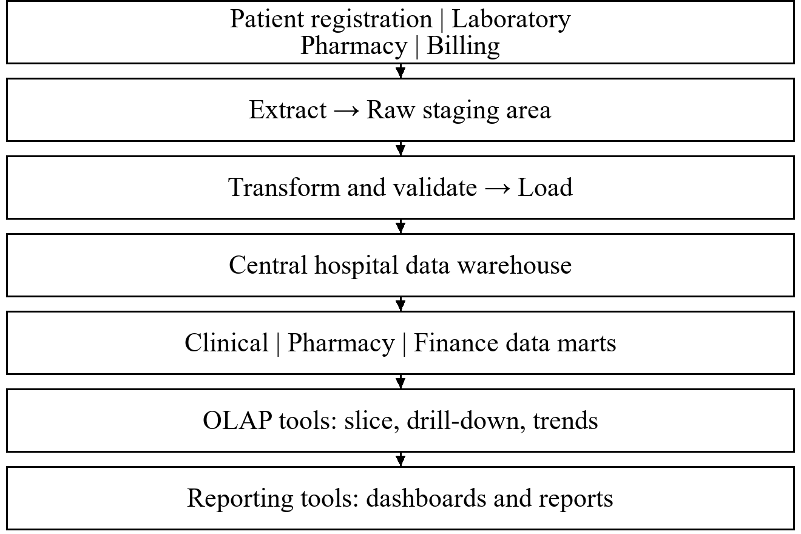
Functions of the components
Sources: Registration supplies patient and visit details; laboratory supplies test results; pharmacy supplies dispensing records; billing supplies charges and payments.
ETL: Extract data, match patient identities, standardize codes and units, remove duplicates, validate records, and load the warehouse.
Staging: Temporarily stores source extracts for cleansing, reconciliation, and recovery before warehouse loading.
Central warehouse: Stores integrated historical data with shared Patient, Date, Department, and Clinician dimensions. Keep visits, tests, dispensing, and billing facts at their own grains to avoid double-counting.
Data marts: Provide subject-specific clinical, pharmacy, and finance views for each management team.
OLAP and reporting: OLAP enables multidimensional analysis; dashboards and reports present trends, indicators, and exceptions.
Decision support: Managers compare demand and revenue, monitor laboratory turnaround, plan medicine stock, and allocate staff. Shared dimensions support consistent comparisons. Apply role-based access, audit logging, and patient-data protection across the architecture.

