COURSE: DSA0406 - Fundamentals of Data Science | Name: Siva Balan K
DATE: 13.10.2026 | Reg.no: 192572037
EXPERIMENT 7: Using Pandas DataFrame operations, find the number of orders by each
customer, average quantity for each product, and earliest and latest order dates.
Aim
To using Pandas DataFrame operations, find the number of orders by each customer, average
quantity for each product, and earliest and latest order dates.
Program
import pandas as pd
order_data = pd.DataFrame({
"customer_id": ["C101", "C102", "C101", "C103", "C102", "C101"],
"order_date": ["2026-09-02", "2026-09-05", "2026-09-10",
"2026-09-15", "2026-09-20", "2026-09-28"],
"product_name": ["Laptop", "Mouse", "Keyboard", "Mouse", "Laptop", "Mouse"],
"order_quantity": [1, 3, 2, 1, 2, 4]
})
order_data["order_date"] = pd.to_datetime(order_data["order_date"])
print("
Output
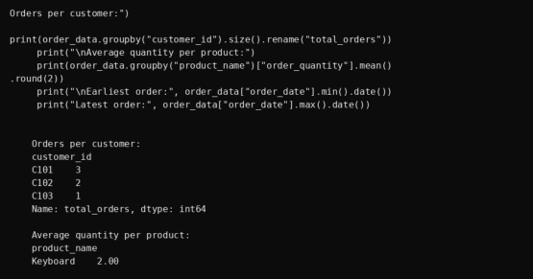
Result
Thus, the required analysis was performed using Python and the results were obtained.

EXPERIMENT 8: How would you find the top 5 products that have been sold the most in
the past month?
Aim
To how would you find the top 5 products that have been sold the most in the past month?.
Program
import pandas as pd
analysis_date = pd.Timestamp("2026-10-01")
month_end = analysis_date.replace(day=1)
month_start = month_end - pd.DateOffset(months=1)
sales_data = pd.DataFrame({
"order_date": ["2026-09-02", "2026-09-04", "2026-09-07", "2026-09-09",
"2026-09-12", "2026-09-15", "2026-09-18", "2026-09-25",
"2026-08-30", "2026-10-01"],
"product_name": ["Mouse", "Keyboard", "Laptop", "Monitor", "Headphones",
"Webcam", "Mouse", "Keyboard", "Webcam", "Laptop"],
"quantity": [40, 25, 10, 20, 30, 15, 35, 20, 100, 200]
})
sales_data["order_date"] = pd.to_datetime(sales_data["order_date"])
last_month = sales_data[
(sales_data["order_date"] >= month_start) &
(sales_data["order_date"] < month_end)
]
top_five = (last_month.groupby("product_name")["quantity"].sum()
.sort_values(ascending=False).head(5))
print("Period:", month_start.date(), "to", (month_end - pd.Timedelta(days=1)).date())
print("Top five products by units sold:")
print(top_five.rename("units_sold"))
Output
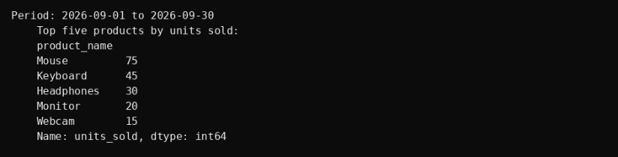
Result
Thus, the required analysis was performed using Python and the results were obtained.

EXPERIMENT 9: Using Pandas DataFrame operations, find average listing price by
location, properties with more than four bedrooms, and the property with the largest area.
Aim
To using Pandas DataFrame operations, find average listing price by location, properties with
more than four bedrooms, and the property with the largest area.
Program
import pandas as pd
property_data = pd.DataFrame({
"property_id": ["P101", "P102", "P103", "P104", "P105", "P106"],
"location": ["Chennai", "Coimbatore", "Chennai", "Madurai", "Coimbatore", "Madurai"
"bedrooms": [3, 5, 6, 4, 2, 5],
"area_sq_ft": [1500, 2400, 3200, 1900, 1200, 2600],
"listing_price": [6500000, 7500000, 12500000, 5500000, 4000000, 8500000]
})
print("
Output
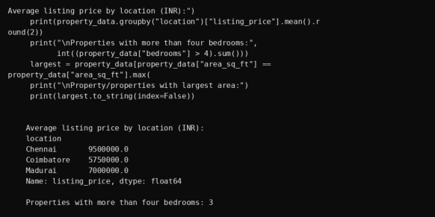
Result
Thus, the required analysis was performed using Python and the results were obtained.

EXPERIMENT 10: Develop a Python program to create a line plot and a bar plot of
monthly sales data.
Aim
To develop a Python program to create a line plot and a bar plot of monthly sales data.
Program
import matplotlib.pyplot as plt
months = ["Jan", "Feb", "Mar", "Apr", "May", "Jun",
"Jul", "Aug", "Sep", "Oct", "Nov", "Dec"]
sales = [12000, 15000, 14000, 18000, 21000, 20000,
24000, 26000, 25000, 28000, 31000, 35000]
fig, axes = plt.subplots(1, 2, figsize=(14, 4))
axes[0].plot(months, sales, marker="o", color="royalblue")
axes[0].set_title("Monthly sales: line plot")
axes[0].grid(alpha=0.3)
axes[1].bar(months, sales, color="seagreen")
axes[1].set_title("Monthly sales: bar plot")
for ax in axes:
ax.set_xlabel("Month")
ax.set_ylabel("Sales (INR)")
plt.tight_layout()
plt.show()
Output
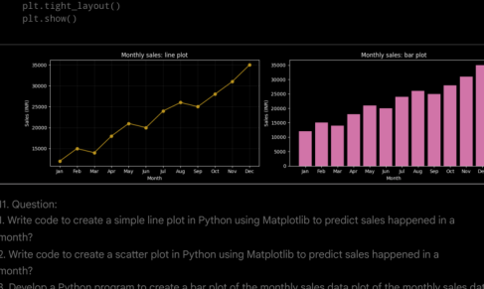
Result
Thus, the required analysis was performed using Python and the results were obtained.

EXPERIMENT 11: Create line, scatter and bar plots of sales data for a month using
Matplotlib.
Aim
To create line, scatter and bar plots of sales data for a month using Matplotlib.
Program
import matplotlib.pyplot as plt
days = list(range(1, 31))
sales = [12, 14, 10, 18, 20, 22, 19, 25, 24, 28,
26, 30, 32, 29, 35, 36, 33, 38, 40, 37,
42, 44, 41, 46, 48, 45, 50, 52, 49, 55]
fig, axes = plt.subplots(3, 1, figsize=(11, 10))
axes[0].plot(days, sales, marker="o", color="royalblue")
axes[0].set_title("Daily product sales: line plot")
axes[1].scatter(days, sales, color="darkorange")
axes[1].set_title("Daily product sales: scatter plot")
axes[2].bar(days, sales, color="seagreen")
axes[2].set_title("Daily product sales: bar plot")
for ax in axes:
ax.set_xlabel("Day of September")
ax.set_ylabel("Units sold")
ax.set_xticks(range(1, 31, 2))
ax.grid(axis="y", alpha=0.3)
plt.tight_layout()
plt.show()
print("Total units sold in the month:", sum(sales))
Output
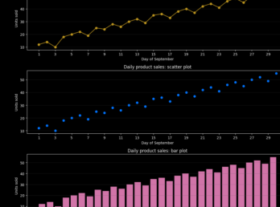
Result
Thus, the required analysis was performed using Python and the results were obtained.

EXPERIMENT 12: Develop a Python program to create a line plot of monthly temperature
and a scatter plot of monthly rainfall.
Aim
To develop a Python program to create a line plot of monthly temperature and a scatter plot of
monthly rainfall.
Program
import matplotlib.pyplot as plt
months = ["Jan", "Feb", "Mar", "Apr", "May", "Jun",
"Jul", "Aug", "Sep", "Oct", "Nov", "Dec"]
temperature = [24, 25, 28, 31, 34, 33, 31, 30, 29, 27, 25, 24]
rainfall = [20, 15, 10, 25, 45, 65, 80, 95, 120, 180, 200, 90]
fig, axes = plt.subplots(1, 2, figsize=(14, 4))
axes[0].plot(months, temperature, marker="o", color="tomato")
axes[0].set_title("Monthly temperature")
axes[0].set_ylabel("Temperature (degrees C)")
axes[1].scatter(months, rainfall, color="royalblue", s=70)
axes[1].set_title("Monthly rainfall")
axes[1].set_ylabel("Rainfall (mm)")
for ax in axes:
ax.set_xlabel("Month")
ax.grid(alpha=0.3)
plt.tight_layout()
plt.show()
Output
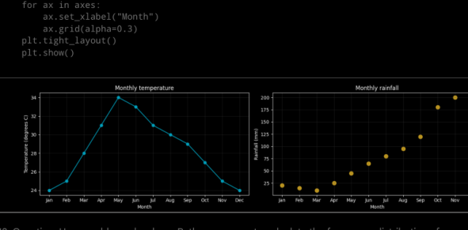
Result
Thus, the required analysis was performed using Python and the results were obtained.

EXPERIMENT 13: Develop a Python program to calculate the frequency distribution of
words in a text document.
Aim
To develop a Python program to calculate the frequency distribution of words in a text document.
Program
from pathlib import Path
from collections import Counter
import re
import pandas as pd
file_path = Path("sample_text.txt")
if not file_path.exists():
file_path.write_text(
"Data science uses data to find patterns. Python makes data analysis "
"simple. Data analysis helps companies make better decisions.",
encoding="utf-8"
)
text = file_path.read_text(encoding="utf-8")
words = re.findall(r"\b[a-z]+\b", text.lower())
frequency = Counter(words)
table = pd.DataFrame(frequency.most_common(), columns=["word", "frequency"])
print(table.to_string(index=False))
word frequency
data 4
analysis 2
science 1
uses 1
to 1
find 1
patterns 1
python 1
makes 1
simple 1
helps 1
companies 1
make 1
better 1
decisions 1
Output
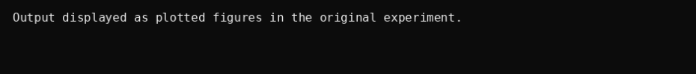
Result
Thus, the required analysis was performed using Python and the results were obtained.

EXPERIMENT 14: Develop Python code to find the frequency distribution of ages of
customers who purchased in the past month.
Aim
To develop Python code to find the frequency distribution of ages of customers who purchased in
the past month.
Program
import pandas as pd
purchase_data = pd.DataFrame({
"customer_id": ["C101", "C102", "C103", "C101", "C104", "C105", "C106", "C107"],
"age": [22, 25, 22, 22, 30, 25, 35, 40],
"purchase_date": ["2026-09-02", "2026-09-05", "2026-09-08", "2026-09-12",
"2026-09-16", "2026-09-20", "2026-09-27", "2026-08-25"]
})
purchase_data["purchase_date"] = pd.to_datetime(purchase_data["purchase_date"])
analysis_date = pd.Timestamp("2026-10-01")
month_end = analysis_date.replace(day=1)
month_start = month_end - pd.DateOffset(months=1)
customers = purchase_data[
(purchase_data["purchase_date"] >= month_start) &
(purchase_data["purchase_date"] < month_end)
].drop_duplicates("customer_id")
age_frequency = customers["age"].value_counts().sort_index()
print("
Output
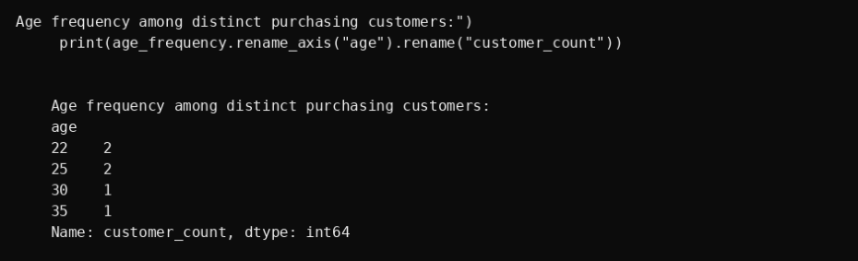
Result
Thus, the required analysis was performed using Python and the results were obtained.

EXPERIMENT 15: Develop a Python program to calculate the frequency distribution of
likes among posts.
Aim
To develop a Python program to calculate the frequency distribution of likes among posts.
Program
import pandas as pd
post_data = pd.DataFrame({
"post_id": range(1, 13),
"likes": [10, 20, 15, 10, 30, 20, 15, 10, 40, 30, 20, 50]
})
frequency = post_data["likes"].value_counts().sort_index()
print("
Output
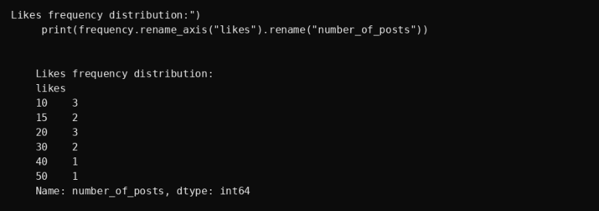
Result
Thus, the required analysis was performed using Python and the results were obtained.

EXPERIMENT 16: Develop a Python program to calculate the frequency distribution of
words in customer reviews.
Aim
To develop a Python program to calculate the frequency distribution of words in customer
reviews.
Program
from collections import Counter
import re
import pandas as pd
reviews = pd.DataFrame({
"review": [
"The product is good and the delivery is fast.",
"Good quality product with fast delivery!",
"The product quality is excellent.",
"Delivery was late but the product is good.",
None
]
})
words = []
for review in reviews["review"].dropna():
words.extend(re.findall(r"\b[a-z]+\b", str(review).lower()))
frequency = Counter(words)
print(pd.DataFrame(frequency.most_common(),
columns=["word", "frequency"]).to_string(index=False))
word frequency
the 4
product 4
is 4
good 3
delivery 3
fast 2
quality 2
and 1
with 1
excellent 1
was 1
late 1
but 1
Output
Result
Thus, the required analysis was performed using Python and the results were obtained.

EXPERIMENT 17: Create a Python program to gain insights from customer feedback
data.
Aim
To create a Python program to gain insights from customer feedback data.
Program
from pathlib import Path
from collections import Counter
import string
import pandas as pd
import matplotlib.pyplot as plt
file_path = Path("data.csv")
if not file_path.exists():
pd.DataFrame({"feedback": [
"The product is excellent and the delivery is fast.",
"Good product quality and good customer service.",
"The delivery is slow but the product is good.",
"Excellent service and fast delivery.",
"The product quality is excellent.",
"Customer service is helpful and the delivery is good."
]}).to_csv(file_path, index=False)
feedback_data = pd.read_csv(file_path)
if "feedback" not in feedback_data.columns:
raise ValueError("data.csv must contain a column named 'feedback'.")
stop_words = {
"a", "an", "the", "and", "or", "but", "is", "are", "was", "were",
"be", "been", "being", "to", "of", "in", "on", "at", "for", "with",
"as", "by", "it", "its", "this", "that", "these", "those", "i", "we",
"you", "he", "she", "they", "my", "our", "your", "their", "from",
"has", "have", "had", "not", "so", "very", "do", "does", "did"
}
punctuation_to_spaces = str.maketrans({ch: " " for ch in string.punctuation})
word_frequency = Counter()
for feedback in feedback_data["feedback"].dropna():
cleaned = str(feedback).lower().translate(punctuation_to_spaces)
tokens = [word for word in cleaned.split()
if word.isalpha() and word not in stop_words]
word_frequency.update(tokens)
while True:
try:
n = int(input("Enter the number of top words to display: "))
if n > 0:
break
print("Please enter a positive integer.")
except ValueError:
print("Please enter a valid integer.")
top_words = word_frequency.most_common(n)
if top_words:
result = pd.DataFrame(top_words, columns=["word", "frequency"])
print(result.to_string(index=False))
Output
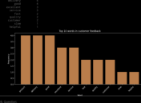
Result
Thus, the required analysis was performed using Python and the results were obtained.

EXPERIMENT 18: Calculate mean, median and standard deviation of age and %fat, and
draw boxplots, scatter and Q-Q plots.
Aim
To calculate mean, median and standard deviation of age and %fat, and draw boxplots, scatter
and Q-Q plots.
Program
import numpy as np
import pandas as pd
import matplotlib.pyplot as plt
from scipy import stats
adult_data = pd.DataFrame({
"age": [22, 25, 28, 31, 34, 37, 40, 43, 46,
49, 52, 55, 58, 61, 64, 67, 70, 73],
"fat_percent": [12.5, 15.2, 14.8, 18.1, 19.5, 17.7,
22.3, 21.0, 24.6, 23.1, 26.4, 25.7,
28.9, 27.5, 30.2, 29.8, 32.1, 31.4]
})
print("Illustrative data: 18 adults")
summary = adult_data.agg(["mean", "median", "std"])
print(summary.round(2))
print("\nStandard deviation uses ddof=1 (sample standard deviation).")
fig, axes = plt.subplots(1, 2, figsize=(10, 4))
axes[0].boxplot(adult_data["age"])
axes[0].set_title("Age boxplot")
axes[0].set_ylabel("Age (years)")
axes[0].set_xticks([1], ["Age"])
axes[1].boxplot(adult_data["fat_percent"])
axes[1].set_title("Body-fat boxplot")
axes[1].set_ylabel("Body fat (%)")
axes[1].set_xticks([1], ["Body fat"])
plt.tight_layout()
plt.show()
plt.figure(figsize=(6, 4))
plt.scatter(adult_data["age"], adult_data["fat_percent"], color="purple")
plt.title("Age versus body fat")
plt.xlabel("Age (years)")
plt.ylabel("Body fat (%)")
plt.grid(alpha=0.3)
plt.tight_layout()
plt.show()
fig, axes = plt.subplots(1, 2, figsize=(12, 4))
stats.probplot(adult_data["age"], dist="norm", plot=axes[0])
axes[0].set_title("Normal Q-Q plot: age")
stats.probplot(adult_data["fat_percent"], dist="norm", plot=axes[1])
axes[1].set_title("Normal Q-Q plot: body fat")
plt.tight_layout()
plt.show()
age_quantiles = np.sort(adult_data["age"].to_numpy())
Output
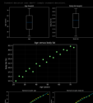
Result
Thus, the required analysis was performed using Python and the results were obtained.

EXPERIMENT 19: Calculate 95% confidence intervals for mean blood-pressure reduction
in drug and placebo groups.
Aim
To calculate 95% confidence intervals for mean blood-pressure reduction in drug and placebo
groups.
Program
import numpy as np
from scipy import stats
drug_reduction = np.array([
12, 15, 14, 10, 18, 16, 13, 17, 11, 15, 14, 19, 12,
16, 13, 18, 15, 14, 17, 11, 16, 15, 13, 20, 14
], dtype=float)
placebo_reduction = np.array([
3, 5, 2, 4, 6, 1, 3, 5, 4, 2, 7, 3, 4,
5, 2, 6, 3, 4, 1, 5, 4, 2, 6, 3, 4
], dtype=float)
def mean_confidence_interval(values, confidence=0.95):
values = np.asarray(values, dtype=float)
if values.size < 2 or not np.isfinite(values).all():
raise ValueError("Provide at least two finite reductions.")
mean = values.mean()
standard_error = values.std(ddof=1) / np.sqrt(values.size)
critical_value = stats.t.ppf((1 + confidence) / 2, df=values.size - 1)
margin = critical_value * standard_error
return mean, mean - margin, mean + margin
print("Illustrative results only")
for label, values in [("Drug", drug_reduction), ("Placebo", placebo_reduction)]:
mean, lower, upper = mean_confidence_interval(values)
print(f"{label}: n={len(values)}, mean reduction={mean:.2f} mmHg")
print(f"95% confidence interval: ({lower:.2f}, {upper:.2f}) mmHg\n")
Output
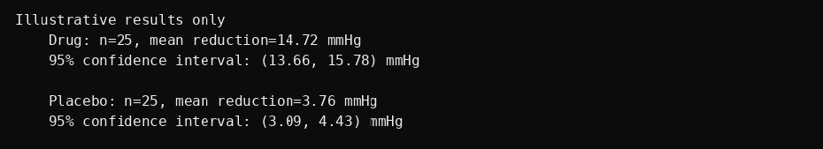
Result
Thus, the required analysis was performed using Python and the results were obtained.

EXPERIMENT 20: Determine whether conversion rates of website designs A and B differ
significantly using an A/B test.
Aim
To determine whether conversion rates of website designs A and B differ significantly using an
A/B test.
Program
import numpy as np
from scipy import stats
design_a = np.array([1] * 120 + [0] * 880)
design_b = np.array([1] * 160 + [0] * 840)
alpha = 0.05
for values in [design_a, design_b]:
if values.size == 0 or not np.isin(values, [0, 1]).all():
raise ValueError("Each group must contain binary visitor outcomes.")
n_a, n_b = len(design_a), len(design_b)
success_a, success_b = design_a.sum(), design_b.sum()
rate_a, rate_b = design_a.mean(), design_b.mean()
pooled_rate = (success_a + success_b) / (n_a + n_b)
expected_counts = [n_a * pooled_rate, n_a * (1 - pooled_rate),
n_b * pooled_rate, n_b * (1 - pooled_rate)]
if min(expected_counts) < 5:
raise ValueError("Expected counts are too small for this z-test; use an exact test.
standard_error = np.sqrt(pooled_rate * (1 - pooled_rate) * (1 / n_a + 1 / n_b))
z_statistic = (rate_b - rate_a) / standard_error
p_value = 2 * stats.norm.sf(abs(z_statistic))
print("Illustrative A/B test results")
Output
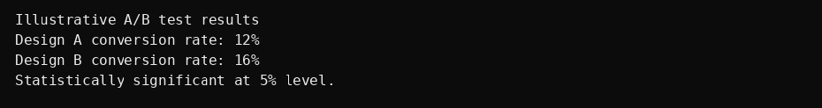
Result
Thus, the required analysis was performed using Python and the results were obtained.

