**Simple**if**Statement**

#include <stdio.h>

int main() {

int number;

printf("Enter a number: ");

scanf("%d", &number);

if (number > 0) {

printf("Number is positive.\n");

}

return 0;

}

**OUTPUT :**

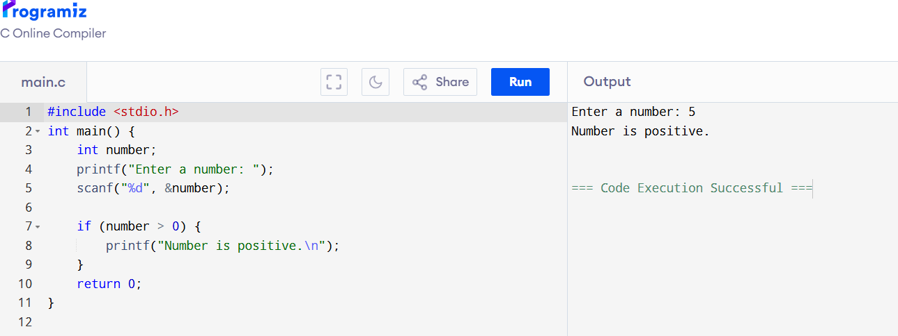

**if...else Statement**

#include <stdio.h>

int main() {

int number;

printf("Enter a number: ");

scanf("%d", &number);

if (number % 2 == 0) {

printf("Even number.\n");

} else {

printf("Odd number.\n");

}

return 0;

}

OUTPUT :

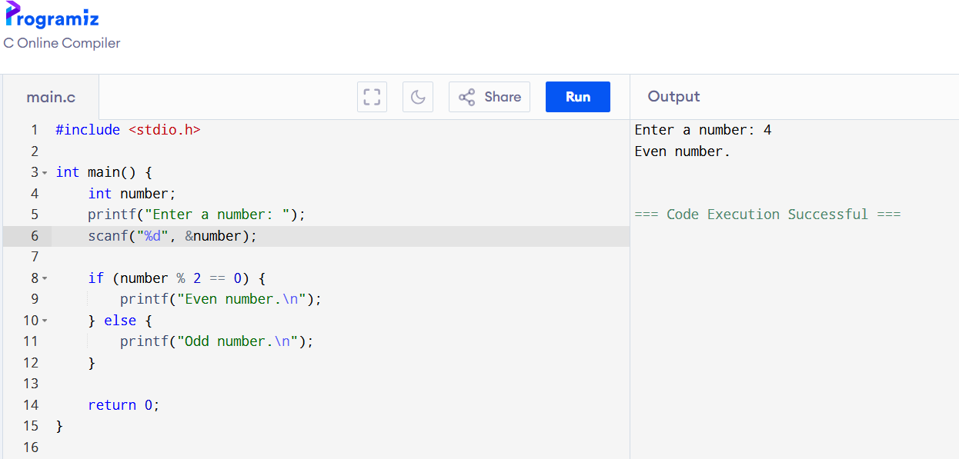

**else if Ladder**

#include <stdio.h>

int main() {

int marks;

printf("Enter marks: ");

scanf("%d", &marks);

if (marks >= 90) {

printf("Grade: A\n");

} else if (marks >= 75) {

printf("Grade: B\n");

} else if (marks >= 60) {

printf("Grade: C\n");

} else {

printf("Grade: F\n");

}

return 0;

}

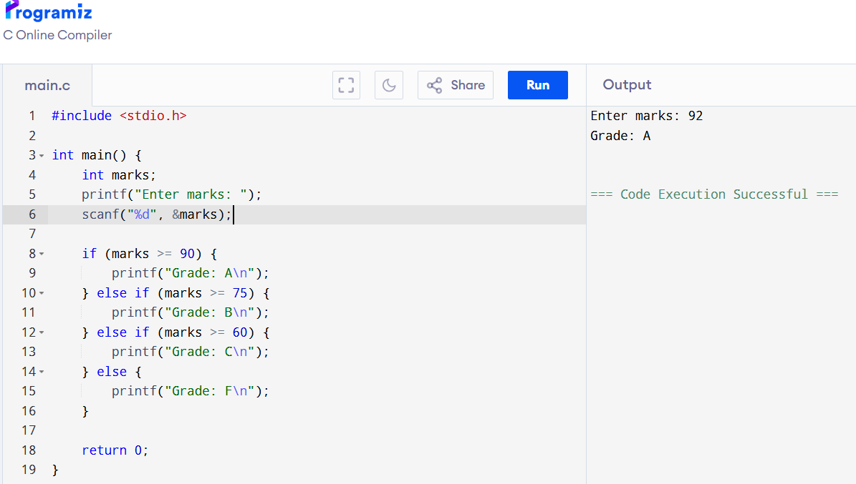

**Nested if Statement**

#include <stdio.h>

int main() {

int age;

printf("Enter your age: ");

scanf("%d", &age);

if (age >= 18) {

if (age >= 60) {

printf("Senior Citizen\n");

} else {

printf("Adult\n");

}

} else {

printf("Minor\n");

}

return 0;

}

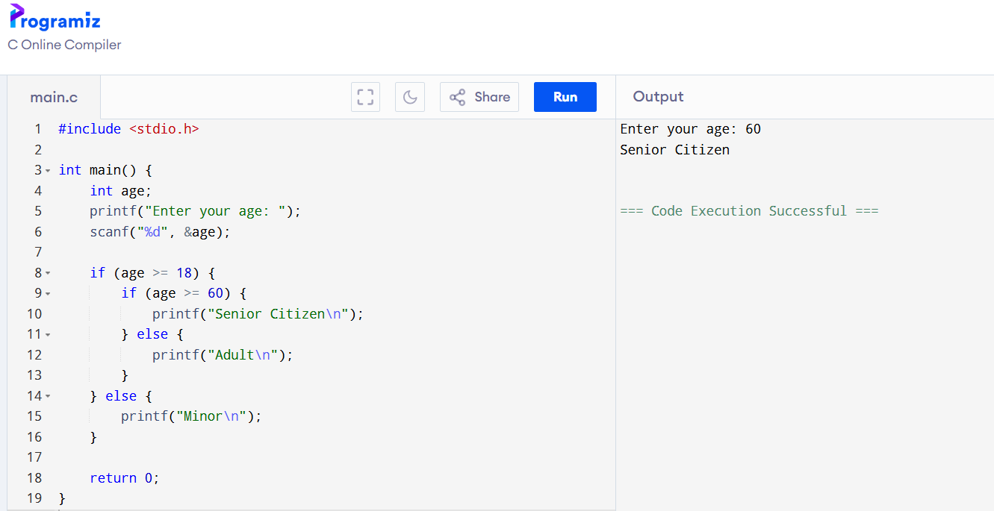

**switch Statement**

#include <stdio.h>

int main() {

int day;

printf("Enter day number (1-7): ");

scanf("%d", &day);

switch (day) {

case 1:

printf("Monday\n");

break;

case 2:

printf("Tuesday\n");

break;

case 3:

printf("Wednesday\n");

break;

case 4:

printf("Thursday\n");

break;

case 5:

printf("Friday\n");

break;

case 6:

printf("Saturday\n");

break;

case 7:

printf("Sunday\n");

break;

default:

printf("Invalid day number\n");

}

return 0;

}

