SIMATS ENGINEERING
ASSIGNMENT - 5

Student Name | P. ASHRITHA
Register Number | 192372200
Subject Code | CSA1001
Subject Name | Software Engineering

Question 1
Explain technical debt. What are the major causes of technical debt, and how can organizations minimize it during software evolution?

1. What is Technical Debt?
Technical Debt is a metaphor coined by Ward Cunningham that describes the implied cost of additional rework caused by choosing an easy, quick solution now instead of using a better, more time-consuming approach. Just like financial debt, technical debt accumulates “interest” over time — the longer a shortcut remains in the codebase, the more effort it eventually takes to fix, and the more it slows down future development.
Technical debt is not always bad in the short term — teams sometimes take on debt deliberately to meet a deadline or validate an idea quickly — but if it is not tracked and repaid, it steadily reduces code quality, system stability, and developer productivity.

2. Major Causes of Technical Debt
- Time pressure and tight deadlines: Developers take shortcuts — skipping proper design, testing, or documentation — to deliver features quickly.
- Poor initial design or architecture: Weak or outdated architectural decisions that do not scale well as the application grows.
- Lack of documentation: Undocumented code and design decisions make future changes riskier and slower for other developers.
- Insufficient testing: Skipping unit/integration tests to save time means bugs surface later and are more expensive to fix.
- Changing requirements: Frequently shifting business requirements can leave behind code that was designed for an earlier version of the system.
- Lack of skills or knowledge: Developers unfamiliar with best practices, design patterns, or the existing codebase may introduce suboptimal solutions.
- Outdated technology and dependencies: Continuing to build on legacy frameworks, libraries, or platforms instead of upgrading them.
- Poor code review practices: Weak or inconsistent code reviews allow low-quality code to enter the main codebase unchecked.

Technical Debt Lifecycle
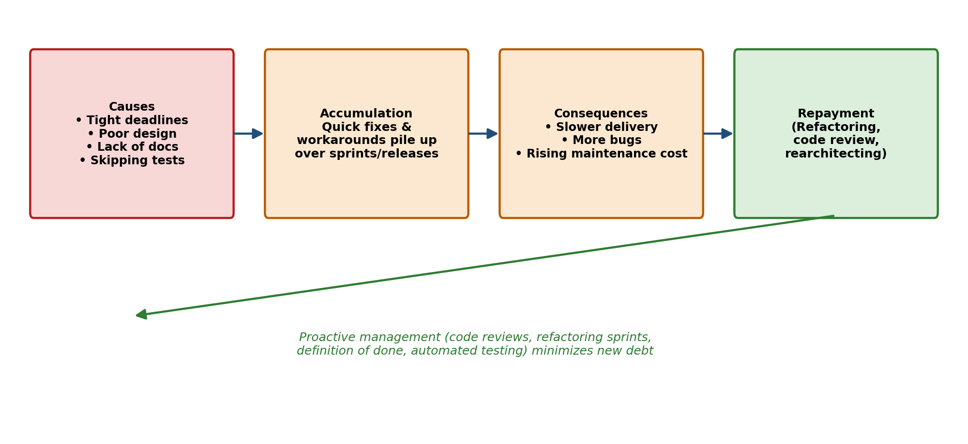
Figure 1: How technical debt accumulates and how proactive management interrupts the cycle

3. How Organizations Can Minimize Technical Debt
- Regular refactoring: Schedule dedicated time (e.g., refactoring sprints) to clean up and simplify existing code before it accumulates further debt.
- Strong code review culture: Enforce peer code reviews and coding standards to catch quality issues before they are merged.
- Automated testing and CI/CD: Maintain a robust suite of unit, integration, and regression tests, run automatically in the pipeline, to catch defects early and enable safe refactoring.
- Maintain documentation: Keep design decisions, architecture diagrams, and code comments up to date so future developers understand the system.
- Track technical debt explicitly: Log debt items in the backlog (e.g., as tagged tickets) so they are visible, prioritized, and not forgotten.
- Balance speed with quality: Educate stakeholders that some short-term investment in quality prevents much larger long-term costs, and negotiate realistic deadlines.
- Adopt good architectural practices: Use modular, loosely coupled designs (e.g., microservices, clean architecture) that are easier to change without widespread side effects.
- Continuous monitoring and static analysis: Use tools such as SonarQube to automatically flag code smells, complexity, and duplication before they grow into larger problems.

Question 2
Explain how AI/ML and Edge Computing are transforming modern software engineering. Provide one practical example for each.

1. AI/ML in Software Engineering
Artificial Intelligence and Machine Learning are increasingly being embedded into the software development lifecycle itself, not just into application features. AI/ML tools now assist developers with writing, testing, and maintaining code, while also enabling applications to make intelligent, data-driven decisions.
- Intelligent code generation and completion: AI-powered assistants suggest code snippets, entire functions, or fixes based on context, speeding up development.
- Automated testing: ML models can automatically generate test cases, predict which parts of the code are most likely to contain bugs, and prioritize testing effort accordingly.
- Predictive analytics for defects: AI models trained on historical bug data can flag risky code changes before they are merged.
- Smart monitoring and anomaly detection: ML-based monitoring tools learn normal system behavior and automatically flag unusual patterns that could indicate performance issues or security threats.
- Practical example: GitHub Copilot uses a large language model to suggest real-time code completions and entire functions directly inside the developer’s editor, significantly speeding up coding and reducing repetitive work.

2. Edge Computing in Software Engineering
Edge Computing moves data processing and computation closer to where data is generated — on local devices or nearby servers — instead of sending everything to a centralized cloud data center. This shift is changing how software is architected, deployed, and tested.
- Reduced latency: Processing data locally allows near-instant responses, which is essential for real-time applications.
- Lower bandwidth and cloud costs: Only relevant, processed data is sent to the cloud instead of raw streams, reducing network load and cloud storage/compute costs.
- New architectural patterns: Software engineers must now design distributed systems that can run reliably on resource-constrained edge devices, with intermittent connectivity and local data processing.
- Improved privacy and resilience: Sensitive data can be processed on-device rather than transmitted externally, and applications can keep functioning even if the connection to the cloud is temporarily lost.
- Practical example: Smart traffic-camera systems process video feeds directly on-device (at the edge) to detect vehicles, congestion, or violations in real time, only sending summarized alerts or metadata to the cloud instead of streaming raw video continuously.

Comparison: AI/ML vs Edge Computing
Aspect | AI / ML | Edge Computing
Focus | Intelligent decision-making from data | Processing data close to its source
Impact on SE | Assists coding, testing, and monitoring | Changes system architecture and deployment
Key benefit | Faster development, predictive insights | Low latency, reduced bandwidth/cloud cost
Practical example | GitHub Copilot for AI-assisted coding | Smart traffic cameras processing video on-device

How They Work Together
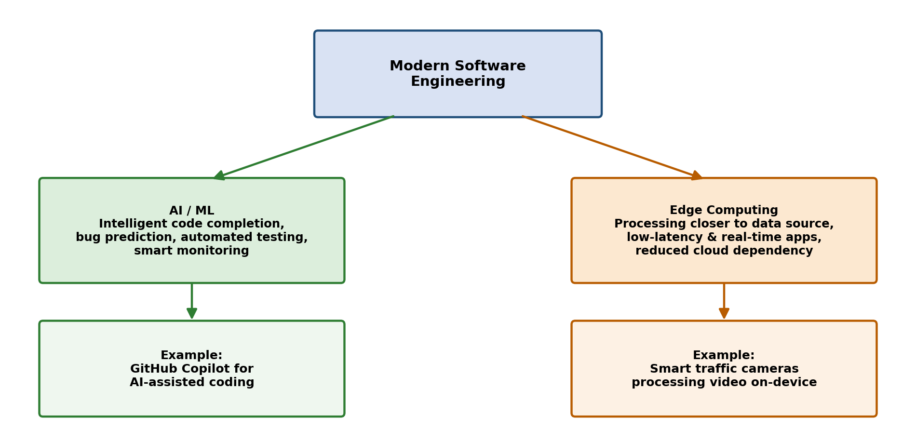
Figure 2: AI/ML and Edge Computing transforming modern software engineering
In practice, AI/ML and Edge Computing increasingly complement each other: lightweight ML models are deployed directly onto edge devices (“Edge AI”) so that intelligent decisions, such as detecting an anomaly or recognizing an object, can be made instantly on-device without waiting for a round trip to the cloud.

Question 3
Case Study – A company deploys dozens of microservices in the cloud and notices that resource usage and energy consumption are increasing. Explain three sustainable DevOps practices that can reduce energy consumption and cloud cost.

Case Study Background
As the company scaled from a single application to dozens of independently deployed microservices, resource usage and energy consumption grew steadily. This is a common outcome of microservice sprawl: each service tends to over-provision resources “just in case,” duplicate infrastructure (databases, logging, queues), and run continuously even when demand is low. Sustainable DevOps (“Green DevOps”) practices aim to reduce this waste while keeping performance and reliability intact.

Three Sustainable DevOps Practices

1. Right-Sizing and Autoscaling
- What it is: Continuously matching allocated CPU, memory, and instance counts to actual real-time demand instead of provisioning for worst-case peak load at all times.
- How it helps: Horizontal/vertical autoscaling (e.g., Kubernetes Horizontal Pod Autoscaler) automatically scales services down during off-peak hours and scales up only when needed, so idle compute capacity — and the energy it consumes — is minimized.
- DevOps integration: Autoscaling policies and resource requests/limits are defined as code (IaC) and validated in the CI/CD pipeline, ensuring every microservice is deployed with sustainable, demand-based resource configuration by default.

2. Green / Energy-Aware Scheduling
- What it is: Scheduling workloads to run in cloud regions or at times when the electricity grid is powered by a higher proportion of renewable energy, and consolidating workloads onto fewer, more efficient nodes.
- How it helps: Cloud providers publish carbon-intensity and renewable-energy data for their regions; batch or non-time-critical jobs can be shifted to greener regions or off-peak windows, directly cutting the carbon footprint and often the cost of running the same workload.
- DevOps integration: CI/CD pipelines and orchestration tools (e.g., Kubernetes bin-packing, carbon-aware schedulers) can be configured to prefer energy-efficient regions or times automatically, without manual intervention.

3. Continuous Monitoring and FinOps-Driven Optimization
- What it is: Continuously tracking resource usage, cost, and performance across all microservices using monitoring tools (e.g., Prometheus, Grafana, cloud cost dashboards) and applying FinOps practices to identify and eliminate waste.
- How it helps: Regular audits reveal idle, orphaned, or over-provisioned resources (unused databases, forgotten test environments, oversized instances) that silently consume energy and money; removing or right-sizing them has a direct, ongoing impact on both cost and sustainability.
- DevOps integration: Monitoring and cost dashboards are embedded into the team’s regular DevOps workflow (e.g., sprint reviews, automated alerts for underutilized resources), making sustainability an ongoing responsibility rather than a one-time cleanup.

Sustainable DevOps Workflow
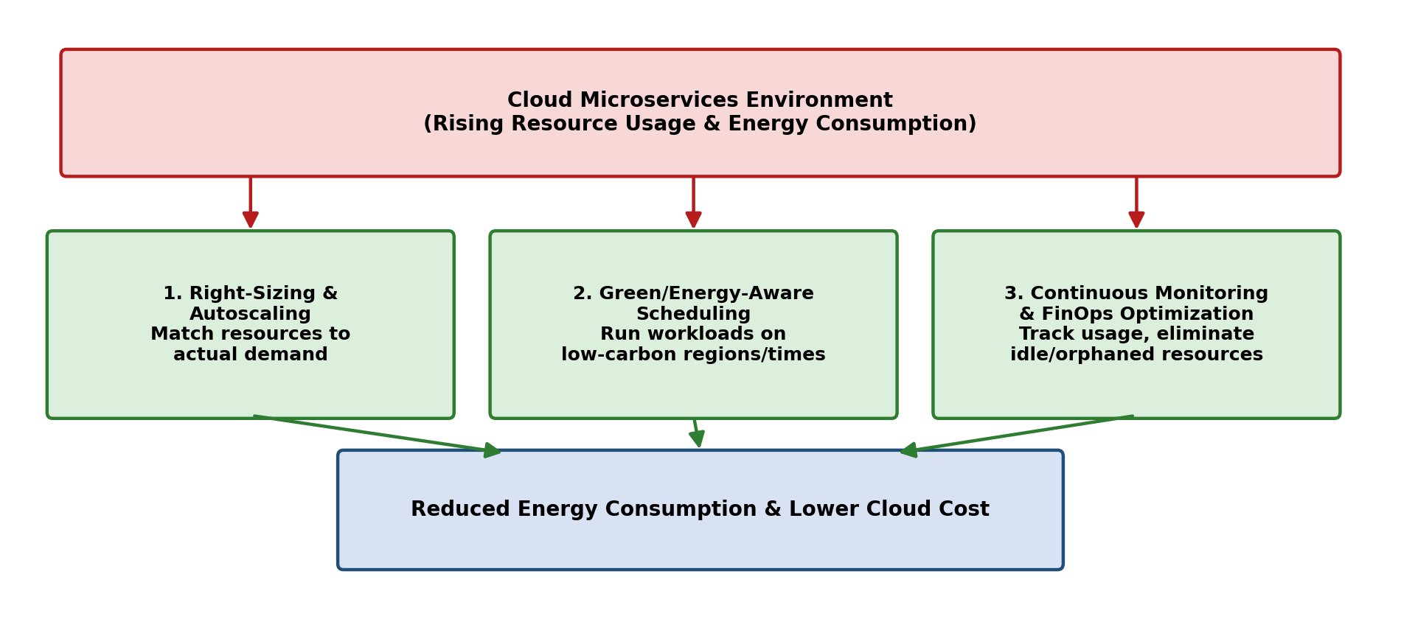
Figure 3: Three sustainable DevOps practices reducing energy consumption and cloud cost
Together, these three practices — right-sizing/autoscaling, energy-aware scheduling, and continuous monitoring with FinOps optimization — allow the company to keep its growing microservices architecture reliable and performant while significantly reducing unnecessary energy consumption and cloud spend.

