Problem 3: Choosing Architecture for a Scalable Food Delivery Platform
Scenario
A startup plans to build a food delivery platform similar to Swiggy or Zomato. The platform must handle thousands of orders per minute, especially during peak hours such as lunch and dinner. The CTO must choose between Monolithic, Serverless, and Microservices architecture.

1. Recommended Architecture Choice
Recommended Architecture: Microservices Architecture with Event-Driven Architecture
Microservices architecture divides the application into small, independent services that communicate through APIs and events. Each service can be developed, deployed, and scaled independently.

2. Three Technical Reasons for Choosing Microservices
Reason 1: Independent Scalability
Different services experience different workloads. During peak hours, only heavily used services (such as Orders or Payments) need additional resources without scaling the entire application.
Example:
- Orders Service → High traffic
- Payment Service → Moderate traffic
- User Profile Service → Low traffic
Each service scales independently.

Reason 2: Fault Isolation
If one service fails, the remaining services continue functioning.
Example:
- Payment Service fails
- Users can still:
  - Browse restaurants
  - Search food
  - Add items to cart
This improves system reliability.

Reason 3: Faster Development and Deployment
Different teams can work independently on different services.
Example:
- Team A → Orders Service
- Team B → Delivery Service
- Team C → Payments Service
Each service can be updated without affecting the others, enabling faster releases.

3. Event-Driven Architecture and Its Benefits
Event-driven architecture allows services to communicate using events instead of directly calling each other.
Example Workflow
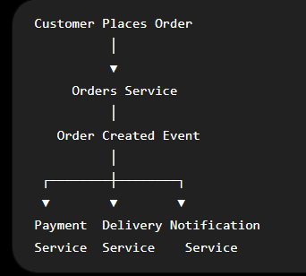

Benefits
- Loose coupling between services
- Faster processing
- Better scalability
- Improved reliability
- Supports asynchronous communication
- Easy integration of new services
Example:
When an order is placed:
- Orders Service publishes OrderCreated event.
- Payment Service processes payment.
- Delivery Service assigns a delivery partner.
- Notification Service sends confirmation.
Each service works independently without waiting for others.

4. Suitable Microservices
Microservice | Responsibility
Orders Service | Creates, updates, and tracks customer orders
Delivery Service | Assigns delivery partners and tracks delivery status
Payment Service | Processes online payments, refunds, and transactions
Additional microservices (optional):
- User Service
- Restaurant Service
- Menu Service
- Notification Service
- Authentication Service
- Recommendation Service
- Review Service

5. Architecture Diagram
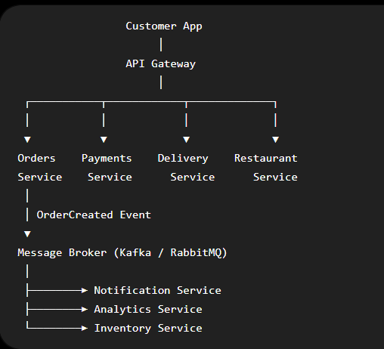

6. Sample Python Code (Microservices Simulation)
# Simple Microservices Simulation

def order_service(order_id):
print(f"Order Service: Order {order_id} created.")
return "OrderCreated"

def payment_service(event):
if event == "OrderCreated":
print("Payment Service: Payment processed.")

def delivery_service(event):
if event == "OrderCreated":
print("Delivery Service: Delivery partner assigned.")

def notification_service(event):
if event == "OrderCreated":
print("Notification Service: Confirmation sent to customer.")

# Main Program
event = order_service(1001)

payment_service(event)
delivery_service(event)
notification_service(event)
Sample Output
Order Service: Order 1001 created.
Payment Service: Payment processed.
Delivery Service: Delivery partner assigned.
Notification Service: Confirmation sent to customer.

7. Conclusion
For a large-scale food delivery platform like Swiggy or Zomato, Microservices Architecture combined with Event-Driven Architecture is the best choice. It provides independent scalability, fault isolation, faster development, and efficient handling of thousands of orders per minute, making it ideal for modern, high-traffic applications.

