6. Scenario: You are a cashier at a grocery store and need to calculate the total cost of a
customer&#39; s purchase, including applicable discounts and taxes. You have the item prices and
quantities in separate lists, and the discount and tax rates are given as percentages. Your task is to
calculate the total cost for the customer.
Question: Use arithmetic operations to calculate the total cost of a customer&#39;s purchase,
including discounts and taxes, given the item prices, quantities, discount rate, and tax rate?

Code;
prices = [100, 200, 150]
quantities = [2, 1, 3]
discount_rate = 10
tax_rate = 5

subtotal = sum(prices[i] * quantities[i] for i in range(len(prices)))

discount = subtotal * discount_rate / 100
amount = subtotal - discount

tax = amount * tax_rate / 100
total_cost = amount + tax

print("Subtotal:", subtotal)
print("Discount:", discount)
print("Tax:", tax)
print("Total Cost:", total_cost)
input;
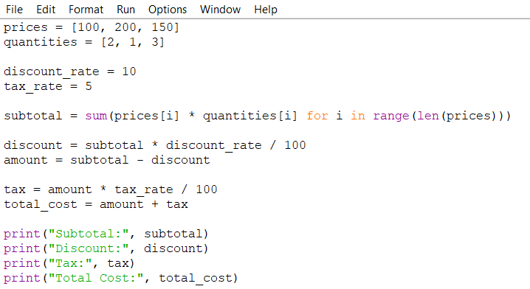
Output;
