

SIMATS ENGINEERING
Department of Computer Science and Engineering
CSA0707 – Computer Networks
ASSIGNMENT 3 – CO3
Performance of Core Network Protocols: TCP, UDP, HTTP, DNS, QoS, QUIC and TLS 1.3

CO3: Analyse and compare the performance of core network protocols such as TCP, UDP, HTTP and DNS under varying conditions – multiplexing and demultiplexing, TCP, UDP, sockets, congestion control, quality of service, queuing models, traffic management, QUIC and TLS 1.3

Student Name | Y. Naga Giridhar | Register Number | 192572124
Department | B.E-CSE(AI) | Academic Year | 2026-2027
Faculty Name | Dr. Santhiya Lakshmi K | Nature of Assignment | Individual
Duration | 1 Week | Total Marks | 50
Date of Submission |  | Date of Evaluation
GitHub Repository | https://github.com/192572124simats-77/CSA0707-CN

Q1 – Which Socket Gets the Segment? 7 Marks
Ans:
Problem context: the sports-app server 203.0.113.5 has one UDP socket (port 5004, live video), one TCP LISTEN socket (port 443) and three ESTABLISHED TCP connections on port 443. Rule used: TCP chooses the socket by the 4-tuple (source IP, source port, destination IP, destination port); UDP chooses it by the 2-tuple (destination IP, destination port) only.

1. Which socket receives each arriving segment
Table 1: Demultiplexing of the four arriving segments
Arriving segment | What the operating system matches | Socket that receives it
TCP from 49.37.2.8:50001 to port 443 | 4-tuple (49.37.2.8, 50001, 203.0.113.5, 443) equals an ESTABLISHED entry | TCP 203.0.113.5:443 ↔ 49.37.2.8:50001 (ESTABLISHED)
TCP from 117.96.4.2:50000 to port 443 | 4-tuple (117.96.4.2, 50000, 203.0.113.5, 443) equals an ESTABLISHED entry | TCP 203.0.113.5:443 ↔ 117.96.4.2:50000 (ESTABLISHED)
TCP SYN from 106.51.7.7:41000 to port 443 | No ESTABLISHED entry has this 4-tuple, so the SYN falls back to the listening socket on port 443 | TCP 203.0.113.5:443 LISTEN. It answers with SYN-ACK; when the handshake ends, accept() creates a new connected socket for 106.51.7.7:41000
UDP from 49.37.2.8:50000 to port 5004 | 2-tuple (203.0.113.5, 5004); the source is not used for matching | UDP 203.0.113.5:5004 (the single video socket)
A full 4-tuple match always wins over the LISTEN socket; the LISTEN socket receives only a segment that matches no connection (a new SYN).

2. Same source port for TCP, but not for UDP
- TCP: the connection is identified by all four values. The connections 49.37.2.8:50000 → 203.0.113.5:443 and 117.96.4.2:50000 → 203.0.113.5:443 differ in the source IP, so they are two different 4-tuples and two different sockets, although both use source port 50000. The same phone also opens 50000 and 50001 – they differ in the source port.
- UDP: the socket on port 5004 is matched by destination IP and port only. Every viewer’s datagram, whatever its source address, is queued on this one socket, so the port alone cannot separate the viewers. The application must read the sender address returned by recvfrom() (or a session ID inside the payload) and keep its own table of viewers.
- TCP and UDP have separate port spaces, so UDP 49.37.2.8:50000 and TCP 49.37.2.8:50000 do not conflict.

3. Header overhead of a 100-byte score update (IPv4)
Table 2: Overhead of a 100-byte payload
Protocol | Headers | Packet size | Overhead (share of packet) | Overhead (share of payload)
UDP over IPv4 | 8 + 20 = 28 B | 128 B | 28 / 128 = 21.9 % | 28.0 %
TCP over IPv4 (no options) | 20 + 20 = 40 B | 140 B | 40 / 140 = 28.6 % | 40.0 %
TCP with timestamp option | 32 + 20 = 52 B | 152 B | 52 / 152 = 34.2 % | 52.0 %
With the Ethernet header and FCS (18 B) added, UDP is 46 / 146 = 31.5 % and TCP is 58 / 158 = 36.7 %. TCP costs 12 bytes more per packet and also needs a three-packet handshake and acknowledgements; for a small update both are expensive, so TCP is chosen only when the reliability is worth this cost.

4. TCP or UDP for each part of the app
Table 3: Protocol choice for each part of the sports app
Part of the app | Protocol | Deciding reason
Live scores | TCP (HTTPS) | Every update must arrive exactly once and in order; a wrong or missing score is worse than a score that is 100 ms late. The data is small, so TCP’s overhead is acceptable.
Ball-by-ball commentary | TCP (HTTPS / WebSocket) | Text events must all arrive in order – a missing ball breaks the story. A delay of a few hundred ms is not noticed.
Live video | UDP (RTP / QUIC datagrams) | A late frame is useless. Retransmission costs at least one round trip and TCP’s in-order delivery makes the whole stream wait for one lost segment. UDP lets the codec hide small losses and the sender adapt the bit rate.

Experimental Investigation
(a) Loopback capture of the UDP and TCP programs
The program below (Q1/q1_sockets.py) was run on the loopback interface. In Wireshark capture on the loopback adapter (Linux: lo; Windows with Npcap: “Npcap Loopback Adapter”) and use the display filter tcp.port == <tcp port> || udp.port == <udp port>. The ports are printed by the program or visible in ss -tunap.
Table 4: What to identify and mark in the capture
Packet(s) | What you must see and label
TCP three-way handshake | SYN (Seq = 0 relative, MSS and window-scale options) → SYN-ACK (Seq = 0, Ack = 1) → ACK (Seq = 1, Ack = 1). One round trip before any data.
TCP data transfer | Segments carrying the 100,000 bytes: Seq grows by the number of bytes sent (1, 1 + len, …); every Ack number equals the next byte expected; ACKs flow back. Closing: FIN-ACK exchange.
UDP datagram “lab1” | No handshake. UDP header is 8 bytes: source port, destination port, Length = 12 (8 + 4 data bytes), checksum. The reply “ACK:lab1” has Length = 16 (8 + 8). IPv4 total length is 32 and 36 bytes.

(b) Effect of 1 %, 5 % and 10 % loss
On Linux, loss is added with sudo tc qdisc add dev lo root netem loss 1% (then change … loss 5%, change … loss 10%) and removed with sudo tc qdisc del dev lo root. The table gives the result obtained with the Python round-based model of Reno (RTT 60 ms, average of 300 runs; the UDP column is 1,000 datagrams sent 200 times). Replace or confirm it with your own netem measurements.
Table 5: What each protocol delivers under loss (model result)
Loss | UDP: datagrams delivered | TCP: data delivered | TCP: time for a 100 KB transfer | Slow-down against no loss
0 % | 100 % | 100 % | 270 ms | 1.0 ×
1 % | 99 % | 100 % | 398 ms | 1.5 ×
5 % | 95 % | 100 % | 871 ms | 3.2 ×
10 % | 90 % | 100 % | 1,760 ms | 6.5 ×
Observation: UDP delivers about (1 − loss) of the datagrams and never repairs anything, but it adds no delay. TCP delivers 100 % of the bytes, but a 10 % loss makes the transfer 6.5 times slower because every loss needs a retransmission and a smaller window.
(c) Listing the open sockets
While the program (or a server such as python3 -m http.server 8080 and a nc -u -l 5004) is running, execute ss -tunap. Identify: a LISTEN TCP socket, the two ESTAB ends of one connection (client and server sockets with swapped addresses), and an UNCONN UDP socket. Columns: Netid, State, Local Address:Port, Peer Address:Port, Process.

Conclusion – reply to the friend
“UDP is unreliable, so never use it” – reply
UDP is not “bad”; it simply leaves the reliability decision to the application. In my test UDP delivered 99 %, 95 % and 90 % of the datagrams at 1 %, 5 % and 10 % loss without any extra delay, while TCP took 1.5, 3.2 and 6.5 times longer to deliver everything. For a live video a late frame is worthless, so waiting for a retransmission is worse than losing it.
Unreliable can be repaired cheaply where needed: in Q7 a 25 % parity (FEC) raised the usable video slices from 82.2 % to 97.8 % at 5 % loss with no retransmission delay. DNS, VoIP, video, online games and even HTTP/3 (QUIC) are built on UDP. Rule: use TCP when every byte must arrive; use UDP when timeliness matters more than completeness.

Complete the Code – Q1/q1_sockets.py
TODO 1: recvfrom(1024) returns the data and the sender address; the server replies with sendto(b"ACK:" + data, addr). TODO 2: recv(4096) is repeated until it returns b"", adding each chunk length to total (total = 0 is initialised before the loop because the final print needs it).
"""UDP and TCP sockets on one machine: a time server answering three clients."""
import socket
import threading
def udp_server(sock):
for _ in range(3):
# TODO 1 (completed)
data, addr = sock.recvfrom(1024)
sock.sendto(b"ACK:" + data, addr)
def tcp_server(sock):
conn, _ = sock.accept()
total = 0
with conn:
# TODO 2 (completed)
while True:
chunk = conn.recv(4096)
if chunk == b"":
break
total += len(chunk)
print(f"TCP server received {total} bytes in order")
u = socket.socket(socket.AF_INET, socket.SOCK_DGRAM)
u.bind(("127.0.0.1", 0))
t = socket.socket(socket.AF_INET, socket.SOCK_STREAM)
t.bind(("127.0.0.1", 0))
t.listen(1)
threading.Thread(target=udp_server, args=(u,)).start()
th = threading.Thread(target=tcp_server, args=(t,))
th.start()
for name in ("lab1", "lab2", "lab3"):
c = socket.socket(socket.AF_INET, socket.SOCK_DGRAM)
c.sendto(name.encode(), u.getsockname())
reply, _ = c.recvfrom(1024)
print("UDP", name, "->", reply.decode())
c.close()
c = socket.create_connection(t.getsockname())
c.sendall(b"x" * 100_000)
c.close()
th.join()
u.close()
t.close()
Output (Python 3):
UDP lab1 -> ACK:lab1
UDP lab2 -> ACK:lab2
UDP lab3 -> ACK:lab3
TCP server received 100000 bytes in order
The output agrees with the expected output (the expected text in the question only lacks the space after “->”). The UDP replies arrive one datagram per request; TCP delivered all 100,000 bytes in order without the program splitting them – TCP is a byte stream and may deliver them in several recv chunks.

Alternative Concept Analysis – live video over TCP
Assumptions: 500 packets/s, 2 % loss, RTT 60 ms, 1,460-byte packets.
Table 6: Freezing of a video sent over TCP
Quantity | Calculation | Result
Packets per minute | 500 × 60 | 30,000
Lost segments per minute | 30,000 × 0.02 | 600 (10 per second)
Freeze after one loss | TCP delivers in order: later data waits for the retransmission, which arrives at least 1 RTT after the original (fast retransmit); if fast retransmit fails, the timeout is ≥ 200 ms | ≥ 60 ms (≥ 260 ms after a timeout)
Freezes per minute (upper bound) | one per lost segment | 600, i.e. up to 600 × 60 ms = 36 s frozen
Freezes per minute with overlaps | 10 losses/s × 60 ms = 0.6; distinct freezes 10·e^−0.6 × 60; frozen share 1 − e^−0.6 | ≈ 329 freezes/min, mean 82 ms, picture frozen ≈ 45 % of the time
Can TCP even sustain the stream? | Mathis: 1.22 × 1,460 × 8 / (0.06 × √0.02) | 1.68 Mbps < video rate 500 × 1,460 × 8 = 5.84 Mbps – no
Result: over TCP the viewer would see roughly 330–600 freezes every minute and, because TCP also halves its window after each loss, the stream could not keep up at all. Over UDP the 600 lost packets per minute only damage parts of single frames and the delay stays at about 30 ms one way. Video must use UDP (RTP or QUIC datagrams).

Q2 – Read the Congestion Window 7 Marks
Ans:
Data read from the Wireshark TCP stream graph (one value per round trip; the printed table in the question PDF is column-shifted, the values below are the ones that agree with the program’s expected output):
Table 7: Congestion window of the hostel download
RTT | 1 | 2 | 3 | 4 | 5 | 6 | 7 | 8 | 9 | 10 | 11 | 12 | 13 | 14 | 15 | 16 | 17
cwnd | 1 | 2 | 4 | 8 | 16 | 17 | 18 | 19 | 9 | 10 | 11 | 12 | 13 | 14 | 1 | 2 | 4

1. Value of ssthresh at the start, after RTT 8 and after RTT 14
Table 8: ssthresh at the three moments
Moment | Evidence in the graph | ssthresh
At the start | The window doubles 1, 2, 4, 8, 16 (slow start) and then grows by only 1 per round trip (17, 18, 19). The change from doubling to +1 happens at 16 | 16 segments
After RTT 8 | cwnd = 19 when the loss is detected; ssthresh = max(19 // 2, 2) = 9; the window is cut to 9 | 9 segments
After RTT 14 | cwnd = 14 when the loss is detected; ssthresh = max(14 // 2, 2) = 7; the window falls to 1 and slow start follows (1, 2, 4, … capped at 7) | 7 segments

2. Kind of loss event at RTT 8 and at RTT 14
- RTT 8 – three duplicate ACKs (fast retransmit and fast recovery). The window is only halved (19 → 9) and then grows linearly at once (9, 10, 11 …). ACKs were still arriving, so the network was delivering most segments – mild congestion; the sender does not go back to slow start.
- RTT 14 – retransmission timeout. The window collapses to 1 and slow start restarts (1, 2, 4). No ACKs came back at all (or too few for three duplicates), which signals severe congestion or a burst loss.
So the shape of the fall (halve and continue linearly versus drop to 1 and restart doubling) identifies the loss type from the graph alone.

3. Tahoe or Reno?
The sender is TCP Reno (or a Reno-type variant). Evidence: at RTT 8 the window is cut to half (19 → 9) and avoidance continues – that is fast recovery, which exists only in Reno. Tahoe has no fast recovery: on any loss, including three duplicate ACKs, it sets cwnd = 1 and re-enters slow start, so Tahoe would show 1 at RTT 9. The drop to 1 at RTT 14 is consistent with Reno, because Reno also falls back to 1 after a timeout.

4. Throughput at round trip 7
cwnd at RTT 7 = 18 segments. Throughput = cwnd × MSS × 8 / RTT = 18 × 1,460 × 8 bits / 0.040 s = 210,240 bit / 0.040 s = 5,256,000 bit/s ≈ 5.26 Mbps. (At the peak, RTT 8, 19 segments give 5.55 Mbps.)

5. Why two downloads sharing a link end up with roughly equal shares (AIMD)
AIMD adds one segment per round trip to each flow (the same absolute gain) and, when the link overflows, halves each window. Adding the same amount keeps the difference between the two windows unchanged, but halving halves the difference. Every loss event therefore halves the gap, and the two windows converge to the same value (fairness) while the sum oscillates around the link capacity (efficiency). In the simulation below two flows start at 10 and 70 segments on a link of 100 segments per round trip: the gap falls from 60 to 15 segments after two loss events and keeps halving. (This assumes equal RTTs; a flow with a shorter RTT grows faster and gets a larger share.)
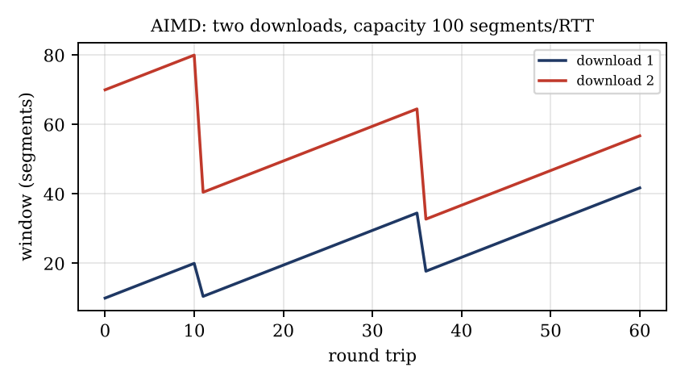
Figure 1: AIMD convergence of two downloads (simulation)

Experimental Investigation
(a) Tahoe and Reno for the same loss pattern
The program in “Complete the Code” was run for the same loss pattern (losses at RTT 8 and RTT 14, 20 round trips); both windows are plotted below next to the Wireshark window of the question.
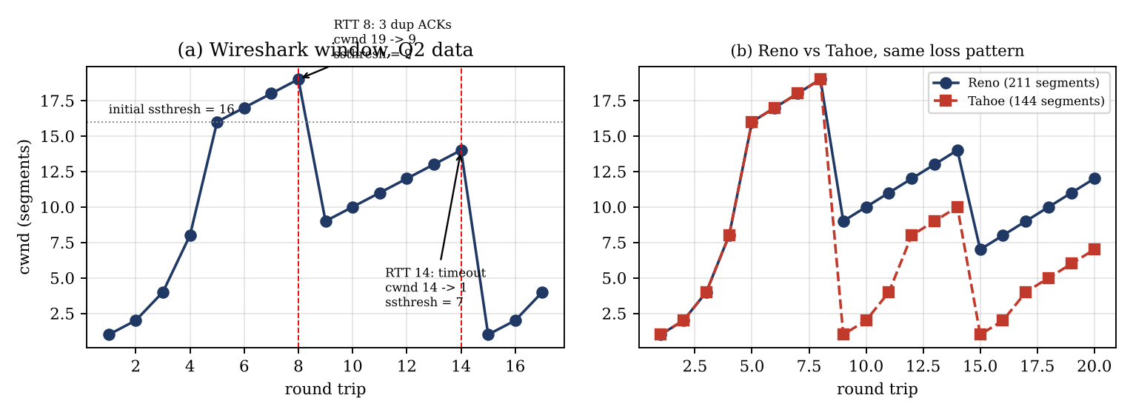
Figure 2: (a) window of the hostel download; (b) Reno and Tahoe for the same loss pattern
Table 9: Segments delivered in 20 round trips
Sender | Window trace (RTT 1 – 20) | Segments sent
Reno | 1 2 4 8 16 17 18 19 9 10 11 12 13 14 7 8 9 10 11 12 | 211
Tahoe | 1 2 4 8 16 17 18 19 1 2 4 8 9 10 1 2 4 5 6 7 | 144
Difference | Reno delivers 211 − 144 more segments | 67 (+46.5 %) = 67 × 1,460 B ≈ 95.5 KB
Reno wins because after each loss it restarts from half the window (9 and 7) instead of from 1, so it does not have to climb again through slow start.
(b) Two iperf3 downloads over one link
Server: iperf3 -s (and a second iperf3 -s -p 5202). Two clients at the same time: iperf3 -c SERVER -t 60 -i 5 and iperf3 -c SERVER -p 5202 -t 60 -i 5. To make a bottleneck: sudo tc qdisc add dev eth0 root tbf rate 20mbit burst 32kbit latency 400ms. Record the Mbps of each flow every 5 s. Expected: about 10 Mbps each (equal shares within about ±20 %), as in the AIMD simulation above.
(c) Window of a real connection and the effect of loss
While a download runs, execute watch -n 0.5 "ss -ti dst SERVER" and read cwnd:, ssthresh:, rtt: and retrans:. Then add loss with sudo tc qdisc change dev eth0 root netem loss 0.5% (and 1 %, 2 %) and observe that cwnd stays small and retrans grows. Remove it with sudo tc qdisc del dev eth0 root.

Conclusion – CUBIC or BBR for the hostel servers?
Decision: use CUBIC (the default) on the hostel servers; keep BBR only for paths with measured random loss
What the observations show. The hostel window grows until about 19 segments and is then cut, once by three duplicate ACKs and once by a timeout: the losses are congestion losses caused by many students sharing one link, so loss is a correct congestion signal. CUBIC reacts to exactly that signal and, like Reno, converges to equal shares between competing downloads (AIMD result above). It is the kernel default, well tested and friendly to the many Reno/CUBIC flows on the same link.
BBR ignores single losses and paces at the estimated bottleneck bandwidth. That is a big gain under random loss (see below: about 28 times more throughput at 1 % random loss), but when the loss is really congestion BBR (v1) can keep sending, create many retransmissions and take more than its fair share from CUBIC users.
Rule: CUBIC for the shared hostel network (RTT about 40 ms, congestion loss). Switch a server to BBR (sysctl net.ipv4.tcp_congestion_control=bbr) only if ss -ti shows frequent retransmissions on a path that is not congested (for example a lossy Wi-Fi last hop) or the RTT is long, and then re-run the iperf3 fairness test.

Complete the Code – Q2/q2_cwnd.py
TODO 1: if the round trip is in losses, set ssthresh = max(cwnd // 2, 2) and set cwnd to ssthresh (Reno) or to 1 (Tahoe); otherwise double in slow start (capped at ssthresh) or add 1 in congestion avoidance.
"""TCP congestion window over 20 round trips: slow start, avoidance and loss."""
def simulate(losses, ssthresh=16, reno=True):
cwnd, trace = 1, []
for rtt in range(1, 21):
trace.append(cwnd)
# TODO 1 (completed)
if rtt in losses:
ssthresh = max(cwnd // 2, 2)
cwnd = ssthresh if reno else 1
elif cwnd < ssthresh:
cwnd = min(cwnd * 2, ssthresh)
else:
cwnd += 1
return trace
for label, reno in (("Reno ", True), ("Tahoe", False)):
tr = simulate({8, 14}, reno=reno)
print(label, " ".join(f"{w:2d}" for w in tr), f"| segments sent {sum(tr)}")
Output (Python 3):
Reno 1 2 4 8 16 17 18 19 9 10 11 12 13 14 7 8 9 10 11 12 | segments sent 211
Tahoe 1 2 4 8 16 17 18 19 1 2 4 8 9 10 1 2 4 5 6 7 | segments sent 144
The totals 211 and 144 agree with the expected output (the expected output in the question is printed with misplaced spaces).

Alternative Concept Analysis – BBR against Reno at 1 % random loss
Assumptions: bottleneck 100 Mbps, RTT 40 ms, MSS 1,460 B, random (non-congestion) loss p = 0.01. Bandwidth-delay product = 100 × 10⁶ × 0.04 / 8 = 500,000 B ≈ 342 segments.
Table 10: Reno against BBR with 1 % random loss
 | Reno | BBR
How it reacts | Every loss halves the window; random losses are treated as congestion | Estimates bottleneck bandwidth and minimum RTT; sends at the estimated rate; random loss does not reduce the rate
Window / rate | Average window ≈ 1.22 / √0.01 = 12.2 segments, sawtooth about 8 – 16, never near the 342 segments needed | Rate ≈ the bottleneck bandwidth (about 95 – 100 Mbps); in-flight data about the BDP (342 segments)
Throughput | 12.2 × 1,460 × 8 / 0.04 = 3.56 Mbps (3.6 % of the link) | ≈ 99 % of the rate is useful: about 90 – 99 Mbps
Result | Link almost empty although it is not congested | About 25 – 28 times more throughput
BBR gives the higher throughput on a link with random loss; Reno (and CUBIC) would only match it if the loss were removed. This is the main reason to try BBR on lossy wireless paths.

Q3 – Why Does the Home Page Take 8 Seconds? 7 Marks
Ans:
Model: 1 HTML file + 80 objects = 81 objects; RTT = 50 ms; transmission times negligible. A new TCP connection costs 1 RTT (handshake) and each request/response costs 1 RTT.

1. Page-load time for each way of fetching
Table 11: Load time of the 81-object page, RTT = 50 ms
Method | Round trips | Calculation | Time | Speed-up
Non-persistent HTTP, one connection at a time | 162 | 81 objects × (1 RTT TCP + 1 RTT request) = 81 × 100 ms | 8,100 ms | 1 ×
Persistent HTTP/1.1, no pipelining | 82 | 1 RTT TCP + 1 RTT HTML + 80 × 1 RTT | 4,100 ms | 2.0 × (−49.4 %)
6 parallel non-persistent connections | 30 | HTML: 2 RTT = 100 ms; 80 objects in ⌈80 / 6⌉ = 14 rounds × 100 ms = 1,400 ms | 1,500 ms | 5.4 × (−81.5 %)
Persistent HTTP/1.1 with pipelining | 3 | 1 RTT TCP + 1 RTT HTML + 1 RTT for all 80 requests sent back-to-back | 150 ms | 54 × (−98.1 %)
HTTP/2 over one connection behaves like the pipelined case (all requests multiplexed in one RTT): 3 RTT = 150 ms, or 4 RTT = 200 ms if a TLS 1.3 handshake (1 RTT) is added to the TCP handshake; HTTP/3 needs 1 RTT for the combined transport and crypto set-up, so 3 RTT = 150 ms on the first visit and 2 RTT = 100 ms with 0-RTT resumption.

2. Why HTTP/2 stalls on one lost segment and how HTTP/3 avoids it
- HTTP/2 over TCP: all streams share one ordered TCP byte stream. If one segment is lost, TCP holds back every later byte – including data of other, unaffected objects – until the retransmission arrives (at least 1 RTT = 50 ms, or an RTO of ≥ 200 ms). This is head-of-line blocking at the transport layer, and it is worst on lossy mobile networks.
- HTTP/3 over QUIC: QUIC runs over UDP and has independent streams: each stream has its own ordering and its own retransmission. A lost packet stalls only the stream(s) whose data it carried; the other objects continue to be delivered. QUIC also needs only 1 RTT to start and survives a change of network (connection ID).

3. Making the second visit faster: Cache-Control and ETag
Table 12: Second visit with caching headers (persistent HTTP/1.1, RTT = 50 ms)
Case | What happens | Round trips | Time
First visit | Everything is fetched | 82 | 4,100 ms
Second visit, ETag only | Each object is revalidated (If-None-Match → 304 Not Modified). Bytes are saved, but every object still costs one round trip | 82 | 4,100 ms (no gain in time)
Second visit, Cache-Control: max-age on the 80 objects + ETag on the HTML | The 80 objects are still fresh in the cache – no request is sent; only the HTML is revalidated (TCP 1 RTT + 304 1 RTT) | 2 | 100 ms (−97.6 % against 4,100 ms; −98.8 % against 8,100 ms)
Second visit with HTTP/2 and ETag only | All 81 conditional requests are multiplexed in one round trip | 3 | 150 ms
Headers to use: for versioned static objects (images, CSS, JS) Cache-Control: public, max-age=31536000, immutable; for the HTML page Cache-Control: no-cache together with an ETag, so the page is always revalidated but sent again only when it has changed. max-age removes the round trips; ETag saves only bytes.

Experimental Investigation
(a) Procedure
- Open the home page in Chrome or Edge, press F12 → Network; tick *Disable cache* for the first-visit tests. Right-click the column header and enable Protocol and Connection ID. Record: number of different connection IDs, the protocol (http/1.1, h2, h3) and the Load time at the bottom.
- Added delay: Network → throttling → *Add…* custom profile with latency 0, 50 and 200 ms (or sudo tc qdisc add dev eth0 root netem delay 25ms for 50 ms of round-trip delay). Repeat for each delay.
- Second visit: untick *Disable cache*, reload (normal reload), and compare the Size column (“disk cache”/“memory cache” against bytes) and the Load time. Also try a hard reload to see the first-visit cost again.
- Compare a page with many small objects with a page with a few large objects (for example 80 icons against 8 images of 1 MB).
(b) Prediction from the model and result table
Table 13: Predicted load time (s) for the three added delays; measured values to be filled
Method | 0 ms (RTT 50) | +50 ms (RTT 100) | +200 ms (RTT 250) | Measured with DevTools
Non-persistent, one at a time | 8.1 | 16.2 | 40.5 | (only if the server allows)
Persistent HTTP/1.1 | 4.1 | 8.2 | 20.5
6 parallel connections (browser h1) | 1.5 | 3.0 | 7.5
HTTP/2 (3 RTT; 4 RTT with TLS) | 0.15 (0.20) | 0.30 (0.40) | 0.75 (1.00)
80 objects bundled into 8 (non-persistent) | 0.9 | 1.8 | 4.5
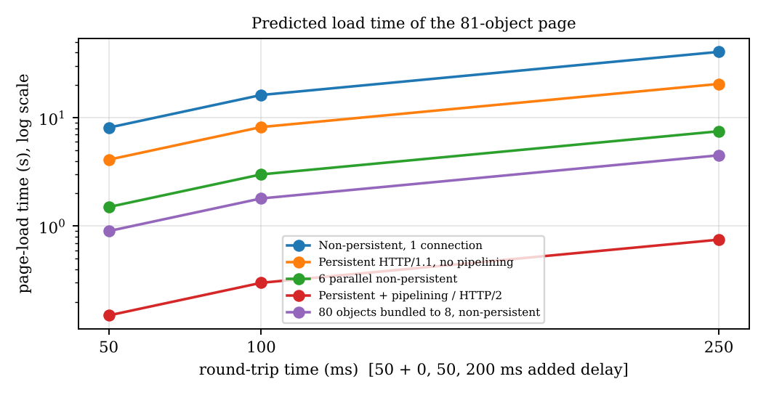
Figure 3: Predicted load time of the page against round-trip time (model, log scale)
The load time is proportional to the number of round trips × RTT: tripling the RTT to 250 ms makes every method five times slower, which is why reducing the number of round trips (persistent/multiplexed connections, caching) is more effective on mobile networks than any other change.
(c) Many small objects against a few large objects
For a page of 9 objects totalling 8 MB on a 20 Mbps link (assumed) the transmission time is 8 × 8 / 20 = 3.2 s. Non-persistent loading adds 9 × 100 ms = 0.9 s (total 4.1 s); HTTP/2 adds 3 × 50 ms = 0.15 s (total 3.35 s): a gain of only 0.75 s (18 %). With many small objects the same change cut the time by 98 %. Small objects are limited by round trips (protocol matters most); large objects are limited by bandwidth (protocol matters little).

Engineering Decision – ranking the changes for mobile networks
Table 14: Ranking of three changes (first-visit time from 8,100 ms)
Rank | Change | Load time | Cut | Why it matters on mobile networks
1 | Persistent, multiplexed connection: HTTP/2, preferably HTTP/3 (QUIC) | 150 ms | −98.1 % on every visit | RTT is large and variable; one connection removes almost all round trips; QUIC avoids head-of-line blocking under loss, sets up in 1 RTT and survives Wi-Fi ↔ 4G changes
2 | Caching headers (Cache-Control: max-age, ETag) | 100 ms on a repeat visit | −98.8 % on repeat visits only; 0 % on the first | No request at all for fresh objects – also saves mobile data; but it does nothing for a new visitor
3 | Bundling the 80 objects into 8 | 900 ms (non-persistent) / 500 ms (persistent) | −88.9 % / −87.8 % | Fewer requests, but the whole bundle must be fetched again when one object changes, and it gives nothing extra once HTTP/2 is used
(6 parallel connections would give −81.5 %, i.e. rank 4, and needs 6 TCP handshakes and 6 congestion windows.) Decision: first enable HTTP/2/HTTP/3 with persistent connections, then add caching headers; bundling is only a stop-gap for HTTP/1.1.

Alternative Concept Analysis – 80 objects combined into 8 bundles
The page now has 1 HTML + 8 bundles = 9 objects.
Table 15: Bundling against changing the protocol (RTT = 50 ms)
Case | Non-persistent HTTP | Persistent HTTP/1.1
Original page (81 objects) | 81 × 2 RTT = 8,100 ms | 82 RTT = 4,100 ms
Bundled page (9 objects) | 9 × 2 RTT = 900 ms | 1 + 1 + 8 = 10 RTT = 500 ms
Gain of bundling | 7,200 ms (−88.9 %) | 3,600 ms (−87.8 %)
Move original page to HTTP/2 | 3 RTT = 150 ms (−98.1 % against 8,100 ms; −96.3 % against 4,100 ms)
Bundled page on HTTP/2 | still 3 RTT = 150 ms – bundling adds nothing
Comparison: bundling gains 88 %, but HTTP/2 gains 98 % without touching the website: HTTP/2 is 750 ms faster than bundling with non-persistent HTTP and 350 ms faster than bundling with persistent HTTP/1.1. Bundling also hurts caching (one changed icon forces the whole bundle to be downloaded again). Moving to HTTP/2 (HTTP/3) is the better choice.

Q4 – How Many Queries Reach the University’s DNS Server? 7 Marks
Ans:
Assumptions: 150,000 students each look up results.simats.ac.in once in the busy hour; there is one caching resolver per city, so R = 40 resolvers (the question does not give the number of providers; a table for 120 and 400 resolvers is added). Each resolver caches the answer for the TTL, so it asks the university’s authoritative server again only after the TTL expires.

1. Queries per hour reaching the authoritative server from one resolver
A resolver that receives at least one lookup in every TTL period (here about 3,750 lookups per hour ≈ 1 per second, far more than one per 300 s) sends exactly one query per TTL: queries per hour = 3,600 / TTL.
Table 16: Queries per hour reaching the university server
TTL | From one resolver | From 40 resolvers (calculated) | From 40 resolvers (simulated) | Against 150,000 without caching
300 s | 3,600 / 300 = 12 | 40 × 12 = 480 (0.13 per second) | 480 | −99.7 %
30 s | 3,600 / 30 = 120 | 40 × 120 = 4,800 (1.3 per second) | 4,672 | −96.8 %

2. Why students hardly matter but resolvers and the TTL do
The load is Q = R × 3,600 / TTL. The number of students N does not appear: once a resolver has the answer in its cache, the 3,750 students behind it are answered locally. Doubling the students (300,000) leaves Q at 480; doubling the resolvers or halving the TTL doubles Q. Only a cache miss reaches the authoritative server, and a resolver can miss at most once per TTL.
Table 17: Load for other numbers of resolvers (simulation of 150,000 random look-ups in one hour)
Resolvers R | TTL 30 s | TTL 60 s | TTL 300 s | TTL 3,600 s
40 | 4,672 | 2,384 | 480 | 40
120 | 13,176 | 6,936 | 1,440 | 120
400 | 36,374 | 20,869 | 4,800 | 400
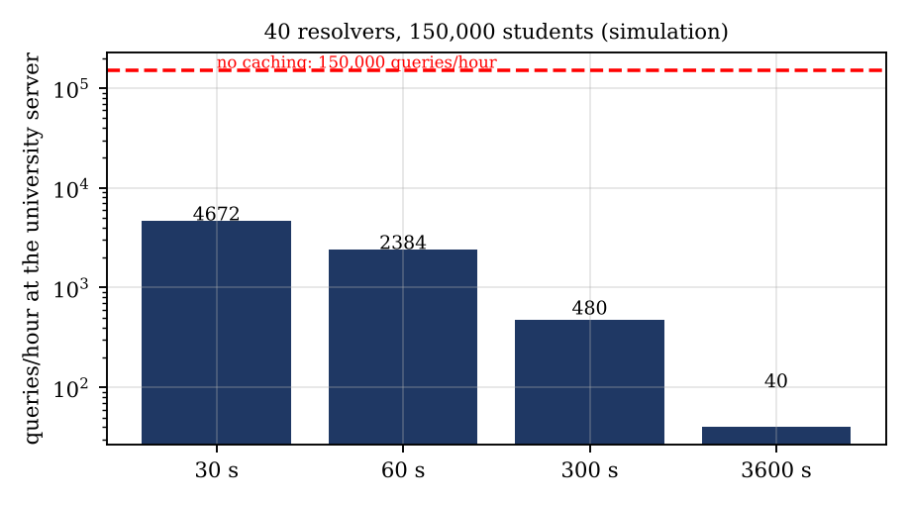
Figure 4: Queries per hour at the university server against TTL (40 resolvers)

3. Recursive query from the phone and iterative queries by the resolver
Table 18: Resolution of results.simats.ac.in
Step | From → to | Type | Answer
0 | Phone → ISP resolver | Recursive: “give me the final answer” | 10.20.30.40 (one question, one answer)
1 | Resolver → root server | Iterative | Referral to the .in TLD servers
2 | Resolver → .in TLD server | Iterative | Referral to the ac.in servers
3 | Resolver → ac.in server | Iterative | Referral to the simats.ac.in name server
4 | Resolver → simats.ac.in authoritative server | Iterative | A 10.20.30.40 with its TTL
The phone asks once and waits (recursive); the resolver does the work and asks four servers in order, each pointing it to the next (iterative) – 4 queries, as in the program. Real resolvers also cache the NS records of in., ac.in. and simats.ac.in. (long TTLs), so after the first resolution an expired A record costs only one query to the university’s server, which is what the calculation in part 1 assumes.

4. Records to publish and UDP against TCP
Table 19: Record types the university must publish
Record | Purpose | Use for simats.ac.in
A | Name → IPv4 address | results.simats.ac.in → 10.20.30.40
AAAA | Name → IPv6 address | Same host for IPv6 students
CNAME | Alias of another name (cannot sit at the zone apex or beside other records) | www or results → a CDN host name, if a CDN is used
MX | Mail servers with priorities | e-mail of the university
NS | Authoritative name servers (at least two, on different networks) | delegation of simats.ac.in
TXT | Free text: SPF, DKIM, DMARC, domain verification | mail authentication and site verification
UDP normally: a DNS query and answer are small and independent, so one UDP datagram each way (port 53) gives a lookup in 1 RTT with no handshake and no connection state on the server. TCP for large answers: the classic UDP limit is 512 bytes (about 1,232 bytes with EDNS0 without fragmentation). If the answer is larger (many records, DNSSEC signatures) the server sets the TC (truncated) bit and the client repeats the query over TCP port 53, costing one more RTT for the handshake. Zone transfers also use TCP.

5. Risk of a very long TTL
Table 20: Time during which students may still be sent to the old address
TTL | Worst case after the server is moved | Queries per hour (R = 40)
30 s | 30 seconds | 4,800
300 s | 5 minutes | 480
3,600 s | 1 hour | 40
86,400 s (1 day) | up to 24 hours – results pages unreachable or wrong | ≈ 2
Resolvers keep the old IP until their copy expires and no one can flush other people’s caches. If the result server must be moved during the day, a long TTL leaves students on a dead address for hours. Remedy: lower the TTL to 300 s (or less) at least one old-TTL period before a planned change, move, and raise it again afterwards.

Experimental Investigation
(a) Iterative resolution with a cache
The program in “Complete the Code” counts the queries: 4 for results.simats.ac.in., 3 for www.example.com. and 0 for the repeated name. The Monte-Carlo run summarised in the tables above (random arrival times of 150,000 look-ups over one hour, 40 resolvers) gave 480 queries per hour for TTL 300 s and 4,672 for TTL 30 s (a little below the 4,800 maximum because a resolver waits for the next student after each expiry).
(b) dig +trace
Command: dig +trace results.simats.ac.in. For every hop record the server name, the type of answer (referral or final answer) and the time shown in the line “Received … bytes from … in … ms”. Expected sequence: root servers (.) → .in servers → ac.in servers → the simats.ac.in name servers → A record.
(c) Three public resolvers, first and second look-up
Table 21: Resolution time (ms) – fill from your own runs
Resolver | Command | First look-up | Second look-up
Google 8.8.8.8 | dig @8.8.8.8 results.simats.ac.in
Cloudflare 1.1.1.1 | dig @1.1.1.1 results.simats.ac.in
Quad9 9.9.9.9 | dig @9.9.9.9 results.simats.ac.in
Read the value of “Query time” in each output. Expected: the second look-up is much faster (often 0 – 5 ms), because the resolver answers from its cache; the first look-up needs the iterative walk.
(d) A name that does not exist
Command: dig nosuchname.simats.ac.in. The answer has status NXDOMAIN (the name does not exist), an empty ANSWER section and the zone’s SOA record in the AUTHORITY section. The SOA gives the negative-caching time (the smaller of the SOA TTL and its minimum field, RFC 2308): resolvers remember “does not exist” for that time, so repeated mistyped names do not reach the authoritative server again. NXDOMAIN differs from NOERROR with an empty answer (NODATA), where the name exists but not for the type asked.

Conclusion – TTL and DNS set-up for result day
Recommendation
TTL 300 s on the A and AAAA records of results.simats.ac.in (lowered from the normal long TTL at least one day before). Load: 12 queries per hour per resolver, 480 per hour for 40 resolvers (0.13 per second), 99.7 % less than 150,000 uncached look-ups; even 400 resolvers give only about 4,800 per hour. A move or failover is visible everywhere within 5 minutes (a 24-hour TTL would take 24 hours).
A TTL of 30 s would cost 10 times more queries (4,800 per hour) for a small gain, and some resolvers ignore very short TTLs; use 60 s only if automatic fail-over is needed (2,400 per hour).
Set-up: at least two authoritative name servers on different networks (NS records), A and AAAA records, results server (or CDN) behind a load balancer, UDP with TCP fallback allowed on the firewall (EDNS buffer 1,232 bytes), DNSSEC if possible, monitoring of query rate and NXDOMAIN rate on result day.

Complete the Code – Q4/q4_dns.py
TODO 1: collect the keys of SERVERS[server] that name ends with, take the longest one, and read its value. If the value contains a digit it is an IP address: store it in the cache (with an expiry time) and return it with the query count; otherwise the value is the next server name and the loop continues. A cache entry is now (ip, expiry) and is used only while expiry > now.
"""Iterative DNS resolution through root, TLD and authoritative servers."""
import time
SERVERS = {
"root": {"in.": "tld-in", "com.": "tld-com"},
"tld-in": {"ac.in.": "ns-ac"},
"tld-com": {"example.com.": "ns-example"},
"ns-ac": {"simats.ac.in.": "ns-simats"},
"ns-simats": {"results.simats.ac.in.": "10.20.30.40"},
"ns-example": {"www.example.com.": "93.184.216.34"},
}
TTL = 300 # seconds (added: cache entries expire)
cache = {} # name -> (ip, expiry_time)
def resolve(name, now=None):
now = time.time() if now is None else now
if name in cache and cache[name][1] > now:
return cache[name][0], 0
server, queries = "root", 0
while True:
queries += 1
# TODO 1 (completed)
keys = [k for k in SERVERS[server] if name.endswith(k)]
key = max(keys, key=len)
value = SERVERS[server][key]
if any(ch.isdigit() for ch in value):
cache[name] = (value, now + TTL)
return value, queries
server = value
for n in ("results.simats.ac.in.", "www.example.com.", "results.simats.ac.in."):
ip, q = resolve(n)
print(f"{n:<24} {ip:<15} queries sent: {q}")
# extra: show expiry of the TTL
ip, q = resolve("results.simats.ac.in.", now=time.time() + 301)
print(f"after {TTL+1} s (TTL expired) {ip} queries sent: {q}")
Output (Python 3):
results.simats.ac.in. 10.20.30.40 queries sent: 4
www.example.com. 93.184.216.34 queries sent: 3
results.simats.ac.in. 10.20.30.40 queries sent: 0
after 301 s (TTL expired) 10.20.30.40 queries sent: 4
The first three lines agree with the expected output (4, 3 and 0 queries). Why the third look-up sends no query: the first look-up of results.simats.ac.in. stored the answer in cache; the second look-up of the same name finds it there and returns at once, so no server is contacted. The last line (added) shows the TTL at work: 301 s later the entry has expired and the name is resolved again with 4 queries.

Alternative Concept Analysis – CDN with anycast DNS
Table 22: Queries reaching the university (40 resolvers, one hour)
Set-up | Queries to the university per hour | Comment
Own authoritative server, A record TTL 300 s | 480 | as calculated above
CNAME results → CDN name, CNAME TTL 300 s | 480 (tiny CNAME answers) | the A lookups go to the CDN’s DNS
Same CNAME with TTL 3,600 s | 40 | one per resolver per hour
Sub-domain delegated to the CDN (NS TTL 1 day) | ≈ 40 per day, about 2 per hour | the university is asked only for the delegation
Look-up time in distant cities (illustrative assumption): with a single university server a resolver in a far city needs one round trip of, say, 150 ms for each cache miss; with anycast the same IP address is announced from many CDN sites and the resolver’s query reaches the nearest one, say 15 ms away. A miss then costs about 15 ms instead of 150 ms (90 % less), and the answer also points students to a nearby edge server, which makes the page itself faster. The price is one more name (the CNAME) to resolve, dependence on the CDN and its DNS, and the need to keep the CNAME TTL consistent with the failover plan.

Q5 – When Will the Video Call Freeze? 6 Marks
Ans:
Model: M/M/1 queue, service rate μ = 1,000 packets/s, arrival rate λ. Utilisation ρ = λ/μ; average number in the system L = ρ/(1 − ρ); average delay W = 1/(μ − λ) (check with Little’s law: L = λ·W).

1. Utilisation, packets in the router and delay
Table 23: M/M/1 results for μ = 1,000 packets/s
λ (packets/s) | ρ = λ/μ | L = ρ/(1 − ρ) | W = 1/(μ − λ)
500 | 0.50 | 1.0 packet | 1/500 = 2 ms
800 | 0.80 | 4.0 packets | 1/200 = 5 ms
900 | 0.90 | 9.0 packets | 1/100 = 10 ms
950 | 0.95 | 19.0 packets | 1/50 = 20 ms
990 | 0.99 | 99.0 packets | 1/10 = 100 ms
1,000 | 1.00 | unstable | queue grows without limit

2. Load at which the delay first exceeds 20 ms, and the effect of doubling the load
- W > 20 ms ⇔ 1/(μ − λ) > 0.020 ⇔ μ − λ < 50 ⇔ λ > 950 packets/s (ρ > 95 %). At exactly 950 the delay is 20 ms; above it the delay exceeds 20 ms.
- Doubling the load from 450 to 900 packets/s: W(450) = 1/550 = 1.82 ms and W(900) = 10 ms, so the delay grows 5.5 times; the number of packets in the router grows from L = 0.45/0.55 = 0.82 to 9, i.e. 11 times. (The question says “ten times”: it is correct for the queue length, approximately; for the delay the exact factor is 5.5. I have shown both.)
- Why so much more than double: the delay depends on the spare capacity μ − λ, not on λ itself. Doubling λ cuts the spare capacity from 550 to 100 packets/s, and 1/(μ − λ) rises steeply (hyperbolically) as λ approaches μ. A small extra load near full utilisation therefore causes a large extra queue.
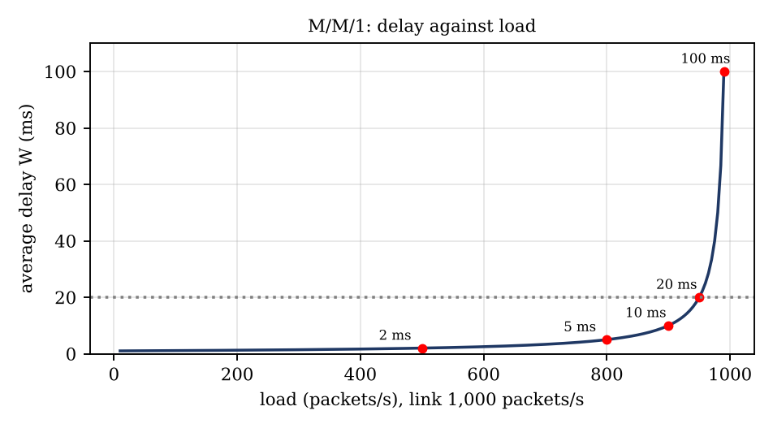
Figure 5: Average delay against load for μ = 1,000 packets/s (M/M/1)

3. Token bucket: how long can the backup burst?
Bucket size B = 1 MB = 8 Mbit, token rate r = 2 Mbps, backup rate R = 10 Mbps. While bursting, the bucket loses tokens at R − r = 8 Mbps, so the burst lasts T = B / (R − r) = 8 Mbit / 8 Mbps = 1.0 s (1.05 s if 1 MB = 1,048,576 B). In that second the backup sends 10 Mbps × 1 s = 10 Mbit = 1.25 MB (the 1 MB in the bucket plus 0.25 MB of newly arriving tokens). After that it is limited to 2 Mbps; refilling the empty bucket needs 8 Mbit / 2 Mbps = 4 s of silence.

4. DiffServ class for each application
Table 24: DiffServ classes
Application | Class (DSCP) | Reason
Video call | EF (46) | Needs low delay, low jitter and low loss: placed in a strict-priority queue with a rate limit so it cannot starve the others
Office business traffic (ERP, web, e-mail) | AF (e.g. AF21/AF31) | Needs a guaranteed share of bandwidth but not the lowest delay; drop precedence handles bursts
Nightly backup | Best effort (0), or a lower class | Elastic bulk traffic that can wait; it is also policed by the token bucket (2 Mbps)

Experimental Investigation
(a) Delay against load
The plot above was drawn from the formula W = 1/(μ − λ) for λ = 10 … 990 packets/s; the knee of the curve lies at about 90 – 95 % utilisation.
(b) FIFO queue against priority queue
A discrete-event simulation (Python, 300,000 packets per run, average of 5 runs) used video 300 packets/s and backup 650 packets/s (total 950, ρ = 0.95) on the 1,000 packets/s link. For non-preemptive priority the theory (Cobham’s formula) is W₀ = λ/μ² = 0.95 ms, W_video = W₀/(1 − ρ_v) + 1 ms = 0.95/0.7 + 1 = 2.36 ms and W_backup = W₀/((1 − ρ_v)(1 − ρ)) + 1 ms = 28.1 ms.
Table 25: Average delay in ms
Class | FIFO (simulated) | FIFO (theory) | Priority for video (simulated) | Priority (theory)
Video | 20.7 | 20.0 | 2.36 | 2.36
Backup | 20.6 | 20.0 | 29.1 | 28.1
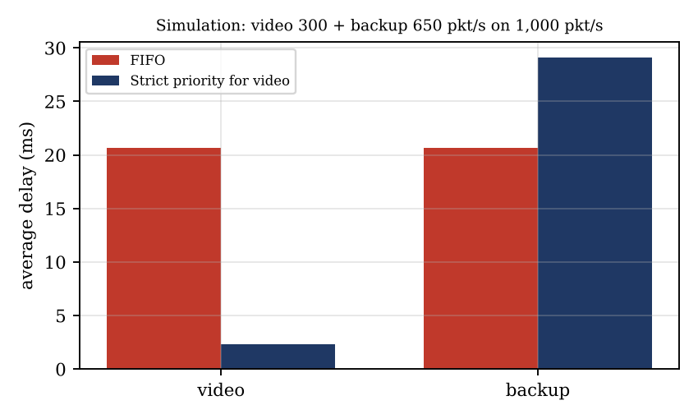
Figure 6: Average delay of video and backup, FIFO against strict priority (simulation)
Result: with FIFO the video suffers the same 20 ms as the backup; with priority the video delay falls to 2.4 ms (−89 %) while the backup rises only from 20 to about 29 ms. The weighted average (300 × 2.36 + 650 × 28.1) / 950 = 20 ms is unchanged: priority does not create capacity, it only moves the waiting to the traffic that can afford it.
(c) Shaping the backup with tc and measuring a ping
# Linux tc commands (interface eth0, 10 Mbit link, backup server 192.168.1.50)
sudo tc qdisc add dev eth0 root handle 1: htb default 10
sudo tc class add dev eth0 parent 1: classid 1:1 htb rate 10mbit
sudo tc class add dev eth0 parent 1:1 classid 1:10 htb rate 8mbit ceil 10mbit prio 0 # video / office
sudo tc class add dev eth0 parent 1:1 classid 1:20 htb rate 2mbit ceil 2mbit prio 1 # backup, shaped to 2 Mbps
sudo tc filter add dev eth0 protocol ip parent 1:0 prio 1 u32 match ip dst 192.168.1.50/32 flowid 1:20
tc -s class show dev eth0 # counters per class
sudo tc qdisc del dev eth0 root # remove the shaping afterwards
Run ping -i 0.2 SERVER for 30 s (a) while the backup is idle, (b) while the backup runs unshaped (for example iperf3 -c SERVER -t 30), and (c) while it runs through the 2 Mbit class. Record the average, maximum and mdev of the round-trip time. Expected: (b) the ping rises by the queuing delay of the full buffer (tens to hundreds of ms); (c) it stays close to (a), because the backup can no longer fill the queue.
(d) Load above the link capacity (λ > μ)
With video 300 and backup 800 packets/s (1,100 offered on a 1,000 packets/s link) and a 100-packet buffer, the formulas of the model no longer apply (the program prints “unstable”); the simulation shows: FIFO – 9.1 % of all packets lost (theory 1 − 1000/1100 = 9.1 %) and the delay pinned near 91.0 ms (the full buffer, about 100 packets × 1 ms), so the video suffers both loss and delay. Priority for video – video delay 2.43 ms and 0 % video loss; the backup absorbs all the loss (12.6 %), because it can use only the 700 packets/s that remain.

Engineering Decision – buy a faster link or configure QoS?
Decision: configure QoS (EF for video, shaping/policing for the backup) first
Numbers: with the backup running, the video on the unchanged link sees 20 ms (FIFO at 950 packets/s) and becomes unusable beyond 1,000 packets/s. With strict priority the video delay is 2.4 ms and stays at 2.4 ms even when the backup pushes the total load to 1,800 or more (see the alternative analysis). Doubling the link gives 5 ms for everything at 1,800 packets/s and degrades again when the backup grows.
The problem is not average bandwidth but one elastic flow filling the queue; QoS removes it at the cost of some configuration, while a faster link is a recurring cost that the backup will eventually fill too. Buy bandwidth only when the business traffic itself (video + office, without the backup) approaches 80 % of the link, i.e. about 800 packets/s.

Complete the Code – Q5/q5_mm1.py
TODO 1: return None when lam >= mu; otherwise rho = lam / mu, L = rho / (1 - rho) and W = 1 / (mu - lam). Two lines were added at the end for the capacity question and the alternative analysis.
"""M/M/1 model of a router output link: arrivals at rate lam, service at rate mu."""
def mm1(lam, mu):
# TODO 1 (completed)
if lam >= mu:
return None
rho = lam / mu
L = rho / (1 - rho)
W = 1 / (mu - lam)
return rho, L, W
mu = 1000
for lam in (500, 800, 900, 950, 990, 1000):
r = mm1(lam, mu)
if r is None:
print(f"load {lam:4d} pkt/s: unstable, queue grows without limit")
else:
rho, L, W = r
print(f"load {lam:4d} pkt/s: rho {rho:.2f} L {L:6.1f} pkts "
f"W {W * 1000:6.1f} ms")
# extra: capacity for W < 10 ms at lam = 1500 -> mu > lam + 1/W
print("capacity needed for W<10 ms at 1500 pkt/s: mu >", 1500 + 1/0.010, "pkt/s")
# alternative: double link, backup load 1800 ; and priority on old link
print("doubled link, lam=1800, mu=2000: W = %.1f ms" % (1000/(2000-1800)))
Output (Python 3):
load 500 pkt/s: rho 0.50 L 1.0 pkts W 2.0 ms
load 800 pkt/s: rho 0.80 L 4.0 pkts W 5.0 ms
load 900 pkt/s: rho 0.90 L 9.0 pkts W 10.0 ms
load 950 pkt/s: rho 0.95 L 19.0 pkts W 20.0 ms
load 990 pkt/s: rho 0.99 L 99.0 pkts W 100.0 ms
load 1000 pkt/s: unstable, queue grows without limit
capacity needed for W<10 ms at 1500 pkt/s: mu > 1600.0 pkt/s
doubled link, lam=1800, mu=2000: W = 5.0 ms
The six table lines agree with the expected output. Link capacity needed for a delay below 10 ms at 1,500 packets/s: W = 1/(μ − λ) < 0.010 s ⇒ μ > λ + 1/W = 1,500 + 100 = 1,600 packets/s (ρ = 93.75 %). At exactly 1,600 the delay is 10 ms, so the link must be slightly faster than 1,600.

Alternative Concept Analysis – double the link, or strict priority on the old link?
Assumption (not given in the question): the video calls generate 300 packets/s and the office traffic 200 packets/s; the backup adds the rest so that the total offered load is 1,800 packets/s.
Table 26: Video delay at a total load of 1,800 packets/s
Option | Calculation | Video delay
Link doubled to 2,000 packets/s, FIFO | ρ = 1,800 / 2,000 = 0.9; W = 1/(2,000 − 1,800) = 5 ms (same for every packet) | 5 ms
Old link (1,000 packets/s), strict priority for video | 1,800 > 1,000: the backup saturates the server, so a video packet waits only for the packet in service (1 ms) and for earlier video packets: W = 1 ms/(1 − 0.3) + 1 ms = 1.43 + 1 | 2.4 ms
Strict priority on the old link is about twice as good (2.4 ms against 5 ms) and costs nothing. Sensitivity: W_video = 1/(1 − ρ_v) + 1 ms gives 2.25 ms for 200, 3.0 ms for 500 and exactly 5 ms for 750 video packets/s; so priority beats the doubled FIFO link as long as video stays below 750 packets/s. The price of priority is that the backup gets only the leftover capacity (about 500 – 700 packets/s) and loses or delays the rest – acceptable for a nightly job, and controlled by the token bucket.

Q6 – Count the Round Trips Before the First Byte 6 Marks
Ans:
Model: RTT = 100 ms, no processing time, no packet loss. The time counted is the time before the first byte of the request can be sent; the first byte of the response arrives one RTT later.

1. Set-up time of the four options
Table 27: Round trips before the request can be sent (RTT = 100 ms)
Option | What happens | RTTs | Request can be sent at | First response byte
TCP + TLS 1.2 | TCP handshake (1 RTT); TLS 1.2 full handshake: ClientHello → ServerHello/Certificate/ServerHelloDone, then ClientKeyExchange/Finished → server Finished (2 RTT) | 3 | 300 ms | 400 ms
TCP + TLS 1.3 | TCP handshake (1 RTT); TLS 1.3: ClientHello with key share → ServerHello … Finished; the client sends its Finished together with the request (1 RTT) | 2 | 200 ms | 300 ms
QUIC, first visit | Transport and TLS 1.3 handshake combined in one exchange (Initial / Handshake packets) | 1 | 100 ms | 200 ms
QUIC with 0-RTT resumption | The client uses the stored session ticket and sends the request in the very first flight | 0 | 0 ms | 100 ms
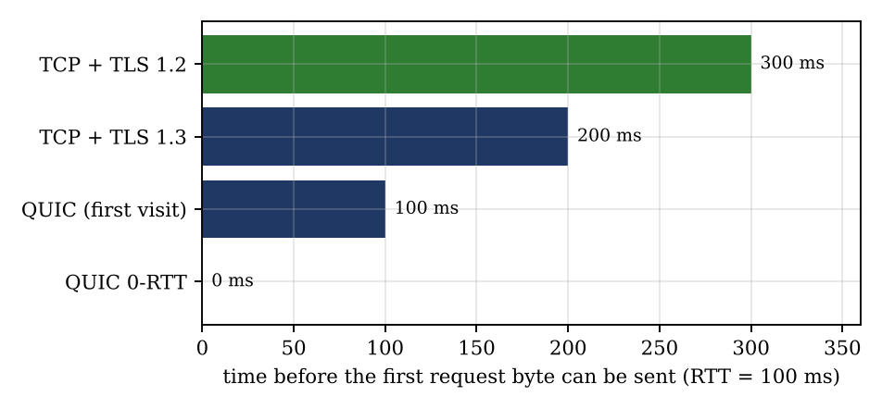
Figure 7: Time before the first request byte can be sent (RTT = 100 ms)
QUIC saves 100 ms against TCP + TLS 1.3 (−50 %) and 200 ms against TCP + TLS 1.2 (−66.7 %); with 0-RTT it saves the whole 300 ms of TLS 1.2 on a repeat visit.

2. Why 0-RTT data can be replayed, and which requests must not use it
0-RTT data is encrypted with a key derived from the stored session ticket, before the server has contributed any fresh random value for this connection. An attacker who records the first flight can send it again, and a server that did not keep a record of what it has seen cannot tell the copy from the original, so the request may be executed twice. (0-RTT data also lacks forward secrecy for that first flight.)
- Safe in 0-RTT: idempotent, read-only requests, for example loading the branch list, exchange rates or a public page.
- Never in 0-RTT: a money transfer, a payment, a change of beneficiary, password or PIN change, an OTP or login submission – anything that changes state or is security-sensitive; replaying it would pay twice.
- Mitigations: the server allows 0-RTT only for whitelisted requests and rejects the rest (the client then repeats it in the normal 1-RTT handshake); single-use tickets with an anti-replay cache; short ticket lifetime; idempotency keys on every transaction.

3. Connection ID and a phone moving from Wi-Fi to 5G
A TCP connection is identified by the 4-tuple (source IP, source port, destination IP, destination port). When the phone changes from Wi-Fi to 5G its source IP changes, so the server sees packets from a different 4-tuple that belong to no connection; the old connection breaks and the app must open a new one. A QUIC connection is identified by a connection ID carried in every packet header, not by addresses. After the switch the phone sends packets with the same connection ID from the new address; the server checks the new path (PATH_CHALLENGE / PATH_RESPONSE, 1 RTT) and the encrypted session, streams and flow-control state continue – the transfer survives.

4. Why some company firewalls block QUIC and what the app must do
QUIC runs on UDP port 443. Many enterprise firewalls allow only TCP 80/443 and inspect traffic with TLS-intercepting proxies, which cannot read QUIC because even most of its transport header is encrypted; to keep their policies and logging, administrators block UDP/443. The app must fall back to HTTP/2 (or HTTP/1.1) over TCP + TLS 1.3 automatically: try QUIC and TCP in parallel or advertise HTTP/3 with Alt-Svc, remember a failed QUIC attempt for a while, and keep the app fully working over TCP. The cost of the fallback is 1 more RTT at connection set-up (200 ms against 100 ms).

Experimental Investigation
(a) TLS 1.3 handshake in Wireshark
Capture with the filter tls while opening an https site (curl -sI https://example.com). To read the encrypted part set export SSLKEYLOGFILE=~/tlskeys.log before starting the browser/curl and give this file to Wireshark (Edit → Preferences → Protocols → TLS → (Pre)-Master-Secret log filename).
Table 28: Messages of the TLS 1.3 handshake to label
Message | Direction | What to mark
ClientHello | client → server | supported_versions = TLS 1.3 (0x0304), key_share (x25519), server_name (SNI), ALPN (h2, http/1.1), cipher suites
ServerHello | server → client | selected version TLS 1.3, selected cipher (for example TLS_AES_128_GCM_SHA256), server key_share – keys can now be derived; everything after this is encrypted
(Change Cipher Spec) | either | compatibility message only; ignored by TLS 1.3
EncryptedExtensions, Certificate, CertificateVerify, Finished | server → client | shown as “Application Data” unless the key log file is used
Finished | client → server | end of the handshake; the first request can follow in the same flight
NewSessionTicket | server → client | ticket for resumption and 0-RTT
(b) TLS versions offered by two websites (openssl s_client)
openssl s_client -connect SITE:443 -tls1_2 < /dev/null and … -tls1_3 < /dev/null for each site. Read the lines “Protocol” and “Cipher”; a handshake failure means that version is not accepted.
Table 29: TLS versions accepted (fill from your own runs)
Website | TLS 1.2 | TLS 1.3 | Cipher used with TLS 1.3
Site A:
Site B:
(c) Which sites support HTTP/3
In Chrome/Edge DevTools → Network enable the Protocol column; h3 means HTTP/3 over QUIC, h2 HTTP/2. Check the sites you use (for example a search engine, a video site, a social network). A site that advertises Alt-Svc: h3=":443" is switched to HTTP/3 on a later request.
(d) Set-up time with added delay
Use curl -o /dev/null -s -w "tcp=%{time_connect}s tls=%{time_appconnect}s first_byte=%{time_starttransfer}s\n" https://SITE (time_connect = TCP handshake ≈ 1 RTT; time_appconnect = TCP + TLS) with sudo tc qdisc add dev eth0 root netem delay 0ms (then 25 ms and 100 ms for +50 and +200 ms of round-trip time). The model predicts:
Table 30: Predicted set-up time before the request can be sent
Round-trip time | TCP + TLS 1.2 | TCP + TLS 1.3 | QUIC (first) | QUIC 0-RTT | Measured TCP + TLS 1.3
100 ms (no added delay) | 300 ms | 200 ms | 100 ms | 0 ms
150 ms (+50 ms) | 450 ms | 300 ms | 150 ms | 0 ms
300 ms (+200 ms) | 900 ms | 600 ms | 300 ms | 0 ms
The saving grows with the RTT: at 300 ms QUIC saves 300 ms against TLS 1.3 and 600 ms against TLS 1.2 on every new connection.

Conclusion – should the bank’s app use QUIC?
Decision: yes – use HTTP/3 over QUIC, with fallback to TCP + TLS 1.3 and with 0-RTT limited to safe requests
Round-trip numbers (RTT 100 ms): QUIC needs 1 RTT (100 ms) before the request, TCP + TLS 1.3 needs 2 (200 ms) and TCP + TLS 1.2 needs 3 (300 ms): a 50 % and 66.7 % reduction of the waiting time at every new connection, and more on a slower cellular link (300 ms saved at 300 ms RTT).
Other reasons: connection migration keeps a transfer alive when the phone moves from Wi-Fi to 5G (TCP has to rebuild it, see below), independent streams avoid head-of-line blocking on lossy mobile links, and encryption is always on.
Conditions: (1) 0-RTT only for idempotent requests – never for a money transfer; login and payments use the normal 1-RTT handshake; (2) automatic fall-back to TCP + TLS 1.3 when UDP/443 is blocked; (3) keep TLS 1.3 certificates, key rotation and anti-replay controls under the bank’s security review.

Alternative Concept Analysis – Wi-Fi to 5G in the middle of a 30-second transfer
Table 31: What each protocol must redo (RTT = 100 ms)
 | TCP with TLS 1.3 | QUIC
What happens to the connection | Breaks: the new IP address matches no 4-tuple; the app discovers it by timeout or reset | Continues: the same connection ID arrives from the new address
What must be redone | New TCP handshake (1 RTT), new TLS 1.3 handshake (1 RTT), a new request to resume the transfer (1 RTT, for example an HTTP Range request); congestion window restarts from the initial window; unacknowledged data is resent | Path validation (PATH_CHALLENGE / PATH_RESPONSE, 1 RTT) while data may already flow; the RTT estimate and congestion window of the new path are re-learned; unacknowledged data is resent
Minimum time lost | 3 RTT = 300 ms before the first resumed byte, plus the time to notice that the old path is dead (an RTO of at least 200 ms and often a second or more) | 1 RTT = 100 ms
Share of the 30 s transfer | 300 ms = 1.0 % (about 4.3 % if detection takes 1 s) | 100 ms = 0.33 %
QUIC loses at least 200 ms less (one third of the stall), and does not need the application to rebuild the session, which for a bank also means no second login or token exchange in the middle of a transfer. The ramp-up of the congestion window after the switch affects both protocols.

Q7 – Choose the Protocols from First Principles 10 Marks
Ans:
Problem: a telemedicine platform between a city hospital and rural health centres over 4G links with 100 – 300 ms RTT and up to 5 % loss, carrying live video consultation, patient records and X-ray images, chat and look-up of hospital services by name. Assumptions where the question gives no value: X-ray 10 MB, 4G link rate 10 Mbps, video 0.5 – 1 Mbps, MSS 1,460 B.

Stage 1 – Interpret the problem (2 marks)
Table 32: Traffic types, needs and measurable requirements
Traffic | Delay | Loss | Ordering | Security | Measurable requirement
Live video consultation (with audio) | Very strict: one-way ≤ 250 ms, jitter ≤ 40 ms | Tolerates ≤ 5 % if concealed or repaired by FEC | By timestamp only | Encrypted, authenticated | Audio never interrupted; ≥ 97 % of video slices decodable at 5 % loss; adaptive bit rate 0.3 – 1 Mbps
Patient records and X-ray images (≈ 10 MB) | Tolerant (seconds) | None – bit-exact | Required | Confidential, integrity, authentication | 10 MB X-ray delivered in ≤ 60 s at RTT 300 ms and 5 % loss; SHA-256 match 100 %; resumable
Chat | ≤ 2 s (95th percentile) | None – every message once | Per conversation | Encrypted | 100 % of messages delivered in order, ≤ 2 s at 95 %
Name look-up (DNS) | ≤ 1 s even with one retry | Lost query is repeated | Not needed | Integrity of the answer | Cold look-up ≤ 1 s; cached ≤ 10 ms; TTL 300 s

Stage 2 – Compare candidate protocols (3 marks)
Table 33: Suitability of each protocol for each type of traffic
Protocol | Live video | X-ray / records | Chat | DNS look-up
TCP | Poor – retransmission and in-order delivery freeze the picture; ≈ 1.7 Mbps at 2 % loss and 60 ms | OK for reliability, but window- and loss-limited (below) | Good | Fallback for large answers
UDP | Best with RTP, FEC and rate adaptation | Poor – no reliability, would have to be built | Needs own ACKs | Default (1 RTT, no state)
QUIC | Usable (datagrams), but not needed for media | Very good – 1-RTT start, independent streams, per-stream loss recovery, connection migration | Good | Possible (DoQ), not needed
HTTP/2 | Not suitable | Good, but one TCP stream: a lost segment stalls all objects | OK (WebSocket / SSE) | DoH only
HTTP/3 | Not for media (WebTransport possible) | Best for web access – no head-of-line blocking, 0-RTT for repeat centres | Good (WebTransport / WebSocket) | DoH over h3 possible
TLS 1.3 | DTLS-SRTP for media | Mandatory – 1-RTT handshake (TLS 1.2 needs 2: 600 ms against 300 ms at RTT 300 ms) | Mandatory | DNS over TLS if privacy is required
TCP throughput limit with a 64 KB window at 300 ms RTT
Throughput ≤ window / RTT = 65,536 × 8 bit / 0.3 s = 1.75 Mbps, whatever the link speed. On a 10 Mbps 4G link this uses only 17.5 %, and a 10 MB (80 Mbit) X-ray needs 80 / 1.75 = 45.8 s even without any loss. To fill the link the window must equal the bandwidth-delay product: 10 × 10⁶ × 0.3 / 8 = 375,000 B ≈ 366 KB, about 5.7 times 64 KB – so TCP window scaling (RFC 7323) and auto-tuning must be on. Loss is worse: with 5 % loss the Mathis limit is 1.22 × 1,460 × 8 / (0.3 × √0.05) = 0.21 Mbps, so the same X-ray would need 80 / 0.212 = 377 s (6 minutes). Hence a loss-tolerant congestion control (BBR) or QUIC with BBR is needed for the X-ray transfers; the images should also be compressed (lossless) and sent as resumable chunks.
DNS and QoS decisions
- DNS: a caching resolver in every health centre (cached look-ups cost ≈ 0 ms instead of 300 ms), two resolvers for redundancy, hospital service names with TTL 300 s, UDP with TCP fallback (EDNS buffer 1,232 B), retry after 1 s; DNSSEC for integrity.
Table 34: DiffServ plan
Class | Traffic | DSCP | Treatment
EF | Live audio and video | 46 | Strict priority queue, limited to about 40 % of the link
AF31 | Chat, patient-record API calls, DNS | 26 | Guaranteed 20 % of the link
AF11 / best effort | X-ray and bulk transfers | 10 / 0 | Remaining capacity; shaped so that it cannot fill the queue
Public 4G networks may not honour DSCP marks end to end, so the shaping is done at the edge routers and the operator is asked for a dedicated bearer for the video (an LTE QCI for conversational video).

Stage 3 – Implement and verify (3 marks)
(a) Implementation – Q7/q7_filetransfer_chat.py
A TCP file transfer (a JSON header with name, size and SHA-256, then the bytes; the server verifies the hash and replies OK) and a two-user chat (server relays each line to the other client), both over sockets.
"""Q7 Stage 3: TCP file transfer (with SHA-256 check) and a two-user chat over sockets."""
import socket, threading, hashlib, os, time, json
def file_server(srv, out):
conn, _ = srv.accept()
with conn:
f = conn.makefile("rb")
meta = json.loads(f.readline()) # {"name":..,"size":..,"sha256":..}
data, left = bytearray(), meta["size"]
while left:
chunk = f.read(min(65536, left)); data += chunk; left -= len(chunk)
ok = hashlib.sha256(data).hexdigest() == meta["sha256"]
conn.sendall(b"OK\n" if ok else b"BAD\n"); out.append(ok)
srv = socket.socket(); srv.bind(("127.0.0.1", 0)); srv.listen(1); res = []
th = threading.Thread(target=file_server, args=(srv, res)); th.start()
payload = os.urandom(1_000_000) # stand-in for a 1 MB X-ray slice
meta = {"name": "xray01.dcm", "size": len(payload), "sha256": hashlib.sha256(payload).hexdigest()}
t0 = time.time(); c = socket.create_connection(srv.getsockname())
c.sendall(json.dumps(meta).encode() + b"\n" + payload)
reply = c.makefile("rb").readline().strip().decode(); dt = time.time() - t0
th.join(); c.close(); srv.close()
print(f"file transfer: {len(payload)} bytes, server verdict {reply}, hash match {res[0]}, {dt*1000:.0f} ms on loopback")

# ---- chat: server relays each line to the other client ----
chat = socket.socket(); chat.bind(("127.0.0.1", 0)); chat.listen(2)
clients = []
def relay(conn, idx):
for line in conn.makefile("rb"):
other = clients[1 - idx]; other.sendall(line)
def accept_two():
for i in range(2):
cn, _ = chat.accept(); clients.append(cn)
for i, cn in enumerate(clients): threading.Thread(target=relay, args=(cn, i), daemon=True).start()
at = threading.Thread(target=accept_two); at.start()
doc = socket.create_connection(chat.getsockname()); nurse = socket.create_connection(chat.getsockname())
at.join()
t0 = time.time()
doc.sendall(b"Doctor: please send the chest X-ray\n")
print("nurse got :", nurse.makefile("rb").readline().decode().strip())
nurse.sendall(b"Nurse : sent, patient is stable\n")
print("doctor got :", doc.makefile("rb").readline().decode().strip())
print(f"chat round trip on loopback: {(time.time()-t0)*1000:.1f} ms")
Output on loopback (no impairment):
file transfer: 1000000 bytes, server verdict OK, hash match True, 8 ms on loopback
nurse got : Doctor: please send the chest X-ray
doctor got : Nurse : sent, patient is stable
chat round trip on loopback: 0.2 ms
(b) Video-like UDP stream with a link emulator – Q7/q7_udp_fec.py
A Python link emulator (loopback) drops packets with probability p and delays the rest by 150 ms ± 20 ms (RTT ≈ 300 ms). The sender sends 2,000 packets of 1,200 bytes in slices of 4 packets, with and without one XOR parity packet per slice (FEC, +25 % overhead). A slice is usable if at least 4 of its packets arrive.
"""Q7 Stage 3: UDP video-like stream through a lossy, delaying link emulator, with and without XOR parity FEC."""
import socket, struct, threading, random, time, heapq, statistics, sys
PAY, BLK, N = 1200, 4, 2000 # 1200-byte packets, 4 data packets per "frame slice"
def run(loss, fec, delay=0.150, jitter=0.020):
rx = socket.socket(socket.AF_INET, socket.SOCK_DGRAM); rx.bind(("127.0.0.1", 0)); rx.settimeout(0.6)
px = socket.socket(socket.AF_INET, socket.SOCK_DGRAM); px.bind(("127.0.0.1", 0)); px.settimeout(0.5)
tx = socket.socket(socket.AF_INET, socket.SOCK_DGRAM)
heap, lock, stop = [], threading.Lock(), False
def proxy_in(): # link emulator: drop with probability 'loss'
while not stop:
try: d, _ = px.recvfrom(2000)
except socket.timeout: continue
if random.random() >= loss:
with lock: heapq.heappush(heap, (time.time() + delay + random.uniform(0, jitter), d))
def proxy_out(): # deliver after the one-way delay
while not stop or heap:
with lock: due = heap[0][0] if heap else None
if due is None or due > time.time(): time.sleep(0.001); continue
with lock: _, d = heapq.heappop(heap)
tx.sendto(d, rx.getsockname())
threads = [threading.Thread(target=proxy_in), threading.Thread(target=proxy_out)]
[t.start() for t in threads]
def sender():
for b in range(N // BLK):
pk = [bytes([random.randrange(256) for _ in range(8)]) * (PAY // 8) for _ in range(BLK)]
parity = bytes(a ^ b2 ^ c ^ d for a, b2, c, d in zip(*pk)) if fec else None
for i, p in enumerate(pk + ([parity] if fec else [])):
tx.sendto(struct.pack("!IBd", b, i, time.time()) + p, px.getsockname()); time.sleep(0.0007)
st = threading.Thread(target=sender); st.start()
got, delays = {}, []
while True:
try: d, _ = rx.recvfrom(2000)
except socket.timeout: break
b, i, ts = struct.unpack("!IBd", d[:13]); got.setdefault(b, set()).add(i); delays.append(time.time() - ts)
st.join(); stop = True; [t.join() for t in threads]
need = BLK
ok = sum(1 for b in range(N // BLK) if len(got.get(b, ())) >= need) # complete or recoverable with 1 parity
sent = N + (N // BLK if fec else 0)
return ok / (N // BLK) * 100, len(delays) / sent * 100, statistics.mean(delays) * 1000, statistics.pstdev(delays) * 1000, sent / N
print(f"{'loss':>5} {'FEC':>4} {'slices OK %':>12} {'pkts delivered %':>17} {'delay ms':>9} {'jitter ms':>10} {'overhead':>9}")
for loss in (0.0, 0.01, 0.05):
for fec in (False, True):
ok, dl, md, jt, ov = run(loss, fec)
print(f"{loss*100:4.0f}% {str(fec):>5} {ok:12.1f} {dl:17.1f} {md:9.1f} {jt:10.1f} {ov:9.2f}x")
Output (measured on loopback):
loss FEC slices OK % pkts delivered % delay ms jitter ms overhead
0% False 100.0 100.0 160.5 5.9 1.00x
0% True 100.0 100.0 160.6 5.8 1.25x
1% False 95.2 98.8 160.9 5.7 1.00x
1% True 99.8 99.0 160.7 5.7 1.25x
5% False 82.2 95.1 161.1 6.4 1.00x
5% True 97.8 94.7 160.8 5.7 1.25x
Table 35: Delivered quality of the video-like stream (measured)
Loss | Usable slices without FEC | Usable slices with FEC (+25 %) | Theory without FEC | Theory with FEC
0 % | 100 % | 100 % | 100 % | 100 %
1 % | 95.2 % | 99.8 % | 0.99⁴ = 96.1 % | 99.9 %
5 % | 82.2 % | 97.8 % | 0.95⁴ = 81.5 % | 97.7 %
The measured values agree with the binomial theory; the average delay stayed at 150 – 160 ms and the jitter at about 6 ms, independent of the loss, because UDP never waits for a retransmission. For a full video frame of 8 packets and 5 % loss, 66.3 % of the frames are complete without protection (0.95⁸), but 98.8 % with 2 parity packets in 10.
(c) Testing the TCP transfer under delay and loss
On your machine apply the expected link: sudo tc qdisc add dev lo root netem delay 150ms 20ms loss 5% (150 ms each way = 300 ms RTT; try loss 0 %, 1 % and 5 %), run the file transfer with a 10 MB payload (change 1_000_000 to 10_000_000), time it with time python3 q7_filetransfer_chat.py, and remove the emulation with sudo tc qdisc del dev lo root. The table gives the result of the Python round-based model (average of 150 runs) for the 10 MB X-ray, link 10 Mbps, RTT 300 ms.
Table 36: Transfer time of a 10 MB X-ray (seconds, model; compare with your netem measurements)
Loss | TCP, 64 KB window | TCP Reno, window scaling | BBR-like (idealised) | UDP without repair
0 % | 47.8 | 9.8 | 10.0 | 8.2 (100 % of data)
1 % | 186.7 | 181.8 | 10.0 | 8.2 (99 % – file damaged)
5 % | 524.8 | 525.9 | 10.4 | 8.2 (95 % – file damaged)
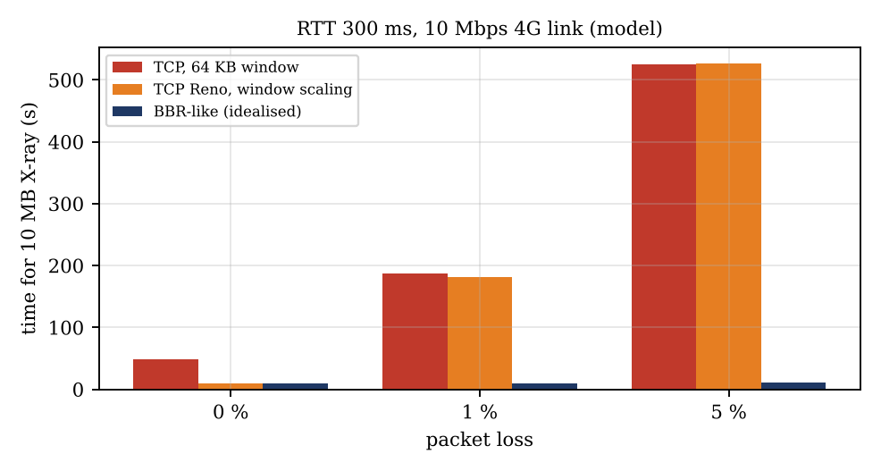
Figure 8: Time for a 10 MB X-ray: TCP with 64 KB window, TCP Reno with window scaling and BBR-like pacing
Measured quality summary: the file transfer delivered every byte (SHA-256 match) and the chat delivered both messages in order – reliable traffic must use TCP/QUIC. The UDP stream delivered video with constant delay and, with FEC, 97.8 % usable slices at 5 % loss. TCP’s completion time grows from seconds to minutes as loss rises (and 64 KB windows alone make it 4.9 times slower even without loss: 47.8 s against 9.8 s).

Stage 4 – Defend the design (2 marks)
Final design and justification
Live video: UDP (WebRTC: SRTP/DTLS) with 20 – 25 % FEC and adaptive bit rate, EF class. Measured: delay constant at about 160 ms and 97.8 % usable slices at 5 % loss; TCP would freeze the picture on every loss.
X-ray and records: HTTP/3 over QUIC (TLS 1.3 built in), BBR congestion control, resumable chunks; fallback HTTP/2 over TCP + TLS 1.3 with window scaling. Model: 10 s for 10 MB at 5 % loss against 525 s for Reno-type TCP and 48 s for TCP limited by a 64 KB window; TLS 1.3 saves one round trip (300 ms) against TLS 1.2 on every new connection and QUIC another (300 ms); the connection ID keeps a transfer alive when a health centre’s 4G changes cell or network.
Chat: WebSocket/WebTransport over TLS 1.3 (reliable, ordered, 1 – 2 s budget). DNS: local caching resolver, UDP with TCP fallback, TTL 300 s. QoS: EF for video, AF31 for chat/records, best effort for bulk X-rays with shaping.
What changes with 5G (assumed RTT 20 – 50 ms and loss below 1 %): the 64 KB window limit rises to 65,536 × 8 / 0.03 = 17.5 Mbps (ten times higher), the Mathis limit at 1 % loss and 30 ms becomes 1.22 × 1,460 × 8 / (0.03 × 0.1) = 4.75 Mbps, so plain TCP+TLS 1.3 becomes acceptable for records; FEC can drop to about 10 %, video can use HD, one-way delay falls well below 100 ms, and network slicing can give the telemedicine service a guaranteed slice instead of DSCP marking. QUIC is still kept for mobility and loss tolerance; the protocol design does not change, only parameters (FEC rate, bit-rate caps, window sizes, timers).

Alternative Concept Analysis – commercial video-consultation service
Table 37: Questions to ask the vendor and the evidence that would make me choose it
Area | Questions to ask | Evidence required
Delay | What is the end-to-end (glass-to-glass) latency at 300 ms RTT? Where are the media servers and relays (TURN) located – in India? What is the jitter-buffer size? | Test report from a pilot on a real rural 4G link: one-way delay ≤ 250 ms, audio never dropped
Loss handling | Does it use UDP/RTP with FEC, packet-loss concealment and adaptive bit rate? How does it behave at 5 % loss? Is there a fall-back to TCP/TLS when UDP is blocked? What happens to the recording? | Measured quality (MOS/VMAF, freeze rate) at 1 % and 5 % loss and 300 ms RTT, equal to or better than my results (97.8 % usable slices)
Privacy and security | Is the media end-to-end encrypted (who holds the keys)? Where are patient data and recordings stored (data residency in India)? Retention, access logs, sub-processors, breach notification? Compliance (DPDP Act, ABDM, ISO 27001)? | Independent security audit and penetration-test report, signed data-processing agreement, data stored in India, audit logs available to the hospital
Reliability and cost | SLA, uptime history, support for low-end phones and 2 Mbps links, exit and data-export terms, price per consultation | 99.9 % SLA in writing; total cost per year lower than building and running my own
Decision rule: choose the vendor only if its pilot meets my measured requirements (delay, loss tolerance), the security and data-residency evidence is satisfactory, and the three-year cost is lower than building the design above. Otherwise build the proposed design, which meets the requirements with measured evidence and keeps control of patient data.

