

CSA0501-DATABASE MANAGEMENT SYSTEMS

LAB EXPERIMENTS DATE: 14/07/2026

EXPERIMENT 6 -- SELECT with various clause – WHERE, pattern matching

AIM:
To retrieve records from the student_cgpa table using the SELECT statement with BETWEEN, IN, and Aggregate Functions in MySQL Workbench.

PROCEDURE:
- Open MySQL Workbench and connect to the MySQL server.
- Select the required database using the USE command.
- Create the student_cgpa table and insert the required records.
- Verify the table contents using the SELECT statement.
- Execute queries using the BETWEEN operator to retrieve records within a specified range.
- Execute queries using the IN operator to retrieve records matching specific values.
- Use aggregate functions such as COUNT(), SUM(), AVG(), MIN(), and MAX() to perform calculations on the table data.
- Observe the output of each query and verify the results.
- Conclude the experiment after successful execution.

PROGRAM:

1. CREATE TABLE

CREATE TABLE student_cgpa (
reg_no VARCHAR(15) PRIMARY KEY,
student_name VARCHAR(50) NOT NULL,
department VARCHAR(20),
no_of_subs_pass INT,
no_of_subs_fail INT,
cgpa DECIMAL(3,2)
);
Then Insert Values:
INSERT INTO student_cgpa
(reg_no, student_name, department, no_of_subs_pass, no_of_subs_fail, cgpa)
VALUES
('192411123','Deepthi','CSE',22,2,8.71),
('192512121','Varun','IT',27,1,9.23),
('192312117','Aadhya','ECE',25,3,8.97),
('192411227','Dimple','CSE',31,0,9.37),
('192820896','Mohan','EEE',18,9,6.48),
('192411122','Yogitha','CSE',31,1,9.01),
( '192516871','Sadhya','IT',25,5,7.22),
('192111101','Rahul','MECH',30,12,5.14),
('192411010','Alekhya','CSE',35,2,9.01),
('192511135','Rahul','CIVIL',37,0,9.72);

SELECT * FROM student_cgpa;

OUTPUT:

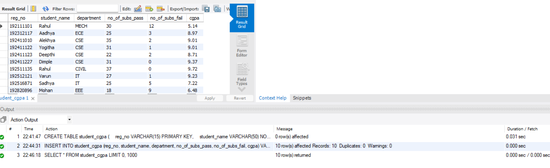

BETWEEN Operator

1. Display students whose CGPA is between 8.00 and 9.50.

SELECT *
FROM student_cgpa
WHERE cgpa BETWEEN 8.00 AND 9.50;

OUTPUT:

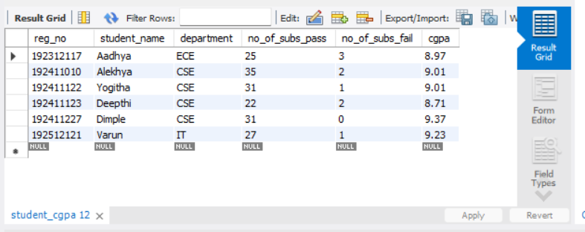

2. Display students who passed between 20 and 35 subjects.

SELECT *
FROM student_cgpa
WHERE no_of_subs_pass BETWEEN 20 AND 35;

OUTPUT:

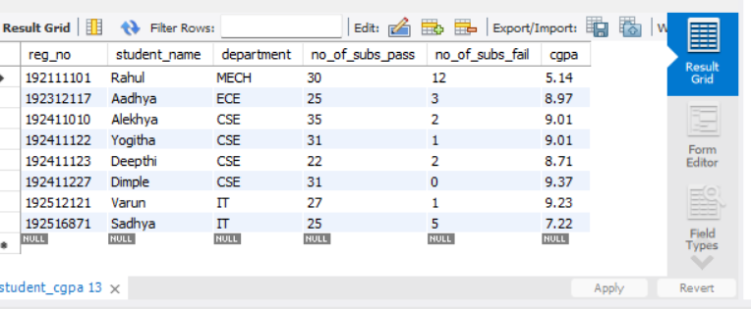

IN Operator

3. Display students belonging to the CSE and IT departments.

SELECT *
FROM student_cgpa
WHERE department IN ('CSE','IT');

OUTPUT:

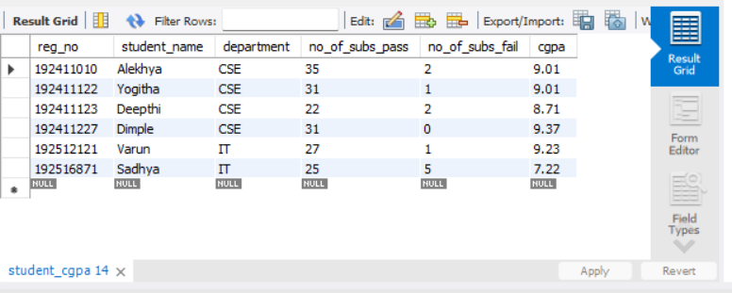

4. Display students whose names are Deepthi, Dimple and Rahul.

SELECT *
FROM student_cgpa
WHERE student_name IN ('Deepthi','Dimple','Rahul');

OUTPUT:

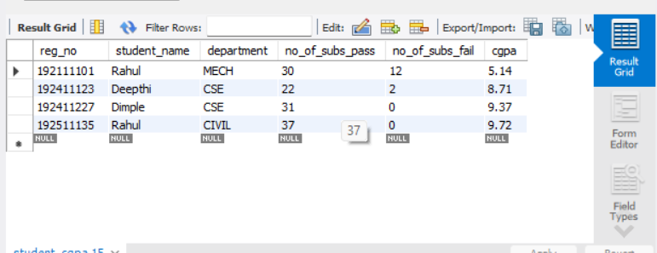

Aggregate Functions

5. Find the average CGPA of all students.

SELECT AVG(cgpa) AS Average_CGPA
FROM student_cgpa;

OUTPUT:

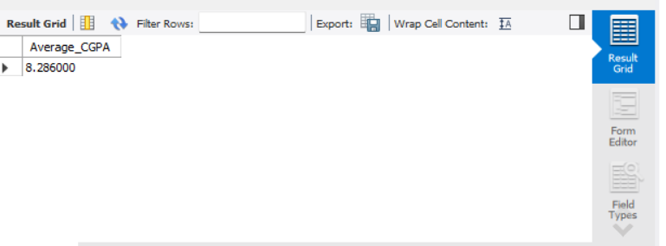

6. Find the maximum and minimum CGPA.
SELECT
MAX(cgpa) AS Maximum_CGPA,
MIN(cgpa) AS Minimum_CGPA
FROM student_cgpa;

OUTPUT:

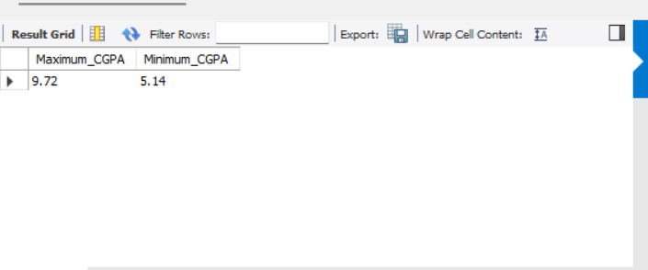

7. Find the maximum, minimum and average CGPA for each department.

SELECT
department,
MAX(cgpa) AS Maximum_CGPA,
MIN(cgpa) AS Minimum_CGPA,
AVG(cgpa) AS Average_CGPA
FROM student_cgpa
GROUP BY department;

OUTPUT:

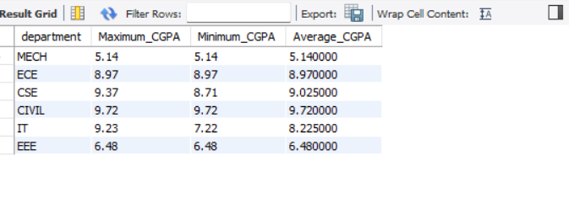

8. Display each department and its average CGPA.

SELECT
department,
AVG(cgpa) AS Average_CGPA
FROM student_cgpa
GROUP BY department;

OUTPUT:

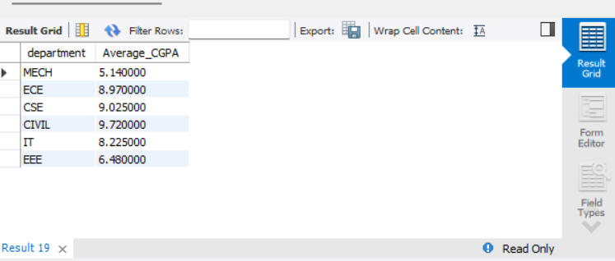

9. Calculate the total number of passed subjects.

SELECT
SUM(no_of_subs_pass) AS Total_Passed_Subjects
FROM student_cgpa;

OUTPUT:

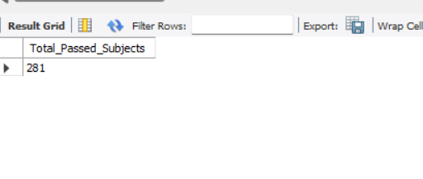

10. Count the number of students in each department.

SELECT
department,
COUNT(*) AS Number_of_Students
FROM student_cgpa
GROUP BY department;

OUTPUT:

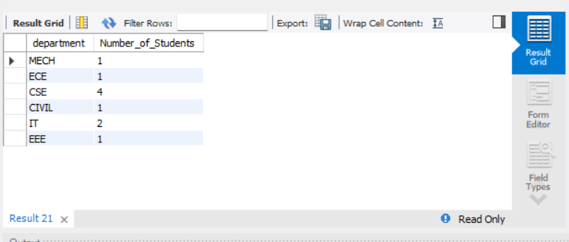

11. Count the total number of students.

SELECT COUNT(*) AS Total_Students
FROM student_cgpa;

OUTPUT:

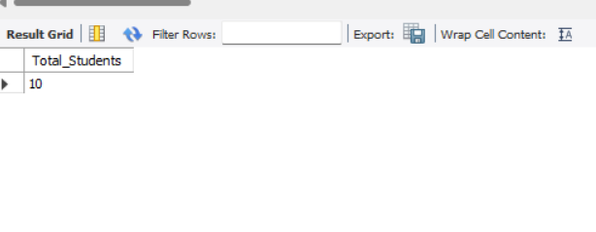

12. Find the highest CGPA student.

SELECT *
FROM student_cgpa
WHERE cgpa = (SELECT MAX(cgpa) FROM student_cgpa);

OUTPUT:
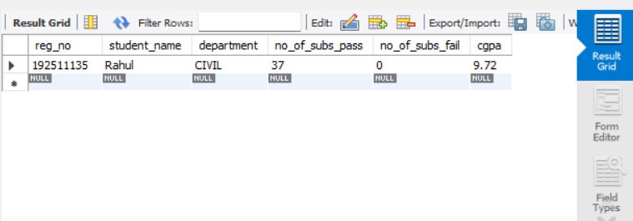

13. Find the lowest CGPA student.

SELECT *
FROM student_cgpa
WHERE cgpa = (SELECT MIN(cgpa) FROM student_cgpa);

OUTPUT:

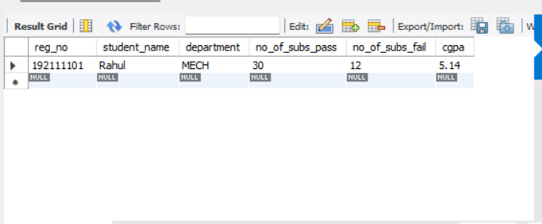

RESULT:
Thus, the records from the student_cgpa table were successfully retrieved using the SELECT statement with BETWEEN, IN, and Aggregate Functions in MySQL Workbench.

