

CSA0501-DATABASE MANAGEMENT SYSTEMS

LAB EXPERIMENTS DATE: 20/07/2026

EXPERIMENT 7 -- SELECT with various clause – GROUP BY, HAVING, ORDER BY

AIM:
To retrieve and organize records from the milks_dairy table using the GROUP BY, HAVING, and ORDER BY clauses in MySQL Workbench.

PROCEDURE:

Open MySQL Workbench and connect to the MySQL server.

Select the required database using the USE command.

Create the milks_dairy table and insert the required records.

Display the table contents using the SELECT statement.

Use the GROUP BY clause to group records based on the department.

Apply the HAVING clause to filter grouped results.

Use the ORDER BY clause to sort records in ascending and descending order.

Execute each query and verify the output in the Result Grid.

Observe the grouped, filtered, and sorted results.

Conclude the experiment after successful execution.

PROGRAM:

1. CREATE TABLE

CREATE TABLE milks_dairy (
name VARCHAR(20),
liters INT,
amount INT,
account_number BIGINT,
phone_number BIGINT,
bank_name VARCHAR(20)
);
Then Insert Values:
INSERT INTO milks_dairy (name, liters, amount, account_number, phone_number, bank_name)
VALUES
('Shanthi', 5, 320, 9679411723, 8639516519, 'SBI'),
('Nagu', 4, 290, 4192233411, 7182111462, 'SBI'),
('Sai', 7, 500, 497481234, 7670972570, 'SBI'),
('Venu', 9, 650, 727446123, 9204639364, 'Canara'),
('Sugana', 10, 700, 825849623, 6305857568, 'Andhra'),
('Sekar', 8, 600, 889241729, 9180091111, 'SBI'),
('Kamala', 15, 1500, 6284942417, 9132277911, 'SBI'),
('Ramu', 11, 950, 723967941, 8918286963, 'SBI'),
('Sita', 9, 650, 5492411763, 9350005229, 'Andhra'),
('Laxmi', 4, 290, 46418234748, 891991835, 'Canara');
OUTPUT:

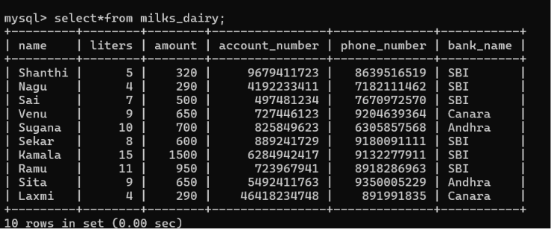

GROUP BY

1. Count bank_name,COUNT(*)
.

SELECT bank_name,COUNT(*)
FROM milks_dairy
GROUP BY bank_name;
OUTPUT:

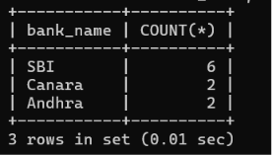

2. HAVING

SELECT bank_name,COUNT(*)
-> FROM milks_dairy
-> GROUP BY bank_name
-> HAVING COUNT(*)>1;

OUTPUT:

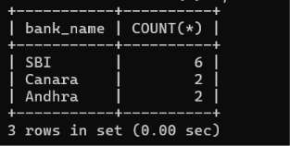

3. ORDER BY ASC

SELECT*FROM milks_dairy
ORDER BY amount ASC;
OUTPUT:

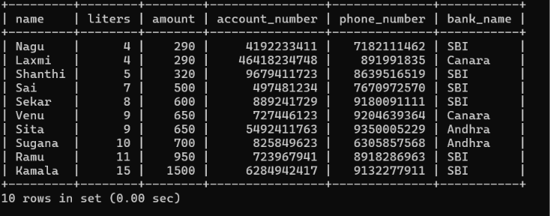
4. ORDER BY DESC

SELECT*FROM milks_dairy
ORDER BY amount DESC;

OUTPUT:

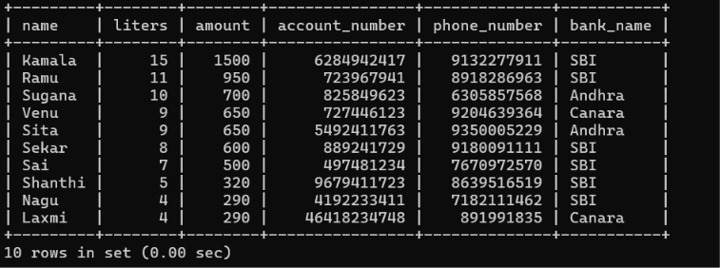

5. GROUP BY WITH SUM

SELECT bank_name,SUM(amount)
FROM milks_dairy
GROUP BY bank_name;
OUTPUT:

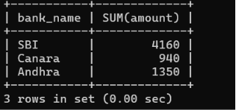

RESULT
Thus, the records from the student_cgpa table were successfully retrieved and organized using the GROUP BY, HAVING, and ORDER BY clauses in MySQL Workbench.

