NAME: MOHAMMED AFFAN M
REG NO: 192572169
Experiment-17
Sum of Integers from 1 to n
Aim:-
To write a Prolog program to find the sum of integers from 1 to n.
Algorithm:-
1. Start the program.
2. Define a base clause sum(0,0) for the terminating condition.
3. Define a recursive clause: sum(N,Result) calls sum(N-1,R1) and adds N to R1.
4. Accept the value of n from the user.
5. Call the sum predicate and display the result.
6. Stop the program.

Program (Prolog):-
sum(0,0).
sum(N,Result):-
N>0,
N1 is N-1,
sum(N1,R1),
Result is R1+N.

:- initialization(main).
main:-
write('Enter n: '), nl,
read(N),
sum(N,S),
write('Sum from 1 to '), write(N), write(' is '), write(S), nl.

Output:-
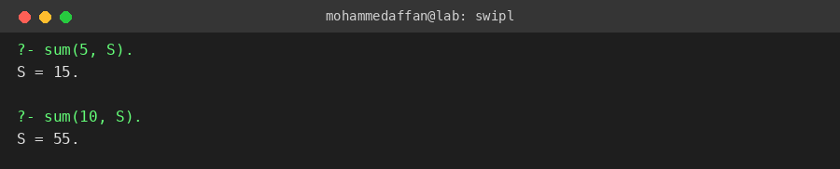

Result:-
Hence the Prolog program has been executed and the output has been verified.

