NAME: MOHAMMED AFFAN M
REG NO: 192572169
Experiment-18
A DB with NAME, DOB
Aim:-
To write a Prolog program to create a database with fields NAME and DOB and retrieve records using queries.
Algorithm:-
1. Start the program.
2. Define facts of the form student(Name, DOB) for each record.
3. Write a predicate to display all records by backtracking through the facts.
4. Accept a query to search for a particular student's date of birth.
5. Display the matching record(s).
6. Stop the program.

Program (Prolog):-
student(john, date(12,5,2000)).
student(mary, date(23,8,1999)).
student(alex, date(4,11,2001)).
student(priya, date(17,2,2002)).

display_all:-
student(Name,DOB),
write(Name), write(' -- '), write(DOB), nl,
fail.
display_all.

:- initialization(main).
main:- display_all.

Output:-
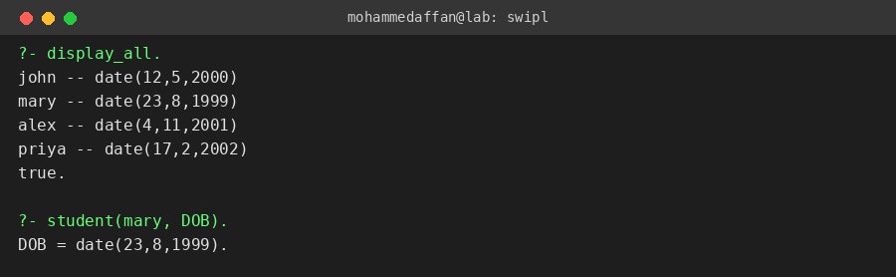

Result:-
Hence the Prolog program has been executed and the output has been verified.

