NAME: MOHAMMED AFFAN M
REG NO: 192572169
Experiment-19
STUDENT-TEACHER-SUB-CODE
Aim:-
To write a Prolog program to represent relationships between Student, Teacher and Subject Code, and to query which teacher teaches a given student.
Algorithm:-
1. Start the program.
2. Define facts teaches(Teacher, SubCode) linking a teacher to the subject code taught.
3. Define facts studies(Student, SubCode) linking a student to the subject code studied.
4. Define a rule taught_by(Student, Teacher) that joins the two relations through SubCode.
5. Query the rule to find the teacher of a given student.
6. Stop the program.

Program (Prolog):-
teaches(prof_smith, cs101).
teaches(prof_jones, cs102).
teaches(prof_smith, cs103).
teaches(prof_rao, cs104).

studies(john, cs101).
studies(mary, cs102).
studies(alex, cs103).
studies(priya, cs104).

taught_by(Student, Teacher):-
studies(Student, Sub),
teaches(Teacher, Sub).

Output:-
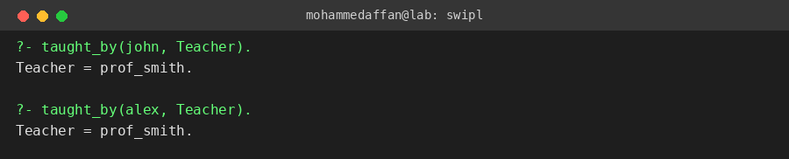

Result:-
Hence the Prolog program has been executed and the output has been verified.

