NAME: MOHAMMED AFFAN M
REG NO: 192572169
Experiment-20
PLANETS DB
Aim:-
To write a Prolog program to create a database of planets with their order and distance from the sun, and to retrieve information using queries.
Algorithm:-
1. Start the program.
2. Define facts planet(Name, Order, DistanceFromSunInMillionKm).
3. Write a rule to find the planet at a given order/position.
4. Write a rule to find planets closer to the sun than a given planet.
5. Query the database for required information.
6. Stop the program.

Program (Prolog):-
planet(mercury,1,57.9).
planet(venus,2,108.2).
planet(earth,3,149.6).
planet(mars,4,227.9).
planet(jupiter,5,778.3).
planet(saturn,6,1427.0).
planet(uranus,7,2871.0).
planet(neptune,8,4497.0).

planet_at(Order, Name):- planet(Name, Order, _).

closer_than(P, Closer):-
planet(P, _, D),
planet(Closer, _, D1),
D1 < D.

Output:-
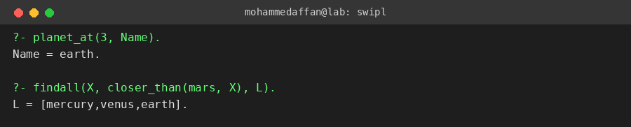

Result:-
Hence the Prolog program has been executed and the output has been verified.

