NAME: MOHAMMED AFFAN M
REG NO: 192572169
Experiment-21
Towers of Hanoi
Aim:-
To write a Prolog program to solve the Towers of Hanoi problem for n disks using recursion.
Algorithm:-
1. Start the program.
2. Define the base clause hanoi(0,_,_,_) which does nothing (terminating condition).
3. Define the recursive clause hanoi(N,From,To,Via) which moves N-1 disks from From to Via, moves disk N from From to To, then moves N-1 disks from Via to To.
4. Print each move performed.
5. Call hanoi/4 with the number of disks and the three peg names.
6. Stop the program.

Program (Prolog):-
hanoi(0,_,_,_):- !.
hanoi(N,From,To,Via):-
N>0,
N1 is N-1,
hanoi(N1,From,Via,To),
format('Move disk ~w from ~w to ~w~n',[N,From,To]),
hanoi(N1,Via,To,From).

:- initialization(main).
main:- hanoi(3,left,right,middle).

Output:-
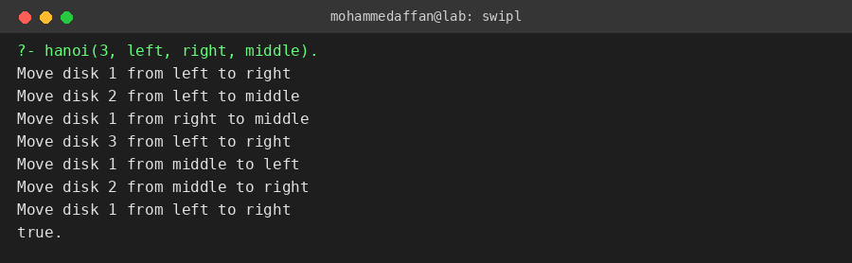

Result:-
Hence the Prolog program has been executed and the output has been verified.

