NAME: MOHAMMED AFFAN M
REG NO: 192572169
Experiment-22
Print whether a particular bird can fly or not
Aim:-
To write a Prolog program that determines whether a particular bird can fly, incorporating the required queries.
Algorithm:-
1. Start the program.
2. Define facts for all known birds using bird(Name).
3. Define facts cannot_fly(Name) for birds that cannot fly (e.g. penguin, ostrich).
4. Define a rule can_fly(X) that succeeds if X is a bird and X is not in cannot_fly.
5. Query can_fly/1 for a given bird and display Yes/No.
6. Stop the program.

Program (Prolog):-
bird(sparrow).
bird(eagle).
bird(penguin).
bird(ostrich).
bird(crow).

cannot_fly(penguin).
cannot_fly(ostrich).

can_fly(X):-
bird(X),
\+ cannot_fly(X).

check_fly(X):-
( can_fly(X) ->
format('~w can fly~n',[X])
; format('~w cannot fly~n',[X])
).

Output:-
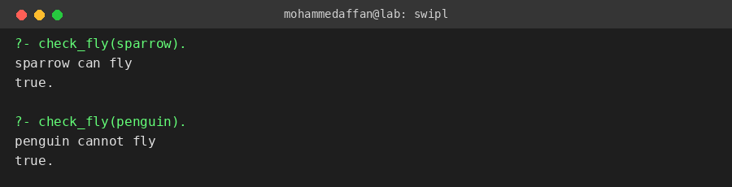

Result:-
Hence the Prolog program has been executed and the output has been verified.

