NAME: MOHAMMED AFFAN M
REG NO: 192572169
Experiment-23
Family Tree
Aim:-
To write a Prolog program to represent a family tree and derive relationships such as father, mother, grandparent and sibling.
Algorithm:-
1. Start the program.
2. Define base facts parent(X,Y), male(X) and female(X).
3. Define rule father(X,Y): X is parent of Y and X is male.
4. Define rule mother(X,Y): X is parent of Y and X is female.
5. Define rule grandparent(X,Z): X is parent of Y and Y is parent of Z.
6. Define rule sibling(X,Y): X and Y share a common parent and are not the same person.
7. Query the rules to derive relationships. Stop the program.

Program (Prolog):-
parent(john, mary).
parent(john, tom).
parent(susan, mary).
parent(susan, tom).
parent(mary, ann).
parent(mary, ben).

male(john).
male(tom).
male(ben).
female(susan).
female(mary).
female(ann).

father(X,Y):- parent(X,Y), male(X).
mother(X,Y):- parent(X,Y), female(X).
grandparent(X,Z):- parent(X,Y), parent(Y,Z).
sibling(X,Y):- parent(P,X), parent(P,Y), X \= Y.

Output:-
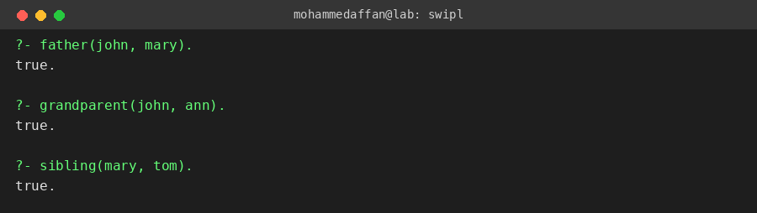

Result:-
Hence the Prolog program has been executed and the output has been verified.

