NAME: MOHAMMED AFFAN M
REG NO: 192572169
Experiment-25
Monkey Banana Problem
Aim:-
To write a Prolog program to solve the classic Monkey Banana problem using state-space search.
Algorithm:-
1. Start the program. Represent the state as state(MonkeyPos, BoxPos, MonkeyOnBox, HasBanana).
2. Define move/2 clauses for actions: walk to a location, push the box to a location, climb onto the box, and grab the banana.
3. Define canget/1 that succeeds when HasBanana = has (goal state).
4. For a non-goal state, canget(State1) tries a move to State2 and recursively calls canget(State2).
5. Start from the initial state and let Prolog search for a sequence of moves leading to the goal.
6. Stop the program once the banana is grabbed.

Program (Prolog):-
move(state(middle,middle,onbox,hasnot),
grab,
state(middle,middle,onbox,has)).

move(state(P,middle,onfloor,H),
climb,
state(middle,middle,onbox,H)).

move(state(P1,P1,onfloor,H),
push(P1,P2),
state(P2,P2,onfloor,H)).

move(state(P1,B,onfloor,H),
walk(P1,P2),
state(P2,B,onfloor,H)).

canget(state(_,_,_,has)).
canget(State1):-
move(State1,_,State2),
canget(State2).

Output:-
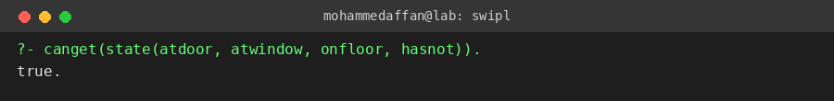

Result:-
Hence the Prolog program has been executed and the output has been verified.

