NAME: MOHAMMED AFFAN M
REG NO: 192572169
Experiment-26
Fruit and its Colour using Backtracking
Aim:-
To write a Prolog program that determines the colour of a given fruit, demonstrating backtracking over multiple facts.
Algorithm:-
1. Start the program.
2. Define fruit(Name, Colour) facts for several fruits.
3. Define a rule colour_of(Fruit, Colour) that unifies with the fruit facts.
4. Query colour_of/2 with the fruit bound and colour unbound to retrieve the colour.
5. Query colour_of/2 with the colour bound and fruit unbound; Prolog backtracks through the facts to find all matching fruits.
6. Stop the program.

Program (Prolog):-
fruit(apple, red).
fruit(banana, yellow).
fruit(grape, green).
fruit(orange, orange).
fruit(strawberry, red).
fruit(mango, yellow).

colour_of(Fruit, Colour):- fruit(Fruit, Colour).

Output:-
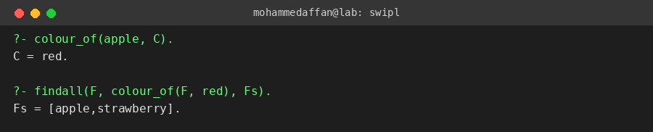

Result:-
Hence the Prolog program has been executed and the output has been verified.

