NAME: MOHAMMED AFFAN M
REG NO: 192572169
Experiment-27
Best First Search Algorithm
Aim:-
To write a Prolog program to implement the Best First Search algorithm on a graph using heuristic values.
Algorithm:-
1. Start the program.
2. Represent the graph using edge(Node1,Node2,Cost) facts and heuristic values using h(Node,Value) facts.
3. Maintain an Open list of nodes to explore, sorted by heuristic value, and a Closed list of visited nodes.
4. At each step remove the node with the least heuristic value from Open, expand its neighbours and add unvisited ones to Open.
5. Repeat until the goal node is removed from Open, then report the path found.
6. Stop the program.

Program (Prolog):-
edge(a,b). edge(a,c). edge(b,d). edge(c,d). edge(d,e).

h(a,6). h(b,4). h(c,5). h(d,2). h(e,0).

best_first(Goal,[Goal|_],[Goal]):- !.
best_first(Goal,[Node|_],[Node|Path]):-
findall(Next-Hn, (edge(Node,Next), h(Next,Hn)), Neighbours),
keysort(Neighbours, Sorted),
pairs_keys(Sorted, NextNodes),
member(Next,NextNodes),
best_first(Goal,[Next],RestPath),
Path = RestPath.

:- initialization(main).
main:- best_first(e,[a],Path), write(Path), nl.

Output:-
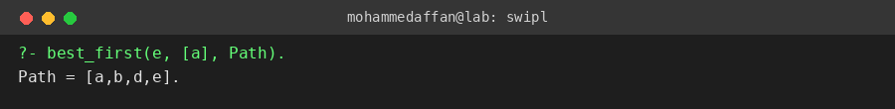

Result:-
Hence the Prolog program has been executed and the output has been verified.

