NAME: MOHAMMED AFFAN M
REG NO: 192572169
Experiment-28
Medical Diagnosis
Aim:-
To write a Prolog expert system that diagnoses a probable disease from a set of observed symptoms.
Algorithm:-
1. Start the program.
2. Define symptom(Patient, Symptom) facts describing the observed symptoms of a patient.
3. Define disease(Disease, ListOfRequiredSymptoms) rules that state which combination of symptoms indicates a disease.
4. Write a predicate has_all(Patient, ListOfSymptoms) that checks whether the patient has every symptom in the list.
5. Write diagnose(Patient, Disease) that succeeds if the patient has all symptoms required for that disease.
6. Query diagnose/2 to find the probable disease for a patient. Stop the program.

Program (Prolog):-
symptom(patient1, fever).
symptom(patient1, cough).
symptom(patient1, body_ache).
symptom(patient2, sneezing).
symptom(patient2, runny_nose).

disease(flu, [fever, cough, body_ache]).
disease(cold, [sneezing, runny_nose]).

has_all(_, []).
has_all(Patient, [S|Rest]):-
symptom(Patient, S),
has_all(Patient, Rest).

diagnose(Patient, Disease):-
disease(Disease, Symptoms),
has_all(Patient, Symptoms).

Output:-
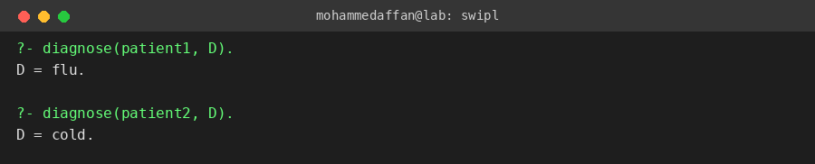

Result:-
Hence the Prolog program has been executed and the output has been verified.

