NAME: MOHAMMED AFFAN M
REG NO: 192572169
Experiment-29
Forward Chaining
Aim:-
To write a Prolog program to implement forward chaining inference, incorporating the required queries.
Algorithm:-
1. Start the program.
2. Define known facts about the world (e.g. animal characteristics).
3. Define rules that derive new facts from existing facts (data-driven inference).
4. Starting from the known facts, repeatedly apply the rules to derive new facts until no more new facts can be derived.
5. Query the derived facts to confirm the conclusion (e.g. the species of the animal).
6. Stop the program.

Program (Prolog):-
has_hair(tom).
gives_milk(tom).
has_feathers(tweety).
flies(tweety).
lays_eggs(tweety).

mammal(X):- has_hair(X).
mammal(X):- gives_milk(X).
bird(X):- has_feathers(X).
bird(X):- flies(X), lays_eggs(X).

animal(X):- mammal(X).
animal(X):- bird(X).

Output:-
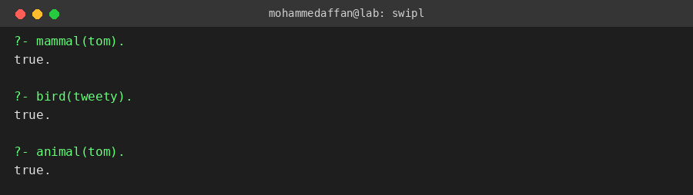

Result:-
Hence the Prolog program has been executed and the output has been verified.

