NAME: MOHAMMED AFFAN M
REG NO: 192572169
Experiment-30
Backward Chaining
Aim:-
To write a Prolog program to implement backward chaining inference, incorporating the required queries.
Algorithm:-
1. Start the program.
2. Define rules in the form Goal :- Condition1, Condition2, ... where the goal depends on conditions.
3. Define base facts that satisfy the lowest-level conditions.
4. To prove a goal, Prolog works backward: it looks at the rule for the goal and tries to prove each condition, recursively, until it reaches known facts.
5. Query the top-level goal; Prolog's SLD resolution performs the backward chaining automatically.
6. Stop the program.

Program (Prolog):-
% Facts
has_feathers(tweety).
can_fly(tweety).
chirps(tweety).

% Rule: goal 'bird' is proved backward from its conditions
bird(X):-
has_feathers(X),
can_fly(X).

canary(X):-
bird(X),
chirps(X).

Output:-
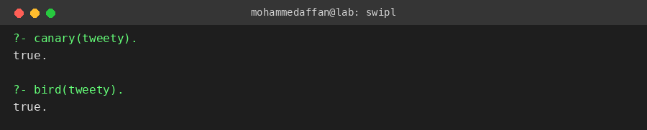

Result:-
Hence the Prolog program has been executed and the output has been verified.

