NAME: MOHAMMED AFFAN M
REG NO: 192572169
Experiment-31
Web Blog using WordPress demonstrating Anchor Tag, Title Tag, etc.
Aim:-
To create a Web Blog using WordPress and demonstrate the use of HTML elements such as the Anchor Tag and Title Tag within a blog post.
Algorithm:-
1. Login to the WordPress dashboard and create a new blog Post/Page.
2. Set the Title Tag of the post through the SEO/Title field so it appears in the browser tab and search results.
3. Switch the post editor to the HTML/Code view to insert custom HTML tags such as anchor (<a>) tags for hyperlinks.
4. Insert an Anchor Tag linking to another page or an external website, and format text using heading and paragraph tags.
5. Preview and Publish the blog post.
6. Verify that the Title Tag and Anchor Tag work correctly in the published page.

Program (HTML):-
<!-- HTML block inserted inside a WordPress blog post -->
<html>
<head>
<title>My First WordPress Blog - AI Lab</title>
</head>
<body>
<h1>Welcome to My AI Lab Blog</h1>
<p>This post demonstrates basic HTML tags inside WordPress.</p>

<!-- Anchor Tag -->
<a href="https://wordpress.org" target="_blank">Visit WordPress</a>
</body>
</html>

Output:-
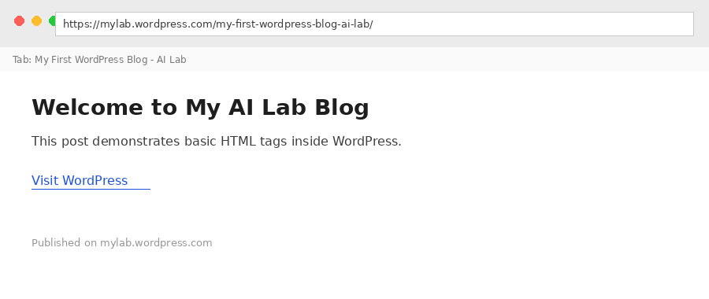

Result:-
Hence a Web Blog was created using WordPress and the Anchor Tag and Title Tag were successfully demonstrated.

