NAME: MOHAMMED AFFAN M
REG NO: 192572169
Experiment-32
Pattern Matching
Aim:-
To write a Prolog program to implement pattern matching using unification.
Algorithm:-
1. Start the program.
2. Define a predicate match(Pattern, List) that uses Prolog's built-in unification to match a pattern against a list structure.
3. Use variables in the pattern to capture parts of the list (head, tail, or specific positions).
4. Call match/2 with a concrete list and observe how the pattern variables get bound.
5. Display the bound values.
6. Stop the program.

Program (Prolog):-
match([First,Second|Rest], First, Second, Rest).

:- initialization(main).
main:-
List = [a,b,c,d,e],
match(List, First, Second, Rest),
format('First = ~w~n',[First]),
format('Second = ~w~n',[Second]),
format('Rest = ~w~n',[Rest]).

Output:-
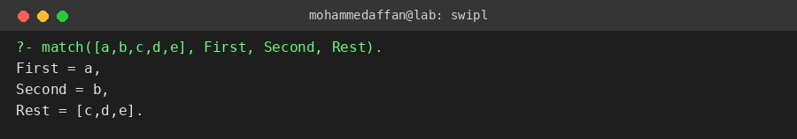

Result:-
Hence the Prolog program has been executed and the output has been verified.

