8 | Cyclomatic Complexity in Software Testing is a testing metric used for measuring the complexity of a software program. It is a quantitative measure of independent paths in the source code of a software program. Cyclomatic complexity can be calculated by using control flow graphs or with respect to functions, modules, methods or classes within a software program. Cyclomatic complexity for a flow graph G is V(G)=E-N+2. Cyclomatic complexity is a software metric (measurement), used to indicate the complexity of a program, Cyclomatic complexity = E - N + P where, E = number of edges in the flow graph, N = number of nodes in the flow graph, P = number of nodes that have exit points. Find Cyclomatic Complexity for a graph having number of edges as 17, number of nodes as 13 and number of predicate nodes in the flow graph as 5. | Raptor | CO1

Given Data
Edges (E) = 17
Nodes (N) = 13
Predicate nodes (P) = 5
Formula used in Software Testing
Two common formulas:
- V(G) = E − N + 2
- V(G) = P + 1
We will compute using both to verify.

🔹 Manual Calculation
Method 1:
V(G) = E − N + 2
V(G) = 17 − 13 + 2
V(G) = 6
Method 2:
V(G) = P + 1
V(G) = 5 + 1
V(G) = 6
✅Cyclomatic Complexity = 6

Aim
To calculate Cyclomatic Complexity using RAPTOR.

Step 1: Open RAPTOR
Open RAPTOR Flowchart Tool.

Step 2: Insert Input Symbols
Add three Input symbols:
- Input E
- Input N
- Input P
Set prompts:
Enter number of edges:
Enter number of nodes:
Enter number of predicate nodes:

Step 3: Insert Assignment Symbol (Formula 1)
Add an Assignment symbol:
V1 = E - N + 2

Step 4: Insert Assignment Symbol (Formula 2)
Add another Assignment symbol:
V2 = P + 1

Step 5: Insert Output Symbols
Add Output symbols:
Cyclomatic Complexity using E-N+2 = V1
Cyclomatic Complexity using P+1 = V2

Step 6: Flowchart Order

Start
↓
Input E
↓
Input N
↓
Input P
↓
V1 = E - N + 2
↓
V2 = P + 1
↓
Output V1
↓
Output V2
↓
End
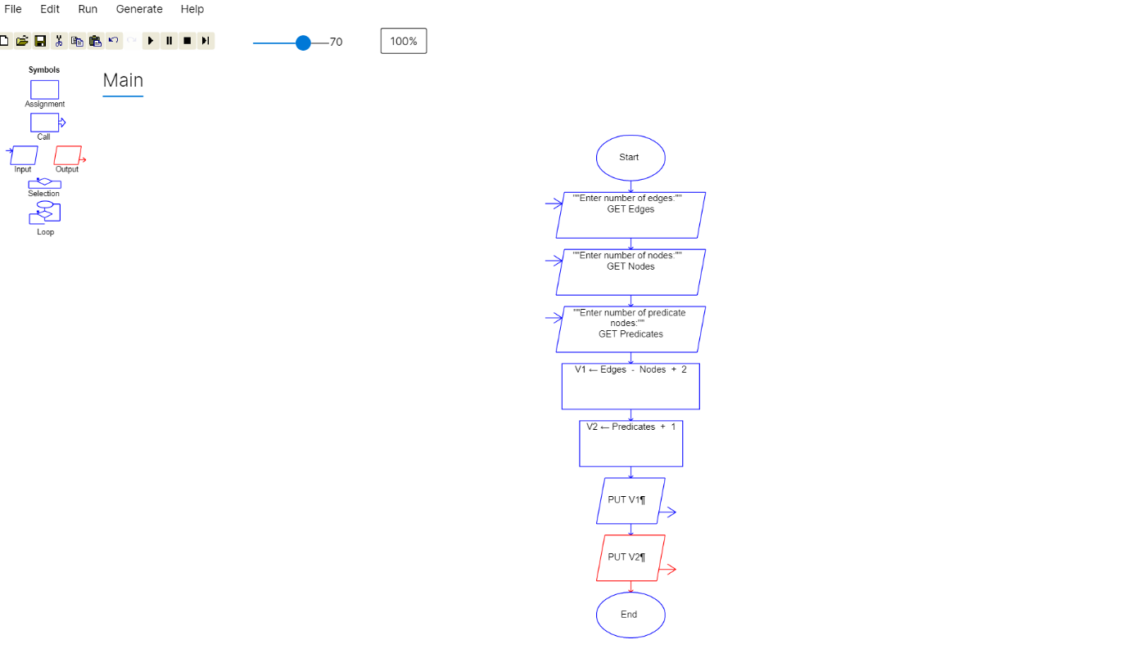

Step 7: Sample Input for Lab
E = 17
N = 13
P = 5
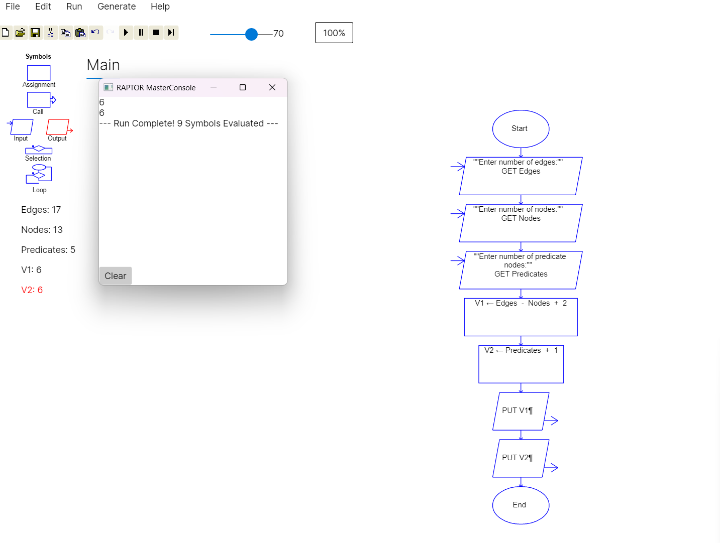
Output:
Cyclomatic Complexity using E-N+2 = 6
Cyclomatic Complexity using P+1 = 6

Result
The Cyclomatic Complexity of the given flow graph is:
👉V(G) = 6

