NAME: K Yamini
REG NO: 192572181

Write the Python program to implement Feed Forward Neural Network.
Aim:
To implement a simple Feed Forward Neural Network (FFNN) using Python and perform forward propagation from the input layer through the hidden layer to the output layer.
Algorithm:
- Start the program.
- Define the input values.
- Initialize weights and biases for the hidden layer.
- Initialize weights and bias for the output layer.
- Define the sigmoid activation function.
- Calculate the weighted sum of inputs for each hidden neuron.
- Apply the sigmoid function to obtain hidden-layer outputs.
- Calculate the weighted sum of hidden-layer outputs.
- Apply the sigmoid function to obtain the final output.
- Display the input, hidden-layer output and final output.
- Stop the program
Formula:
Hidden Layer:
H = sigmoid(XWₕ + Bₕ)
Output Layer:
O = sigmoid(HWₒ + Bₒ)
where,
sigmoid(x) = 1 / (1 + e⁻ˣ)
.Python Code:
# Feed Forward Neural Network
import math
# Sigmoid activation function
def sigmoid(x):
return 1 / (1 + math.exp(-x))
# Input data
inputs = [
[0, 0],
[0, 1],
[1, 0],
[1, 1]
]
# Weights from input layer to hidden layer
w11 = 0.5
w12 = 0.4
w21 = 0.3
w22 = 0.2
# Biases for hidden layer
b1 = 0.1
b2 = 0.1
# Weights from hidden layer to output layer
wo1 = 0.6
wo2 = 0.5
# Output bias
bo = 0.1
print("FEED FORWARD NEURAL NETWORK")
print("--------------------------------")
# Process each input
for x in inputs:
print("\nInput:", x)
# Step 1: Calculate hidden layer inputs
h1_input = x[0] * w11 + x[1] * w21 + b1
h2_input = x[0] * w12 + x[1] * w22 + b2
# Step 2: Apply sigmoid activation
h1 = sigmoid(h1_input)
h2 = sigmoid(h2_input)
print("# Hidden neuron 1 output:", round(h1, 4))
print("# Hidden neuron 2 output:", round(h2, 4))
# Step 3: Calculate output layer input
output_input = h1 * wo1 + h2 * wo2 + bo
# Step 4: Apply sigmoid activation
output = sigmoid(output_input)
print("# Final output:", round(output, 4))
print("\nFeed Forward Neural Network executed successfully.")
Input:
Input 1: 0 0
Input 2: 0 1
Input 3: 1 0
Input 4: 1 1
Output :
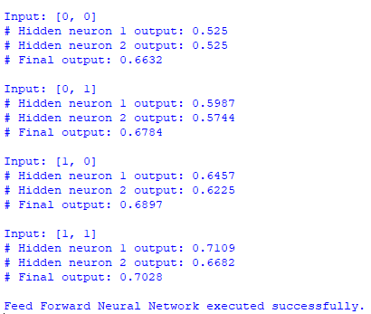
Result:
Thus, the Feed Forward Neural Network was successfully implemented in Python, and the output was obtained through forward propagation.

